Persons performing work under contracts of mandate and related contracts in Poland in September 2024
2 429.4 thousand
the number of persons performing work under contracts of mandate and related contracts in Poland as at 30 September 2024
On the last day of September 2024, there were over 2.4 million persons performing work under contracts of mandate and related contracts in Poland. Of these, 1 004.1 thousand were simultaneously performing work qualifying them as employed persons in the national economy.
The data presented in this study concern persons performing work under contracts of mandate together with contracts of a related nature, i.e. agency agreements, service contracts, activation agreements, appointment letters and contracts with members of supervisory boards. The results presented are part of experimental work aimed at determining the number of persons performing work under civil law contracts.
9 out of 10 persons performing contracts of mandate and related contracts were related to the private sector
At the end of September 2024, there were 2 429.4 thousand persons performing work under contracts of mandate and related contracts (contractors) in Poland. Among them, the proportion of women was slightly higher, accounting for 51.2%. This type of contracts was mainly used in the private sector, where 89.6% of all contractors were concentrated. In the public sector, women accounted for 58.1% and in the private sector for 50.4%.
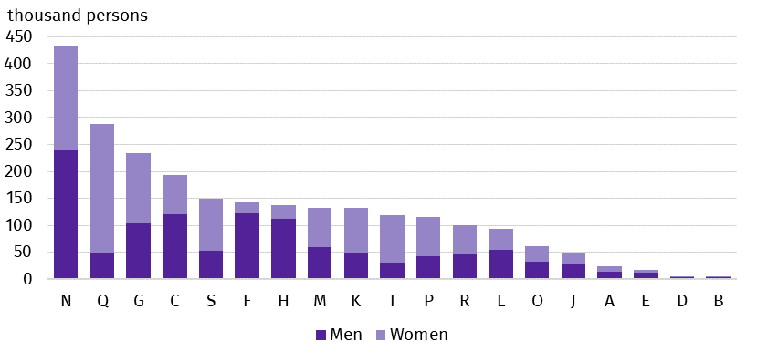
Chart 1. Persons performing work under contracts of mandate and related contracts by PKD 2007/NACE Rev. 2 section and sex in 2024
As at 30 September
As at 30 September 2024, the most persons performing work under contracts of mandate and related contracts were in the section Administrative and support service activities (18.3%), which includes, inter alia, the activities of employment agencies providing placement services. The second section in terms of the number of persons performing work under contracts of mandate and related contracts was Human health and social work activities, which accounted for 12.2% of all contractors. In the analysed population, this was the most feminised PKD 2007/ NACE Rev. 2 section, in which the share of women was 83.2%. The share of women was also high in the section Financial and insurance activities - 73.5%. On the other hand, the highest share of men among contractors was recorded in the sections Construction and Transportation and storage (84.5% and 81.8%, respectively).
One in five persons performing contracts of mandate and related contracts was related to the section Administrative and support service activities
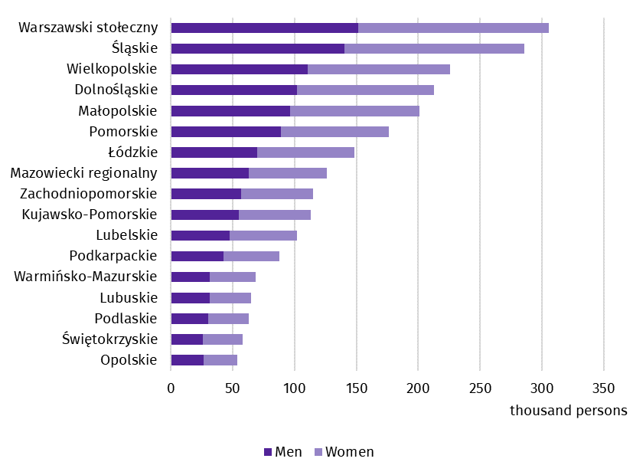
Chart 2. Persons performing work under contracts of mandate and related contracts by place of residenceª and sex in 2024
As at 30 September
One in four contractors lived in the Warszawski stołeczny region or the Śląskie region
a Data by statistical region; excluding persons performing contracts of mandate and related contracts living abroad.
On the last day of September 2024, the most persons performing work under contracts of mandate and related contracts lived in the Warszawski stołeczny region and the Śląskie region – 305.7 thousand and 285.6 thousand, respectively. The regions with the smallest number of contractors were Opolskie and Świętokrzyskie, where 54.0 thousand and 57.9 thousand persons respectively lived. The share of women ranged from 49.6% in the Pomorskie region to 54.7% in the Świętokrzyskie region.
There were 21.1 thousand persons living abroad among the contractors, and women accounted for 36.0% of this group.

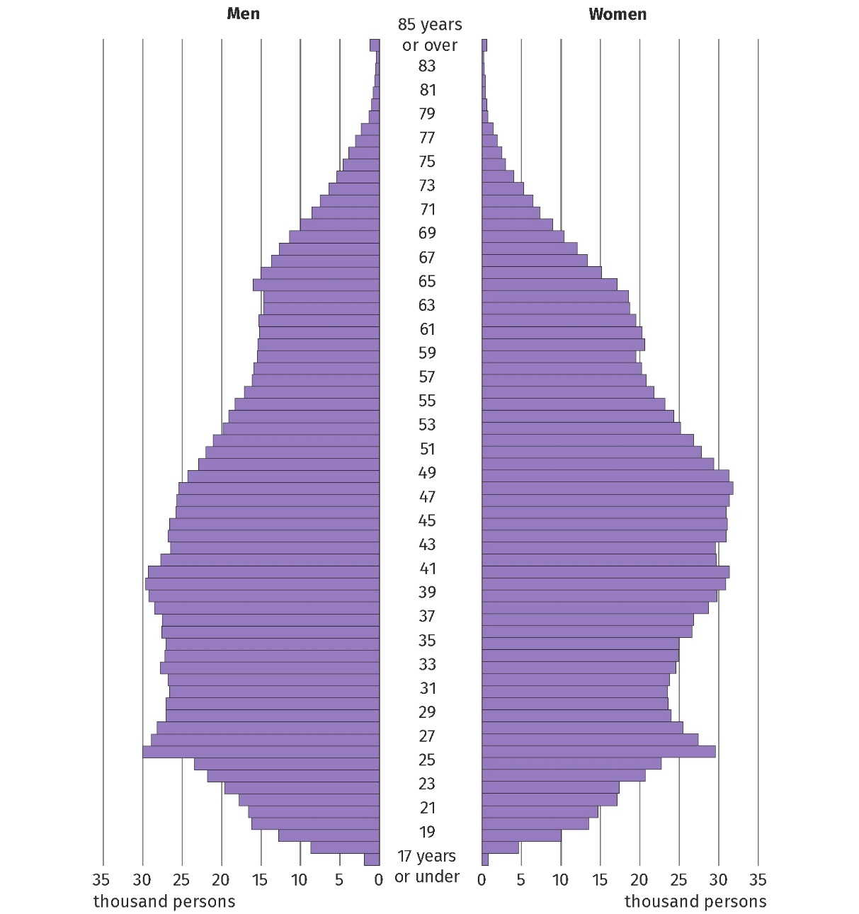
Chart 3. Persons performing work under contracts of mandate and related contracts by age and sex in 2024
As at 30 September
The median age of women working under contracts of mandate and related contracts was 2 years higher than that of men
At the end of September 2024, the median age of contractors was 43 years, with a median age of 44 years for women, two years higher than for men. Among contractors between the ages of 38 and 66, there were more women than men performing contracts of mandate and related contracts, while there was a male predominance in the other single-year cohorts.
Women outnumbered men among contractors aged 38 to 66 years
In labour market statistics, persons performing contracts of mandate and related contracts are not counted as employed persons in the national economy. However, among the population of contractors it is possible to distinguish a group of persons who simultaneously performed work meeting the criteria for employed persons in the national economy. On the last day of September 2024, there were 1 004.1 thousand such contractors. Among them 54.0% were women.
Methodological notes
The source of the presented data is administrative registers. The population under study includes persons performing work under contracts of mandate, together with contracts of a related nature to which the provisions of the Civil Code apply and which involve the obligation to be covered by social and/or health insurance at the Social Insurance Institution (ZUS), i.e. agency agreements, service contracts, activation agreements, appointment letters and contracts with members of supervisory boards. According to the provisions of the Polish Civil Code in Poland, contracts of mandate and related contracts can be concluded by persons aged 13 or over. The population under study does not include those working under contracts to perform a specified task or those performing harvest assistance contracts (farmer's helpers). It also does not include those persons performing work under contracts of mandate and related contracts who have concluded such a contract with their own employer or with another entity but on behalf of their own employer, or who are secondary school pupils or students under the age of 26.
In this news release abbreviated names of NACE Rev. 2 sections were used. Abbreviations are marked with a ‘Δ’ symbol. Full names are listed below.
The data presented refer to the predominant kind of activity. The data for the section Other service activities (S) also include those employed in the sections Activities of households as employers; undifferentiated goods- and services-producing activities of households for own use (T) and Activities of extraterritorial organisations and bodies (U).
PKD 2007/NACE Rev. 2 section symbols:
A – Agriculture, forestry and fishing;
B – Mining and quarrying;
C – Manufacturing;
D – Electricity, gas, steam and air conditioning supply;
E – Water supply; sewerage, waste management and remediation activities;
F – Construction;
G – Wholesale and retail trade; repair of motor vehicles and motorcycles;
H – Transportation and storage;
I – Accommodation and food service activities;
J – Information and communication;
K – Financial and insurance activities;
L – Real estate activities;
M – Professional, scientific and technical activities;
N – Administrative and support service activities;
O – Public administration and defence; compulsory social security;
P – Education;
Q – Human health and social work activities;
R – Arts, entertainment and recreation;
S – Other service activities;
T – Activities of households as employers; undifferentiated goods- and services-producing activities of households for own use;
U – Activities of extraterritorial organisations and bodies.
In the case of quoting Statistics Poland data, please provide information: ‘Source of data: Statistics Poland’, and in the case of publishing calculations made on data published by Statistics Poland, please provide information: ‘Own work based on Statistics Poland data.’
Prepared by:  Statistical Office in Bydgoszcz  Director Wiesława Gierańczyk, Ph.D.  Phone: (+48 52) 366 93 90 | Issued by:  Press Office  Mobile phone: +48 695 255 032  Landline phones: +48 22 608 38 04, +48 22 449 41 45, +48 22 608 30 09  e-mail: obslugaprasowa@stat.gov.pl

www.stat.gov.pl/en/

@StatPoland

@GlownyUrzadStatystyczny

gus_stat

glownyurzadstatystycznygus

glownyurzadstatystyczny
Reletad information
Methodological report Employment in the national economy
Methodological report Employment in the national economy according to administrative data sources
Employed persons in the national economy in Poland in September 2024
Terms used in official statistics
Employed persons in the national economy

The category of employed persons includes: employees; self-employed persons, including contributing family workers; outworkers; members of farming cooperatives; clergy fulfilling pastoral duties.
Act of 23 April 1964, Civil Code (Journal of Laws of 2024, item 1061, as amended).

