Financial results of insurance companies in 2024
8.6%
Increase in gross premiums written y/y
The overall net financial result of insurance companies in 2024 was higher than a year earlier and amounted to PLN 10.0 billion (PLN 9.4 billion in 2023). This was mainly influenced by the improved performance of life insurance companies (Branch I), which increased by 17.1% year-on-year.

Incomes and costs
Total gross written premium amounted to PLN 85.7 billion
Earned premium was the dominant item in the total income structure. In 2024, the total gross written premium amounted to PLN 85 676.3 million (an increase of 8.6% compared to 2023), of which PLN 23 601.6 million were premiums of life insurance companies, and PLN 62 074.8 million of non-life insurance.

Chart 1. Life insurers financial results (Branch I)

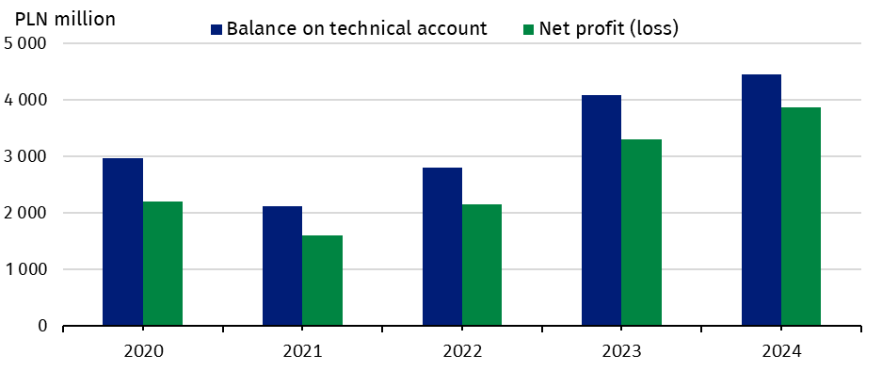

Chart 2. Non-life insurers financial results (Branch II)

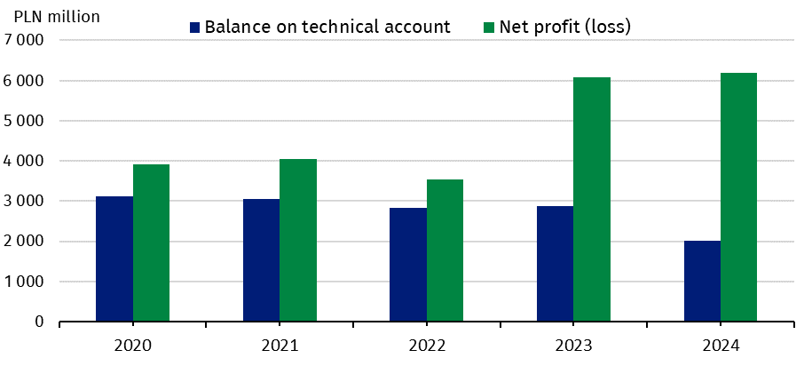

Claims incurred constituted the dominant position in the total cost structure. Total gross claims paid in 2024 amounted to PLN 50 273.5 million and were 13.6% higher than in 2023; in Branch I they increased to PLN 16 370.6 million (by 0.8%), and in Branch II their value increased to PLN 33 903.0 million (by 21.0%).
Total gross claims paid amounted to PLN 50.3 billion

Fianncial results and balance on technical account
Net financial result
amounted to PLN 3.9 billion in the life sector, and PLN 6.2 billion in non-life sector
The total net financial result of insurance companies amounted to PLN 10 042.9 million and was higher by 7.1% compared to 2023. Life insurance companies generated a result of PLN 3 861.1 million (an increase of 17.1%), and non-life insurance companies’ profits amounted to PLN 6 181.8 million (an increase of 1.7%).
The technical result (in aggregate) amounted to PLN 6 457.3 million and was 7.4% lower than in 2023. The technical result in life insurance (branch I) increased to PLN 4 451.8 million (by 8.9%), which was mostly due to the technical results generated in the insurance class 5: “Accident and sickness insurance if they are supplementary to insurance from classes 1-4” (PLN 2 106.0 million) and in the class 1: “Life insurance” (PLN 1 742.4 million). The technical result in non-life insurance (branch II) decreased to PLN 2 005.6 million (by 30.5%). The largest contributor to its value was technical profit generated in class 3: “Casco insurance of land vehicles, except for rail vehicles” (PLN 857.4 million) and in the class 9: “Insurance of other damage to property (where not included in classes 3, 4, 5, 6 or 7) caused by hail or frost and other causes (such as theft) where those causes are not included in class 8” (PLN 452.2 million).

Table 1. Income, costs and balance on technical life and non-life insurance account
Specification | Life (Branch I) |  |  | Non-life (Branch II)
Specification | 2023 | 2024 |  | 2023 | 2024
Specification | million PLN |  | 2023=100 | million PLN |  | 2023=100
Total income | 32 049.6 | 28 470.5 | 88.8 | 51 170.5 | 56 194.1 | 109.8

of which:
earned premiums | 22 275.6 | 22 954.9 | 103.1 | 42 683.2 | 47 388.2 | 111.0
investment incomeª | 9 612.2 | 5 212.8 | 54.2 | 7 207.9 | 7 573.3 | 105.1
Total costs | 28 752.7 | 24 609.5 | 85.6 | 45 091.8 | 50 012.3 | 110.9
of which:
claims incurred  including change in provisions - net of reinsurance^{b} | 16 060.0 | 16 332.8 | 101.7 | 26 193.1 | 30 371.4 | 116.0
change in other technical provisions - net of reinsurance | 4 274.4 | -180.9 | . | 7.6 | 15.1 | 199.4
net operating  expenses | 6 120.6 | 6 107.8 | 99.8 | 13 552.6 | 14 962.3 | 110.4
investment charges | 872.3 | 850.1 | 97.5 | 1 549.0 | 1 160.6 | 74.9
Net financial account | 3 296.9 | 3 861.1 | 117.1 | 6 078.7 | 6 181.8 | 101.7
Balance on technical account | 4 090.0 | 4 451.8 | 108.9 | 2 884.2 | 2 005.6 | 69.5

a Including unrealised gains on investments. b Net of reinsurance including change in provisions.

Gross written premiums and gross claims paid in direct activities
Gross written premiums
collected from motor insurance amounted to PLN 31.4 billion

In the structure of gross premiums written from total direct activities, the premiums of life insurers accounted for 29.0% and premiums of non-life insurers for 71.0% of the total value.

As in the previous year, the dominant position in Branch I, in terms of gross premiums collected, was achieved by insurance class 1: “Life insurance”. This was followed by the insurance class 5: “Accident and sickness insurance where it is complementary to the insurance listed in classes 1 to 4”. The share of these two classes of life insurance amounted to 44.0% and 37.8% of the value of gross premiums written, respectively.
In Branch II, the largest item (54.2%) was the gross insurance premium collected from motor insurances. The value of these premiums increased by 11.0% compared to 2023 and amounted to PLN 31 385.8 million. Class 3 “Casco insurance for land vehicles, except rail vehicles” accounted for 23.9% of Branch II gross premiums and class 10 “Liability insurance of all kinds arising out of the ownership and use of self-propelled land vehicles, including carrier's liability insurance” for 30.3%.

Table 2. Gross written premiums and gross claims paid by selected types of insurance from direct activities
Specification | Gross written premiums  (from direct activities) |  |  | Gross claims paid  (from direct activities)
Specification | 2023 | 2024 | 2023=100 | 2023 | 2024 | 2023=100
Specification | million PLN |  | 2023=100 | million PLN |  | 2023=100
LIFE
Total | 22 836.6 | 23 601.6 | 103.4 | 16 235.2 | 16 370.6 | 100.8

of which:
life insurance (Class 1) | 10 395.9 | 10 394.4 | 100.0 | 6 314.8 | 6 540.5 | 103.6
life insurance linked to investment fund (Class 3) | 3 907.7 | 4 029.3 | 103.1 | 6 279.6 | 5 794.7 | 92.3
accident and sickness insurance (Class 5) | 8 291.4 | 8 929.8 | 107.7 | 3 419.2 | 3 827.2 | 111.9
NON-LIFE
Total | 52 235.0 | 57 887.5 | 110.8 | 26 261.7 | 31 954.8 | 121.7
of which:
accident and sickness insurance (Class 1 and 2) | 3 107.4 | 3 363.4 | 108.2 | 928.5 | 1 097.1 | 118.2
casco insurance of land vehicles (Class 3)ª | 12 567.8 | 13 837.2 | 110.1 | 7 251.3 | 8 558.3 | 118.0
insurance against fire and natural forces (Class 8) | 5 815.6 | 6 632.4 | 114.1 | 2 258.8 | 3 696.7 | 163.7
insurance against other damage and loss of property (Class 9) | 5 741.7 | 6 433.3 | 112.1 | 1 917.8 | 2 490.6 | 129.9
motor vehicle liability  arising out of the possession of land vehicles (Class 10) | 15 697.5 | 17 548.7 | 111.8 | 10 661.3 | 12 004.2 | 112.6
of which compulsory third-party liability insurance of owners of motor vehicle | 15 156.8 | 16 987.0 | 112.1 | 10 399.3 | 11 729.0 | 112.8
general third-party liability insurance (Class 13) | 3 588.9 | 3 996.4 | 111.4 | 1 335.9 | 1 524.6 | 114.1
a Except rail vehicles.

Assets and liabilities
The total assets of insurance companies increased by 3.7% year-on-year
The total assets of insurance companies for the year ended 31 December 2024 amounted to PLN 225 832.5 million (an increase of 3.7%), of which PLN 88 977.3 million was allocated to life insurance companies, and PLN 136 855.2 million to non-life insurance companies.

Table 3. Assets and liabilities of insurance companies (as of 31 December)
Specification | Life |  |  | Non-life
Specification | 2023 | 2024 | 2023=100 | 2023 | 2024 | 2023=100
Specification | million PLN |  | 2023=100 | million PLN |  | 2023=100
Total assets | 89 317.0 | 88 977.3 | 99.6 | 128 509.3 | 136 855.2 | 106.5

of which:
investments | 43 822.7 | 44 776.2 | 102.2 | 102 403.1 | 108 781.0 | 106.2

of which:
shares, participating interests and other variable-yield securities, units and investment certificates in investment funds | 5 735.9 | 6 198.3 | 108.1 | 12 170.0 | 12 862.6 | 105.7
debt securities and other fixed-income securities | 31 947.3 | 32 956.0 | 103.2 | 64 400.8 | 69 540.3 | 108.0
net assets for  life assuranceª | 40 330.9 | 38 945.8 | 96.6 | . | . | .
Total liabilities | 89 317.0 | 88 977.3 | 99.6 | 128 509.3 | 136 855.2 | 106.5

of which:
capital and reserves | 11 926.7 | 11 936.6 | 100.1 | 36 834.7 | 39 599.9 | 107.5
technical provisions | 73 458.4 | 72 733.8 | 99.0 | 93 707.1 | 101 771.4 | 108.6
a Where the investment risk is borne by the policyholders.

Due to data rounding, in some cases sums of components may slightly differ from the amount given in the ”total” item.

This information has been compiled on the basis of preliminary data for 2024 provided to the GUS by the UKNF as they were at 11.03.2025. Comparative values for 2023 have been provided on the basis of data provided by insurance companies to the UKNF after their prior verification by auditors, as they were at 30.08.2024.

In case of quoting Statistics Poland data, please provide information: “Source of data: Statistics Poland”, and in case of publishing calculations made on data published by Statistics Poland, please include the following disclaimer: “Own study based on figures from Statistics Poland”.

Prepared by:  Macroeconomics Studies  and Finance Department  Director Miroslaw Blazej  Phone: (+48 22) 608 37 73 | Issued by:  Press Office  Mobile: (+48) 695 255 032  Phone: (+48 22) 608 38 04, (+48 22) 449 41 45,  (+48 22) 608 30 09  e-mail: obslugaprasowa@stat.gov.pl

stat.gov.pl/en/

@StatPoland

@GlownyUrzadStatystyczny

gus_stat

glownyurzadstatystycznygus

glownyurzadstatystyczny
Related information
Polish insurance market 2018

Data available in databases
Financial Results of Insurance Companies
Quarterly bulletin. Insurance market

Terms used inn official statistics
Insurance undertaking
Gross written premium

Based on the subject matter covered, insurance is divided into two branches: branch I - life insurance and branch II – non life insurance. An insurance company may not carry out activities in branch I and II at the same time. Within each branch, insurances are divided into groups.

