Maritime economy in Poland in 2024

Compared to 2023, cargo traffic through Polish seaports decreased, while both passenger movements and the number of ship arrivals in seaports increased. The volume
of international carriages of cargo and passengers by Polish operators also decreased. As at the end of 2024, the number of units in the maritime and coastal transport fleet remained at the same level as in the previous year, while the number of vessels in the Polish fishing fleet decreased. The fish and shellfish catches were lower.
8.9%
Decrease in cargo traffic
compared to 2023

Seaports
Cargo traffic in seaports
in 2024 was 8.9% lower than
in the previous year
Cargo traffic in seaports in 2024 amounted to 124.2 million tonnes and was lower by 8.9%
in comparison to previous year. The largest increase of cargo traffic was recorded at the port of Police (by 39.2%) and Świnoujście (by 3.5%) while a decrease was reported in Szczecin
(by 16.1%), Gdańsk (by 11.0%) and Gdynia (by 10.0%).
Chart 1. Cargo traffic in seaports
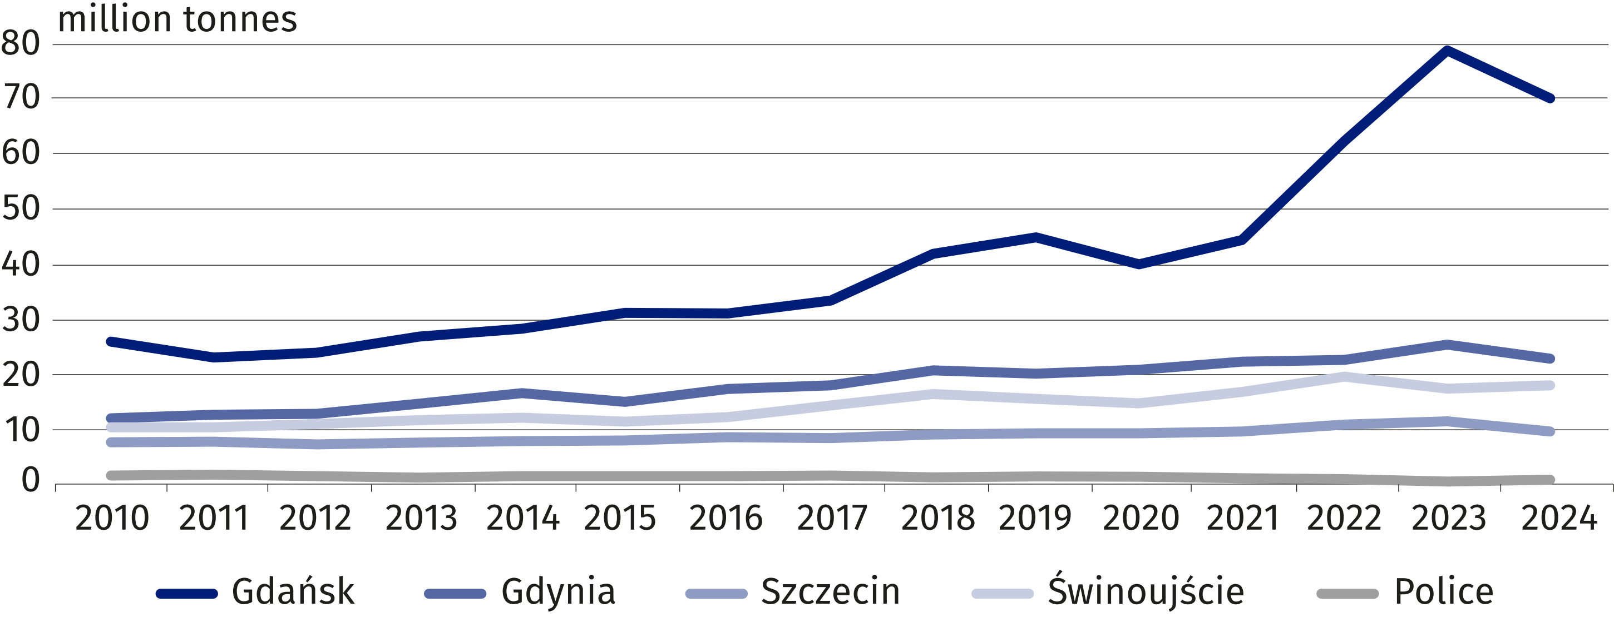

The share of individual seaports in the domestic cargo traffic in 2024 was as follows: Gdańsk (57.2%), Gdynia (18.7%), Świnoujście (14.8%), Szczecin (8.0%), Police (0.9%) and other ports (0.4%).
In the structure of cargo traffic in 2024, dry liquid prevailed (44.4%)

In the structure of cargo traffic in 2024, liquid bulk had the largest share (44.4%), including crude oil and oil products (38.3%), followed by dry bulk (24.5%), including coal and coke (8.0%) and cargo in large containers (19.6%).
In comparison to the previous year, an increase was recorded in the cargo traffic of ro-ro units (by 6.8%) and liquid bulk (by 3.8%, of crude oil and oil products 4.2%), while decreases were observed in dry bulk (by 28.2%), large containers (by 9.3%) and other general cargo
(by 6.6%).

Chart 2. Cargo traffic by seaports and cargo categories in 2024
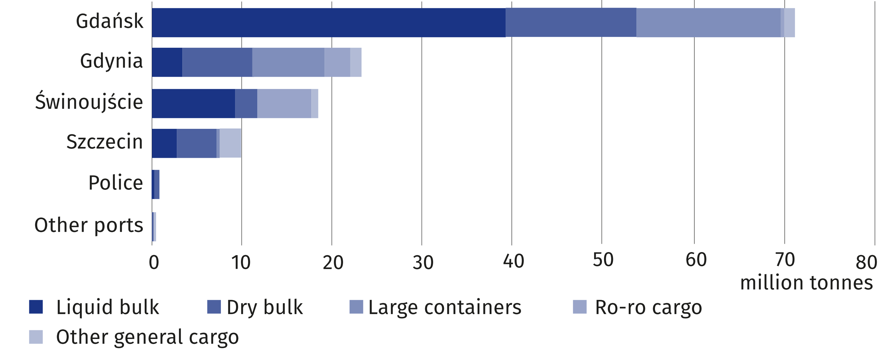

In 2024, domestic maritime traffic amounted to 4.4 million tonnes (by 25.4% more than in the previous year) and accounted for 3.6% of the total cargo traffic. A total of 119.8 million tonnes of cargo was handeled in international maritime traffic, which is 9.8% less than
in 2023.
In 2024, most of the international maritime traffic was made in relation to European ports (63.0%)
In 2024, cargo traffic on the routes to/from European ports accounted for 63.0% of the international maritime traffic in Polish seaports. The international maritime traffic with other continents amounted as follows: with Africa (17.4%), North America (8.4%), Asia (5.8%), Central and South America (5.1%), Australia and Oceania (0.4%).
Chart 3. International maritime traffic in seaports by country of loading or unloading in 2024
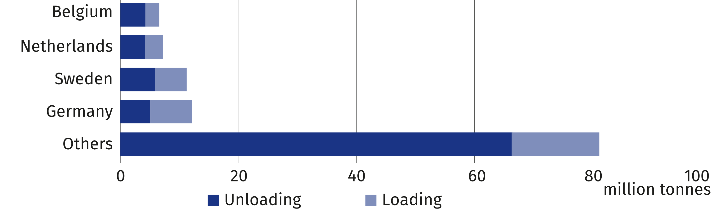
In 2024, the main partners
in sea-land and land-sea transit through Polish ports were
Germany (60.3%), Ukraine (4.2%), Czechia (4.0%) and Slovakia (4.0%)
In 2024, the volume of cargo transit amounted to 21.6 million tonnes and decreased by 5.3% in comparison to previous year. The largest weight of transit cargo was handled by the port of Gdańsk (65.1%), followed by Świnoujście (24.8%), Szczecin (7.3%), and Gdynia (2.8%).
No freight transit traffic was recorded through the seaport of Kołobrzeg.
On an annual basis, an increase in the weight of transit cargo handled was observed in the port of Świnoujście (by 3.3%), while decreases were recorded in Gdynia (by 30.1%), Szczecin (by 17.6%) and Gdańsk (by 4.8%). Compared to the previous year, transit cargo turnover
decreased for both imports (by 0.8%) and exports (of 27.7%).
Chart 4. Structure of transit cargo in seaports in 2024
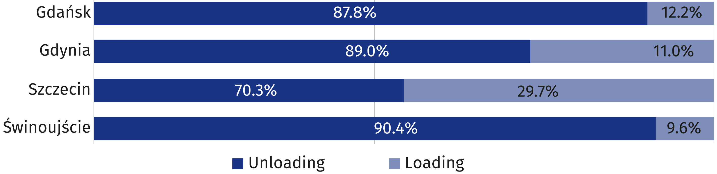

In 2024 a total of 2.4 million passengers began or ended their sea journey at seaport (7.8% more than in 2023). Domestic passenger traffic amounted to 700.3 thousand persons (35.3% more than a year ago), while international passenger traffic reached 1.7 million persons (0.4% less than a year ago).
Sweden was the main destination and origin country for passengers travelling through Polish seaports, accounting for 99.8% of international passenger traffic.
Chart 5. International passenger movements in seaports by country of embarkation
or disembarkation in 2024
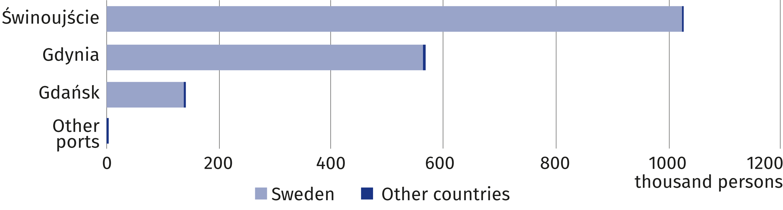
In 2024, 6.0% more ships called at Polish seaports than a year ago
In 2024, 20.0 thousand ships called at Polish seaports (compared to 18.9 thousand ships
reported in 2023) with a gross tonnage (GT) of 301.9 million (by 3.9% higher in comparison
to 2023) and deadweight (DWT) of 225.5 million tonnes (by 4.8% lower in comparison to the previous year).
Compared to 2023, all key metrics used to assess the avarage size of vessels that entered
the Polish seaports have desreased as follows – deadweight (by 10.3%), net tonnage (by 5.2%) and gross tonnage (by 2.0%).

Maritime and coastal shipping
In comparison to 2023, an increase in the gross tonnage (GT)
by 3.5% and deadweight (DWT) by 3.2% was recorded
At the end of 2024, the maritime fleet consisted of 89 ships (one more than in 2023), owned or co-owned by Polish shipowners and fleet operators. The total volume of deadweight (DWT) of the fleet amounted to 2807.1 thousand tonnes, whereas its gross tonnage (GT) reached
2029.0 thousands (compared to 2721.1 thousand tonnes and 1960.1 thousands in 2023,
respectively).
Chart 6. Maritime cargo-carrying fleet in 2024
As of 31 December
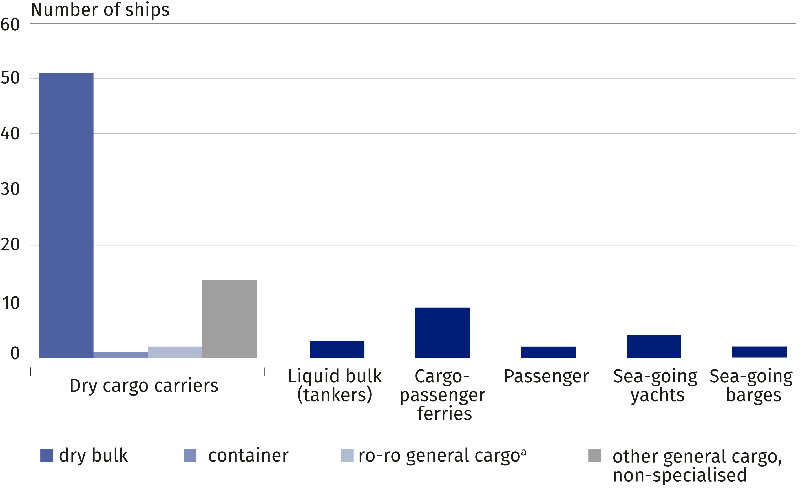
a Excluding ferries.
At the end of 2024 ships registered under the Polish flag constituted 15.7% of the total number of maritime cargo-carrying fleet. The total deadweight (DWT) of ships flying the Polish flag (14 vessels) amounted to 18.1 thousand tonnes (0.6% of the total deadweight of maritime fleet), while the gross tonnage (GT) – 13.9 thousands (0.7% of the total gross tonnage). The maritime cargo-carrying fleet companies shipped 6683.8 thousand tonnes of goods (compared to 7363.0 thousand tonnes in 2023).
Using the maritime cargo-
-carrying fleet, Polish shipping
operators transferred 9.2% goods less than in 2023
The average age of vessels in the maritime transport fleet was 19.2 years (for ships flying the Polish flag – 43.9 years, whereas operating under foreign flags – 14.6 years on average).
Chart 7. Structure of goods shipped by maritime cargo-carrying fleet by categories in 2024
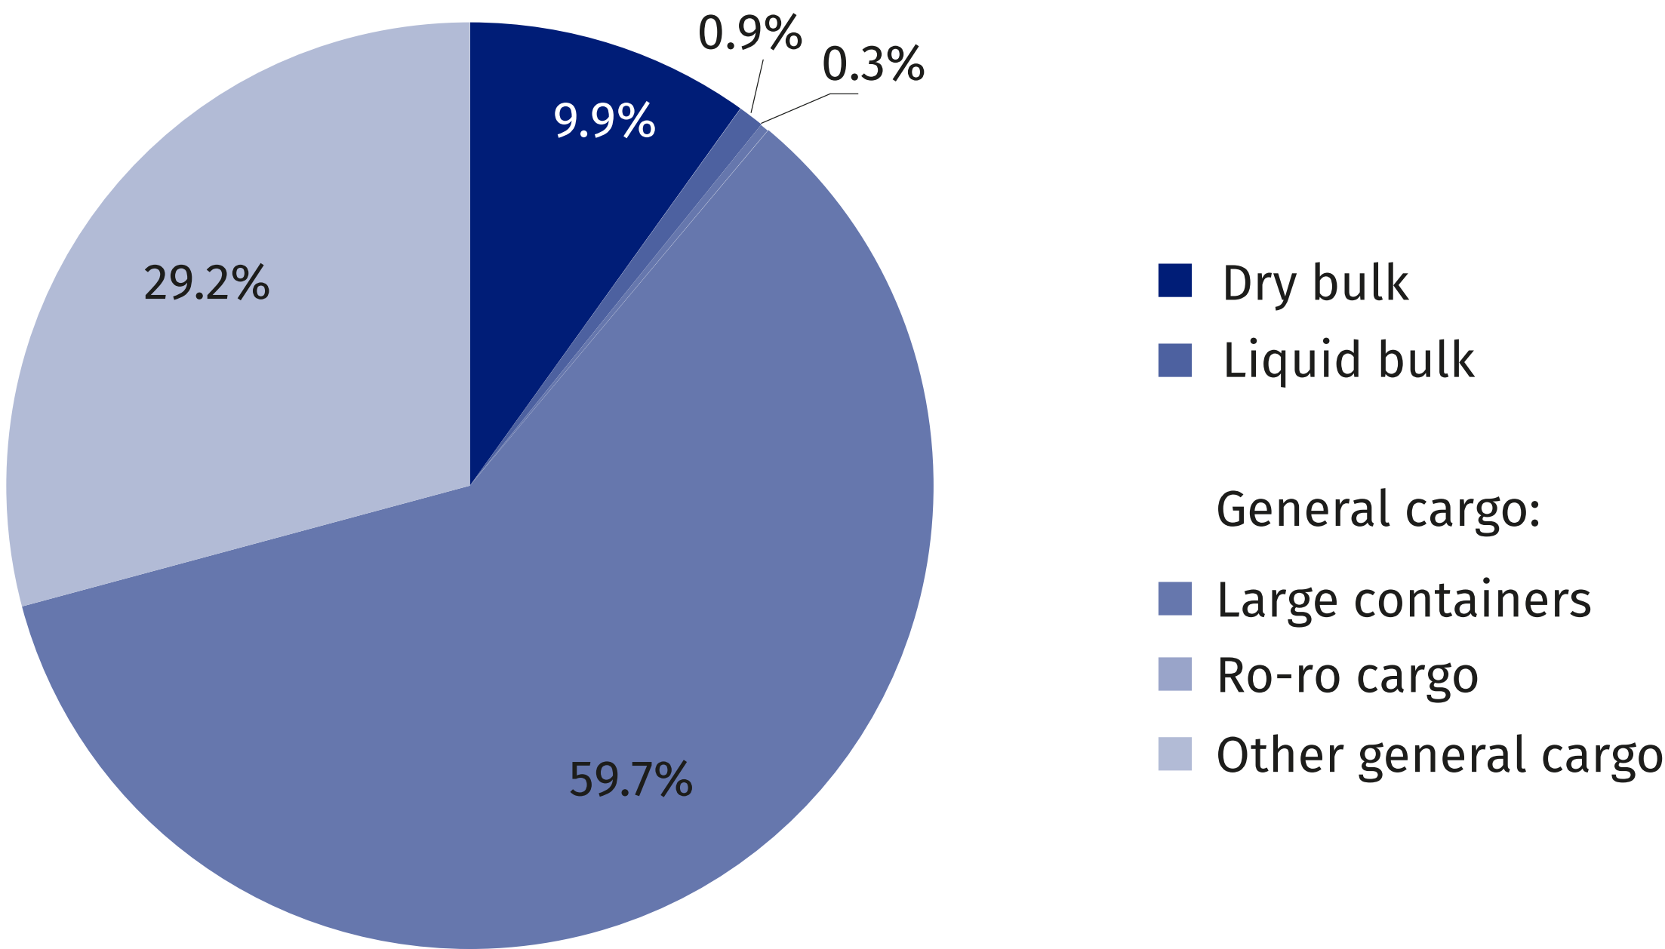

On the routes to/from Polish seaports there were 5562.7 thousand tonnes of cargo carried
(less by 10.6% than in 2023), of which the goods shipped abroad from Polish ports represented 52.5% (by 10.9% less than the previous year), whereas the goods shipped inwards
– 47.5% (10.3% less).
The weight of goods carried between Polish and foreign ports amounted to 1061.1 thousand tonnes (by 3.7% less than in the previous year), whereas between Polish ports – 42.0 thousand tonnes (no such carriages were reported in 2023). Intra-ports transfers of goods represented 0.3% of the total cargo shipped by the maritime cargo-carrying fleet and amounted to 18.0 thousand tonnes.
Chart 8. Transport of goods and transportation volume performed by type of shipping
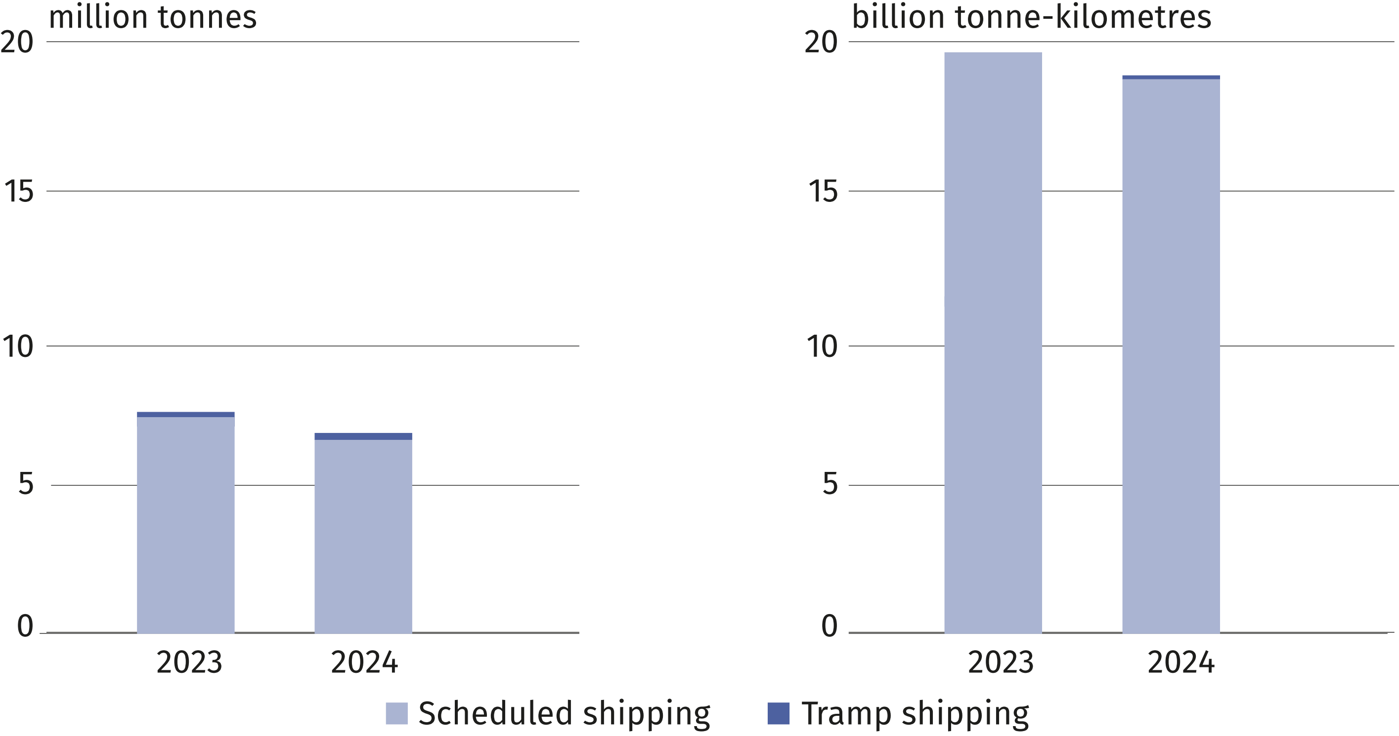
The number of international passenger transfers decreased by 7.1% as compared to 2023
to 2022
In 2024, the Polish fleet owners and operators transferred 535.8 thousand passengers
on international routes. In addition, 231.0 thousands truck drivers travelled onboard ferries
(by 11.1% less than the previous year).
Chart 9. Structure of passengers transferred onboard maritime and coastal fleets in 2024
(excluding truck drivers)

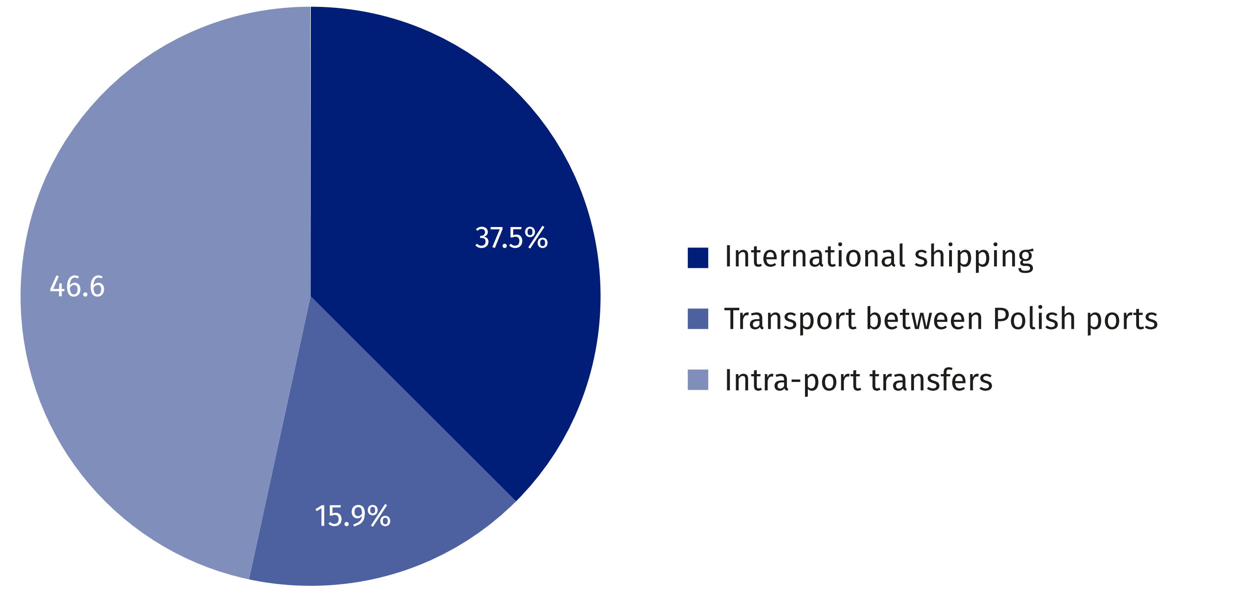
Compared to 2023, a decrease
of 7.2% in deadweight tonnage (DWT) and 5.3% in gross tonnage (GT) was recorded for vessels
in the coastal fleet
At the end of 2024 coastal fleet consisted of 41 vessels with the total deadweight (DWT)
of 11.5 thousand tonnes and gross tonnage (GT) of 9.9 thousands. All coastal vessels hoisted the flag of Poland. They were 49.4 years on average.
In 2024, 153.8 thousand persons travelled on routes between Polish ports, using coastal
passenger fleet (5.9% more than in the previous year), with the transport performance
performed equal to 3207.6 thousand passenger-kilometers (6.9% more compared to 2023).
In 2024, on intra-port routes there were travelled onboard coastal passenger fleet 611.0 thousand persons (increase of 17.3% on an annual basis), an average distance per a single passenger journey was on the level of 7.5 km.
At the end of 2024 the number of crew of maritime and coastal fleet amounted to 2022
persons (2.1% more than in the previous year), including the maritime fleet – 1857 persons,
(increase by 2.5%) and 165 persons in the coastal one (decrease by 2.9%).

Shipbuilding and ship repair industry¹
No changes were recorded in the order portfolio on a year-on-year basis. At the end of 2024,
it included 5 vessels.
In 2024, 403 vessels with a total gross tonnage (GT) exceeding 3.8 million were repaired
in Polish shipyards (compared to 458 vessels with a total gross tonnage exceeding 4.9 million
in the previous year).

Marine fisheries
As of the end of 2024, Polish maritime fishing fleet consisted of 721 ships and boats (a 12.5% decrease compared to 2023), with the total gross tonnage (GT) of 34.0 thousands (a decrease by 4.2% compared to 2023) and engine power of 76.3 thousand kW (a 9.1% decrease).
The Polish fishing fleet consisted of 2 trawlers, 108 cutters and 611 small-scale boats. For trawlers, Gdynia remained their home port. Most of the cutters (71.3%) were stationed in the Pomorskie Voivodship with the remainder in the Zachodniopomorskie Voivodship. On the other hand fishing boats were stationed in all the Baltic Sea voivodships: Pomorskie (45.8% of the total number of Polish fishing boats), Zachodniopomorskie (42.4%), and Warmińsko-
-Mazurskie (11.8%).

¹ On the basis of data from the Maritime Advanced Research Centre (CTO S.A.) in Gdańsk.
In 2024, 75.5 thousand tonnes of fish (representing 57.7% of the total catch weight) were caught in the Baltic fisheries, i.e. 20.5% less than in 2023. Outside the Baltic Sea, in 2024 Polish fishing companies operated only in the Northeast Atlantic and the Pacific, having withdrawn from the Central and Eastern Atlantic fishing areas. Deep-sea catches amounted to 55.3 thousand tonnes, and was by 15.6% lower than in the previous year.
The catches of fish and invertebrates in marine waters in 2024 amounted to 130.7 thousand tonnes, and were by 18.5%
lower than the previous year
As in previous years the species breakdown of the catch was dominated by sprats, caught
exclusively in the Baltic fisheries. In 2024, 52.7 thousand tonnes of those fish were caught, accounting for 40.3% of the total weight of fish and shellfish caught.
Among the organisms caught in the Baltic Sea and lagoons, in addition to marine fin fish, species typical of fresh and brackish waters (freshwater and diadromous ones) were also caught, with a total weight of 3.3 thousand tonnes in 2024. The most numerous representatives in this group were bream, whose catch accounted for 49.2% of the total weight of diadromous and freshwater fish, followed by roach (19.3%) and perch (12.6%).
Deep-sea catches in 2024 were dominated by blue whiting (68.7%) and Chilean horse mackerel (19.7% of the total weight of fish and other marine organisms taken from Atlantic and
Pacific basins). Marine invertebrates made up a small proportion of these catches.

Chart 10. Structure of marine finfish and shellfish catches by species in 2024
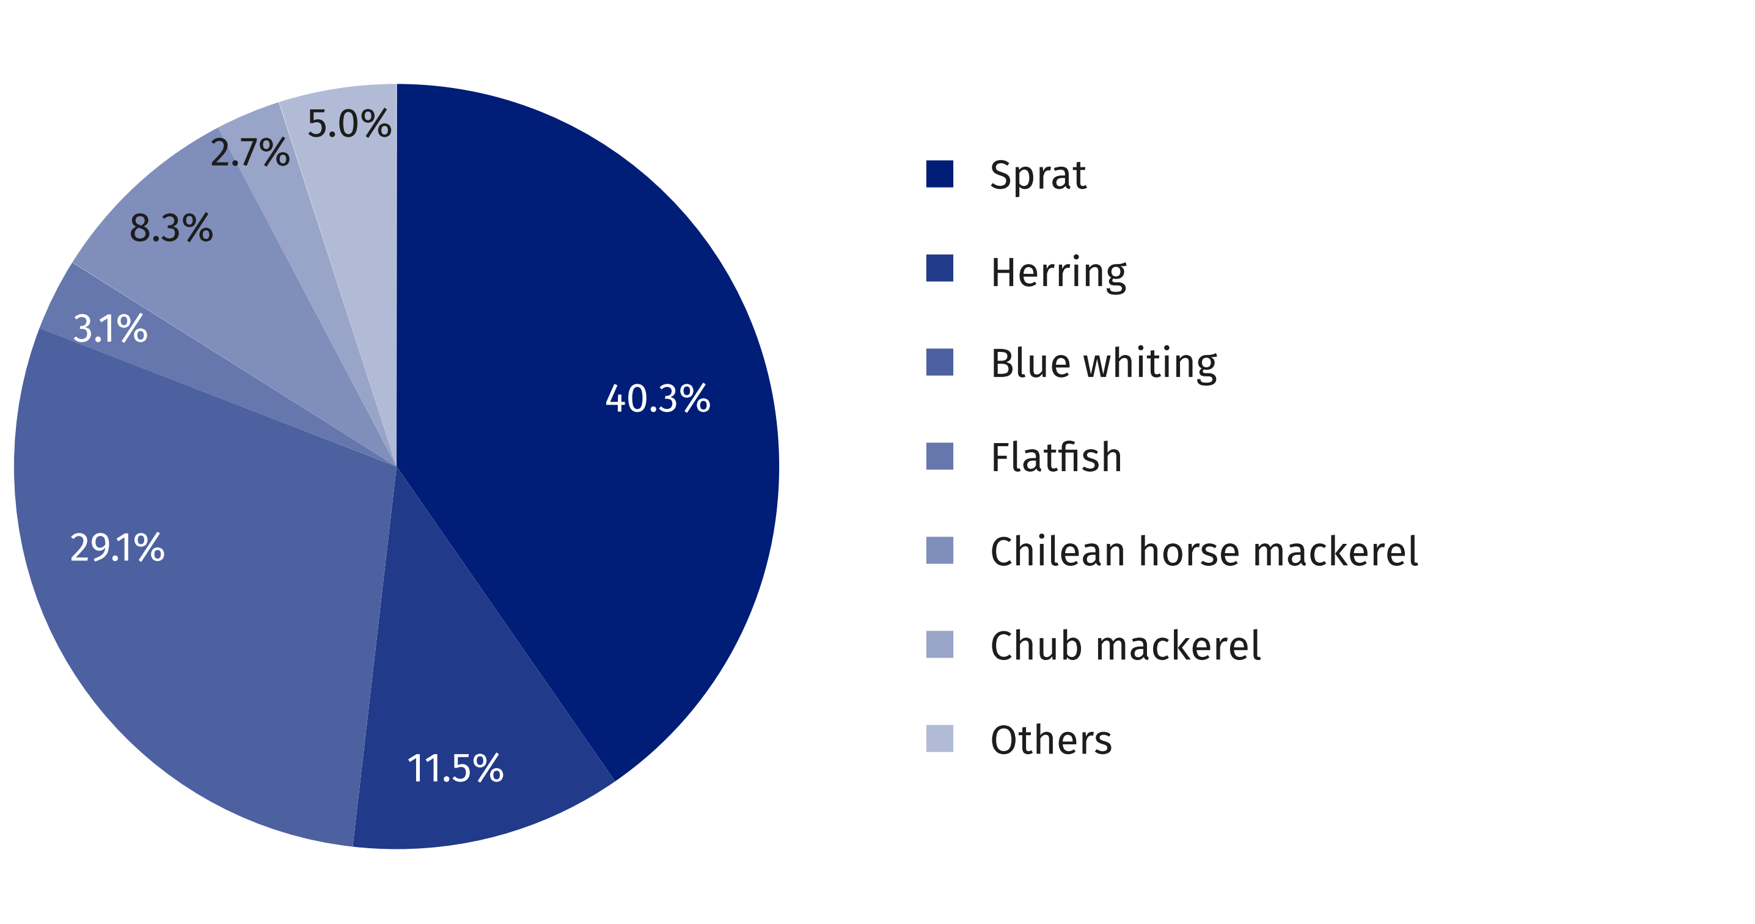

When quoting data from the Statistics Poland, please include the following information: "Source of data from the Statistics Poland", and in the case of publishing calculations made on the data published by the Statistics Poland, please include the following information: "Own study based on Statistics Poland data".

Prepared by:  Statistical Office in Szczecin  Deputy director Katarzyna Dmitrowicz-Życka  Phone: (+48 91) 459 77 00 | Issued by:  Press Office  Mobile: (+48) 695 255 032  Phone: (+48 22) 608 38 04, (+48 22) 449 41 45,  (+48 22) 608 30 09  e-mail: obslugaprasowa@stat.gov.pl

stat.gov.pl/en/

@StatPoland

@GlownyUrzadStatystyczny

gus_stat

glownyurzadstatystycznygus

glownyurzadstatystyczny
Related information
The maritime economy in Poland in years 2021 and 2022
Statistical Yearbook of Maritime Economy 2024
Terms used inn official statistics
Seaport
Seagoing vessels
Gross tonnage (GT)
Net tonnage (NT)
Cargo maritime transport in ton - kilometers
Coastal transport fleet
Cargo traffic at sea ports
Average distance of cargo transportation by sea and coastal fleet
Average transport distance of a passenger by sea and coastal transport fleet

