Active enterprises in the fourth quarter of 2024

In the fourth quarter of 2024, there were 2 788 814 active enterprises in Poland. With regard to the kind of economic activity, the largest population were enterprises from section trade; repair of motor vehicles (18.0% of total). The largest number of active enterprises had their registered offices in Mazowieckie voivodship (20.1% of total).
3.7%
Increase in the number of active enterprises in the fourth quarter of 2024 compared to the corresponding period of the previous year

Basic information on active enterprises
Micro entities accounted for 95.7% of active enterprises in the fourth quarter of 2024
In the fourth quarter of 2024, compared to the fourth quarter of 2023, the number of active enterprises increased by 3.7%. Micro entities (with up to 9 persons employed) constituted 95.7% of the total population of active enterprises and in relation to the same period of 2023 their number increased by 3.8%. Small enterprises (with a number of persons employed from 10 to 49), medium (with a number of persons employed from 50 to 249) and large enterprises (with 250 or more persons employed) accounted for 3.5%, 0.6% and 0.1% of all active enterprises, respectively. Compared to the fourth quarter of 2023, the number of small and large enterprises increased by 1.6% and 1.1%. Only for the medium enterprises a decrease in the number was recorded (by 1.1%).

Table 1. Number of active enterprises by the number of persons employed
Quarter | Active enterprises
Quarter | total | by the number of persons employed
Quarter | total | up to 9 persons | 10-49 | 50-249 | 250 and more persons
Q4 2024 | 2 788 814 | 2 669 110 | 97 920 | 17 601 | 4 183
Q4 2023 | 2 690 457 | 2 572 184 | 96 347 | 17 788 | 4 138

Active enterprises by kind of economic activity
In the fourth quarter of 2024, the largest number of enterprises conducted activity in sections: trade; repair of motor vehicles (18.0% of all active enterprises), construction (15.2%) and professional, scientific and technical activities (13.7%). The smallest share was accounted to enterprises from mining and quarrying (0.1%) and energy generation and supply (0.3%).
In the fourth quarter of 2024, the largest number of enterprises conducted activity in sections trade; repair of motor vehicles (18.0%) and construction (15.2%)
Compared to the same period of 2023, the largest increase in the number of active enterprises was recorded in the following sections: energy generation and supply (20.9%), administrative and support service activities (7.7%) and information and communication (7.1%).
In the population of large entities, the largest share was held by enterprises from manufacturing (42.5%). In the number of micro entities, the large share was recorded in sections: trade; repair of motor vehicles (17.8%), construction (15.3%) and professional, scientific and technical activities (14.0%).
Chart 1. Number of active enterprises

Table 2. Number of active enterprises by size classes and NACE Rev. 2 section in the fourth quarter of 2024
Specification | Active enterprises
Specification | total | by the number of persons employed
Specification | total | up to 9 persons | 10-49 | 50-249 | 250 and more persons
Total | 2 788 814 | 2 669 110 | 97 920 | 17 602 | 4 182
Agriculture, forestry, hunting and fishing | 25 706 | 23 455 | 1 764 | 472 | 15
Mining and quarrying | 2 474 | 1 987 | 349 | 104 | 34
Manufacturing | 234 657 | 205 385 | 21 378 | 6 115 | 1 779
Energy generation and supply | 9 201 | 8 702 | 294 | 157 | 48
Water supply; sewage and waste management | 8 396 | 6 303 | 1 343 | 652 | 98
Construction | 423 130 | 407 836 | 13 971 | 1 194 | 129
Trade; repair of motor vehicles | 502 409 | 476 116 | 22 538 | 3 208 | 547
Transportation and storage | 165 198 | 153 962 | 9 562 | 1 374 | 300
Accomodation and catering | 77 184 | 72 119 | 4 650 | 340 | 75
Information and communication | 227 031 | 223 572 | 2 623 | 627 | 209
Financial and insurance activities | 56 835 | 55 154 | 1 088 | 460 | 133
Real estate activities | 75 111 | 72 670 | 2 016 | 397 | 28
Professional, scientific and technical activities | 381 004 | 374 730 | 5 293 | 736 | 245
Administrative and support service activities | 112 619 | 107 857 | 3 505 | 913 | 344
Education | 80 740 | 78 180 | 2 234 | 301 | 25
Human health and social work activities | 235 050 | 230 338 | 4 126 | 442 | 144
Arts, entertainment and recreation activities | 30 365 | 29 905 | 391 | 56 | 13
Other service activities | 141 704 | 140 839 | 795 | 54 | 16

Active enterprises by registered office

In the fourth quarter of 2024, the largest number of active enterprises (according to the place of registered offices) was in the Mazowieckie (20.1% of all active enterprises), the Wielkopolskie (10.3%) and the Małopolskie (9.9%) voivodships. The smallest number of enterprises was in the Opolskie voivodship (1.9% of active enterprises), and in the following four voivodships the percentage of active enterprises did not exceed 3%: in the Lubuskie (2.3%), the Podlaskie (2.4%), the Świętokrzyskie (2.4%) and the Warmińsko-Mazurskie voivodships (2,7%).

Compared to the same period of 2023, the largest increase in the number of active enterprises was recorded in the Mazowieckie (6.1%) and the Małopolskie (4.7%) voivodships, and the smallest in the Świętokrzyskie (1.6%) and the Zachodniopomorskie (1.5%) voivodships.

The largest share in the number of large entities was recorded in the Mazowieckie (26.9%), the Śląskie (12.0%) and the Wielkopolskie (11.1%) voivodships. The largest share in the number of microenterprises was recorded in the same voivodships: Mazowieckie (20.1%), Wielkopolskie (10.3%) and Śląskie (10.2%).

Chart 2. Structure of active enterprises by voivodships in the fourth quarter of 2024

Table 3. Number of active enterprises by size classes and voivodships in the fourth quarter of 2024
Specification | Active enterprises
Specification | total | by the number of persons employed
Specification | total | up to 9 persons | 10-49 | 50-249 | 250 and more persons
Total | 2 788 814 | 2 669 110 | 97 920 | 17 602 | 4 182
Dolnośląskie | 227 830 | 219 387 | 6 757 | 1 305 | 381
Kujawsko-Pomorskie | 123 144 | 117 353 | 4 760 | 857 | 174
Lubelskie | 112 725 | 107 905 | 4 098 | 628 | 94
Lubuskie | 65 216 | 62 361 | 2 319 | 443 | 93
Łódzkie | 160 770 | 153 540 | 6 019 | 1 008 | 203
Małopolskie | 277 253 | 265 813 | 9 568 | 1 528 | 344
Mazowieckie | 559 691 | 537 568 | 17 554 | 3 444 | 1 125
Opolskie | 53 527 | 50 963 | 2 088 | 392 | 84
Podkarpackie | 113 761 | 108 284 | 4 495 | 828 | 154
Podlaskie | 68 085 | 65 252 | 2 315 | 454 | 64
Pomorskie | 193 070 | 185 226 | 6 456 | 1 144 | 244
Śląskie | 286 767 | 272 694 | 11 531 | 2 039 | 503
Świętokrzyskie | 66 424 | 63 571 | 2 398 | 380 | 75
Warmińsko-Mazurskie | 75 481 | 72 290 | 2 623 | 492 | 76
Wielkopolskie | 287 445 | 273 619 | 11 370 | 1 992 | 464
Zachodniopomorskie | 117 625 | 113 284 | 3 569 | 668 | 104

Map 1. Number of active enterprises by powiats in fourth quarter of 2024
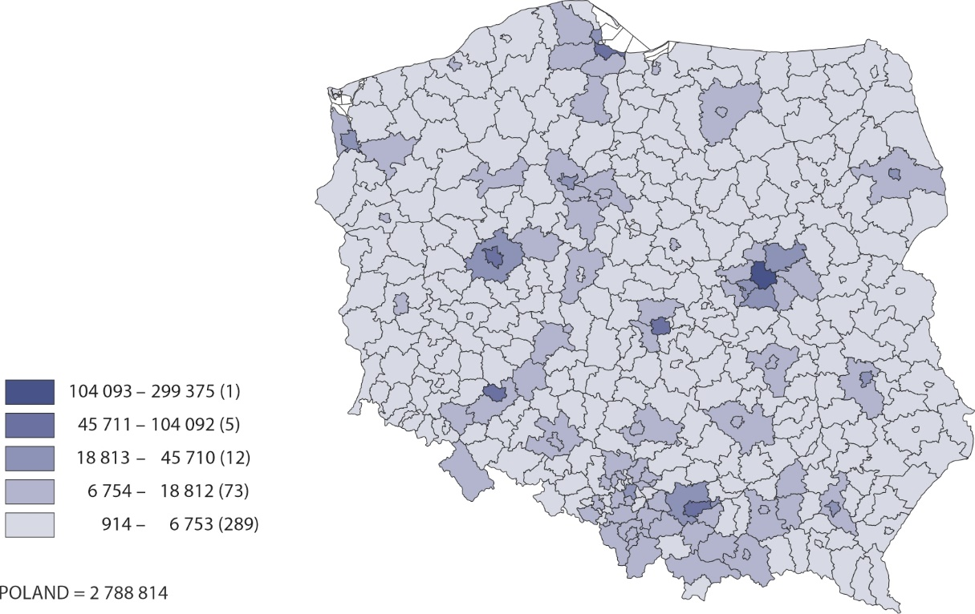

The data presented in this news release concern active enterprises (understood as a one legal unit) regardless of the size class by number of persons employed, the kind of accounting record kept and the kind of business activity conducted. The data include entities of the national economy which are market producers, for which the predominant activity is classified according to the NACE Rev. 2 to section A (excluding indywidual agricultural holdings), B, C, D, E, F, G, H, I, J, K, L, M, N, P, Q, R, S (excluding division 94).
The enterprises method was used for preparing the data, and this method involves taking entire enterprises as the basic for grouping data according to clasifications and territorial divisions.
An enterprise is considered to have been active in the quarter if it conducted economic activity at least in one month of that quarter (regardless of the number of days of activity conduted).
In this news release, abbreviated names of some sections of NACE Rev. 2 were used; the list of letter symbols of the section (code), full names and abbreviated names is as follows:
Code | Full name | Abbreviation
A* | Agriculture, forestry, hunting and fishing | –
B | Mining and quarrying | –
C | Manufacturing | –
D | Electricity, gas, steam, hot water and air conditioning manufacturing and supply | Energy generation and supply
E | Water supply; sewerage, waste management and remediation activities | Water supply; sewage and waste management
F | Construction | –
G | Wholesale and retail trade; repair of motor vehicles including motorcycles | Trade; repair of motor vehicles
H | Transportation and storage | –
I | Accommodation and food service activities | Accommodation and catering
J | Information and communication | –
K | Financial and insurance activities | –
L | Real estate activities | –
M | Professional, scientific and technical activities | –
N | Administrative and support service activities | –
P | Education | –
Q | Human health and social work activities | –
R | Arts, entertainment and recreation activities | –
S** | Other service activities | –

* Section A– excluding indywidual agricultural holdings
** Section S – excluding division 94 Activities of membership organisations

An integral part of this news release are tables in XLSX format (downloadable files) with a set of tables presenting data in detailed breakdown, including by NACE Rev. 2 groups and by powiats.

In case of quoting Statistics Poland data, please provide information: “Source of data: Sta-tistics Poland”, and in case of publishing calculations made on data published by Statistics Poland, please include the following disclaimer: “Own study based on figures from Statistics Poland”.

Prepared by:  Enterprise Department  Director Katarzyna Walkowska  Phone: (+48 22) 608 31 25 | Issued by:  Press Office  Mobile: (+48) 695 255 032  Phone: (+48 22) 608 38 04, (+48 22) 449 41 45,  (+48 22) 608 30 09  e-mail: obslugaprasowa@stat.gov.pl

stat.gov.pl/en/

@StatPoland

@GlownyUrzadStatystyczny

gus_stat

glownyurzadstatystycznygus

glownyurzadstatystyczny

