Index numbers of construction and assembly
production in April 2025
According to preliminary data construction and assembly production (in constant prices) carried out domestically in April 2025 was lower by 4.2% than in the same period of 2024 (in April 2024 a decrease of 2.0%) and by 5.6% higher compared to March 2025.
4.2%
Decrease of construction and assembly production
compared to April of 2024

After seasonally adjusted, the decrease in construction and assembly production in April 2025 amounted of 0.8% an annual

In April 2025, after eliminating the seasonal factors, construction and assembly production reached the level by 2.9% lower than in the corresponding month of the previous year and lower by 0.8% in comparison to March 2025.
Chart 1. Index numbers of construction and assembly production (constant prices; average monthly base 2021=100) ª
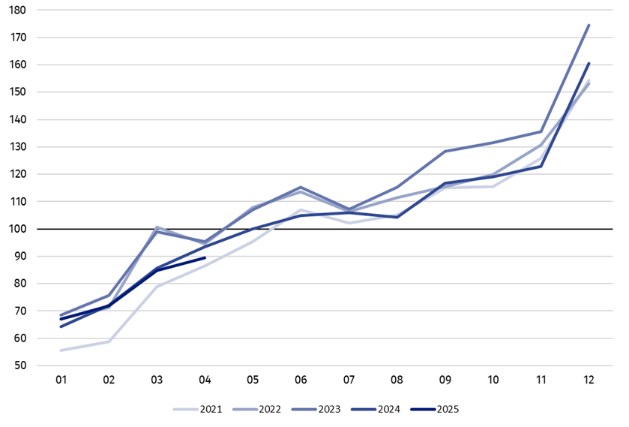
a Preliminary data for April 2025.

The decrease in construction and assembly production in April 2025 (in constant prices), compared to the average monthly value of 2021, was 10.5%.
Table 1. Index numbers of construction and assembly production (constant prices)
Specification | 04 2025 |  | 01‒04 2025ª
Specification | 03 2025=100 | 04 2024=100 | 01‒04 2024=100
CONSTRUCTION | 105.6 | 95.8 | 99.5
Construction of buildings ^{Δ} | 99.9 | 89.7 | 94.3
Civil engineering works ^{Δ} | 120.3 | 91.7 | 97.1
Specialised construction activities | 95.8 | 110.5 | 109.1
a Data including final information on production and prices in March and preliminary data in April 2025.
^{Δ} Abbreviated form according to PKD 2007.

Construction and assembly production in April 2025 decreases were observed an annual in the entities dealing mainly with construction of buildings and for whose basic type of activity was civil engineering works of 10.3% and of 8.3% respectively, whereas increase was in the entities performing specialised construction activities of 10.5%.
In the period of January-April 2025 the construction and assembly production decreased by 0.5% an annual
In the period of January‒April 2025, in relation to the same period of the previous year, in entities in whose basic type of activity was construction of buildings a decrease was recorded of 5.7% and in entities dealing mainly with civil engineering works of 2.9%, whereas an increase in the sales of construction and assembly production was noted in entities performing specialised construction activities of 9.1%.
In April 2025 compared to March 2025, an increase in the sales of construction and assembly production was noted in entities dealing mainly with civil engineering works of 20.3%, whereas decreased by 4.2% in entities performing specialised construction activities and in entities whose basic type of activity was construction of buildings of 0.1%.
Analyzing the value of construction and assembly production in terms of construction works (investment and restoration works) were observed:
In April 2025 was noted an increase in the construction and assembly production for investment works of 1.9% an annual
- An annual increase for investment works by 1.9% and a decrease for restoration works by 16.0% (in 2024, an increase of 5.3% and a decrease of 13.7% respectively),
- Compared to March 2025, an increase for investment works by 7.3% and for restoration works by 1.9%.
In the period of January‒April 2025, in relation to the same period of the previous year, an increase in the sales of construction and assembly production was noted for investment works by 3.2% and a decrease for restoration works by 7.8% (in 2024, decreases of 3.0% and 18.4% respectively).

In case of quoting Statistics Poland data, please provide information: “Source of data: Statistics Poland” and in case of publishing calculations made on data published by Statistics Poland, please include the following disclaimer: “Own study based on figures from Statistics Poland”.

Prepared by:  Statistical Office in Lublin  Director Krzysztof Markowski, Ph.D.  Phone: (+48) 695 255 301 | Issued by:  Press Office  Mobile: (+48) 695 255 032  Phone: (+48 22) 608 38 04, (+48 22) 449 41 45,  (+48 22) 608 30 09  e-mail: obslugaprasowa@stat.gov.pl

stat.gov.pl/en/

@StatPoland

@GlownyUrzadStatystyczny

gus_stat

glownyurzadstatystycznygus

glownyurzadstatystyczny
Related information
Statistical Bulletin
Socio-economic situation of the country
Data available in databases
Knowledge Database - Construction
Macroeconomic Data Bank
Macroeconomic indicators
Local Data Bank

Terms used in official statistics
Sale of construction and assembly production
Seasonally unadjusted index of sale of construction and assembly production in constant prices
Seasonally adjusted index of sale of construction and assembly production
Sale of construction works with an investment character
Sale of construction works with a restoration character and other works

Preliminary data; comprise enterprises employing over 9 persons, whose the main type of activity is included in the section F “Construction” in accordance with the Polish Classification of Activities (PKD 2007).

