Index numbers of construction and assembly
production in March 2025
According to preliminary data construction and assembly production (in constant prices) carried out domestically was in March 2025 was lower by 1.1% than in the same period of 2024 (in March 2024 a decrease of 13.4%) and by 17.6% higher compared to February 2025.
1.1%
Decrease of construction and assembly production
compared to March of 2024

After seasonally adjusted, the increase in construction and assembly production in March 2025 amounted of 0.4% an annual

In March 2025, after eliminating the seasonal factors, construction and assembly production reached the level by 0.4% higher than in the corresponding month of the previous year and lower by 3.7% in comparison to February 2025.
Chart 1. Index numbers of construction and assembly production (constant prices; average monthly base 2021=100) ª
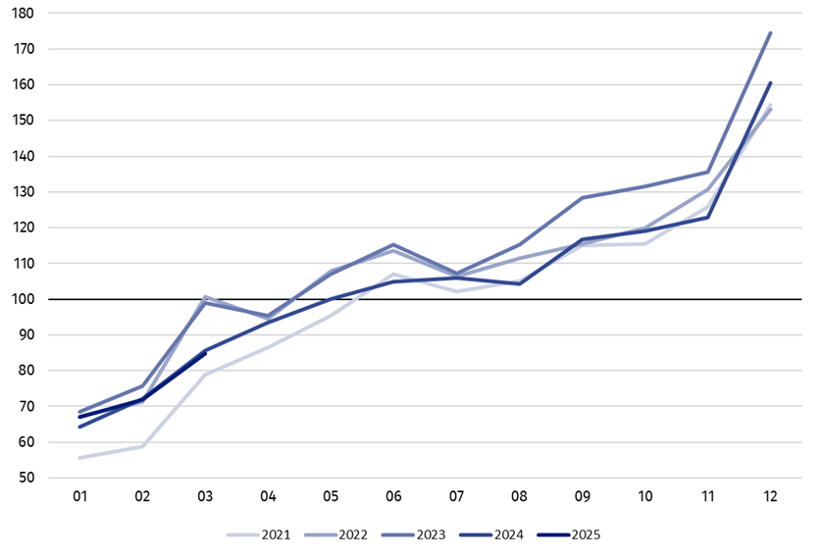
a Preliminary data for March 2025.

The decrease in construction and assembly production in March 2025 (in constant prices), compared to the average monthly value of 2021, was 15.3%.
Table 1. Index numbers of construction and assembly production (constant prices)
Specification | 03 2025 |  | 01‒03 2025ª
Specification | 02 2025=100 | 03 2024=100 | 01‒03 2024=100
CONSTRUCTION | 117.6 | 98.9 | 100.2
Construction of buildings ^{Δ} | 106.3 | 96.6 | 93.5
Civil engineering works ^{Δ} | 122.5 | 95.1 | 101.8
Specialised construction activities | 126.0 | 106.0 | 106.6
a Data including final information on production and prices in February and preliminary data in March 2025.
^{Δ} Abbreviated form according to PKD 2007.

Construction and assembly production in March 2025 in the entities for whose basic type of activity was civil engineering works and dealing mainly with construction of buildings decreased of 4.9% and 3.4% respectively, whereas an increase was observed an annual for entities performing specialised construction activities of 6.0%.
In the period from of January-March 2025 the construction and assembly production increased by 0.2% an annual
In the period of January‒March 2025, in relation to the same period of the previous year, an increase in the sales of construction and assembly production was noted in entities performing specialised construction activities of 6.6% and in entities dealing mainly with civil engineering works of 1.8%, whereas in entities in whose basic type of activity was construction of buildings decrease was recorded of 6.5%.
In March 2025 compared to February 2025, an increase was noted in all divisions of construction. The increase of 26.0% in the sales of construction and assembly production was noted in entities performing specialised construction activities, in entities dealing mainly with civil engineering works of 22.5% and in entities whose basic type of activity was construction of buildings of 6.3%.
Analyzing the value of construction and assembly production in terms of construction works (investment and restoration works) were observed compared to:
In March 2025 was noted an increase for investment works of 3.5% an annual
- March 2024, an increase for investment works by 3.5% and a decrease for restoration works by 10.1% (in 2024, a decrease of 2.2% and 29.0% respectively),
- February 2025, an increase for investment works by 23.3% and for restoration works by 6.6%.
In the period of January‒March 2025, in relation to the same period of the previous year, an increase in the sales of construction and assembly production was noted for investment works by 4.5% and a decrease for restoration works by 8.0% (in 2024, decreases of 3.5% and 21.8% respectively).

In case of quoting Statistics Poland data, please provide information: “Source of data: Statistics Poland” and in case of publishing calculations made on data published by Statistics Poland, please include the following disclaimer: “Own study based on figures from Statistics Poland”.

Prepared by:  Statistical Office in Lublin  Director Krzysztof Markowski, Ph.D.  Phone: (+48) 695 255 301 | Issued by:  Press Office  Mobile: (+48) 695 255 032  Phone: (+48 22) 608 38 04, (+48 22) 449 41 45,  (+48 22) 608 30 09  e-mail: obslugaprasowa@stat.gov.pl

stat.gov.pl/en/

@StatPoland

@GlownyUrzadStatystyczny

gus_stat

glownyurzadstatystycznygus

glownyurzadstatystyczny
Related information
Statistical Bulletin
Socio-economic situation of the country
Data available in databases
Knowledge Database - Construction
Macroeconomic Data Bank
Macroeconomic indicators
Local Data Bank

Terms used in official statistics
Sale of construction and assembly production
Seasonally unadjusted index of sale of construction and assembly production in constant prices
Seasonally adjusted index of sale of construction and assembly production
Sale of construction works with an investment character
Sale of construction works with a restoration character and other works

Preliminary data; comprise enterprises employing over 9 persons, whose the main type of activity is included in the section F “Construction” in accordance with the Polish Classification of Activities (PKD 2007).

