Index numbers of construction and assembly
production in February 2025
According to preliminary data construction and assembly production (in constant prices) carried out domestically by construction enterprises employing more than 9 persons was in February 2025 remained at the level of previous year (in February 2024 a decrease of 4.8%) and by 7.5% higher compared to January 2025.
100.0
Index number of construction and assembly production
compared to February of 2024

In February 2025, after eliminating the seasonal factors, construction and assembly production reached the level by 0.8% higher than in the corresponding month of the previous year and lower by 2.3% in comparison to January 2025.
Table 1. Index numbers of construction and assembly production (constant prices)
SPECIFICATION | 02 2025 |  | 01‒02 2025^{b}
SPECIFICATION | 01 2025=100 | 02 2024=100 | 01‒02 2024=100
CONSTRUCTION | 107.5 | 100.0 | 100.4
Construction of buildings ^{Δ} | 108.1 | 96.2 | 98.4
Civil engineering works ^{Δ} | 109.8 | 101.7 | 99.1
Specialised construction activities | 104.3 | 103.0 | 104.3
^{Δ} Abbreviated form according to PKD 2007.
^{b} Data including final information on production and prices in January and preliminary data in February 2025.

Construction and assembly production in February 2025, increases were observed an annual for entities performing specialised construction activities of 3.0% and for whose basic type of activity was civil engineering works of 1.7%. The decrease of 3.8% was noted for entities dealing mainly with construction of buildings.
In the period of January‒February 2025, in relation to the same period of the previous year, an increase in the sales of construction and assembly production was noted in entities performing specialised construction activities of 4.3%, whereas in entities dealing mainly with civil engineering works and in whose basic type of activity was construction of buildings
decreases were recorded of 0.9% and of 1.6% respectively.
In February 2025 compared to January 2025, an increase was noted in all divisions of construction. The increase of 9.8% in the sales of construction and assembly production was noted in entities dealing mainly with civil engineering works, in entities whose basic type of activity was construction of buildings of 8.1% and performing specialised construction activities of 4.3%.
Analyzing the value of construction and assembly production in terms of construction works (investment and restoration works) were observed compared to:
- February 2024, an increase for investment works by 1.3% and an decrease for restoration works by 2.6% (in 2024, an increase of 6.5% and a decrease of 20.4% respectively),
- January 2025, an increase for investment works by 11.6% and for restoration works by 0.5%.
In the period of January‒February 2025, in relation to the same period of the previous year, an increase in the sales of construction and assembly production was noted for investment works by 5.3% and decreased for restoration works by 0.8% (in 2024, decreases of 2.4% and 16.1% respectively).
Chart 1. Index numbers of construction and assembly production (constant prices; average monthly base 2021=100) ^{c}
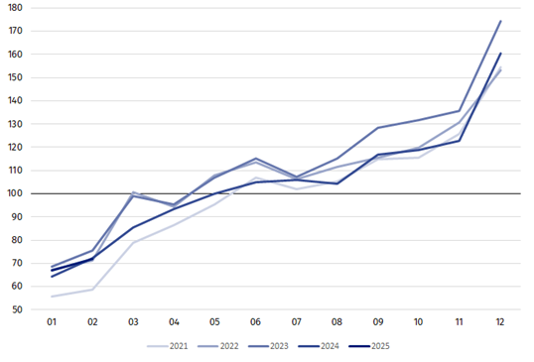
^{c} Preliminary data for February 2025.
The decrease in construction and assembly production in February 2025 (in constant prices), compared to the average monthly value of 2021, was 28.0%.

In case of quoting Statistics Poland data, please provide information: “Source of data: Statistics Poland” and in case of publishing calculations made on data published by Statistics Poland, please include the following disclaimer: “Own study based on figures from Statistics Poland”.

Prepared by:  Statistical Office in Lublin  Director Krzysztof Markowski, Ph.D.  Phone: (+48) 695 255 301 | Issued by:  Press Office  Mobile: (+48) 695 255 032  Phone: (+48 22) 608 38 04, (+48 22) 449 41 45,  (+48 22) 608 30 09  e-mail: obslugaprasowa@stat.gov.pl

stat.gov.pl/en/

@StatPoland

@GlownyUrzadStatystyczny

gus_stat

glownyurzadstatystycznygus

glownyurzadstatystyczny
Related information
Statistical Bulletin
Socio-economic situation of the country
Data available in databases
Knowledge Database - Construction
Macroeconomic Data Bank
Macroeconomic indicators
Local Data Bank

Terms used in official statistics
Sale of construction and assembly production
Seasonally unadjusted index of sale of construction and assembly production in constant prices
Seasonally adjusted index of sale of construction and assembly production
Sale of construction works with an investment character
Sale of construction works with a restoration character and other works

Preliminary data; comprise enterprises employing over 9 persons, whose the main type of activity is included in the section F “Construction” in accordance with the Polish Classification of Activities (PKD 2007).

