Index numbers of construction and assembly
production in January 2025
According to preliminary data construction and assembly production (in constant prices) carried out domestically by construction enterprises employing more than 9 persons was in January 2025 by 4.3% higher than in the same period of 2024 (a decrease of 6.2% in the corresponding period of 2024) and by 58.2% lower compared to December 2024 (a decrease of 63.1% in the corresponding period of 2024).
104.3
Index number of construction and assembly production
compared to January of 2024
Table 1. Index numbers of construction and assembly production (constant prices)

SPECIFICATION | 01 2025
SPECIFICATION | 12 2024=100 | 01 2024=100
CONSTRUCTION | 41.8 | 104.3
Construction of buildings ^{Δ} | 63.5 | 107.1
Civil engineering works ^{Δ} | 25.2 | 101.6
Specialised construction activities | 58.1 | 103.9
^{Δ} Abbreviated form according to PKD 2007.

Construction and assembly production in January 2025, showed an annual increase in all divisions of construction. For entities dealing mainly with construction of buildings it recorded of 7.1%, performing specialised construction activities of 3.9% and for whose basic type of activity was civil engineering works of 1.6%.
In January 2025 compared to December 2024, the decrease was noted in all divisions of construction. The decrease of 74.8% in the sales of construction and assembly production was noted in entities dealing mainly with civil engineering works, performing specialised construction activities of 41.9% and in entities whose basic type of activity was construction of buildings of 36.5%.
Analyzing the value of construction and assembly production in terms of construction works (investment and restoration works) increases in January 2025 were observed comparing to the corresponding period of 2024, for investment works and for restoration works by 5.1% and by 2.9% respectively (in 2024, a decrease of 2.1% and of 12.3% respectively).
Chart 1. Index numbers of construction and assembly production (constant prices; average monthly base 2021=100)
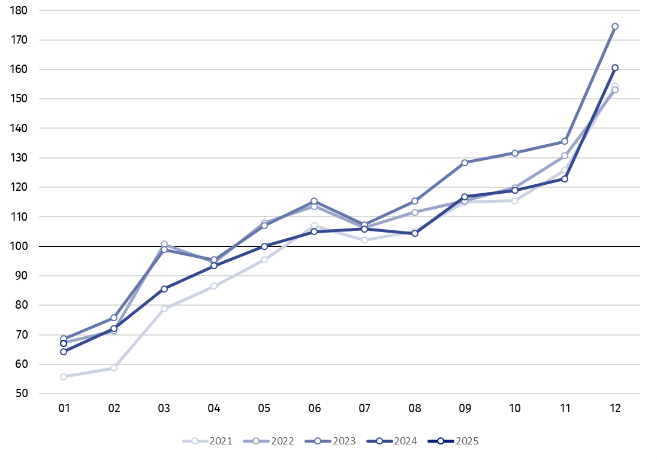

Index number of construction and assembly production in January 2025 (in constant prices), compared to the average monthly value of 2021, was 67.1.
In January 2025, after eliminating the seasonal factors, construction and assembly production reached the level by 6.1% higher than in the corresponding month of the previous year and maintained the level from December 2024.

In case of quoting Statistics Poland data, please provide information: “Source of data: Statistics Poland” and in case of publishing calculations made on data published by Statistics Poland, please include the following disclaimer: “Own study based on figures from Statistics Poland”.

Prepared by:  Statistical Office in Lublin  Director Krzysztof Markowski, Ph.D.  Phone: (+48) 695 255 301 | Issued by:  Press Office  Mobile: (+48) 695 255 032  Phone: (+48 22) 608 38 04, (+48 22) 449 41 45,  (+48 22) 608 30 09  e-mail: obslugaprasowa@stat.gov.pl

stat.gov.pl/en/

@StatPoland

@GlownyUrzadStatystyczny

gus_stat

glownyurzadstatystycznygus

glownyurzadstatystyczny
Related information
Statistical Bulletin
Socio-economic situation of the country
Data available in databases
Knowledge Database - Construction
Macroeconomic Data Bank
Macroeconomic indicators
Local Data Bank

Terms used in official statistics
Sale of construction and assembly production
Seasonally unadjusted index of sale of construction and assembly production in constant prices
Seasonally adjusted index of sale of construction and assembly production
Sale of construction works with an investment character
Sale of construction works with a restoration character and other works

Preliminary data; comprise enterprises employing over 9 persons, whose the main type of activity is included in the section F “Construction” in accordance with the Polish Classification of Activities (PKD 2007).
Preliminary data for January 2025.

