Residential construction in the period of January–April 2025

In the period January–April 2025, there were less by 3.3% dwellings completed than in the corresponding period of the previous year. The number of dwellings for which permits have been granted or which have been registered with a construction project as well as dwellings in which construction has begun also decreased (by 14.7% and 6.8%, respectively).
3.3%
Decrease in the number of dwellings completed compared to the corresponding period of 2024

Dwellings completed
Developers and private
investors completed respectively: 60.7% and 36.8% of the total number of dwellings
According to the preliminary data, 62.2 thousand dwellings were completed in the period January–April 2025, i.e. by 3.3% less than in the corresponding period of 2024. Developers completed 37.7 thousand dwellings – by 2.9% less than a year ago, whereas private investors completed 22.9 thousand dwellings, i.e. by 4.5% less. Within these two forms of construction, 97.5% of the total number of new dwellings was completed. In the other forms, 1.5 thousand dwellings were completed.
The total useful floor area of newly dwellings completed amounted to 5.6 million m², i.e. by 3.6% less than a year ago and its average value for 1 dwelling was 90.8 m².

Table 1. Dwellings completed
SPECIFICATION | 04 2025 |  |  | 01-04 2025
SPECIFICATION | number  of dwellings | 03 2025=100 | 04 2024=100 | number  of dwellings | 01-04 2024=100
TOTAL | 16 125 | 102.6 | 101.2 | 62 192 | 96.7
Private | 5 847 | 99.3 | 98.7 | 22 911 | 95.5
For sale or rent | 10 011 | 106.1 | 103.8 | 37 748 | 97.1
of which for rent | 93 | 77.5 | 244.7 | 331 | 124.0
Cooperative | ‒ | . | . | 210 | 176.5
Municipal | 16 | over 11-  fold less | 17.0 | 293 | 56.7
Public building society | 251 | 224.1 | 121.8 | 991 | 121.3
Company | ‒ | . | . | 39 | 39- fold more

Dwellings for which permits have been granted
In the period January–April 2025, building permits were issued for 80.9 thousand dwellings, i.e. by 14.7% less than a year ago, of which 51.1 thousand permits to developers (a decrease of 25.0% y/y) and 26.1 thousand to private investors (an increase of 4.7%). Within these two forms of construction, permits have been granted for 95.4% of dwellings in total. In other forms of construction, building permits were issued for 3.7 thousand dwellings.

Table 2. Dwellings for which permits have been granted
SPECIFICATION | 04 2025 |  |  | 01-04 2025
SPECIFICATION | number  of dwellings | 03 2025=100 | 04 2024=100 | number  of dwellings | 01-04 2024=100
TOTAL | 18 997 | 85.5 | 76.4 | 80 861 | 85.3
Private | 7 783 | 109.4 | 105.0 | 26 069 | 104.7
For sale or rent | 10 683 | 76.9 | 62.7 | 51 087 | 75.0
Cooperative | ‒ | . | . | 164 | .
Municipal | 157 | 107.5 | 373.8 | 1 394 | 338.3
Public building society | 374 | 39.0 | 100.8 | 2 147 | 149.3
Company | ‒ | . | . | ‒ | .

Dwellings in which construction has begun
In the period January–April 2025, the number of dwellings in which construction has begun was 75.8 thousand, i.e. by 6.8% less than a year before. Developers have started construction of 48.4 thousand dwellings (by 11.4% less than in the previous year), and private investors of 25.9 thousand (by 1.4% more). Altogether the share of these forms of construction amounted to 98.0% of the total number of dwellings. In other forms of construction the number of dwellings in which construction has begun was 1.5 thousand.

Table 3. Dwellings in which construction has begun
SPECIFICATION | 04 2025 |  |  | 01-04 2025
SPECIFICATION | number  of dwellings | 03 2025=100 | 04 2024=100 | number  of dwellings | 01-04 2024=100
TOTAL | 20 061 | 91.6 | 94.5 | 75 778 | 93.2
Private | 7 914 | 94.8 | 93.2 | 25 878 | 101.4
For sale or rent | 11 828 | 91.1 | 94.0 | 48 359 | 88.6
of which for rent | 222 | 86.7 | 672.7 | 538 | 322.2
Cooperative | ‒ | . | . | 168 | 123.5
Municipal | 3 | over 32-  fold less | over 23-  fold less | 432 | 251.2
Public building society | 316 | 86.6 | 585.2 | 936 | 104.1
Company | ‒ | . | . | 5 | 29.4

It is estimated that at the end of April 2025, there were 848.3 thousand dwellings under construction, i.e. by 3.7% more than in the corresponding month of 2024.

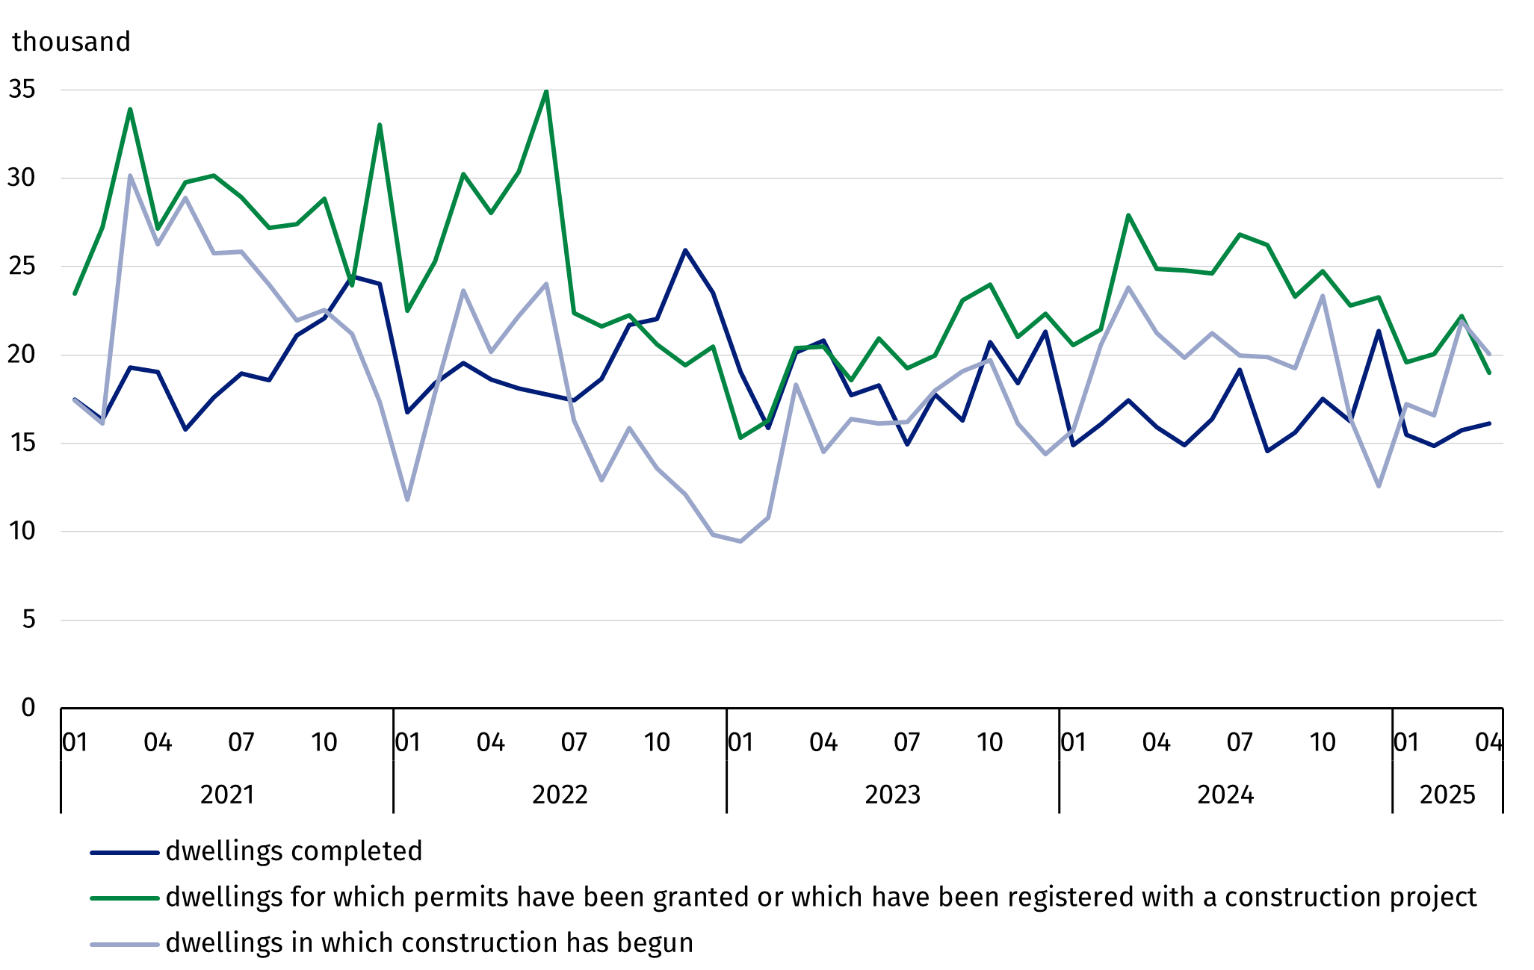
Chart 1. Residential construction in Poland
In April 2025, compared to the previous month, the number of dwellings completed increased (by 2.6%), whereas the number of dwellings for which permits have been granted as well as the number of dwellings in which construction has begun decreased (by 14.5% and 8.4%, respectively).

In the period January-April 2025, the highest total number of dwellings completed, as well as dwellings in which construction has begun and dwellings for which permits have been granted, were recorded in Mazowieckie voivodship (12.8 thousand, 15.2 thousand and 14.5 thousand dwellings, respectively) and in the following voivodeships: Małopolskie (6.0 thousand, 8.2 thousand and 9.1 thousand), Wielkopolskie (6.6 thousand, 6.1 thousand and 7.8 thousand), Śląskie (4.9 thousand, 6.5 thousand and 8.5 thousand) and Pomorskie (5.0 thousand, 7.1 thousand and 7.0 thousand).

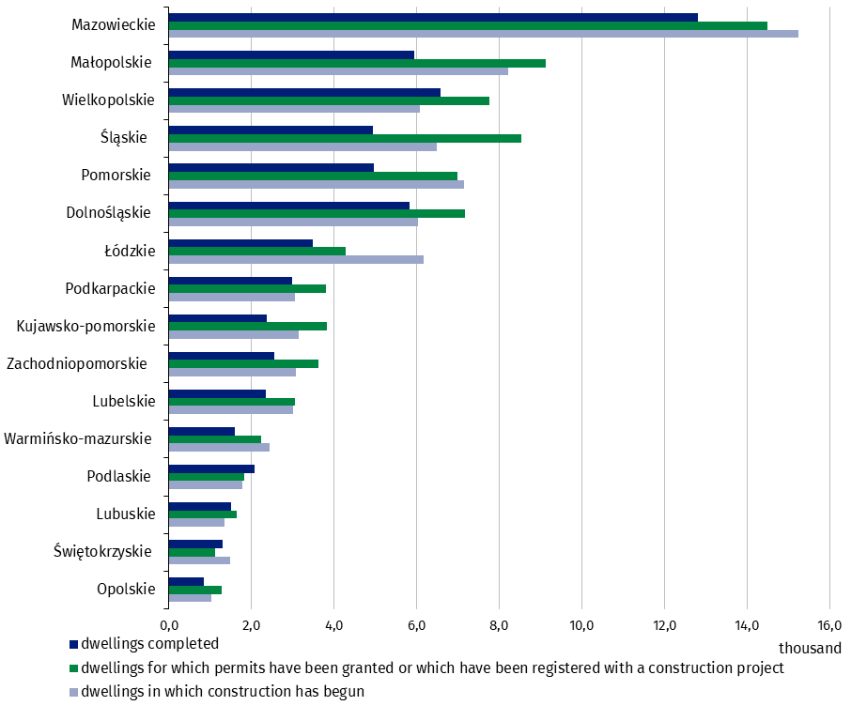
Chart 2. Residential construction by voivodships in January-April 2025

Meaning of symbols:
Dash (–) – means magnitude zero.
Dot ( . ) – means: data not available, classified data (statistical confidentiality) or providing data impossible or purposeless.

In case of quoting Statistics Poland data, please provide information: “Source of data: Statistics Poland” and in case of publishing calculations made on data published by Statistics Poland, please include the following disclaimer: “Own study based on figures from Statistics Poland”.
Prepared by:  Statistical Office in Lublin  Director Krzysztof Markowski, Ph.D.  Phone: (+48) 695 255 301 | Issued by:  Press Office  Mobile +48 695 255 032  Phone +48 22 608 38 04, +48 22 449 41 45,  +48 22 608 30 09  e-mail: obslugaprasowa@stat.gov.pl

www.stat.gov.pl/en/

@StatPoland

@GlownyUrzadStatystyczny

gus_stat

glownyurzadstatystycznygus

glownyurzadstatystyczny
Related information
Statistical Bulletin
Socio-economic situation of the country
Construction results
Data available in databases
Macroeconomic Data Bank
Knowledge Databases - Construction
Local Data Bank
Terms used in official statistics
Dwellings for which permits have been granted or which have been registered with a construction project
Dwellings in which construction has begun
Dwellings completed

Preliminary data; subject to change upon developing final data.
The form of construction - “For sale or rent”.
Including registrations with a construction project and a simplified procedure for single-family residential buildings.

