Residential construction in January 2025

In January 2025, there were more dwellings completed than the year before, the number of dwellings in which construction has begun also increased. Whereas the number of dwellings for which permits have been granted decreased.
103.8
Index number of dwellings
completed y/y

Dwellings completed
Developers and private
investors completed respectively: 60.6% and 35.8% of the total number of dwellings
According to the preliminary data, 15.5 thousand dwellings were completed in January 2025, i.e. by 3.8% more than in the corresponding month of 2024. Developers completed 9.4 thousand dwellings – by 12.9% more than a year ago, whereas private investors completed 5.5 thousand , i.e. by 10.0% less. Within these forms of construction, 96.4% of the total new dwellings were completed. In other forms, 550 dwellings were completed (432 in the previous year).
The total useful floor area of dwellings completed amounted to 1.4 million m², i.e. by 0.8%
less than a year ago and its average value for 1 dwelling was 90.6 m².

Table 1. Dwellings completed
SPECIFICATION | 01 2025
SPECIFICATION | Number  of dwellings | 01 2024=100 | 12 2024=100
TOTAL | 15 482 | 103.8 | 73.2
Private | 5 546 | 90.0 | 82.2
For sale or rent | 9 386 | 112.9 | 67.3
of which for rent | 50 | 64.1 | 10.8
Cooperative | 24 | 66.7 | 14.2
Municipal | 53 | 28.3 | 41.7
Public building society | 472 | 225.8 | 354.9
Company | 1 | . | 42-  fold less

Dwellings for which permits have been granted
In January 2025, building permits have been granted for 19.6 thousand dwellings, i.e. by 4.7% less than a year ago, of which 13.1 thousand were issued to developers (a decrease of 10.5% y/y) and 5.5 thousand to private investors (an increase of 3.5%). Within these two forms of construction, permits have been granted for 95.2% of dwellings in total. In other forms of construction 945 dwellings covered by issued building permits were noted in the analysed period (553 in the previous year).

Table 2. Dwellings for which permits have been granted
SPECIFICATION | 01 2025
SPECIFICATION | Number  of dwellings | 01 2024=100 | 12 2024=100
TOTAL | 19 606 | 95.3 | 84.5
Private | 5 533 | 103.5 | 96.7
For sale or rent | 13 128 | 89.5 | 77.2
Cooperative | 60 | . | .
Municipal | 599 | 479.2 | 13–  fold more
Public building society | 286 | 67.5 | 70.3
Company | - | . | .
Dwellings in which construction has begun
In January 2025, the number of dwellings in which construction has begun was 17.2 thousand, i.e. by 9.6% more than a year before. Developers have started construction of 12.6 thousand dwellings (by 4.7% more y/y), and private investors of 4.1 thousand (by 17.5% more). Altogether the share of these forms of construction was 97.3% of the total number of dwellings. In other forms of construction the number of dwellings in which construction has begun was 468 (139 in the previous year).

Table 3. Dwellings in which construction has begun
SPECIFICATION | 01 2025
SPECIFICATION | Number  of dwellings | 01 2024=100 | 12 2024=100
TOTAL | 17 233 | 109.6 | 137.0
Private | 4 147 | 117.5 | 119.3
For sale or rent | 12 618 | 104.7 | 153.8
of which for rent | 53 | 139.5 | 85.5
Cooperative | 1 | 23- fold less | 100- fold less
Municipal | 230 | almost 13- fold more | 37.6
Public building society | 237 | 241.8 | 123.4
Company | - | . | .
It is estimated that at the end of January 2025, there were 836.6 thousand dwellings under construction, i.e. by 4.3% more than in the corresponding month of 2024.

Chart 1. Residential construction in Poland
In January 2025, compared to December 2024, the number of dwellings completed as well as the number of dwellings for which permits have been granted decreased (by 26.8% and 15.5%, respectively), whereas the number of dwellings in which construction has begun increased (by 37.0%).
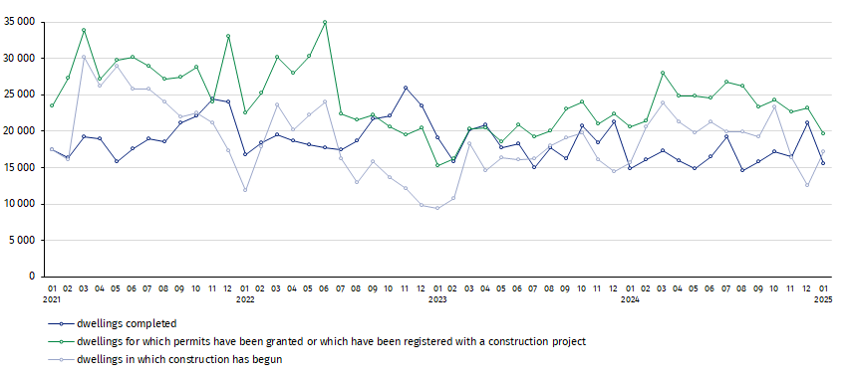

In January 2025, the highest total number of dwellings completed, as well as dwellings in which construction has begun and dwellings for which permits have been granted, were recorded in Mazowieckie voivodship (3.3 thousand, 3.8 thousand and 3.3 thousand dwellings, respectively). High values were also noted in: Małopolskie (1.6 thousand, 1.6 thousand and 2.2 thousand), Pomorskie (1.1 thousand, 1.3 thousand and 2.6 thousand), Dolnośląskie (1.2 thousand, 1.3 thousand and 2.0 thousand) and Wielkopolskie (1.6 thousand, 1.4 thousand and 1.4 thousand).

Chart 2. Residential construction by voivodships in January 2025
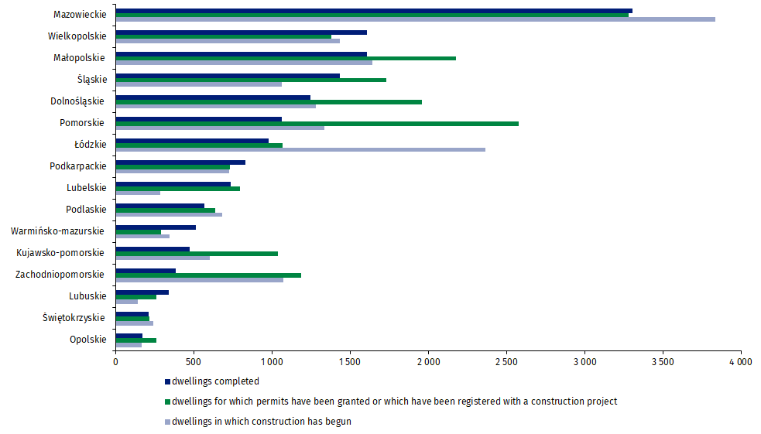

In case of quoting Statistics Poland data, please provide information: “Source of data: Statistics Poland” and in case of publishing calculations made on data published by Statistics Poland, please include the following disclaimer: “Own study based on figures from Statistics Poland”.
Prepared by:  Statistical Office in Lublin  Director Krzysztof Markowski, Ph.D.  Phone: (+48) 695 255 301 | Issued by:  Press Office  Mobile +48 695 255 032  Phone +48 22 608 38 04, +48 22 449 41 45,  +48 22 608 30 09  e-mail: obslugaprasowa@stat.gov.pl

www.stat.gov.pl/en/

@StatPoland

@GlownyUrzadStatystyczny

gus_stat

glownyurzadstatystycznygus

glownyurzadstatystyczny
Related information
Statistical Bulletin
Socio-economic situation of the country
Construction results
Data available in databases
Macroeconomic Data Bank
Knowledge Databases - Construction
Local Data Bank
Terms used in official statistics
Dwellings for which permits have been granted or which have been registered with a construction project
Dwellings in which construction has begun
Dwellings completed

Preliminary data; subject to change upon developing final data.
Including registrations with a construction project and a simplified procedure for single-family residential buildings.

