Culture Satellite Account for 2020
2.9%
Contribution of the area of culture to the creation of gross value added in 2020
Gross value added created by the area of culture amounted to PLN 60 billion. Three domains dominated in the majority of transactions that make up the culture satellite account: Advertising, Audio-visual arts and multimedia and Books and Press.
In connection with the announcement of the state of epidemic threat in Poland, from March 12, 2020, the possibility of conducting business activities has been limited, among others by cultural entities, that had to close their facilities suddenly. The introduced temporary restrictions resulted in changes in the functioning of entities operating in the area of culture. At that time, some units did not undertake any activities related to the preparation and sharing of cultural offer, and some tried to reach the public by making their offer available on the Internet. Restrictions on the activities of cultural entities in individual months had different scope and forms, depending on the current epidemic situation in the country. Some entities received financial support. This had an impact on the transactions calculated as part of the culture satellite account.

The share of the area of culture in the national economy
The culture satellite account allows to estimate the contribution of the area of culture, understood as the activities of local and state cultural institutions, non-governmental organisations operating in the area of culture and entities classified as cultural and creative industries, to the national economy. The share of the area of culture in the national economy is best determined by the gross value added of the area of culture in relation to the gross value added of the entire economy. This share in 2020 increased compared to previous years (by 0.1 percentage points) and amounted to 2.9%. The gross value added generated by the area of culture reached almost PLN 60 billion in 2020.
The largest share in the creation of gross value added in the area of culture in 2020 had entities belonging to Advertising domain (17.8%). Audio-visual arts and multimedia (17.3%), Artistic education (14.5%), Books and press (10.8%) had also a significant share. The share of Advertising domain in the creation of gross value added has been steadily decreasing – in 2018 amounted to 20.9%, in the following year it was already 1.5 p.p. lower (19.4%), and in 2020 it decreased by 1.6 p.p. (17.8%). Compared to 2019, the share of entities from the Book and Press domain in the creation of gross value added also decreased (by 2.8 p.p.). The largest increase was observed in the domain of Artistic education (by 5.6 p.p. compared to 2019). The share of Cultural heritage (2.9%), Libraries and archives (2.9%) and Culture management and administration (0.4%) did not change.
Chart 1. Gross value added of the area of culture by cultural domains in 2020
The largest share in the creation of gross value added in the area of culture was held by entities belonging to the Advertising domain (17.8%)
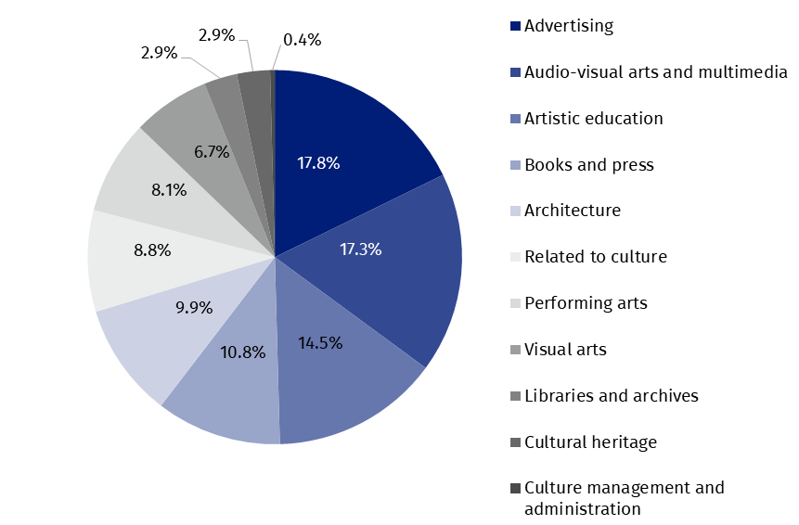
Comparison of the area of culture with other sectors of the national economy, taking into account the Polish Classification of Activities (PKD), shows the real role of the area of culture in the national economy, and therefore the contribution of the area of culture to the creation of the Gross Domestic Product (GDP) of Poland. The share of gross value added generated by entities operating within the PKD classes classified as belonging to the area of culture in 2020 was higher than the share of value added generated by entities from section B - mining and quarrying (by 1.4 p.p.) and similar to the share of entities included in section A - agriculture, forestry, hunting and fishing (2.9%), and slightly lower than entities from section D - production and supply of electricity, gas, steam and hot water (3.1%) and section N - administration and support activities (3.1%).
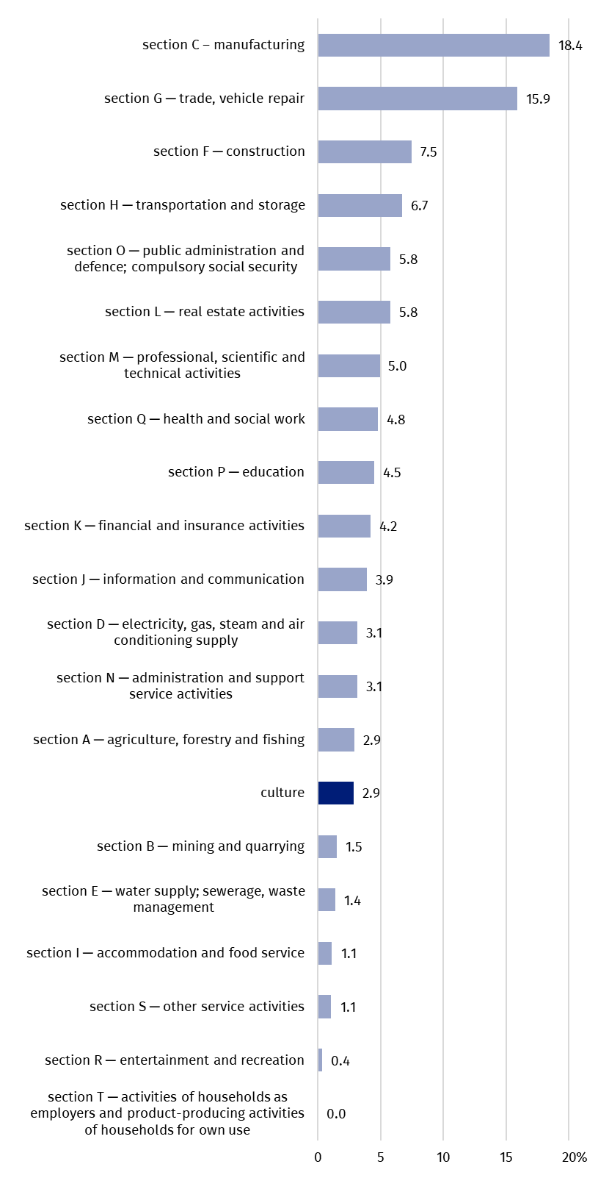
Chart 2. The share of the area of culture in the creation of gross value added as compared to other sections of national economy in 2020 (according to PKD 2007)

Transactions in the culture satellite account
In the area of culture, the value of gross output in 2020 decreased by 1.5% (i.e. by PLN 2,016.0 million) compared to 2019 and amounted to PLN 128,694.5 million. The highest value of gross output was recorded in the Advertising domain (PLN 30,637.6 million, i.e. 23.8% of the gross output for the entire area of culture). Domains Audio-visual arts and multimedia (19.7%), Related to culture (11.4%) and Books and press (10.3%) also accounted for a significant share. The total share of gross output generated by these four domains amounted to 65.2% of total gross output in the area of culture. The smallest contribution to the gross output of the area of culture was made by entities from Culture management and administration (0.4%) domain. The largest increase in the gross output compared to 2019 was recorded in the Artistic education domain (by 61.1%). The share of most cultural domains in gross output did not change significantly compared to 2019, with the exception of Artistic education (an increase of 3.9 p.p.) and Advertising domain (a decrease of 2.5 p.p.) and Books and press (a decrease of 1.6 p.p.).
In the area of culture, 65.2% of total gross output was generated by four domains: Advertising, Audio-visual arts and multimedia, Books and press, and Related to culture
The value of intermediate consumption, measuring the value of goods and services consumed as inputs in the production process, compared to 2019 decreased by 5.3% (i.e. by PLN 3,870.9 million) to PLN 69,600.9 million. Total gross value added for the entire area of culture reached PLN 59,093.6 million (3.2% more than in 2019). In the case of cultural domains such as Libraries and archives and Artistic education, the gross value added was about twice as high as the value of intermediate consumption. On the other hand Advertising and Related to culture domains were characterised by almost twice as much intermediate consumption as their gross value added generated (i.e. by 92.0% and 83.2%, respectively).
Intermediate consumption of entities operating within the domains of Advertising and Audio-visual arts and multimedia constituted 50.7% of the value of intermediate consumption of the area of culture
In 2020, the compensation of employees in the area of culture amounted to PLN 26,080.1 million (an increase of PLN 2,028.9 million compared to 2019, i.e. by 8.4%). In the structure of compensation of employees, the largest share was observed for entities from Artistic education domain (17.0%). The share of the following domains was also important in this respect: Advertising (14.7%), Audio-visual arts and multimedia (12.8%), Performing arts and Related to culture (12.3% each) and Books and press (11.2%). On the other hand, the smallest share in the structure of compensation of employees had entities from Culture management and administration domain (0.9%).
The gross operating surplus, which is the difference between gross value added and compensation of employees and other taxes related to production less other subsidies related to production, amounted to PLN 38,115.5 million (16.5%, i.e. PLN 5,400.4 million more than in 2019). The highest result was achieved by entities in the Advertising domain (PLN 7,282.4 million). The lowest gross operating surplus values were observed for Related to culture domain (PLN 11.1 million). The highest increase in gross operating surplus compared to 2019 was recorded in the Artistic education domain (by 239.5%). The largest decrease was recorded in the Books and press domain (by 15.3%).
In Artistic education domain the gross operating surplus increased more than threefold compared to 2019
In 2020, the value of subsidies on production in the area of culture increased significantly compared to 2019 (by PLN 5,633.4 million, i.e. by 1806.2%), which was related to the period of the COVID-19 pandemic. The largest number of subsidies (52.8%) was received by entities in Artistic education domain (a total of PLN 3,140.6 million). As in 2019, the highest other taxes related to production were recorded for entities in Audio-visual arts and multimedia domain (50.3% of all other taxes related to production, i.e. PLN 424.1 million), and compared to 2019, this domain had a larger share in them (in 2019 – 48.9%).
In the year under review, gross capital formation in the area of culture reached PLN 5,013.1 million (PLN 616.6 million less than in 2019). The highest value, as in 2019, was recorded in the Architecture domain (PLN 2,655.8 million).
Gross capital formation in 2020 amounted to PLN 5,013.1 million (11.0% less than in 2019)

Table 1. Main transactions in the culture satellite account according to cultural domains in 2020
Specification | Gross output | Intermediate consumption | Value added, gross | Compensation of employ-ees | Other taxes on production | Other subsidies on produc-tion | Operating surplus, gross
Specification | in PLN million
Total | 128,694.5 | 69,600.9 | 59,093.6 | 26,080.1 | 843.2 | 5,945.3 | 38,115.5
Cultural heritage | 3,294.3 | 1,602.1 | 1,692.2 | 1,334.9 | 31.8 | 24.3 | 349.8
Libraries and archives | 2,522.9 | 829.3 | 1,693.6 | 1,499.5 | 15.9 | 16.2 | 194.3
Books and press | 13,203.3 | 6,802.0 | 6,401.3 | 2,926.8 | 58.3 | 361.6 | 3,777.7
Visual arts | 7,097.7 | 3,147.3 | 3,950.4 | 827.5 | 14.9 | 486.9 | 3,594.9
Performing arts | 8,017.6 | 3,220.2 | 4,797.4 | 3,215.3 | 81.3 | 169.6 | 1,670.5
Audio-visual arts and multimedia | 25,411.2 | 15,172.1 | 10,239.0 | 3,345.0 | 424.1 | 243.0 | 6,713.0
Architecture | 10,323.8 | 4,484.7 | 5,839.1 | 1,196.0 | 26.3 | 370.8 | 4,987.7
Advertising | 30,637.6 | 20,144.2 | 10,493.5 | 3,845.9 | 97.3 | 732.2 | 7,282.4
Artistic education | 13,013.9 | 4,454.1 | 8,559.7 | 4,423.3 | 46.3 | 3,140.6 | 7,230.7
Related to culture | 14,687.3 | 9,501.7 | 5,185.6 | 3,220.6 | 45.0 | 383.6 | 2,303.6
Culture management and administration | 485.0 | 243.3 | 241.7 | 245.2 | 2.1 | 16.6 | 11.1

Table 1. Main transactions in the culture satellite account according to cultural domains in 2020 (cont.)
Specification | Final consumption expenditure |  |  | Gross capital formation | Imports of goods and services | Exports of goods and services
Specification | by house-holds | by non-profit institu-tions | by general govern-ment | Gross capital formation | Imports of goods and services | Exports of goods and services
Specification | in PLN million
Total | 33,065.0 | 1,330.4 | 15,951.9 | 5,013.1 | 21,044.9 | 26,480.7
Cultural heritage | 592.2 | 366.2 | 682.3 | -1.8 | 278.5 | 453.5
Libraries and archives | _ | 142.4 | 3,372.4 | -0.5 | _ | _
Books and press | 6,059.4 | 44.4 | 1,613.9 | 25.9 | 2,994.2 | 6,771.6
Visual arts | 3,081.0 | 56.3 | 69.2 | 1.2 | 71.8 | 31.3
Performing arts | 1,077.9 | 327.9 | 4,970.4 | 1,616.9 | 600.7 | 277.1
Audio-visual arts and multimedia | 20,937.1 | 6.1 | 2,020.8 | 684.5 | 9,847.2 | 8,600.0
Architecture | _ | _ | 315.0 | 2,655.8 | 127.1 | 208.8
Advertising | _ | _ | _ | -4.3 | 7,082.6 | 9,991.0
Artistic education | 797.0 | 289.8 | 2,822.2 | 1.3 | _ | _
Related to culture | 520.5 | 7.7 | _ | 33.4 | 42.9 | 147.4
Culture management and administration | _ | 89.5 | 85.7 | 0.7 | _ | _

Final consumption expenditure for the area of culture amounted to PLN 50,347.2 million (PLN 3,780.1 less than in 2019). Audio-visual arts and multimedia domain was responsible for almost half of it (PLN 22,963.9 million). High final consumption expenditure was also recorded in the case of Books and press (PLN 7,717.7 million). The consumption related to households accounted for 65.7% of total final consumption in the area of culture. The highest value of this consumption was recorded in Audio-visual arts and multimedia domain (PLN 20,937.0 million, i.e. PLN 1,572.1 million less than in 2019). In the general government sector (31.7% of total consumption, 828.2 million more than in 2019), the highest value of final consumption was recorded in Performing arts (PLN 4,970.4 million). A significant share was also recorded for the following domains: Libraries and archives (PLN 3,372.4 million) and Artistic education (PLN 2,822.2 million). In the sector of non-profit institutions serving households, which are related to culture, final consumption expenditure amounted to PLN 1,330.4 million (PLN 40.9 million more than in 2019). The highest value of final consumption was recorded in Cultural heritage domain (PLN 366.2 million).
In 2020, a positive balance was recorded in foreign trade in cultural and creative goods and services of PLN 5,435.8 million (PLN 515.9 million less than in 2019). The positive foreign trade balance was mainly influenced by Books and press domain (balance of PLN 3,777.5 million) and Advertising (balance of PLN 2,908.5 million). In the domains of Audio-visual arts and multimedia, Performing arts and Visual arts, the balance was again negative (minus PLN 1,247.2 million, minus PLN 323.7 million and minus PLN 40.5 million, respectively). The largest share in exports of cultural and creative goods and services was observed in the Advertising domain (37.7%). Audio-visual arts and multimedia (32.5%) and Books and press (25.6%) also had a large share in exports. In the case of imports, the same domains dominated: Audio-visual arts and multimedia (46.8% of all imports of the area of culture), Advertising (33.7%) and Books and press (14.2%). The value of imports in the following domains: Audio-visual arts and multimedia amounted to PLN 9,847.2 million, Advertising – PLN 7,082.6 million, and Books and press – PLN 2,994.2 million. Compared to 2019, the highest percentage increase in imports was recorded in Visual arts domain (by 22.3%), and the highest percentage increase in exports – in Audio-visual arts and multimedia domain (by 12.8%).
The positive balance (PLN 5,435.8 million) in foreign trade in cultural goods and services is mainly related to Advertising and Books and press domains
Information on the used data sources and the methodological solutions can be found in the Report on methodological work. Culture Satellite Account (hyperlink available on the last page).
In the case of quoting data from the Statistics Poland, please include the information: "Statistics Poland data source", and in the case of publishing calculations made on data published by the Statistics Poland, please provide information: "Own study based on Statistics Poland data".

Prepared by:  Statistical Office in Kraków  Director Agnieszka Szlubowska  Phone: (+48 12) 420 40 50 | Issued by:  Press Office  Mobile: (+48) 695 255 032  Phone: (+48 22) 608 38 04, (+48 22) 449 41 45,  (+48 22) 608 30 09  e-mail: obslugaprasowa@stat.gov.pl

stat.gov.pl/en/

@StatPoland

@GlownyUrzadStatystyczny

gus_stat

glownyurzadstatystycznygus

glownyurzadstatystyczny
Related information
Report on methodological work. Culture Satellite Account (PL version only)
Culture satellite account for 2019
Cultural and creative industries in 2017-2021
Cultural and creative industries in 2022
Culture and national heritage in 2023
Terms used in the official statistics
Gross capital formation
Exports of goods and services
Imports of goods and services
Compensation of employees
Operating surplus, gross
Gross output
Gross Domestic Product (GDP)
Final consumption expenditure
Value added, gross
Intermediate consumption

Based on data from before the introduction of the benchmarking revision in national accounts carried out in 2024 and covering the years 1995–2022.
In order to present data according to PKD section, it was necessary to exclude from some sections of the national economy individual classes of PKD, which were included in the calculations for the area of culture. The area of culture includes the following classes of PKD: 18.11; 18.12; 18.20; 32.20; 47.61; 47.62; 47.63; 58.11; 58.13; 58.14; 58.21; 59.11; 59.12; 59.13; 59.14; 59.20; 60.10; 60.20; 63.91; 71.11; 73.11; 74.10; 74.20; 74.30; 77.22; 90.01; 90.02; 90.03; 90.04; 91.01; 91.02; 91.03 and for data concerning the general government sector also some part of classes: 84.11; 84.12; 84.25, 94.12, and in the domain of Artistic education of some part of classes: 85.10; 85.20; 85.31; 85.32; 85.41; 85.42; 85.52; 85.59; 85.60.
Gross capital formation measures the increase of national capital in given period that includes gross fixed capital formation, changes in inventories and acquisition less disposals of valuables.
Data on final consumption expenditure, gross capital formation and foreign trade in Culture satellite account are calculated on the basis of data by balance groups presented in the supply and use tables.
Expenditure incurred by resident institutional units (including household sector, general government sector and non-profit institutions servicing households sector) on goods and services used to meet the direct, individual and collective needs of members of society.

