Cinematography in 2024
In 2024, there were 535 indoor cinemas with 1.6 thousand screens and 290.4 thousand seats for the audience. 2.2 million film screenings were shown, watched by 49.5 million viewers.
2.9%
Increase in the number of film screenings in indoor cinemas in comparison to 2023
262 films for cinema and television were produced.

Cinemas activity
At the end of 2024, there were 535 indoor cinemas operating in Poland. The number of indoor cinemas has not changed compared to 2023. The largest number of indoor cinemas operated in Mazowieckie Voivodship (81), and the lowest in Podlaskie Voivodship (12). Indoor cinemas had 1.6 thousand screens and 290.4 thousand seats for the audience.
During the year, indoor cinemas attracted 49.5 million viewers (0.4% less than in 2023). The largest number of audience per indoor cinema was in Kujawsko-pomorskie Voivodship (118.9 thousand), and the fewest – in Świętokrzyskie Voivodship (53.0 thousand).

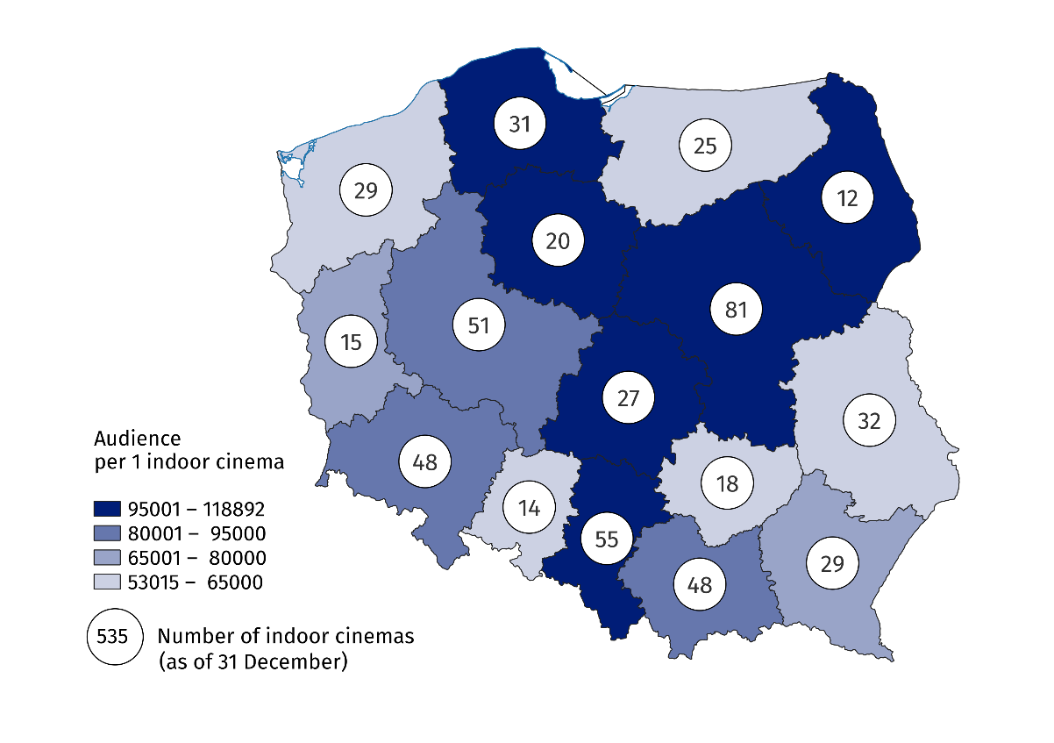
Map 1. Indoor cinemas in 2024
Indoor cinemas in Mazowieckie Voivodship gathered almost one-fifth of the total number of audience
As in 2023, more than half of indoor cinemas (59.1%) were single-screen cinemas. Miniplexes (with 3 to 7 screens) constituted 20.7% of the total number of indoor cinemas, multiplexes (with 8 or more screens) – 11.2%, while indoor cinemas with two screens – 9.0%. Multiplexes displayed 49.4% of the total number of screenings, watched by 49.9% of the total audience. Miniplexes displayed 37.5% of screenings, watched by 36.0% of audience. One multiplex had an average of 2.0 thousand seats for the audience and displayed an average of 18.1 thousand screenings.
59.1% of the total number of indoor cinemas were single-screen cinemas
Chart 1. Indoor cinemas by number of screens in 2024
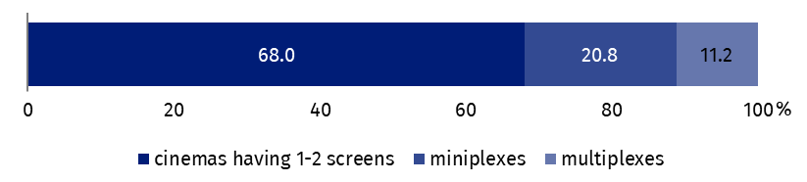
As of 31 December

Film production
In 2024, 262 films (27.6% less than in 2023) were produced in Poland, including 92 full-length films (13.2% less than in 2023) and 170 medium- and short-length films (33.6% less than in 2023).

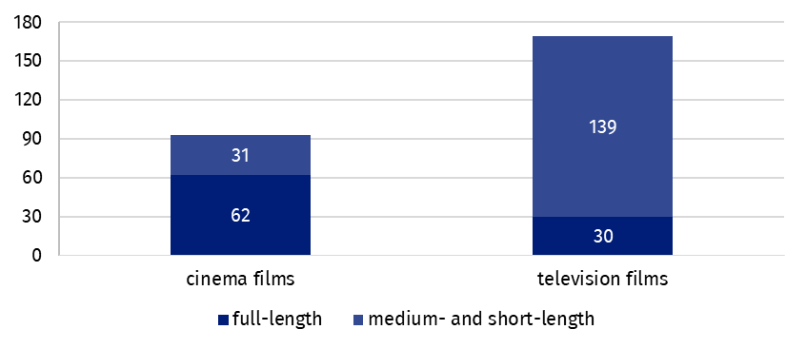
Chart 2. Films produced in 2024
The majority of full-length films produced were cinema films (67.4%), while among medium- and short-length films were television films (81.8%). Feature films (57.0%) dominated in case of cinema films, while documentaries (62.7%) dominated among television films. Compared to 2023, the number of all cinema films produced decreased by 5.1%, and television films by 36.0%.

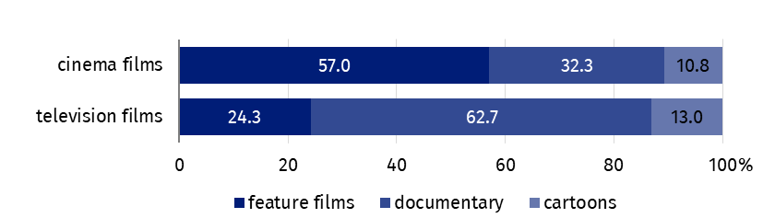
Chart 3. Films produced by type in 2024
Documentary films accounted for 51.9% of the total number of films produced
Data presented in this study come from the survey on the K-06 form Report on Film Production and K-08 form Cinema Report. Information on the survey methodology can be found in the Methodological report. Culture Statistics.
In the case of quoting data from the Statistics Poland, please provide information: "Statistics Poland data source", and in the case of publishing calculations made on data published by the Statistics Poland, please provide information: "Own study based on Statistics Poland data".

Prepared by:  Statistical Office in Kraków  Director Agnieszka Szlubowska  Phone: (+48 12) 420 40 50 | Issued by:  Press Office  Mobile: (+48) 695 255 032  Phone: (+48 22) 608 38 04, (+48 22) 449 41 45,  (+48 22) 608 30 09  e-mail: obslugaprasowa@stat.gov.pl

stat.gov.pl/en/

@StatPoland

@GlownyUrzadStatystyczny

gus_stat

glownyurzadstatystycznygus

glownyurzadstatystyczny
Related information
Culture and national heritage in 2023
Cinematography in 2023
Methodological report. Culture Statistics
Topic available in databases
Knowledge Databases – Society – Culture – Cinematography
Local Data Bank – Culture – Cinemas
Terms used in the official statistics
Indoor cinema
Audience
Film

