Cultural and creative industries in 2023
In 2023, there were 124.1 thousand enterprises classified as cultural and creative industries, of which 99.1% were micro-enterprises. The number of employed people amounted to 236.7 thousand people, and the average paid employment amounted to 92.5 thousand full-time jobs. On average, the gross monthly salary per one employee amounted to PLN 8,868.
4.7%
Decrease in the number of entities belonging to the cultural and creative industries in comparison to 2022
Cultural and creative industries are the part of non-financial enterprises, separated according to specific PKD classes. These are economic entities engaged in mass production and sale of cultural and creative goods and services. Cultural industries produce cultural goods and services based on copyright, using industrial production techniques, and these are primarily: the publishing industry, the phonographic industry, TV, radio, the film industry and creating computer games. Creative industries are created by entities whose activities are primarily related to design, architecture, advertising and translations – culture is an inspiration and creative contribution here.

Number and types of entities belonging to the cultural and creative industries
In 2023, the number of entities belonging to the cultural and creative industries amounted to 124.1 thousand, i.e. 4.7% less than in 2022.

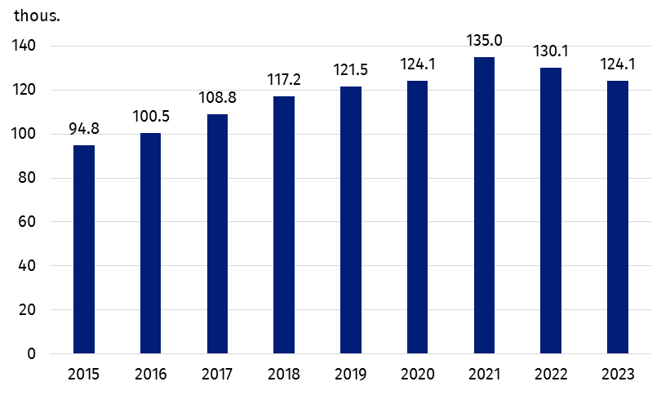
Chart 1. Number of enterprises belonging to the cultural and creative industries
The largest number of entities operated in the Visual arts domain (33.5 thousand), and the fewest – Libraries and archives (0.1 thousand). The structure of entities belonging to the cultural and creative industries by domains of culture has not changed in comparison to 2022. A decrease in the number of entities in all domains of culture was observed, and the largest decrease was observed in the Books and press domain (by 10.1%).
Chart 2. Entities classified as cultural and creative industries by domain of culture in 2023
The largest number of enterprises belonging to the cultural and creative industries operated in the Visual arts domain (27.0%)
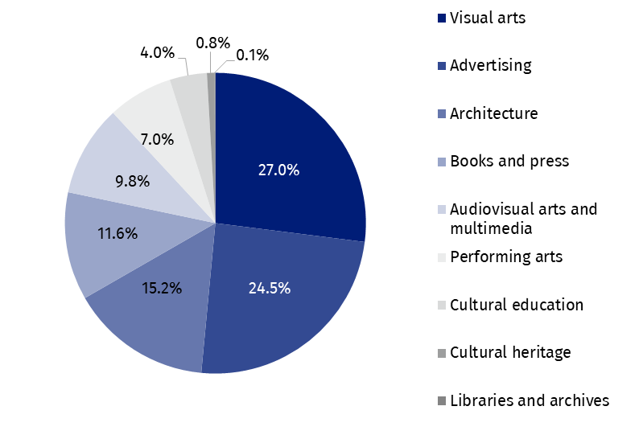
Entities belonging to the cultural and creative industries accounted for 5.4% of all non-financial enterprises in Poland. The overwhelming majority of entities were micro-enterprises (122.9 thousand entities, i.e. 99.1% belonging to the cultural and creative industries), which constituted 5.5% of all non-financial micro-enterprises. 1.9% of small enterprises and 1.2% of medium and large enterprises. In the others enterprise size classes, the share of cultural and creative industries in the group of non-financial enterprises was as follows: small – 1.9%, medium and large – 1.2% each.
The overwhelming majority of entities belonging to the cultural and creative industries are micro-enterprises. They accounted for 5.5% of all non-financial micro-enterprises

Employed persons, average employment and salaries
Along with the decrease in the number of entities belonging to the cultural and creative industries, there was a decrease in the number of employees and average employment. As of the end of 2023, the number of employees in enterprises belonging to the cultural and creative industries was 236.7 thousand people (7.6% less than in 2022), and the average employment during the year was 92.5 thousand full-time jobs (8.9% less than in the previous year).
In comparison to 2022, there was a decrease in entities belonging to cultural and creative industries in both the number of employed persons and the average employment in micro and large enterprises (in micro-enterprises by 9.1% and by 19.0%, respectively, in large enterprises – by 9.6% and by 8.9%). In small and medium enterprises, the number of employed persons increased by 2.0% and by 3.3%, respectively, and the average employment increased – by 2.5% and by 4.4%.
In the group of micro-enterprises belonging to the cultural and creative industries, the ratio of average employment to the number of employed persons in 2023 was 1:5 (32.4 thousand full-time jobs compared to 173.2 thousand of employees). In the case of other enterprise size classes, the ratio of average employment to the number of employees was approximately 1:1 (small enterprises – 16.9 thousand full-time jobs against 18.1 thousand employed persons; medium enterprises – 16.9 thousand against 17.8 thousand; large enterprises – 26.4 thousand against 27.5 thousand). These data allow us to conclude, that in the group of micro-enterprises the majority of people employed under employment contracts worked part-time or periodically.
The gross monthly wages and salaries per one employee in 2023 was PLN 8,868, i.e. 11.1% more than in 2022. In comparison, the average gross wages and salaries for all non-financial enterprises increased by 13.1% to PLN 7,610.
The value of the average wages and salaries increased – although to varying degrees – in all classes of enterprises belonging to the cultural and creative industries, with the highest increase recorded for small enterprises – by 11.8% (to PLN 9,280). In medium enterprises, the average wages and salaries increased by 8.8%, in micro-enterprises – by 8.2%, and in large enterprises – by 7.6%. The highest gross monthly wages and salaries per one employee was recorded in large enterprises – PLN 11,392, i.e. more than twice as high as in the case of micro-enterprises (PLN 5,610).
Regardless of the size class of enterprises, in the cultural and creative industries, the gross monthly wages and salaries per employee was higher than in the total non-financial enterprises – by PLN 1,258. In the largest group of entities, i.e. in micro-enterprises, this difference amounted to PLN 782, in small enterprises – PLN 2,023, in medium enterprises – PLN 2,636, and in large enterprises – PLN 2,612.
Gross monthly wages and salaries per one employee in the cultural and creative industries was higher by PLN 1,258 compared to the total non-financial enterprises
The share of gross wages and salaries in total costs for enterprises classified as cultural and creative industries was 11.3% (0.3 percentage points less than in 2022).

Table 1. Employed persons, average employment, gross wages and salaries in cultural and creative industries in 2023
Specification | Number  of persons employedª | Average paid employment | Gross wages and salaries  in thousand PLN | Monthly gross wages and salaries per 1 paid employee in PLN
Total | 236,686 | 92,542 | 9,847,861 | 8,868
Micro-enterprises | 173,228 | 32,412 | 2,181,796 | 5,610
Small enterprises | 18,111 | 16,850 | 1,876,423 | 9,280
Medium enterprises | 17,828 | 16,896 | 2,182,828 | 10,766
Large enterprises | 27,519 | 26,384 | 3,606,814 | 11,392
a As of 31 December.

Financial results
The surplus of total revenues over total costs for cultural and creative industries amounted to PLN 16.8 billion
In 2023, entities classified as cultural and creative industries generated total revenues of PLN 104.3 billion, with total costs of PLN 87.5 billion. As in previous years, a surplus of total revenues over total costs of PLN 16.8 billion was recorded (PLN 1.1 billion more than in 2022). Compared to 2022, total revenues increased by 4.6%, while total costs increased by 4.2%.
In 2023, the cost level indicator (the ratio of total costs to total revenues) for enterprises classified as cultural and creative industries amounted to 83.9% (a decrease of 0.3 percentage points compared to 2022) and was 8.0 percentage points lower compared to the cost level indicator for all non-financial enterprises.
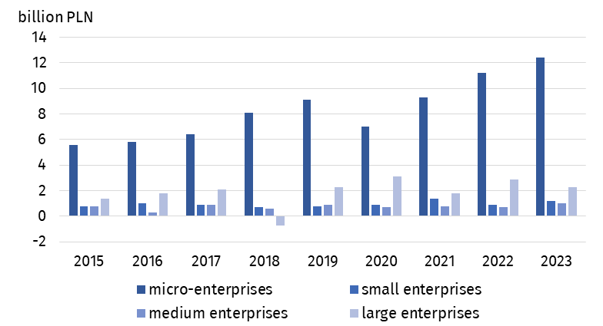
Chart 3. Gross financial resultª in enterprises classified as cultural and creative industries by enterprise size class
a Gross financial result is calculated as the difference between total revenues and total costs – in the case of a surplus of total costs over total revenues, the financial result is recorded with a (-) sign.
Total costs per one entity amounted to PLN 705.5 thousand, while total revenues amounted to PLN 840.8 thousand. The share of total revenues and total costs generated by enterprises classified as cultural and creative industries in total revenues and total costs generated by all non-financial enterprises amounted to 1.3% and 1.2%, respectively.
Enterprises belonging to the cultural and creative industries generated value added of PLN 32.6 billion (PLN 1.5 billion more than in 2022), which accounted for 1.6% of the value added generated by all non-financial enterprises. Almost half of the value added was provided by micro-enterprises – PLN 14.7 billion. In case of large enterprises, it was PLN 9.3 billion, and in case of small and medium enterprises – PLN 3.9 billion and PLN 4.7 billion, respectively. Per one enterprise, the total value added of the cultural and creative industries was more than three times lower than the value added per one non-financial enterprise.

International trade of cultural and creative goods and services
In 2023, cultural and creative goods worth PLN 13.8 billion were sold abroad (PLN 2.7 billion, i.e. 16.4% less than in 2022). Imports decreased by PLN 1.3 billion (i.e. 12.0%) to PLN 9.2 billion. The foreign trade balance was positive and amounted to PLN 4.6 billion (PLN 1.5 billion less than in 2022).
In 2023, a positive balance of international trade of cultural and creative goods was recorded in the amount of PLN 4.6 billion. The balance of trade of cultural and creative services was negative and amounted to minus PLN 3.0 billion
The largest amount from the sale of goods was obtained in the Audio-visual arts and multimedia domain (PLN 6.3 billion), while the lowest – in the Architecture domain (PLN 0.2 million). The highest positive balance of international trade in goods was recorded in the Books and press domain (PLN 3.4 billion). The largest negative balance of international trade was observed in the case of Cultural heritage domain (minus PLN 164.3 million).
Compared to 2022, the largest increase in the value of exported cultural and creative goods was observed in the Arts and crafts domain (by 91.9%), while in case of imports, the value increased only in the Cultural heritage domain (by 30.0%).
The value of cultural and creative services delivered abroad amounted to PLN 17.7 billion (PLN 2.2 billion more than in 2022), while cultural and creative services purchased abroad – PLN 20.7 billion (PLN 2.9 billion more than in the previous year). The balance of turnover was therefore negative and amounted to minus PLN 3.0 billion. The positive balance of turnover in cultural and creative services was recorded only in the domains Advertising (PLN 150.7 million) and Cultural heritage (PLN 144.6 million). The largest negative balance of turnover in cultural and creative services was recorded in the Audio-visual arts and multimedia domain (minus PLN 2.3 billion). In the Advertising domain, both the highest values of exports (PLN 14.6 billion) and imports (PLN 14.4 billion) were recorded.
In the structure of Poland's foreign trade, the share of both exports and imports of cultural and creative goods, as well as cultural and creative services, was relatively small and similar to recorded in the previous years. The share of cultural and creative goods in exports of goods in 2023 was 0.9%, while in imports – 0.6%. The share of cultural and creative services in foreign trade of services was higher than in cultural and creative goods: the share amounted to 3.9% in exports and in imports – 7.5%.
The recipients of Polish cultural and creative goods were mainly EU countries (88.7% of all turnover). The value of exports to EU countries amounted to PLN 12.2 billion (a decrease of 17.5% compared to 2022), of which 82.0% (i.e. PLN 10.0 billion) was attributable to the Euro area countries. Imports of cultural and creative goods came mainly from EU countries (PLN 4.3 billion, i.e. 46.7% of the value of imports of cultural and creative goods) and from economically developing countries (PLN 3.1 billion, i.e. 33.6%).
It is worth noting that it is not only the value of cultural and creative goods sold and bought abroad that has declined. The same phenomenon was visible for the entire foreign trade in goods in 2023 (a decrease in exports by 0.3% and imports by 8.4%).
The recipients of Polish cultural and creative services were mainly EU countries (61.1% of the value of exports), including the Euro area (84.2% of the value of exports to the EU). The situation was similar in the case of imports of services, where the main turnover was mainly with EU countries (73.0%), including the Euro area countries (62.6%).

Table 2. Foreign trade in cultural and creative goods and services by cultural domains in 2023
Specification | Cultural  and creative goods |  | Cultural  and creative services
Specification | exports | imports | exports | imports
Specification | in PLN million
Total | 13,802.0 | 9,230.4 | 17,688.3 | 20,737.2
Cultural heritage | 127.1 | 291.4 | 580.6 | 436.0
Books and press | 5,350.3 | 1,996.7 | 347.9 | 962.5
Visual arts | 351.9 | 142.8 | – | –
Architecture | 0.2 | 1.7 | 354.9 | 443.5
Performing arts | 227.0 | 279.5 | 334.0 | 690.4
Audio-visual arts and multimedia | 6,340.7 | 6,385.8 | 1,513.0 | 3,797.7
Advertising | 1,403.5 | 131.7 | 14,557.8 | 14,407.1
Arts and crafts | 1.1 | 0.9 | – | –
Note: Data does not add up due to rounding.
Information on the data sources used and the methodological solutions used can be found in Methodological report. Culture statistics and the publication Cultural and creative industries 2017–2021.
In the case of quoting data from the Statistics Poland, please provide information: "Statistics Poland data source", and in the case of publishing calculations made on data published by the Statistics Poland, please provide information: "Own study based on Statistics Poland data".
Prepared by:  Statistical Office in Krakow  Director Agnieszka Szlubowska  Phone: (+48 12) 420 40 50 | Issued by:  Press Office  Mobile: (+48) 695 255 032  Phone: (+48 22) 608 38 04, (+48 22) 449 41 45,  (+48 22) 608 30 09  e-mail: obslugaprasowa@stat.gov.pl

stat.gov.pl/en/

@StatPoland

@GlownyUrzadStatystyczny

gus_stat

glownyurzadstatystycznygus

glownyurzadstatystyczny
Related information
Cultural and creative industries 2017–2021
Cultural and creative industries in 2022
Culture and national heritage in 2023
Methodological report. Culture statistics
Terms used in the official statistics
Exports of goods and services
Imports of goods and services
Total costs
Average monthly gross wages and salaries
Average paid employment
Total revenues
Balance foreign trade commodity turnover
Balance of services
Cost level indicator
Gross earnings

Micro-enterprises – entities with 9 or fewer employees; small enterprises – entities with 10–49 employees; medium enterprises – entities with 50–249 employees; large enterprises – entities with 250 or more employees.

