Market of the works of art and antiques in 2024
In 2024, the value of sales of works of art and antiques in Poland amounted to PLN 656.9 million, of which PLN 403.8 million at auctions.
15.7%
Increase in the value of sales of works of art and antiques in comparison to 2023
In 2024, there were 188 entities operating on the works of art and antiques market in Poland (6.0% less than in 2023), of which 59.6% were engaged exclusively in the sale of works of art and antiques, and 40.4% also conducted exhibition activities.
The largest number of entities on the market of works of art and antiques were located in Mazowieckie (25.5%) and Małopolskie Voivodeships (18.1%). More than two-thirds of the entities involved in the sale of works of art and antiques were based in the capitals of Voivodeships, including 21.3% in Warszawa and 16.0% in Kraków.
The total amount of sales of works of art and antiques amounted to PLN 656.9 million and increased by 15.7% in comparison to 2023. In Mazowieckie Voivodeship the works of art and antiques were sold for the amount of PLN 526.8 million, which accounted for 80.2% of the total amount of sales of works of art and antiques in Poland.
Painting had the highest share (82.5%) in the structure of sales of works of art and antiques in Poland. In 2024, the amount of sales of works of art in the field of painting amounted to PLN 541.8 million. Sales of old painting accounted for 43.4% of the total amount of sales (PLN 284.8 million), and contemporary painting accounted for 39.1% (PLN 257.0 million). Compared to 2023, there was a 14.8% increase in sales of painting. Sales of old painting increased by 24.0%, and contemporary painting by 6.2%.

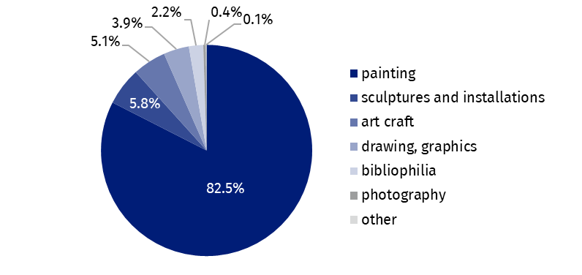
Chart 1. The sale of works of art and antiques by type in 2024
82.5% of the total amount of sales of works of art and antiques was obtained from the sale of works in the field of painting
The largest share of the total amount of sales of works of art and antiques was obtained by entities through auctions – PLN 403.8 million (15.2% more than in 2023), including online auctions – PLN 57.9 million (116.8% more than in 2023).
In terms of the total value of sales of works of art and antiques, a significant distribution channel was sales in retail outlets. Its value amounted to PLN 217.3 million, which accounted for 33.1% of the total amount of sales. Compared to 2023, sales of works of art and antiques in retail outlets increased by 15.1%.

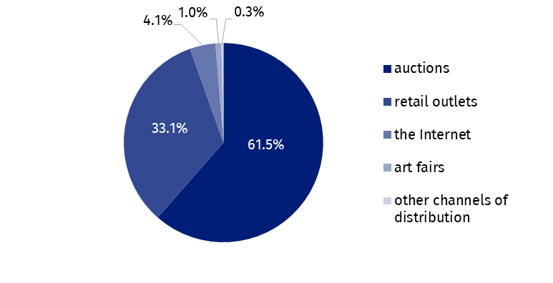
Chart 2. The sale of works of art and antiques by distribution channel in 2024
Almost two-thirds of the value of works of art and antiques sales (61.5%) was obtained through auctions
Works of art and antiques were sold via the Internet (e.g. online stores, sales platforms) for the amount of PLN 27.2 million (4.1% of the total sales value), which was 24.5% more than in comparison to 2023.
Data presented in this study come from the survey on the K-10 form Report on the Activity on the Market of Works of Art and Antiques. Information on the survey methodology can be found in the Methodological report. Culture Statistics.
In the case of quoting data from the Statistics Poland, please provide information: "Statistics Poland data source", and in the case of publishing calculations made on data published by the Statistics Poland, please provide information: "Own study based on Statistics Poland data".
Prepared by:  Statistical Office in Kraków  Director Agnieszka Szlubowska  Phone: (+48 12) 420 40 50 | Issued by:  Press Office  Mobile: (+48) 695 255 032  Phone: (+48 22) 608 38 04, (+48 22) 449 41 45,  (+48 22) 608 30 09  e-mail: obslugaprasowa@stat.gov.pl

stat.gov.pl/en/

@StatPoland

@GlownyUrzadStatystyczny

gus_stat

glownyurzadstatystycznygus

glownyurzadstatystyczny
Related information
Culture and national heritage in 2023
Market of works of art and antiques in 2023
Methodological report. Culture statistics
Terms used in the official statistics
Works of art
Antiques
Art gallery

including art galleries, auction houses.

