Mass events in 2024
In 2024, 6.9 thousand mass events were organised in Poland. The events gathered a total of 28.2 million participants. Compared to 2023, the number of organised mass events increased by 8.7% and the number of participants increased by 4.7%.
4.7%
Increase in the number of participants of mass events in comparison to 2023
In 2024, city and municipal offices issued permits for organisation of 6,9 thousand mass events (8.7% more than in 2023). Most of mass events took place in Śląskie Voivodship (1078) and the fewest in Podlaskie Voivodship (143). On average, 4.1 thousand people participated in one mass event during the year. The highest average number of participants during the year was recorded in Mazowieckie Voivodship (5.8 thousand), and the lowest in Opolskie Voivodship (2.3 thousand).
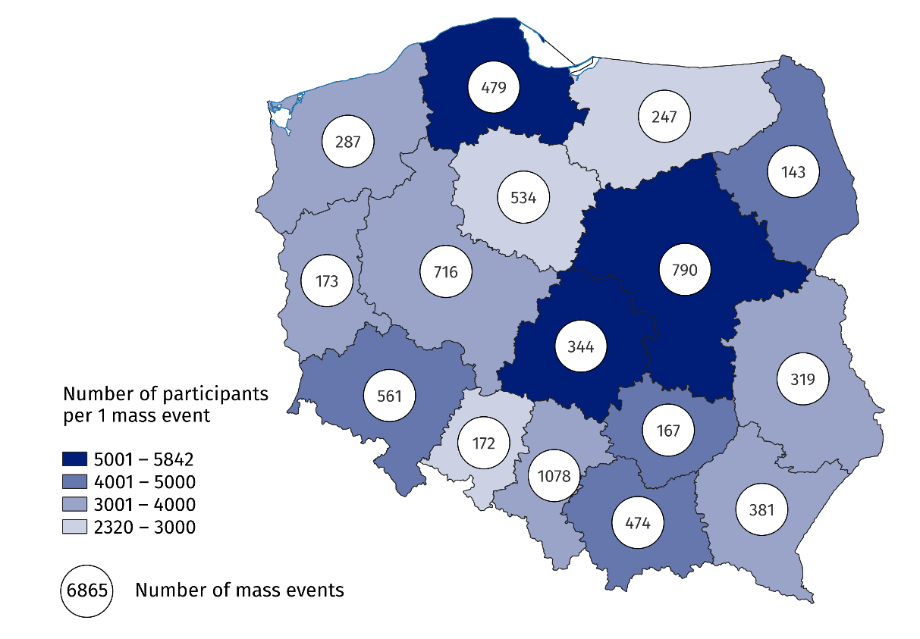
Map 1. Mass events in 2024
Nearly one third of mass events (27.2%) took place in Śląskie and Mazowieckie Voivodships
The majority of mass events were sports events (54.3%), most of which were organised in Śląskie Voivodship (758), and the fewest in Podlaskie Voivodship (69). In 2024 3.1 thousand artistic and entertainment events were organised (8.5% more than in 2023). The largest number of artistic and entertainment events took place in Mazowieckie Voivodship (452), and the fewest in Opolskie Voivodship (68). Concerts constituted the majority (68.4%) of all artistic and entertainment events.
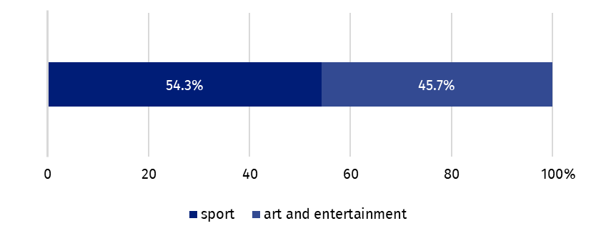
Chart 1. Mass events by type in 2024
Compared to 2023, the number of participants in mass events increased by 1.3 million people (by 4.7%), the number of participants in artistic and entertainment events increased by 1.8 million people (by 17.7%), while mass sports events decreased by 0.5 million people (by 3.3%). The majority of mass events participants took part in paid events (85.6%). 98.7% of the audience of sport events and 68.1% of the artistic and entertainment events took part in paid events.
Compared to 2023, the number of participants in artistic and entertainment events increased by 17.7%
Most of mass events (4.4 thousand) were organised indoor (11.1% more than in 2023). 2.5 thousand events were organised outdoor (4.8% more than in 2023).
Data presented in this study come from the survey on the K-09 form Report on the organisation of mass events. Information on the survey methodology can be found in the Methodological report. Culture Statistics.
In the case of quoting data from the Statistics Poland, please provide information: "Statistics Poland data source", and in the case of publishing calculations made on data published by the Statistics Poland, please provide information: "Own study based on Statistics Poland data".
Prepared by:  Statistical Office in Kraków  Director Agnieszka Szlubowska  Phone: (+48 12) 420 40 50 | Issued by:  Press Office  Mobile: (+48) 695 255 032  Phone: (+48 22) 608 38 04, (+48 22) 449 41 45,  (+48 22) 608 30 09  e-mail: obslugaprasowa@stat.gov.pl

stat.gov.pl/en/

@StatPoland

@GlownyUrzadStatystyczny

gus_stat

glownyurzadstatystycznygus

glownyurzadstatystyczny
Related information
Culture and national heritage in 2023
Mass events in 2023
Methodological report. Culture statistics
Topic available in databases
Knowledge Databases – Society – Culture
Local Data Bank – Culture – Organization of mass events
Terms used in the official statistics
Mass event
Event participant

Within mass events, a division into artistic and entertainment events and sports events has been adopted. Among artistic and entertainment events, the following are distinguished: concerts, performances and shows, film screenings and screenings, festivals, cabarets, circus shows, historical reconstructions, combined events (e.g. film screening and cabaret) and others.

