Activity of centres of culture, cultural centres and establishments, clubs and community centres in 2024
At the end of 2024, there were 3,911 centres of culture, cultural centres and establishments, clubs and community centres. During the year, these entities organised 276.6 thousand events attended by 35.2 million participants.
6.9%
Increase in the number of events organised by centres of culture, cultural centres and establishments, clubs and community centres in comparison to 2023
The largest number of centres of culture, cultural centres and establishments, clubs and community centres operated in Małopolskie Voivodeship (421), and the lowest in Lubuskie Voivodeship (78). Among all types of units, the largest number were cultural centres (32.8% of the total number of entities), and the fewest clubs (7.3%). Most of the entities (60.0%) were located in the countryside.
79
313
348
203
228
342
333
163
284
214
372
123
452
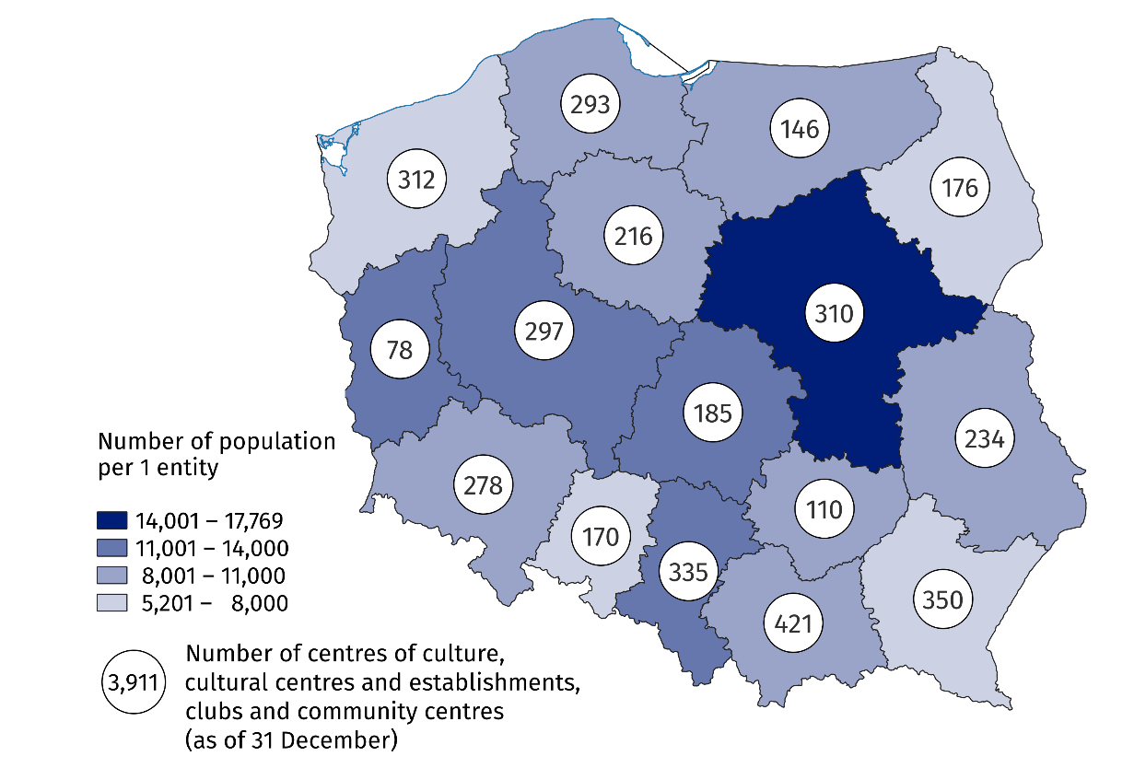
Map 1. Centres of culture, cultural centres and establishments, clubs and community centres in 2024
10.8% of the total number of entities were operating in Małopolskie Voivodship

The vast majority of centres of culture, cultural centres and establishments, clubs and community centres (93.0%) belonged to the public sector. Local government units were the organisers of 90.3% of all public institutions.
Centres of culture, cultural centres and establishments, clubs and community centres organised a total of 276.6 thousand events, attended by 35.2 million people. The largest number of events (105.8 thousand) was organised by cultural centres, and the least – by community centres (18.4 thousand). Compared to 2023, both the number of organised events and the number of participants increased (by 6.9% and 5.1%, respectively).
On average, 127 people participated in one event, with festivals and artistic reviews being the most numerous in this respect (642 people on average).
Compared to 2023, the number of groups (clubs/sections) increased by 2.9% and their participants by 5.9%
In 2024, there were 25.8 thousand different types of groups (clubs/sections) in centres of culture, cultural centres and establishments, clubs and community centres (2.9% more than the year before), with 534.7 thousand members (5.9% more than the year before). As part of the activities of groups (clubs/sections), the largest number of art and technical classes were organised (7.2 thousand), which were also the largest in terms of participation (117.3 thousand people).
Centres of culture, cultural centres and establishments, clubs and community centres conducted a total of 5.2 thousand courses. 70.9 thousand people obtained the status of a course graduate (a decrease of 3.2% compared to 2023. The largest number of courses conducted were foreign languages courses (21.0% of the total number of courses) and learning to play instruments (19.2%).
Chart 1. Groups (clubs, sections) and their participants in the centres of culture, cultural centres and establishments, clubs and community centres by type in 2024
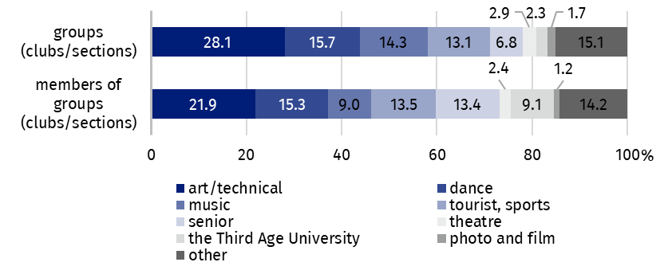
As of 31 December

As of the end of 2024, there were 14.7 thousand artistic groups operating in centres of culture, cultural centres and establishments, clubs and community centres, including the largest number of dance groups (3.8 thousand). Out of the total number of 256.1 thousand members of artistic groups, 63.4% were children and youth, while person above 60 years old accounted for 20.8%.
Children and youth constituted 63.4% of the members of artistic groups

Chart 2. Artistic groups and their participants in the centres of culture, cultural centres and establishments, clubs and community centres by type in 2024
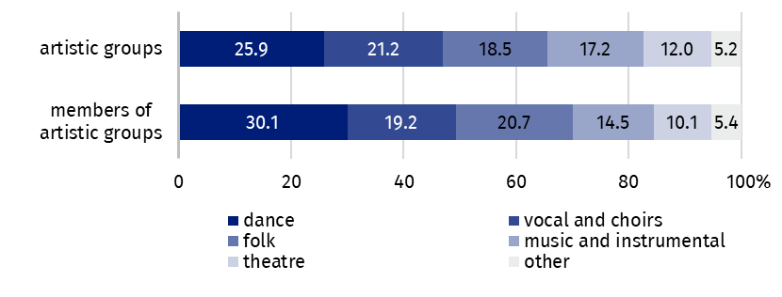
As of 31 December
Data presented in this study come from the survey on the K-07 form Report on centres of culture, cultural centres and establishments, clubs and community centres. Information on the survey methodology can be found in the Methodological report – Culture Statistics.
In the case of quoting data from the Statistics Poland, please provide information: "Statistics Poland data source", and in the case of publishing calculations made on data published by the Statistics Poland, please provide information: "Own study based on Statistics Poland data".

Prepared by:  Statistical Office in Kraków  Director Agnieszka Szlubowska  Phone: (+48 12) 420 40 50 | Issued by:  Press Office  Mobile: (+48) 695 255 032  Phone: (+48 22) 608 38 04, (+48 22) 449 41 45,  (+48 22) 608 30 09  e-mail: obslugaprasowa@stat.gov.pl

stat.gov.pl/en/

@StatPoland

@GlownyUrzadStatystyczny

gus_stat

glownyurzadstatystycznygus

glownyurzadstatystyczny
Related information
Culture and national heritage in 2023
Activity of centres of culture, cultural centres and establishments, clubs and community centres in 2023
Methodological report. Culture statistics
Topic available in databases
Knowledge Databases – Society – Culture
Local Data Bank – Culture – Activity of centres of culture, cultural centres and establishments, clubs and community centres
Terms used in the official statistics
Cultural establishment
Show (event)
Club
Group in cultural institution
Unit’s organiser
Cultural centre
Performance hall
Community centre
Event participant

