Activity of art galleries in 2024
In 2024, art galleries organised 4.1 thousand exhibitions in Poland, which were visited by 4.5 million people. In comparison to 2023, the number of exhibitions increased by 11.0% and the number of visitors – by 12.0%.
12.0%
Increase in the number of visitors in comparison to 2023
There were 310 art galleries operating in Poland. In terms of both the number of art galleries and the number of visitors, two voivodeships stood out ‒ Małopolskie and Mazowieckie. On their territory there were 35.2% of all art galleries, which were visited by 58.0% of visitors. The lowest number of art galleries was located in Opolskie Voivodeship (2 entities), and the fewest visitors were recorded in Lubuskie Voivodeship (33.2 thousand people).
More than half of visitors (58.0%) visited art galleries in Małopolskie and Mazowieckie Voivodeships
Art galleries belonging to the public sector gathered 92.3% of visitors. Of all visitors, 31.0% were people who visited open-air exhibitions.
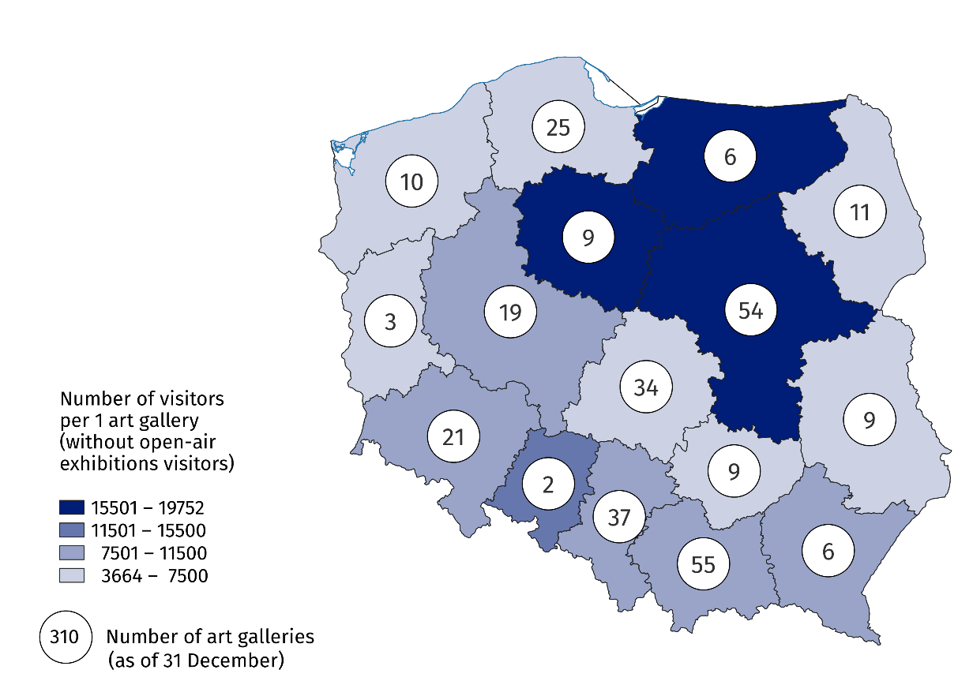
Map 1. Art galleries in 2024
Art galleries organised a total of 4,140 exhibitions in Poland, which included national exhibitions (3,770), international (248) and exhibitions from abroad (122). In addition, Polish art galleries organised 59 exhibitions abroad.

Chart 1. Own collections of public art galleries in 2024
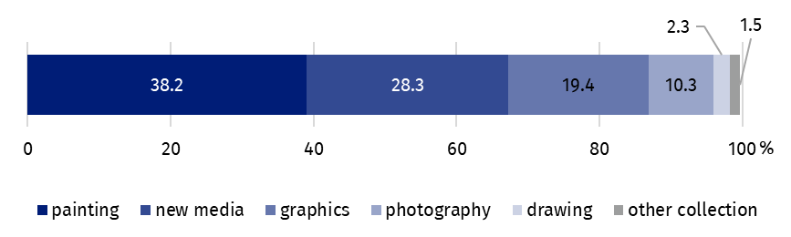
As of 31 December
State and local art galleries had 1.2 million own collections (2.0% more than in 2023), among which painting accounted for the largest part (38.2%). Objects in the new media, graphics and photography categories together accounted for more than half of the own collections of public art galleries (58.1%).
The majority of art galleries conducting exhibition activities in Poland belonged to the public sector (66.1%), in which 84.9% of the galleries were organised by local government units.
Data presented in this study come from the survey on the K-05 form Report on exhibition activity. Information on the survey methodology can be found in the Methodological report – Culture Statistics.
In the case of quoting data from the Statistics Poland, please provide information: "Statistics Poland data source", and in the case of publishing calculations made on data published by the Statistics Poland, please provide information: "Own study based on Statistics Poland data".

Prepared by:  Statistical Office in Krakow  Director Agnieszka Szlubowska  Phone: (+48 12) 420 40 50 | Issued by:  Press Office  Mobile: (+48) 695 255 032  Phone: (+48 22) 608 38 04, (+48 22) 449 41 45,  (+48 22) 608 30 09  e-mail: obslugaprasowa@stat.gov.pl

stat.gov.pl/en/

@StatPoland

@GlownyUrzadStatystyczny

gus_stat

glownyurzadstatystycznygus

glownyurzadstatystyczny
Related information
Culture and national heritage in 2023
Activity of art galleries in 2023
Methodological report. Culture statistics
Topic available in databases
Knowledge Databases – Society – Culture – Exhibition activity
Local Data Bank – Culture – Performances and exhibitions
Terms used in the official statistics
Art gallery
Unit’s organiser
Exhibition
Open-air exhibition in the galleries
Exposition
Visitor

Due to the place of presentation of exhibitions and the country of origin of their authors, we distinguish between national exhibitions (presentation of Polish art), exhibitions from abroad (presentation of foreign art), international exhibitions (presentation of foreign and Polish art) and Polish exhibitions abroad.

