Activity of museums in 2024
In 2024, 982 museums and museum branches were operating, visited by 44.4 million people. Museums presented 2.8 thousand permanent exhibitions and organised 4.6 thousand temporary exhibitions in Poland.
4.9%
Increase in the number of visitors in museums and museum branches in comparison to 2023
The largest number of museums and museum branches were located in Mazowieckie and Małopolskie Voivodeships, where 139 and 110 entities operated respectively. In these two voivodeships, visitors accounted for a total of 61.1% of the total number of visitors to museums and museum branches. The lowest number of museums and visitors was recorded in Lubuskie Voivodeship (17 museums and 287.7 thousand visitors). The number of museum visitors in Poland per 1,000 population was 1,181.
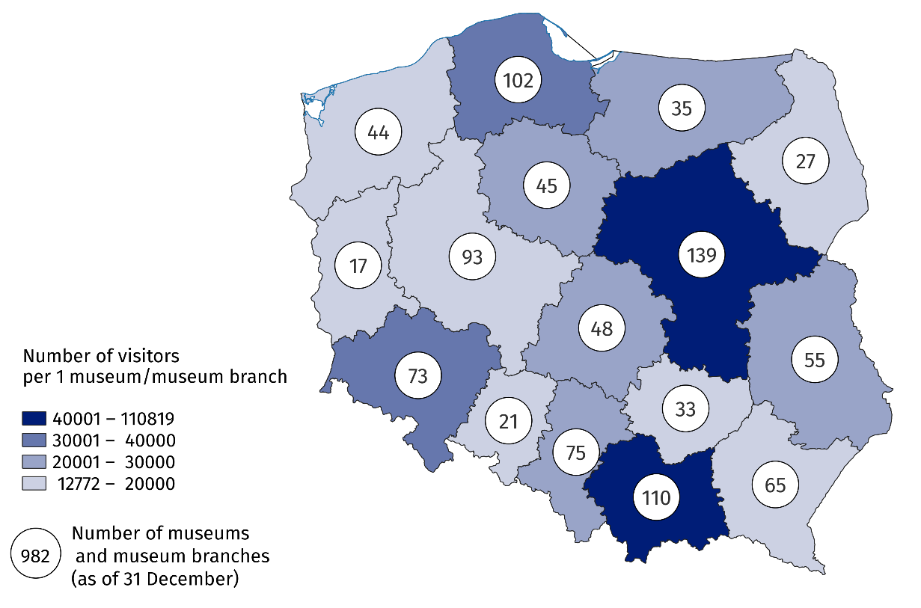
Map 1. Museums and museum branches in 2024
A quarter of the total number of museums operated in Mazowieckie and Małopolskie Voivodeships
71.8% of museums belonged to the public sector, of which local government units (83.3%) were the organisers for the vast majority. On the other hand, in the private sector, museum organisers were most often natural persons (55.6% of private museums).
71.8% of museums and museum branches belonged to the public sector
Museums and museum branches were visited by 44.4 million people (4.9% more than in 2023), including 14.3 million free of charge. At the same time, there were 7.7 million visitors with reduced-price tickets. Organised groups of school youth accounted for 8.6% of all visitors. Art museums were the most popular, with 16.5 million visitors (37.3% of all visitors).
The annual "Night of Museums" was attended by 795.1 thousand visitors (4.3% more than in 2023). During this event, the largest number of people visited historical museums – 304.7 thousand people (5.0% more than in 2023).
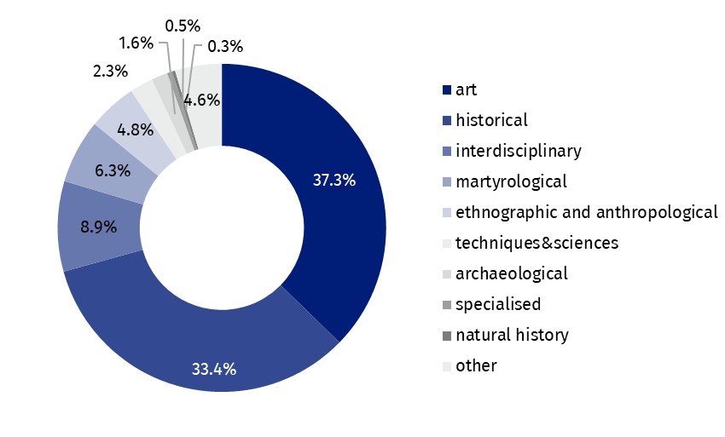
Chart 1. Visitors to museums and museum branches by type in 2024
As of the end of 2024, the total number of museum collections amounted to 21.7 million pieces (1.2% more than in 2023). Interdisciplinary museums have the largest number of collections (over a third of the total number of collections).
In 2024, museums presented 2.8 thousand permanent exhibitions (4.4% more than in 2023) and 4.6 thousand temporary exhibitions (as in the previous year). The largest number of temporary exhibitions (2.4 thousand) were organised by historical museums.
The number of cultural and educational events increased by 5.7% compared to 2023
In addition to exhibition activities, in 2024 museums and museum branches also organised 152.4 thousand events (5.7% more than in 2023), attended by 7.6 million people (11.1% more than in 2023). The largest number of them were museum lessons and workshops – 107.7 thousand, attended by 2.3 million people. Museums and branches also organised 14.1 thousand curatorial tours – 342.2 thousand people took advantage of this form of visiting.
Chart 2. Cultural and educational activity of museums and museum branches in 2024
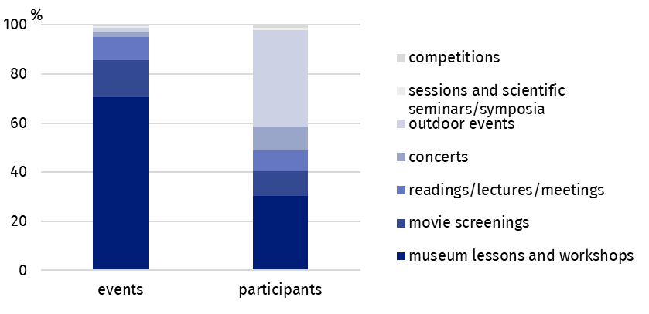
Data presented in this study come from the survey on the K-02 form Report on the activities of the museums and institutions related to museum. Information on the survey methodology can be found in the Methodological report – Culture Statistics.
In the case of quoting data from the Statistics Poland, please provide information: "Statistics Poland data source", and in the case of publishing calculations made on data published by the Statistics Poland, please provide information: "Own study based on Statistics Poland data".

Prepared by:  Statistical Office in Kraków  Director Agnieszka Szlubowska  Phone: (+48 12) 420 40 50 | Issued by:  Press Office  Mobile: (+48) 695 255 032  Phone: (+48 22) 608 38 04, (+48 22) 449 41 45,  (+48 22) 608 30 09  e-mail: obslugaprasowa@stat.gov.pl

stat.gov.pl/en/

@StatPoland

@GlownyUrzadStatystyczny

gus_stat

glownyurzadstatystycznygus

glownyurzadstatystyczny
Related informations
Culture and national heritage in 2023
Activity of museums in 2023
Methodological report. Culture statistics
Topic available in databases
Knowledge Databases – Society – Culture
Local Data Bank – Culture – Museums
Terms used in the official statistics
Museum
Museum branch
Unit’s organiser
Museum lesson
Exhibits
Temporary exhibitions
Permanent exhibitions
Visitor

