Activity of theatres and music institutions in 2024
2.3%
Increase in the number of performances and concerts in theatres and music institutions in comparison to 2023
In 2024, theatres and music institutions presented 60.5 thousand performances and concerts, with 12.2 million audience. As of the end of the year, theatres and music institutions had 378 scenes and 102.9 thousand seats in permanent halls.
In 2024, 206 theatres and music institutions conducted stage activities (207 in 2023), of which 180 had their own artistic ensemble (182 in 2023). The largest number of theatres and music institutions operated in Mazowieckie Voivodeship (42), and the lowest in the following voivodeships: Lubuskie, Opolskie, Podkarpackie and Świętokrzyskie (4 each).
84.5% of theatres and music institutions belonged to the public sector. Local government units were organisers for 93.1% of public entities.

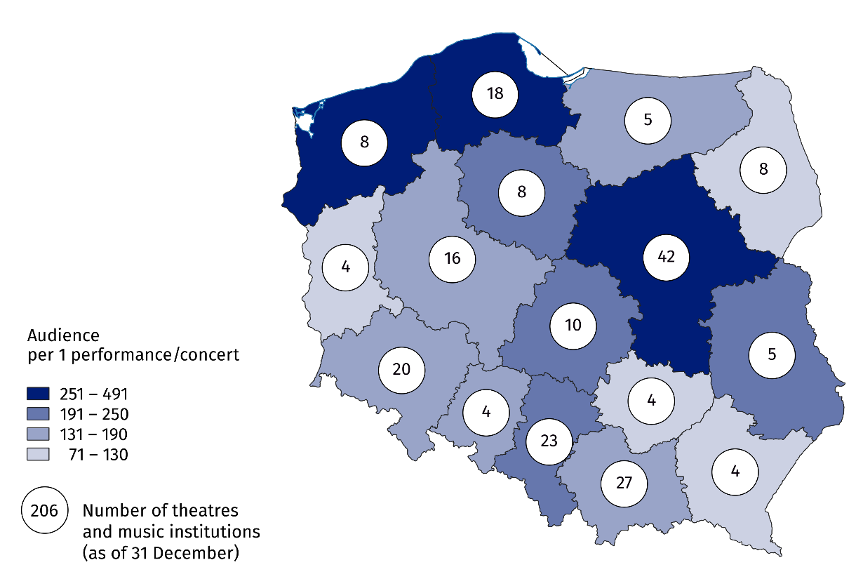
Map 1. Theatres and music institutions in 2024
Nearly one-third of the audience (31.5%) attended performances and concerts organised by theatres and music institutions in Mazowieckie Voivodeship
Performances and concerts organised by theatres and music institutions were attended by 12.2 million audience (0.8% less than in 2023). The largest number of audience visited theatres and music institutions from Mazowieckie Voivodeship – 3.8 million people (i.e. over 3 times more than from Małopolskie Voivodeship which ranked second in terms of the number of audience). The smallest number of audience attended performances and concerts in theatres and music institutions from Opolskie Voivodeship (145.2 thousand).

Chart 1. Theatres and music institutions by type in 2024

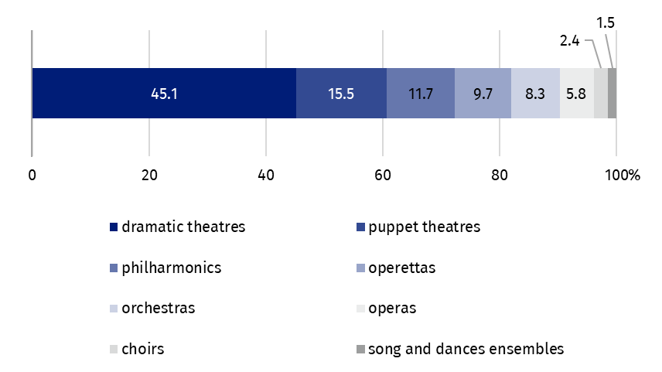
As of 31 December
In 2024, theatres and music institutions organised a total of 60.5 thousand performances and concerts, including 842 premiere shows. Compared to 2023, the number of performances and concerts increased by 2.3%, including premiere shows – by 5.5%. The largest number of premieres were staged by drama theatres (516).
Nearly one-third of all performances and concerts were addressed to children and youth. More than half (55.0%) of them were school music programs.
Data presented in this study come from the survey on the K-01 form Report on artistic and entertainment activities. Information on the survey methodology can be found in the Methodological report. Culture Statistics.
In the case of quoting data from the Statistics Poland, please provide information: "Statistics Poland data source", and in the case of publishing calculations made on data published by the Statistics Poland, please provide information: "Own study based on Statistics Poland data".

Prepared by:  Statistical Office in Kraków  Director Agnieszka Szlubowska  Phone: (+48 12) 420 40 50 | Issued by:  Press Office  Mobile: (+48) 695 255 032  Phone: (+48 22) 608 38 04, (+48 22) 449 41 45,  (+48 22) 608 30 09  e-mail: obslugaprasowa@stat.gov.pl

stat.gov.pl/en/

@StatPoland

@GlownyUrzadStatystyczny

gus_stat

glownyurzadstatystycznygus

glownyurzadstatystyczny
Related information
Culture and national heritage in 2023
Activity of theatres and music institutions in 2023
Methodological report. Culture statistics
Topic available in databases
Knowledge Databases – Society – Culture – Exhibition activity
Local Data Bank – Culture – Performances and exhibitions
Terms used in the official statistics
Choir
Artistic activities and entertainment
Philharmonic
Music institution
Concert
Orchestra
Premiere
Performance
Scene
Theatre
Audience
Own artistic team
Song and dance ensemble

