Financial results of non-financial enterprises
in the 1st quarter of 2025
In the 1st quarter of 2025 gross financial result of the surveyed non-financial enterprises was higher by 13.9% comparing to a year earlier. The economic and financial indicators improved. Investment outlays were lower by 3.6% than those recorded in the 1st quarter 2024 (when there was a decrease by 2.2%).
13.9%
Increase in gross financial result y/y
Total revenues were at the similar level comparing to the previous year (1,250.6 bn PLN in the 1st quarter of 2025, 1,251.1 bn PLN a year ago) and total costs of obtaining the revenues decreased by 0.6% (1,197.3 bn PLN). The cost level indicator improved (from 96.3% in the previous year to 95.7%) as well as gross turnover profitability indicator (from 3.7% to 4.3%) and net turnover profitability indicator (from 2.8% to 3.4%). Net revenues from sale of products, goods and materials decreased by 0.3% and the costs of obtaining them – by 0.7%.
The financial result from the sale of products, goods and materials amounted to 52.6 bn PLN and was by 9.9% higher than in the 1st quarter of 2024. The financial result from other operating activity amounted to 4.5 bn PLN and was higher by 1.2 bn PLN over the year. There was an improvement observed in the negative result on financial activities (minus 3.8 bn PLN compared to minus 4.3 bn PLN in the 1st quarter of 2024).
In the 1st quarter of 2025 net financial result of non-financial enterprises was by 19.3% higher than the year before
Gross financial result amounted to 53.3 bn PLN (compared to 46.9 bn PLN in the 1st quarter of 2024) and its obligatory encumbrances amounted to 11.2 bn PLN (compared to 11.5 bn PLN a year ago). Net financial result amounted to 42.2 bn PLN and was by 19.3% higher than the year before. Net profit amounted to 64.2 bn PLN and was higher by 1.2 bn PLN than in the 1st quarter of 2024 while net loss was 22.0 bn PLN and decreased by 5.7 bn PLN over the year. Net profit was recorded by 65.1% of all enterprises (compared to 65.2% a year ago) and the revenues obtained by them constituted 75.2% of total revenues of the surveyed enterprises (compared to 74.4% the year before). In manufacturing, net profit was recorded by 67.5% of all enterprises (it was 67.8% a year ago) and the share of the total revenues generated by these enterprises in the total revenues of all enterprises in this section was 79.6% (compared to 78.1% a year ago).
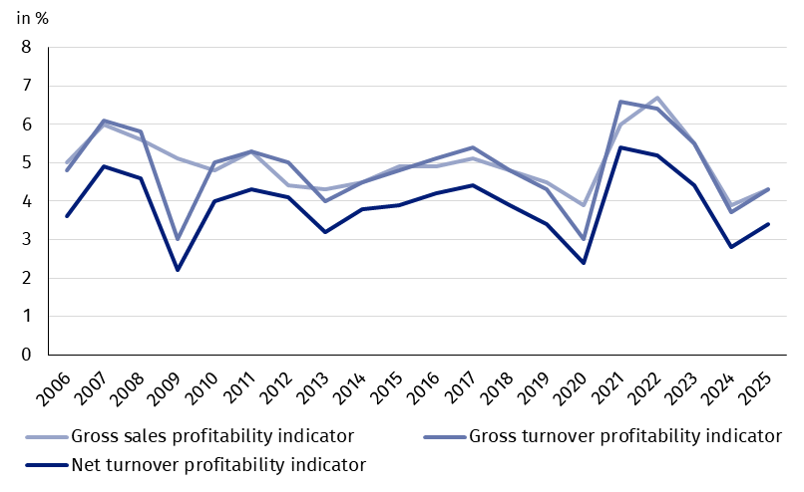
Chart 1. Profitability indicators from 2006 to 2025
Table 1. Basic financial data of surveyed non-financial enterprises
SPECIFICATION | Jan.-March 2024 | Jan.-March 2025 | Jan.-March 2024 = 100
SPECIFICATION | in million PLN |  | Jan.-March 2024 = 100
Total revenues | 1,251,051.5 | 1,250,617.2 | 100.0
of which net revenues from sale  of products, goods and materials | 1,215,500.6 | 1,211,979.8 | 99.7
Total costs | 1,204,197.4 | 1,197,268.9 | 99.4
of which cost of products,  goods and materials sold | 1,167,631.1 | 1,159,354.4 | 99.3
Financial result from the sale of products,  goods and materials | 47,869.5 | 52,625.3 | 109.9
Financial result from other  operating activity | 3,284.6 | 4,533.2 | 138.0
Result on financial activity | -4,300.1 | -3,810.2 | .
Gross financial result | 46,854.1 | 53,348.3 | 113.9
Net financial result | 35,344.3 | 42,173.5 | 119.3
Net profit | 63,045.5 | 64,197.4 | 101.8
Net loss | 27,701.2 | 22,023.9 | 79.5
 | in %
Cost level indicator | 96.3 | 95.7 | .
Gross sales profitability indicator | 3.9 | 4.3 | .
Gross turnover profitability indicator | 3.7 | 4.3 | .
Net turnover profitability indicator | 2.8 | 3.4 | .
First degree financial liquidity indicator | 42.0 | 44.5 | .
Second degree financial liquidity indicator | 107.9 | 108.0 | .
Cost level indicator for all surveyed enterprises improved and was 95.7% (compared to 96.3% in the 1st quarter of 2024). Gross sales profitability indicator increased from 3.9% to 4.3%, gross turnover profitability indicator – from 3.7% to 4.3% as well as net turnover profitability indicator – from 2.8% to 3.4%.
An improvement in net turnover profitability indicator was recorded i.a. in electricity, gas, steam and air conditioning supply (from 3.4% to 8.3%), transportation and storage (from 2.0% to 3.6%), professional, scientific and technical activities (from 2.7% to 3.3%), manufacturing (from 3.6% to 3.8%), trade; repair of motor vehicles (from 1.2% to 1.4%) as well as water supply; sewerage, waste management and remediation activities (from 6.1% to 6.2%). A deterioration of net turnover profitability indicator was recorded i.a. in mining and quarrying (from minus 0.3% to minus 7.5%), accommodation and catering (from 4.8% to 2.6%), administrative and support service activities (from 5.6% to 4.8%), real estate activities (from 5.1% to 4.3%), information and communication (from 7.2% to 6.7%) as well as construction (from 3.0% to 2.9%).
First degree financial liquidity indicator improved – 44.5% (compared to 42.0% in the 1st quarter of 2024) and second degree financial liquidity indicator was 108.0% (compared to 107.9%). First degree financial liquidity indicator at the level over 20% was achieved by 56.6% of the surveyed enterprises (compared to 57.0% a year ago). Second degree financial liquidity indicator ranged from 100% to 130% was recorded by 11.6% of the surveyed enterprises (compared to 11.5% a year ago).
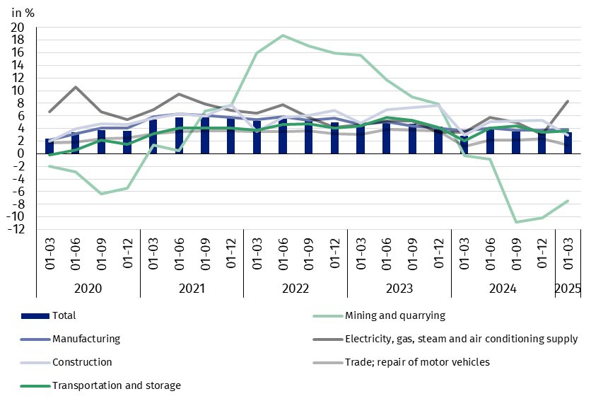
Chart 2. Net turnover profitability indicator
The share of taxes and fees (by 1.4 pp.) decreased the most in the structure of total costs compared to the 1st quarter of 2024
In the structure of total costs, there was an increase in the share of external services (by 1.0 pp.), wages and salaries (by 0.9 pp.), other costs by kind (by 0.6 pp.), social insurances and other benefits (by 0.3 pp.) as well as depreciation (by 0.1 pp.). There was a decrease in the share of taxes and fees (by 1.4 pp.), consumption of materials (by 1.2 pp.) as well as comsumption of energy (by 0.3 pp.).
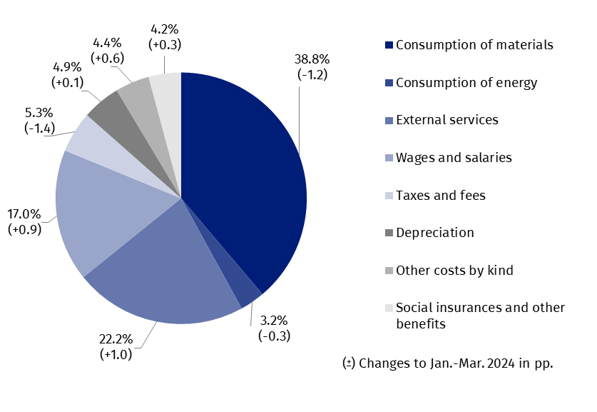
Chart 3. Structure of costs by type in the first quarter of 2025

52.8% of the surveyed enterprises reported net revenues from sale of products, goods and materials for export in the 1st quarter of 2025 (compared to 52.5% in the 1st quarter of 2024). The revenues from export sales were by 0.8% lower than a year before. The share of export in total sales revenues of all surveyed enterprises decreased slightly from 23.8% to 23.7%. The share of the exporting enterprises which reported net profit was 66.9% (compared to 67.3% in the 1st quarter of 2024). The basic economic and financial relations of the exporting enterprises improved.
There was a decrease in investment outlays of the surveyed enterprises by 3.6% compared to January-March 2024

In January-March 2025 investment outlays of the surveyed enterprises amounted to 38.7 bn PLN and were (in constant prices) by 3.6% lower than in the previous year (when an decrease by 2.2% was recorded). The expenditures on buildings and structures decreased by 5.5% (in the previous year they decreased by 14.2%), on purchases by 2.7% (in the 1st quarter of 2024 they increased by 4.5%) including decrease of outlays on machinery, technical equipment and tools by 0.4% (in comparison to the increase in the 1st quarter of 2024 by 2.8%), and on transport equipment – by 8.1% (in comparison to the increase in the 1st quarter of 2024– 8.7%).
The decrease in investment outlays (in current prices) was noticed i.a. manufacturing (by 11.9%, compared to the decrease by 2.0% the year before), mining and quarrying (by 7.0%, compared to the increase by 12.9% ), administrative and support service activities (by 1.3%, compared to the increase by 21.7%), electricity, gas, steam and air conditioning supply (by 1.0%, compared to the decrease by 10.5%) and water supply; sewerage, waste management and remediation activities (by 0,5%, compared to the decrease by 16.4%). The increase in investment outlays was recorded i.a. for real estate activities (by 93.5%, compared to the decrease by 14.1%), construction (by 40.6%, compared to the increase by 53.2%), accommodation and catering (by 13.6%, compared to the increase by 3.9%), information and communication (by 12.0%, compared to the decrease by 17.6%) trade; repair of motor vehicles (by 4.7%, compared to the decrease by 2.9%), transportation and storage (by 4.3%, compared to the decrease by 20.4%).
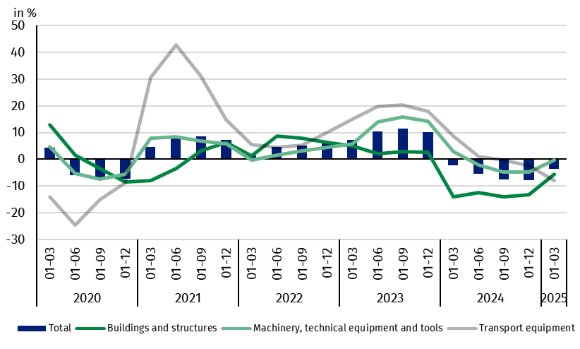
Chart 4. Investment outlays – change compared to the corresponding period of the previous year
The data refer to 16 838 non-financial enterprises (legal units) with 50 and more persons employed keeping accounting ledgers. The data do not include agriculture, forestry, hunting and fishing (section A according to NACE rev. 2); financial and insurance activities (section K according to NACE rev. 2); higher education institutions; independent public health care facilities; cultural institutions with legal personality; trade unions, religious and political organisations.
When quoting Statistics Poland data, please provide the information: “Source of data: Statistics Poland”, and when publishing calculations made on data published by Statistics Poland, please include the following disclaimer: “Own study based on figures from Statistics Poland”.
Prepared by:  Enterprise Department  Director Katarzyna Walkowska  Phone: (+48 22) 608 31 25 | Issued by:  Press Office  Mobile: (+48) 695 255 032  Phone: (+48 22) 608 38 04, (+48 22) 449 41 45,  (+48 22) 608 30 09  e-mail: obslugaprasowa@stat.gov.pl

stat.gov.pl/en/

@StatPoland

@GlownyUrzadStatystyczny

gus_stat

glownyurzadstatystycznygus

glownyurzadstatystyczny
Related information
Statistical Bulletin
Information on the socio-economic situation of the country
News releases. Financial results of non-financial enterprises
Methodological report. Non-financial enterprises surveys
Data available in databases
Local Data Bank
Knowledge Database Non-financial Enterprises
Macroeconomic Data Bank
Terms used in official statistics
Total revenues
Total costs
Gross financial result
Net financial result
Cost level indicator
Gross turnover profitability indicator
Net turnover profitability indicator
First degree financial liquidity indicator
Second degree financial liquidity indicator
Investment outlays

