Outpatient health care in 2024
5.0%
Increase in the number of specialised doctors consultations compared to 2023

At the end of 2024, outpatient health care was carried out by 24 225 outpatient departments, 532 doctors practises and 2 508 dentists practises providing services funded by public sources. During the year, 324.7 million doctors consultations and 35.8 million stomatological consultations were provided. Almost 8.6% of total doctors consultations in primary health care were provided via telephone.

Outpatient departments and medical practices
At the end of 2024, outpatient consultations were provided by 27 265 providers
At the end of 2024, 27 265 providers of ambulatory health care were operating – 24 225 outpatient departments, 532 doctors’ practices and 2 508 dentists practices providing services funded by public sources. Compared to previous year the number of outpatient departments increased by 765 providers (3.3%) while the number of doctors and dentists practices decreased by 134 (4.2%). 21 829 providers of ambulatory health care were located in urban areas, and 5 436 in rural areas.
The most outpatient departments were operating in Mazowieckie Voivodship (3 685), and the lowest – in Opolskie Voivodship (587). The highest number of practices providing health services funded by public sources was in Wielkopolskie Voivodship (347), while the lowest – in Lubuskie and Małopolskie Voivodships (per 114).

Chart 1. Outpatient departments in urban areas and rural areas by voivodships in 2024
As of 31 December
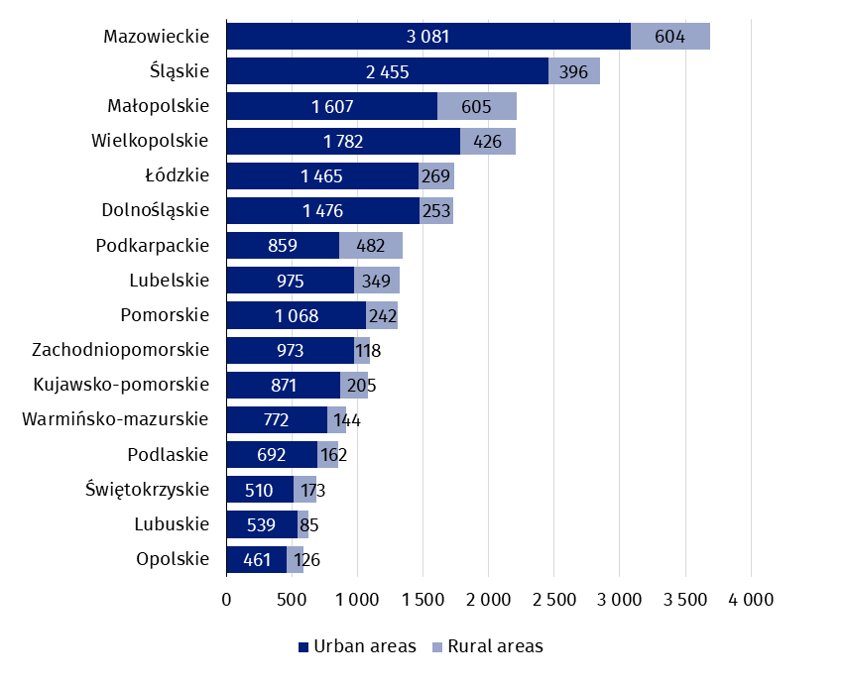

Chart 2. Doctors and dentists practises providing health services funded by public sources in urban areas and rural areas by voivodships in 2024
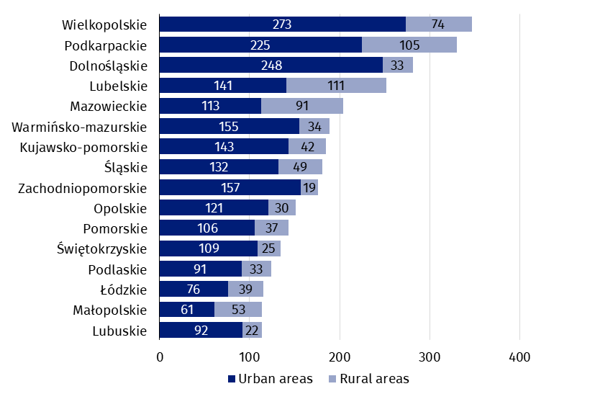
As of 31 December
The number of population per one provider of ambulatory health care amounted to 1 375 persons (by 38 less than in 2023). The highest value was recorded in Pomorskie Voivodship (1 624 persons), while the lowest – in Podlaskie Voivodship (1 158).

Map 1. The number of population per 1 provider of ambulatory health care by voivodships in 2024
As of 31 December 2024 there were 1 375 persons per one provider of ambulatory health care
As of 31 December
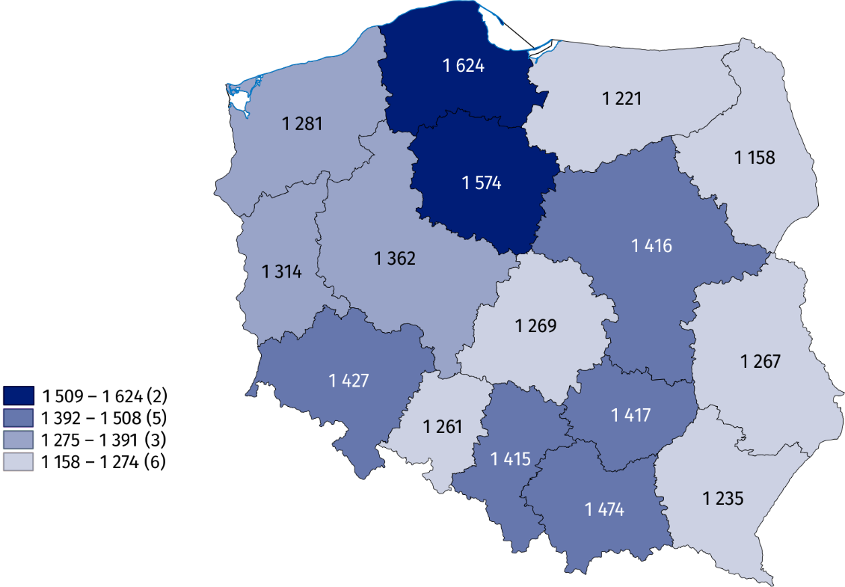

Outpatient consultations
In 2024, there were provided 360.6 million consultations in outpatient health care
In 2024, there were 360.6 million outpatient consultations – 324.7 million doctors consultations (increase of 4.0% compared to 2023) and 35.8 million stomatological consultations (by 2.6% more than in previous year). 187.0 million doctors consultations were in primary health care (by 3.2% more than in 2023), and 137.8 million in specialised health care (increase of 5.0% compared to the previous year).
In primary health care children and youth in age up to 18 years had 37.1 million consultations (increase of 0.6% compared to 2023), while people aged 65 years and more – 67.3 million (by 6.1% more than a year earlier). There were 17.6 million specialised consultations provided to children and youth in age up to 18 years (increase of 4.1% compared to 2023) and 42.5 million consultations provided to people aged 65 years and more (by 7.1% more than in previous year).

Chart 3. Outpatient consultations by type of consultation and patients’ age in 2024
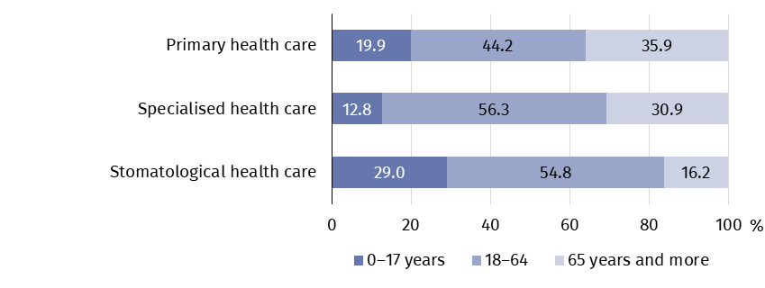
In 2024, 16.1 million doctors consultations in primary health care and 9.3 million in specialised health care were provided via telephone (by 6.1% and 3.8% respectively less than in previous year). 26.3 thousand stomatological consultations were provided remotely.
In 2024 the most doctors consultations in specialised outpatient health care were provided in surgical clinics (over 24 million)
In specialised health care, the highest share of consultations was in surgical clinics (17.7%). A large number of consultations were also recorded in gynecological and obstetrical clinics (10.5%) and ophthalmology clinics (8.5%).

Chart 4. Selected specialised doctors consultations by type of clinic in 2024
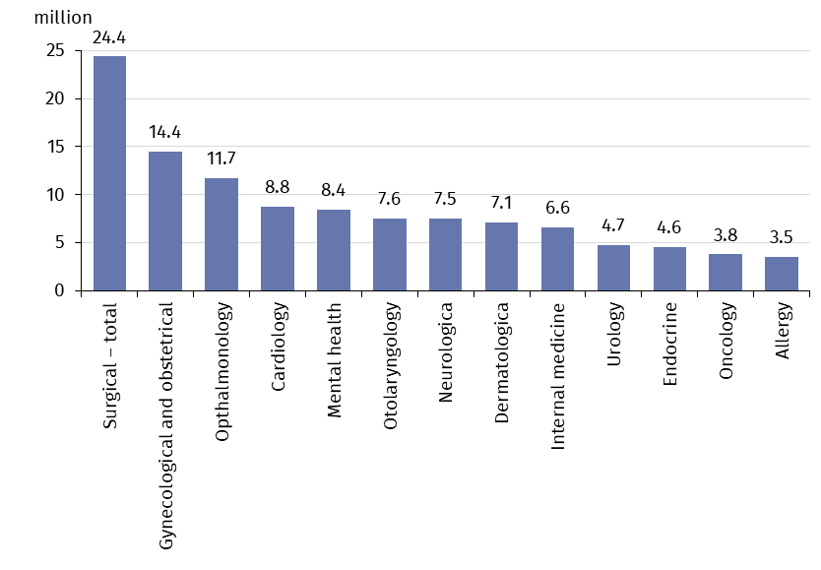
In 2024, the average number of outpatient consultations per capita was 9.6
In review year, the average number of outpatient consultations per capita was 9.6. The highest value was recorded in Mazowieckie Voivodship (10.6), while the lowest – in Opolskie Voivodship (7.9).
Map 2. Outpatient consultations per capita by voivodships in 2024
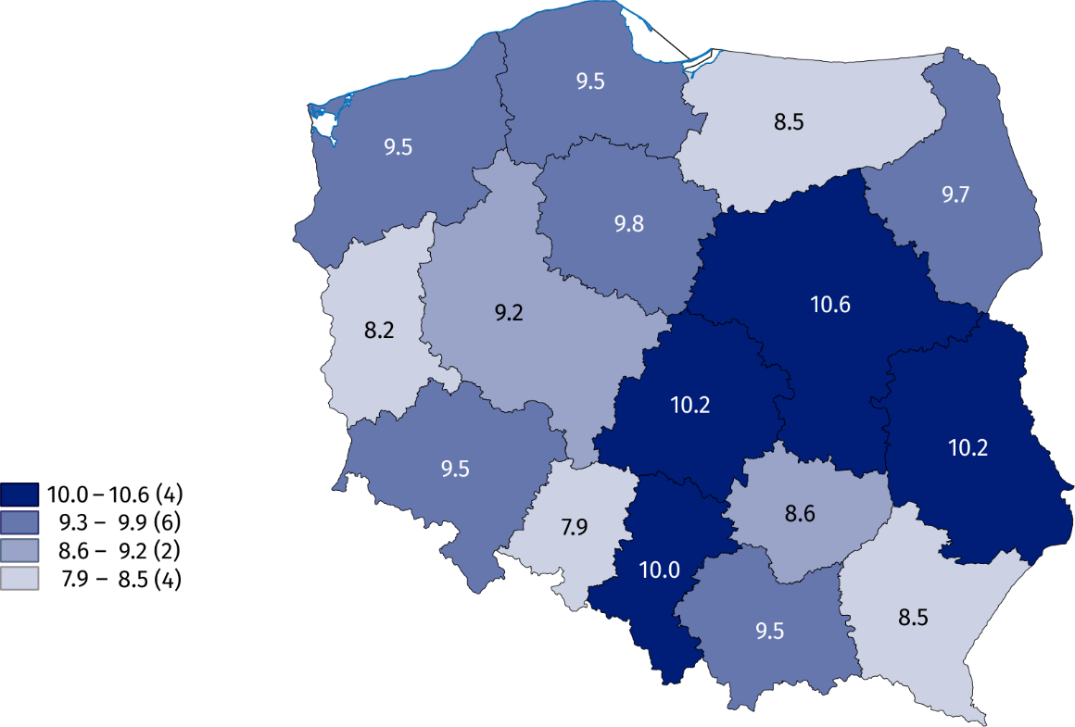
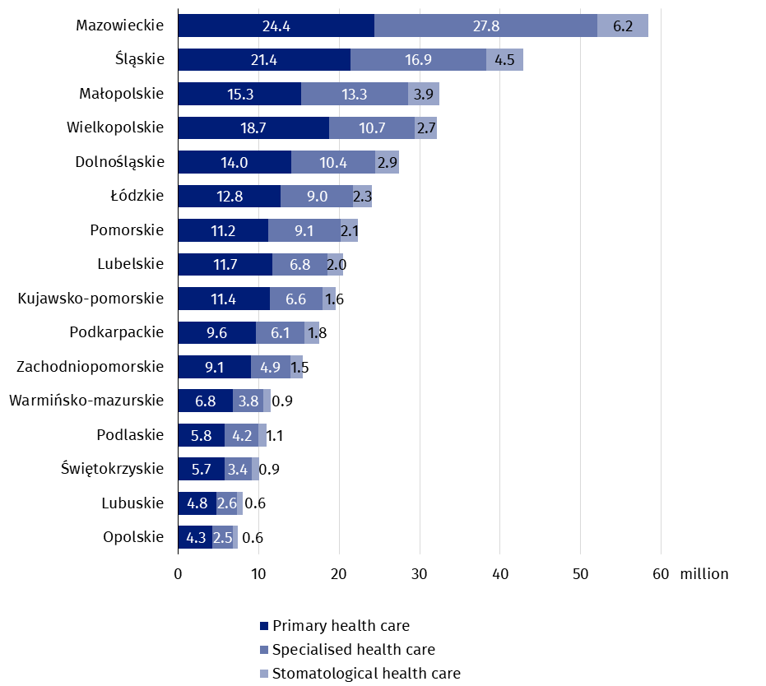
Chart 5. Outpatient consultations by type of consultation and voivodships in 2024

In the case of quoting data from the Statistics Poland, please provide information: "Statistics Poland data source", and in the case of publishing calculations made on data published by the Statistics Poland, please provide information: "Own study based on Statistics Poland data".

Prepared by:  Statistical Office in Kraków  Director Agnieszka Szlubowska  Phone: (+48 12) 420 40 50 | Issued by:  Press Office  Mobile: (+48) 695 255 032  Phone: (+48 22) 608 38 04, (+48 22) 449 41 45,  (+48 22) 608 30 09  e-mail: obslugaprasowa@stat.gov.pl

stat.gov.pl/en/

@StatPoland

@GlownyUrzadStatystyczny

gus_stat

glownyurzadstatystycznygus

glownyurzadstatystyczny
Related information
Health and health care in 2023
Methodological report. Health and health care statistics – Statistics Poland’s reports
Data available in databases
Local Data Bank -> Health care, social welfare and benefits to the family
Knowledge Databases -> Society -> Health and health care
Terms used inn official statistics
Specialised out-patient services
Out-patient health care services
Primary health care
Consultation
Medical practice
An out-patient department
Teleconsultation

Population as of 31 December.
Including holiday and night time medical services. There are health care benefits in primary health care, provided from 6 pm to 8 am on the following day and 24 hours on public holidays. Including also holiday and night time medical services given as a subcontract with a hospital.
Population as of 30 June.

