First aid and emergency medical services in 2024
13.1% Increase in the number of persons who received health care benefits in the occurrence place compared to 2023

In 2024 emergency rescue teams provided health care benefits in the occurrence place to nearly 3.2 million of persons. Almost 4.1 million of persons received health care benefits in hospital emergency wards or admission rooms under the outpatient treatment while over 2.3 million of persons received health care benefits in hospital emergency wards under the inpatient treatment.

Units of the State Emergency Medical Services System (denoted as PRM)
The State Emergency Medical Services System covered: 1 664 emergency rescue teams, 21 medical air rescue teams and 250 hospital emergency wards

In 2024 the State Emergency Medical Services System covered functioning of the 1 664 emergency rescue teams (47 more than in previous year). There were 1 416 basic emergency rescue teams and 248 specialist (85.1% and 14.9% respectively). The number of basic teams has increased by 114 (8.8%) while the number of specialist teams has decreased by 67 (21.3%) compared to 2023.
The emergency medical treatment was also offered by 21 medical air rescue teams (the number remained at the same level compared to 2023) and 250 hospital emergency wards -denoted as SOR (4 more than in previous year). The cooperating units role was played by 151 admission rooms, 17 trauma centers and 11 children trauma centers.

Map 1. Units of the State Emergency Medical Services System by voivodships in 2024
As of 31 December
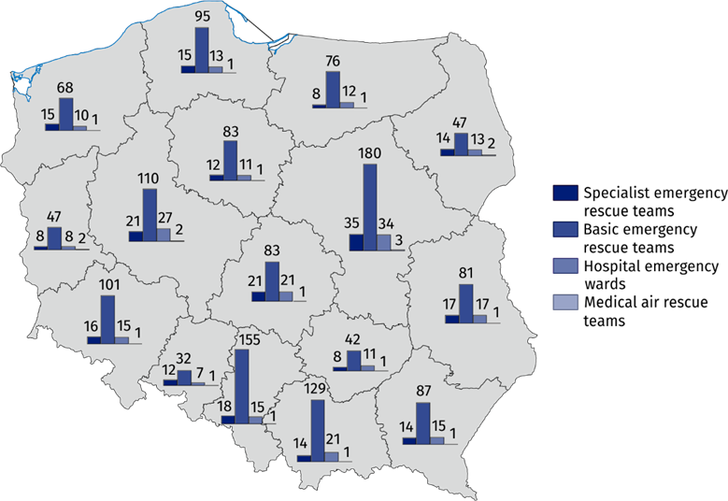

Emergency rescue teams, medical air rescue teams
Over 3.1 million of calls of the emergency rescue teams (including medical air rescue teams) to the occurrence places were recorded, of which 76.7% was at patients’ home
The emergency rescue teams provided medical treatment for patients whose life is threatened. In 2024 there were over 3.1 million of calls of the emergency rescue teams (including medical air rescue teams) during which the emergency medical activities were provided. The number of calls of the emergency rescue teams (including medical air rescue teams) to the occurrence places increased by 12.9% (359.8 thousand) compared to previous year. Among all emergency rescue teams’ call (including medical air rescue teams) 76.7% was at the patient’ home (compared to 77.1% in 2023).

Chart 1. Calls of the emergency rescue teams to the occurrence places by the type of occurrence place in 2024
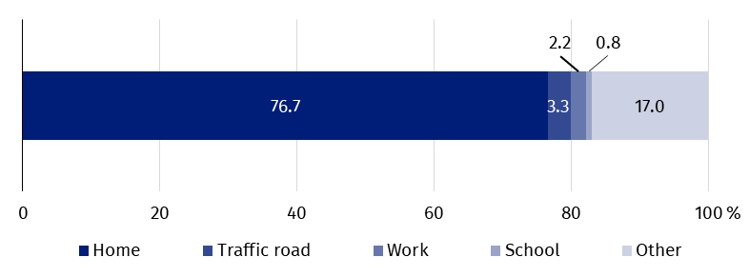
The emergency rescue teams provided medical treatment to 3.2 million of persons (13.1% more than in previous year). Among these persons 5.9% were children and youth up to age 18 and 50.5% – persons aged 65 and more (in 2023 6.1% and 50.1% respectively).

Chart 2. Occurrence places where emergency medical teams provided health care benefits by the age of persons in 2024
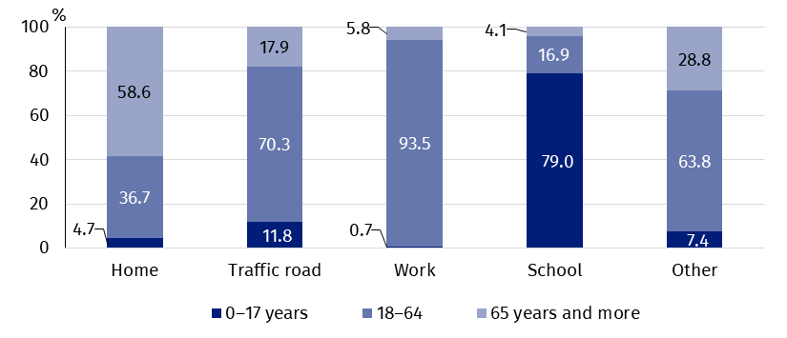
Per 1 000 population, the emergency rescue teams provided medical treatment to 84 persons
There were 84 persons to whom the emergency rescue teams provided medical treatment per 1 000 population (compared to 74 in 2023). The maximum value (101) was observed in Zachodniopomorskie Voivodship and the minimum value (61) in Wielkopolskie Voivodship.

Map 2. Emergency rescue teams and persons who received health care benefits in the place of occurrence per 1 000 population by voivodships in 2024
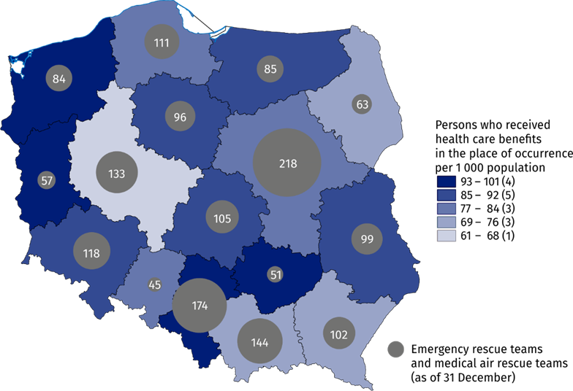
The number of medical personnel of emergency rescue teams amounted to 12.9 thousand workers (as of 31 of December 2024). The largest group was constituted by emergency medical technicians (11.4 thousand). Moreover, there were more than 1 thousand of nurses of emergency medical services, more than 0.2 thousand of physicians of emergency medical services and 0.3 thousand of other personnel. Compared to 2023, the total number of medical personnel of emergency rescue teams remained at a similar level. However, increase in number of emergency medical technicians (by 0.2 thousand persons) and decrease in number of physicians of emergency medical services (by 0.1 thousand persons) were observed. It was connected with the change in numbers of specialist and basic medical rescue teams.

Hospital emergency wards, admission rooms
Hospital emergency wards (SOR) provide medical treatment of two distinct kind: outpatient treatment (with no subsequent hospitalization) and inpatient treatment. In both hospital emergency wards and admission rooms the largest number of services was provided under the outpatient treatment.
In 2024 the number of patients who received health care benefits in both hospital emergency wards and admission rooms under the outpatient treatment amounted to 4.1 million persons (increase by 2.9% as compared to 2023), while in the hospital emergency wards under the inpatient treatment – over 2.3 million (increase by 13.1% as compared to previous year). The number of persons who received health care benefits under outpatient and inpatient treatment in both hospital emergency wards and admission rooms increased by 6.4% compared to 2023. Children and youth up to age 18 stood for 19.1% of the total number of treated in hospital emergency wards or in admission rooms while persons aged 65 and more – 27.6% (in 2023 19.5% and 26.8% respectively).
In hospital emergency wards the inpatient treatment was provided to 2.3 million persons
Chart 3. Persons who received health care benefits in the hospital emergency wards or admission rooms by the age of persons in 2024

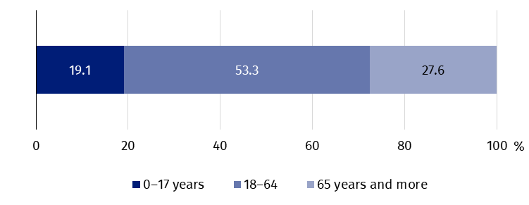
There were 171 persons who received health care benefits in the hospital emergency wards or in admission rooms per 1 000 population (160 persons in 2023). The maximum ratio of persons who received medical treatment in these places per 1 000 population was observed in Pomorskie Voivodship (245) and the minimum value (111) in Śląskie Voivodship.

Map 3. Persons who received health care benefits in the hospital emergency wards or admission rooms per 1 000 population by voivodships in 2024
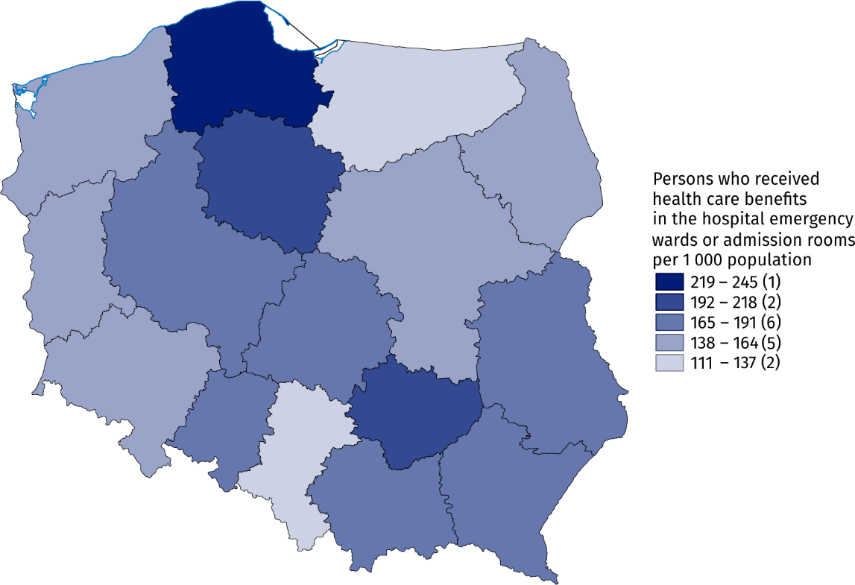
In the case of quoting data from the Statistics Poland, please provide information: "Statistics Poland data source", and in the case of publishing calculations made on data published by the Statistics Poland, please provide information: "Own study based on Statistics Poland data".

Prepared by:  Statistical Office in Kraków  Director Agnieszka Szlubowska  Phone: (+48 12) 420 40 50 | Issued by:  Press Office  Mobile: (+48) 695 255 032  Phone: (+48 22) 608 38 04, (+48 22) 449 41 45,  (+48 22) 608 30 09  e-mail: obslugaprasowa@stat.gov.pl

stat.gov.pl/en/

@StatPoland

@GlownyUrzadStatystyczny

gus_stat

glownyurzadstatystycznygus

glownyurzadstatystyczny
Related information
Health and health care in 2023
Methodological report. Health and health care statistics − Statistics Poland’s reports
Data available in databases
Local Data Bank -> Health care, social welfare and benefits to the family
Knowledge Databases -> Society -> Health and Health care
Terms used inn official statistics
Emergency medical services
Units of emergency medical service
Hospital emergency ward
The place of occurrence
Trauma center
Physician of emergency medical services
Nurse of emergency medical services

Population as of 30 June.
Medical personnel for whom it was the main workplace, regardless of the form of employment contract.
Drivers and pilots.
Population as of 30 June.

