Foster care in 2024
2.6%
Increase in the number of children in foster care compared to 2023
At the end of 2024, in foster care there were 77.3 thousand children, including 59.8 thousand in family foster care and 17.5 thousand in institutional foster care. In comparison to 2023, the number of children in foster care increased by 2.6%.

Family foster care
63.6% of foster families were related families
As of 31 December 2024 in Poland there were 36.5 thousand foster families and 0.9 thousand foster homes. Among foster families, related families accounted for 63.6%, not professional families – 30.4%, and professional families – 6.0%.
The function of foster family was fulfilled by 18.9 thousand married couples and by 17.6 thousand lone persons. The families which admitted one child accounted for 71.7%, two children – 18.5%, three children – 5.6%, and four or more children 4.1% of all foster families. Over a half (52.6%) of persons performing the role of foster family were persons at age of 51–70. Foster homes were run by 760 married couples and 140 lone persons. Foster homes which admitted from one to five children accounted for 21.2%, six children – 15.8%, seven children – 14.8% and 8 or more children – 47.9% of all foster homes. Whereas foster homes with no admitted children accounted for 0.3%. Most persons (75.3%) performing the function of a family foster home were in the 41–60 age group.

Children in family foster care
7.6 thousand children in family foster care held legal confirmation of disability or of level of disability
There were 59.8 thousand children in family foster care, including 6.8 thousand children in foster homes. Out of all children who were provided with foster care 7.6 thousand held legal confirmation of disability or of level of disability, 2.6 thousand were orphans, 486 foreigners (of which 374 under age). 24.4 thousand children enjoyed regularised legal status. There were 29.8 thousand girls in family foster care, including 52 mothers under age. Children at age of 7–13 constituted the major group (20.8 thousand in total) both in foster families and in foster homes, while infants were in the smallest group (1.0 thousand). Moreover 9.7 thousand adult residents stayed in family foster care. In 2024 there were 10.4 thousand children were admitted for the first time to family foster care, while 8.5 thousand children up to age of 18 left family foster care. The largest number of children were placed in another foster family or foster home (2.8 thousand). 1.4 thousand children went to adoption families and 2.6 thousand returned to their natural families. 927 children left family foster care because they were moved to institutional foster care, 42 children were transferred to social assistance house, while 755 children left institutional foster care for other reasons. Out of 3.9 thousand adult residents who left foster care in 2024, 2.2 thousand set up their own households, 170 returned to their own families or relatives and 292 are the other residents who started to live independent life. Out of the residents who left foster care at age over 18, 1.3 thousand have not started to live independent life yet.

Chart 1. Children in family foster care by age group in 2024
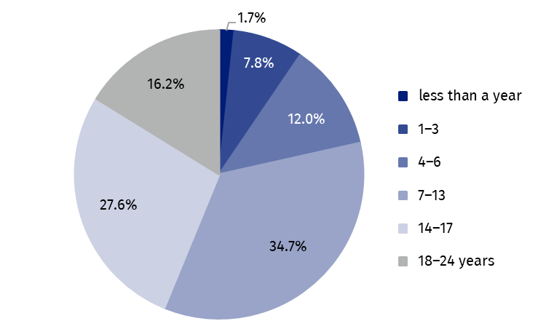
As of 31 December

Institutional foster care centres
Socialisation centres accounted for 62.5% of all institutional foster care centres
At the end of 2024 in Poland there were 1 326 institutional foster care centres, including 1 311 care and education centres, 12 regional care and therapy centres and 3 intervention pre-adoptive centres. The care and education centres encompass socialisation centres (829) tasks combining centres (197), family centres (189), intervention centres (62) and specialist therapy centres (34).

Places in institutional foster care
There were 16.8 thousand places in institutional foster care centres, including 11.0 thousand places in socialisation centres, 2.9 thousand places in task combining centres, 1.4 thousand in family centres, 0.8 in intervention centres and 0.4 thousand in specialist therapy centres. In other centres there were 0.4 thousand places in total.

Chart 2. Places in institutional foster care centres by type in 2024
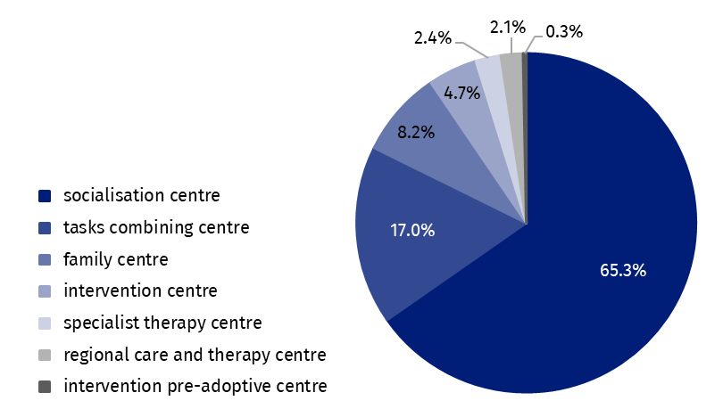
As of 31 December
In 2024 in institutional foster care there were predominantly the centres led by local government – 995 (75.1%), including: powiat government (42.4%), towns of powiat status (29.9), gmina government (2.4%) and voivodship government (0.4%). Other bodies governing institutional foster care centres included associations (9.5%), Catholic Church, other churches and religious unions (8.5%) and foundations (6.9%).

Residents in institutional foster care
Children at age of 14–17 constituted the major group of residents in institutional foster care (47.7%)
At the end of 2024, there were 17.5 thousand children in institutional foster care, out of which 8.4 thousand girls (47.9%). Out of all children under foster care 7.5 thousand had regularised legal status, including 4.3 thousand reported to adoptive centres. Children at age of 14–17 constituted the major group (8.3 thousand). The second biggest group (4.5 thousand) included children at age of 10–13 (4.5 thousand) and the smallest group of residents encompassed children under age of 1 (172). In institutional foster care centres there were 1.2 thousand adult residents who continued their education.
In institutional foster care there were 379 orphans, 2.6 thousand half-orphans, 53 under age mothers, 2.5 thousand, chronically ill persons. Foreigners accounted for 2.5% of all residents, i.e. 431 persons.

Chart 3. Residents in institutional foster care by age group in 2024
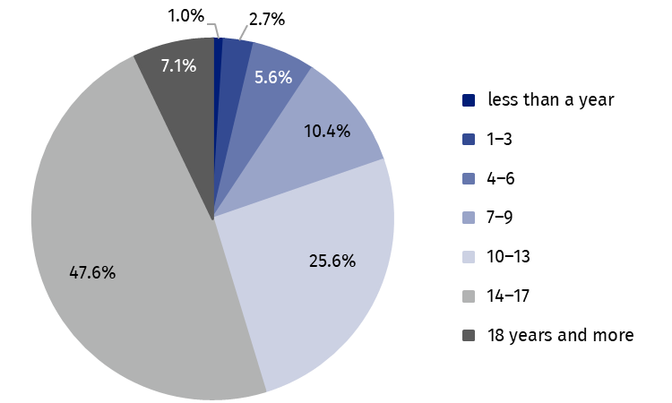
As of 31 December
By the end of 2024 there were 2.3 thousand disabled residents in institutional foster care, out of which 2.0 thousand persons certified as disabled or holding a certificate of the level of disability in care and education centres and 259 residents in regional care and therapy centres. In socialisation centres the disabled persons accounted for 61.0% of all disabled residents staying in care and education centres, 18.2% in tasks combining centres, 9.6% in family centres, 7.7% in specialist therapy centres and 3.5% in intervention centres.
In 2024, 4.5 thousand residents up to age of 18 left institutional foster care centres. The major group (42.3%) were residents who returned to their own family. Transfer to other type of institutional foster care was the reason for leaving the centres for 25.6% of children, 20.2% of residents were placed in family foster care, while 4.5% went to adoption families. Remaining 7.4% left the centre for other reason. Out of 2.0 thousand residents at age over 18 who left the centres, 1.1 thousand set up their own household and 720 returned to their own family. 198 adult residents have not started to live independent life.

Volunteers in institutional foster care
In 2024, 1.4 volunteers did charity work in institutional foster care. The works of education and care centres were attended by 1.3 thousand persons, regional care and therapy centres by 46 persons and 41 volunteers supported the works of pre-adoptive intervention centres. Among care and education centres most volunteers supported the activities of socialisation centres (72.1%) and the smallest group worked in intervention centres (3.5%).

Table 1. Foster care by voivodships in 2024
As of 31 December
Specification | Family care |  | Institutional care
Specification | families | children | centres | residents
POLSKA | 37 441 | 59 842 | 1 326 | 17 456
Dolnośląskie | 4 050 | 6 303 | 157 | 2 096
Kujawsko-pomorskie | 2 271 | 3 702 | 96 | 1 347
Lubelskie | 1 784 | 2 799 | 91 | 1 020
Lubuskie | 1 347 | 2 122 | 42 | 539
Łódzkie | 2 792 | 4 109 | 86 | 1 231
Małopolskie | 2 047 | 3 160 | 96 | 1 117
Mazowieckie | 4 148 | 6 443 | 139 | 1 798
Opolskie | 993 | 1 600 | 31 | 457
Podkarpackie | 1 158 | 1 785 | 46 | 672
Podlaskie | 913 | 1 410 | 32 | 420
Pomorskie | 2 529 | 4 801 | 83 | 1 134
Śląskie | 4 967 | 7 951 | 180 | 2 337
Świętokrzyskie | 968 | 1 386 | 46 | 643
Warmińsko-mazurskie | 1 745 | 2 908 | 70 | 915
Wielkopolskie | 3 369 | 5 309 | 68 | 928
Zachodniopomorskie | 2 360 | 4 054 | 63 | 802
In the case of quoting data from the Statistics Poland, please provide information: “Statistics Poland data source”, and in the case of publishing calculations made on data published by the Statistics Poland, please provide information: “Own study based on Statistics Poland data”.
Prepared by:  Statistical Office in Kraków  Director Agnieszka Szlubowska  Phone: (+48 12) 420 40 50 | Issued by:  Press Office  Mobile: (+48) 695 255 032  Phone: (+48 22) 608 38 04, (+48 22) 449 41 45,  (+48 22) 608 30 09  e-mail: obslugaprasowa@stat.gov.pl

stat.gov.pl/en/

@StatPoland

@GlownyUrzadStatystyczny

gus_stat

glownyurzadstatystycznygus

glownyurzadstatystyczny
Related information
Social assistance, child and family services in 2023
Institutional foster care in 2023
Family foster care in 2023
Data available in databases
Database Local Data Bank – health care, social welfare and benefits to the family
Terms used in official statistics
Pre-adoptive intervention centre
Family foster care coordinator
The organiser of family foster care
Foster care
Centres combining tasks of the centres
Care and education centre for children and young people
Intervention centre
Family centre
Socialization centre
Specialist therapy centre
Poviat centre for family support
Regional care and therapy centre

Regularised legal status means that both parents have been deprived of parental rights.

