Prices of agricultural products in April 2025
Procurement prices of basic agricultural products increased in April 2025 in comparison with the previous month (by 2.2%) as well as while compared to the corresponding period of the last year (by 12.5%).
12.5%
an increase in procurement prices of basic agricultural products in comparison with April 2024

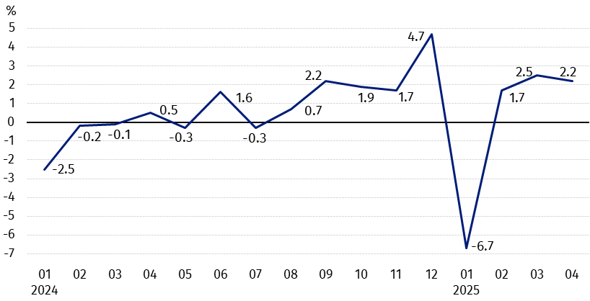
Chart 1. Changes in procurement prices of basic agricultural products in relation to the previous month
In April 2025, in comparison with March 2025, the procurement prices of all basic agricultural products except cattle for slaughter and cows’ milk increased

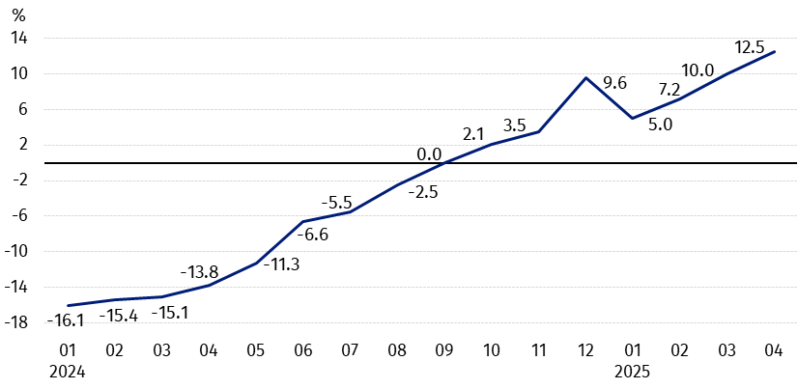
Chart 2. Changes in procurement prices of basic agricultural products in relation to the corresponding month of the previous year
Procurement prices of basic agricultural products, except pigs for slaughter prices, in April 2025 were higher than those recorded in April 2024

Procurement prices and marketplace prices received by farmers
In April 2025 wheat, rye, maize, potatoes, pigs for slaughter and poultry purchased at higher prices than in the previous month. While prices of other agricultural products decreased. On marketplaces only wheat was sold cheaper than in March this year.
Compared to the corresponding month of the previous year, both in procurement and on marketplaces the growth in prices of most agricultural products was recorded, except oats and pigs for slaughter in procurement as well as potatoes on marketplaces.

Table 1. Prices of agricultural products (excluding VAT) in April 2025
Specification | Procurement prices |  |  | Marketplaces prices
Specification | 04 2025
Specification | in zloty | 03 2025=100 | 04 2024=100 | in zloty | 03 2025=100 | 04 2024=100
Cereal grain – per dt
Wheat | 90.72 | 100.5 | 120.3 | 114.72 | 99.8 | 108.9
Rye | 73.42 | 101.4 | 128.4 | 87.32 | 100.7 | 109.9
Barley | 82.27 | 98.4 | 115.5 | 110.05 | 100.7 | 108.6
Triticale | 83.10 | 99.8 | 124.6 | 98.94 | 100.0 | 110.4
Oat | 73.49 | 90.6 | 80.2 | 103.36 | 100.4 | 101.5
Maize | 87.45 | 101.7 | 127.0 | 123.82 | 101.5 | 105.3
Potatoes – per dt | 145.95 | 105.3 | 100.9 | 212.55 | 101.1 | 90.2
Animals for slaughter – per kg
Cattle (excl. calves) | 13.48 | 96.7 | 129.8 | 12.29 | 100.4 | 104.5
of which young cattle | 13.75 | 96.0 | 128.9 | . | . | .
Pigs | 7.02 | 114.3 | 92.1 | . | . | .
Poultry | 6.21 | 102.6 | 120.3 | . | . | .
Cows’ milk – per hl | 226.99 | 99.6 | 112.1 | . | . | .

Data on procurement prices were calculated on the basis of information on value and quantity of procurement by legal persons and independent organizational entities without legal personality (without natural persons).
Indices of procurement prices and prices received by farmers on marketplaces were calculated on the basis of absolute data expressed with more precision than In the tables.

Prices of major agricultural products in April 2025
In April 2025, PLN 90.72 was paid per dt of wheat in procurement, i.e. by 0.5% more than in the previous month and by 20.3% – than a year ago. On the marketplaces, the price of wheat (PLN 114.72 per dt) decreased in comparison with March this year (by 0.2%), but increased compared to April last year (by 8.9%).
The procurement price of rye (PLN 73.42 per dt) was by 1.4% higher than in March 2025 and by 28.4% – than in April 2024. The transaction price of rye on marketplace (PLN 87.32 per dt) increased on a monthly basis (by 0.7%), as well as on an annual basis (by 9.9%).
In April 2025, PLN 145.95 was paid per dt of potatoes in procurement, i.e. by 5.3% more than in the previous month and by 0.9% – than in the corresponding period of the last year. On the marketplaces, the price of potatoes (PLN 212.55 per dt) increased by 1.1% in comparison with March this year, but decreased by 9.8% compared to April 2024.
The procurement price of cattle for slaughter (PLN 13.48 per kg) was lower on a monthly basis (by 3.3%), but increased on an annual basis (by 29.8%). On the marketplaces, cattle for slaughter (PLN 12.29 per kg) were sold more expensive compared to March this year (by 0.4%), as well as to April last year (by 4.5%).
In April 2025, PLN 7.02 was paid per kg of pigs for slaughter in procurement, i.e. by 14.3% more than a month ago, but by 7.9% less than a year ago.
The procurement price of poultry for slaughter (PLN 6.21 per kg) increased by 2.6% in comparison with March this year and by 20.3% compared to April 2024.
PLN 226.99 was paid in procurement per hl of cows’ milk, i.e. by 0.4% less than in the previous month, but by 12.1% more than a year ago.

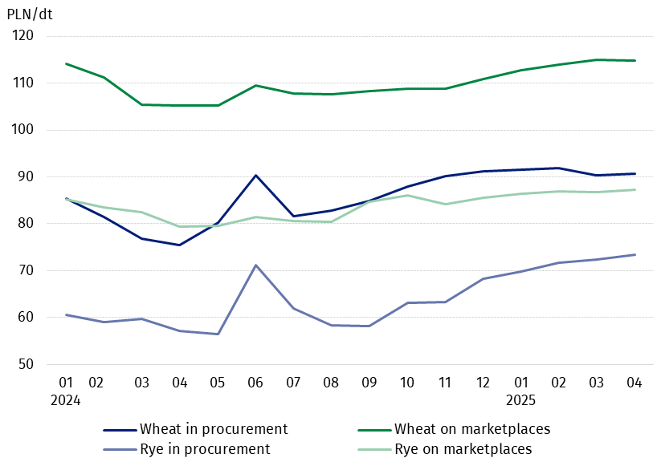
Chart 3. Procurement and marketplaces prices of wheat and rye

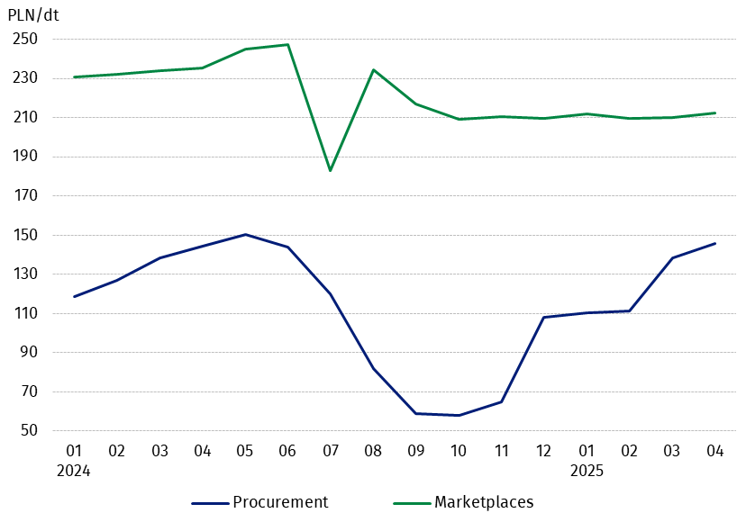
Chart 4. Procurement and marketplaces prices of potatoes

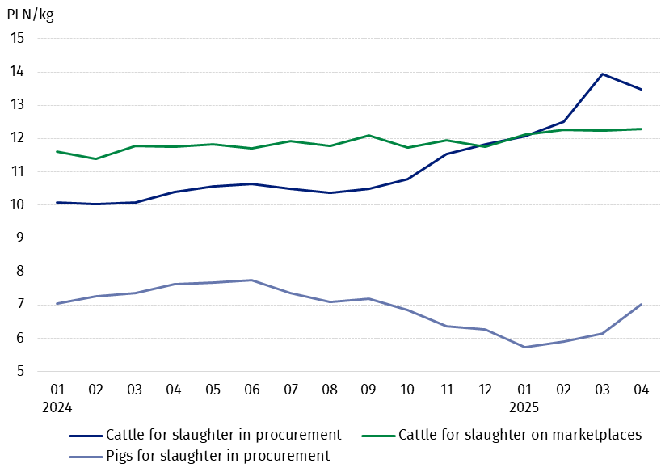
Chart 5. Procurement and marketplaces prices of cattle for slaughter and procurement prices of pigs for slaughter

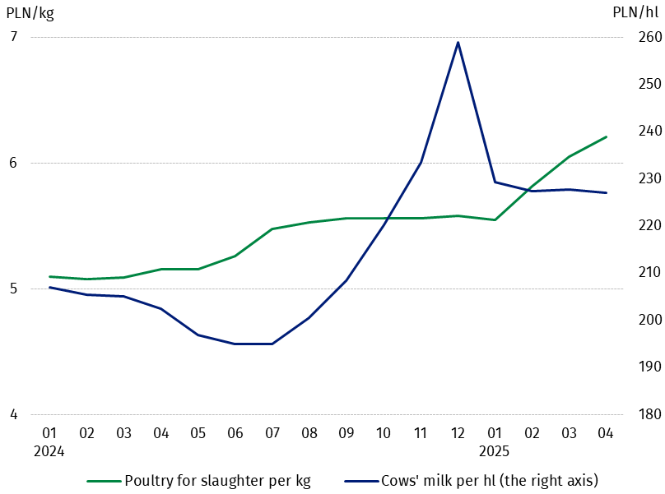
Chart 6. Procurement prices of poultry for slaughter and cows’ milk

The differentiation of the level of prices of basic agricultural products in particular voivodships is presented in Table 2 for procurement prices and in Table 3 for prices obtained by farmers on marketplaces (Excel sheet).
In case of quoting Statistics Poland data, please provide information: “Source of data: Statistics Poland”, and in case of publishing calculations made on data published by Statistics Poland, please include the following disclaimer: “Own study based on figures from Statistics Poland”.

Prepared by:  Trade and Services Departament  Director Ewa Adach-Stankiewicz  Phone: (+48 22) 608 31 24 | Issued by:  Press Office  Mobile: (+48) 695 255 032  Phone: (+48 22) 608 38 04, (+48 22) 449 41 45.  (+48 22) 608 30 09  e-mail: obslugaprasowa@stat.gov.pl

stat.gov.pl/en/

@StatPoland

@GlownyUrzadStatystyczny

gus_stat

glownyurzadstatystycznygus

glownyurzadstatystyczny
Related information
Socio-economic situation of the country in 2025
Procurement and prices of agricultural products in 2023

Data available in databases
BDL - Prices in agriculture (monthly and annual data)
DBW - Prices in agriculture (monthly and annual data)

Terms used in official statistics
Procurement of agricultural products
Procurement prices
Marketplace
Marketplace prices

Wheat, rye, cattle for slaughter, pigs for slaughter, poultry, cows’ milk
Procurement prices – excluding sowing seed.
Procurement prices – total (of which: edible early kinds, seed, edible late, industrial, of which starch). Marketplaces prices – edible excluding early kinds.
Marketplaces prices – average weighted price of cattle for slaughter calculated with the adoption of the structure of procurement quantity of young cattle and cows for slaughter.

