Prices of agricultural products in March 2025
Procurement prices of basic agricultural products increased in March 2025 in comparison with the previous month (by 2.5%) as well as while compared to the corresponding period of the last year (by 10.0%).
10.0%
an increase in procurement prices of basic agricultural products in comparison with March 2024

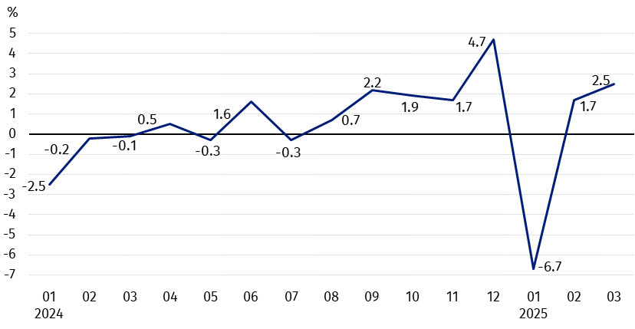
Chart 1. Changes in procurement prices of basic agricultural products in relation to the previous month
In March 2025, in comparison with February 2025, the procurement prices of all basic agricultural products except wheat increased

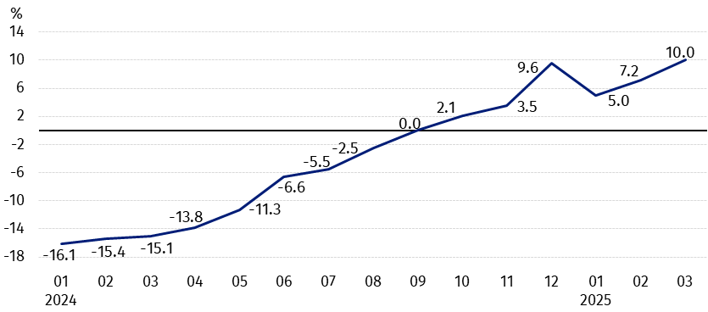
Chart 2. Changes in procurement prices of basic agricultural products in relation to the corresponding month of the previous year
Procurement prices of basic agricultural products, except pigs for slaughter prices, in March 2025 were higher than those recorded in March 2024

Procurement prices and marketplace prices received by farmers
In March 2025, in comparison with the previous month, as well as compared to the corresponding period of the last year, both in procurement and on marketplaces, prices of most agricultural products were higher. On a monthly basis the prices of wheat and barley in procurement, as well as rye, maize and cattle for slaughter on marketplaces decreased. Oats and pigs for slaughter in procurement, and also potatoes on marketplaces were cheaper on an annual basis.

Table 1. Prices of agricultural products (excluding VAT) in March 2025
Specification | Procurement prices |  |  | Marketplaces prices
Specification | 03 2025
Specification | in zloty | 02 2025=100 | 03 2024=100 | in zloty | 02 2025=100 | 03 2024=100
Cereal grain – per 1 dt
Wheat | 90.27 | 98.3 | 117.5 | 114.98 | 100.9 | 109.2
Rye | 72.39 | 101.1 | 121.3 | 86.71 | 99.8 | 105.2
Barley | 83.58 | 97.9 | 112.7 | 109.29 | 101.2 | 107.5
Triticale | 83.25 | 100.1 | 115.6 | 98.93 | 101.3 | 108.7
Oat | 81.11 | 103.0 | 84.3 | 102.92 | 101.1 | 101.0
Maize | 86.01 | 102.4 | 126.0 | 121.97 | 99.6 | 105.2
Potatoes – per 1 dt | 138.58 | 124.6 | 100.2 | 210.31 | 100.3 | 89.8
Animals for slaughter – per kg
Cattle (excl. calves) | 13.95 | 111.4 | 138.4 | 12.24 | 99.8 | 104.0
of which young cattle | 14.31 | 112.1 | 139.3 | . | . | .
Pigs | 6.14 | 104.4 | 83.3 | . | . | .
Poultry | 6.05 | 104.0 | 118.9 | . | . | .
Cows’ milk – per 1 hl | 227.83 | 100.2 | 111.1 | . | . | .

Data on procurement prices were calculated on the basis of information on value and quantity of procurement by legal persons and independent organizational entities without legal personality (without natural persons).
Indices of procurement prices and prices received by farmers on marketplaces were calculated on the basis of absolute data expressed with more precision than In the tables.

Prices of major agricultural products in March 2025
In March 2025, PLN 90.27 was paid per dt of wheat in procurement, i.e. by 1,7% less than in the previous month, but by 17.5% more than a year ago. On the marketplaces, the price of wheat (PLN 114.98 per dt) increased by 0.9% in comparison with February this year and by 9.2% compared to March 2024.
The procurement price of rye (PLN 72.39 per dt) was by 1.1% higher than in February 2025 and by 21.3% – than in March last year. The transaction price of rye on marketplace (PLN 86.71 per dt) decreased on a monthly basis (by 0.2%), but increased on an annual basis (by 5.2%).
In March 2025, PLN 138.58 was paid per dt of potatoes in procurement, i.e. by 24.6% more than in the previous month and by 0.2% – than in the corresponding period of the last year. On the marketplaces, the price of potatoes (PLN 210.31 per dt) increased by 0.3% in comparison with February this year, but decreased by 10.2% compared to March 2024.
The procurement price of cattle for slaughter (PLN 13.95 per kg) was by 11.4% higher on a monthly basis and by 38.4% - on an annual basis. On the marketplaces, cattle for slaughter (PLN 12.24 per kg) were sold cheaper compared to February this year (by 0.2%), but more expensive in comparison with March last year (by 4.0%).
In March 2025, PLN 6.14 was paid per kg of pigs for slaughter in procurement, i.e. by 4.4% more than a month ago, but by 16.7% less than a year ago.
The procurement price of poultry for slaughter (PLN 6.05 per kg) increased by 4.0% in comparison with February this year and by 18.9% compared to March 2024.
PLN 227.83 was paid in procurement per hl of cows’ milk, i.e. by 0.2% more than in the previous month and by 11.1% – than a year ago.

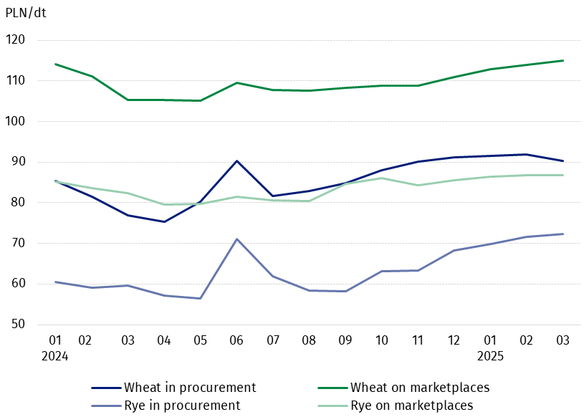
Chart 3. Procurement and marketplaces prices of wheat and rye

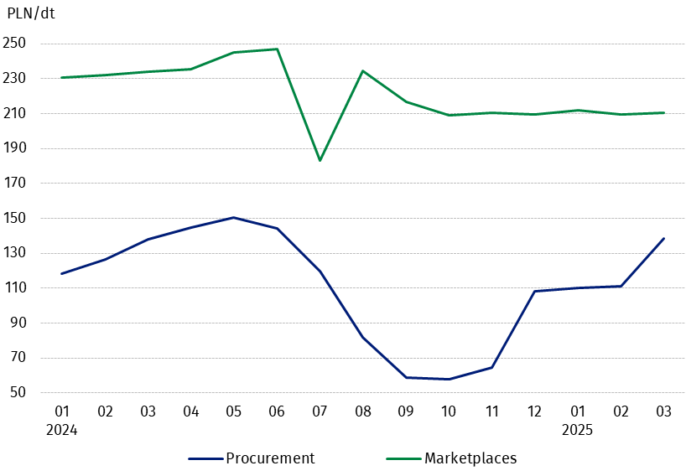
Chart 4. Procurement and marketplaces prices of potatoes

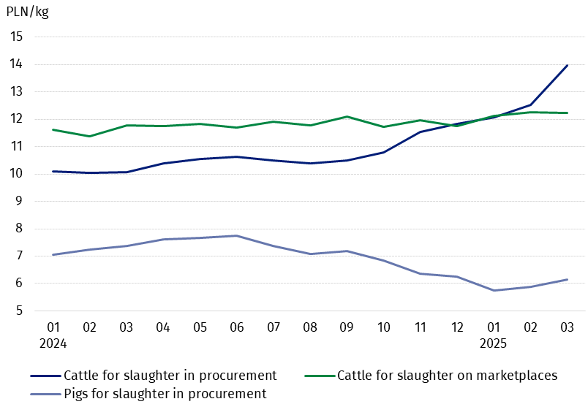
Chart 5. Procurement and marketplaces prices of cattle for slaughter and procurement prices of pigs for slaughter

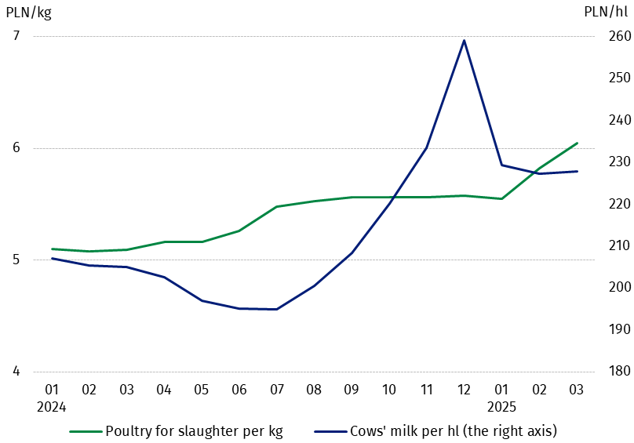
Chart 6. Procurement prices of poultry for slaughter and cows’ milk

The differentiation of the level of prices of basic agricultural products in particular voivodships is presented in Table 2 for procurement prices and in Table 3 for prices obtained by farmers on marketplaces (Excel sheet).
In case of quoting Statistics Poland data, please provide information: “Source of data: Statistics Poland”, and in case of publishing calculations made on data published by Statistics Poland, please include the following disclaimer: “Own study based on figures from Statistics Poland”.

Prepared by:  Trade and Services Departament  Director Ewa Adach-Stankiewicz  Phone: (+48 22) 608 31 24 | Issued by:  Press Office  Mobile: (+48) 695 255 032  Phone: (+48 22) 608 38 04, (+48 22) 449 41 45.  (+48 22) 608 30 09  e-mail: obslugaprasowa@stat.gov.pl

stat.gov.pl/en/

@StatPoland

@GlownyUrzadStatystyczny

gus_stat

glownyurzadstatystycznygus

glownyurzadstatystyczny
Related information
Socio-economic situation of the country in 2025
Procurement and prices of agricultural products in 2023

Data available in databases
BDL - Prices in agriculture (monthly and annual data)
DBW - Prices in agriculture (monthly and annual data)

Terms used in official statistics
Procurement of agricultural products
Procurement prices
Marketplace
Marketplace prices

Wheat, rye, cattle for slaughter, pigs for slaughter, poultry, cows’ milk
Procurement prices – excluding sowing seed.
Procurement prices – total (of which: edible early kinds, seed, edible late, industrial, of which starch). Marketplaces prices – edible excluding early kinds.
Marketplaces prices – average weighted price of cattle for slaughter calculated with the adoption of the structure of procurement quantity of young cattle and cows for slaughter.

