Prices of agricultural products in December 2024
Procurement prices of basic agricultural products increased in December 2024 in comparison with the previous month (by 4.7%) as well as while compared to the corresponding period of the last year (by 9.6%).
9.6%
an increase in procurement prices of basic agricultural products in comparison with December 2023

Chart 1. Changes in procurement prices of basic agricultural products in relation to the previous month
In December 2024, compared to November 2024, the procurement prices of all basic agricultural products increased, except for pigs for slaughter
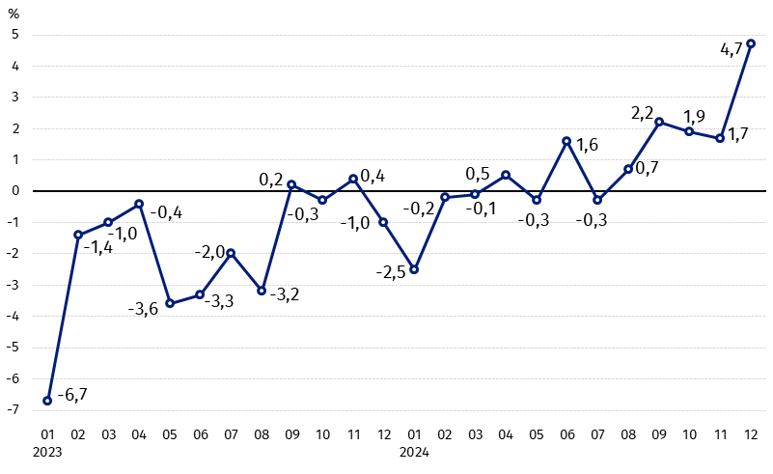

Chart 2. Changes in procurement prices of basic agricultural products in relation to the corresponding month of the previous year 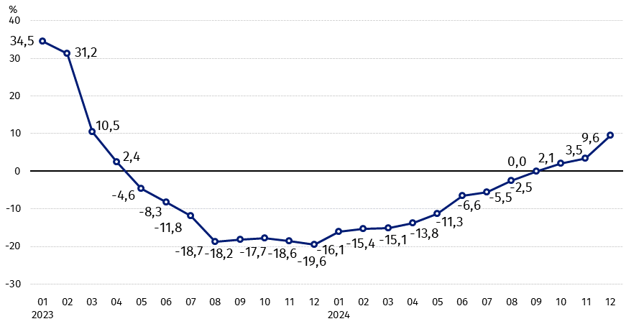
Procurement prices of basic agricultural products, except pigs for slaughter prices, in December 2024 were higher than those recorded in December 2023

Procurement prices and marketplace prices received by farmers

In December 2024 in comparison with the previous month, procurement prices of agricultural products were higher with the exception of pigs for slaughter. At marketplaces, the prices of wheat, rye, barley and triticale rose, while the prices of oats, corn, potatoes and cattle for slaughter fell.

Compared to the corresponding month of the previous year, in December 2024, procurement prices for most agricultural products increased, while only cattle for slaughter were more expensive on the marketplaces. Barley, oats and potatoes were cheaper on both markets.

Table 1. Prices of agricultural products (excluding VAT) in December 2024
Specification | Procurement prices |  |  | Marketplaces prices
Specification | 12 2024
Specification | in zloty | 11 2024=100 | 12 2023=100 | in zloty | 11 2024=100 | 12 2023=100
Cereal grain – per 1 dt
Wheat | 91.26 | 101.3 | 105.2 | 110.89 | 101.9 | 97.7
Rye | 68,33 | 108.0 | 107.3 | 85.55 | 101.5 | 98.9
Barley | 81.33 | 105.7 | 98.3 | 105.39 | 103.5 | 98.3
Triticale | 77.54 | 100.9 | 105.0 | 95.20 | 101.6 | 96.0
Oat | 83.06 | 101.6 | 85.9 | 98.98 | 99.9 | 96.3
Maize | 82.85 | 115.3 | 110.7 | 119.07 | 98.9 | 96.5
Potatoes– per 1 dt | 108.25 | 166.9 | 97.4 | 209.52 | 99.4 | 92.3
Animals for slaughter – per kg
Cattle (excl. calves) | 11.83 | 102.5 | 119.9 | 11.75 | 98.2 | 116.0
of which young cattle | 12.23 | 102.3 | 118.8 | . | . | .
Pigs | 6.26 | 98.5 | 83.9 | . | . | .
Poultry | 5.58 | 100.4 | 107.3 | . | . | .
Cows’ milk – per 1 hl | 259.06 | 111.0 | 122.5 | . | . | .

Data on procurement prices were calculated on the basis of information on value and quantity of procurement by legal persons and independent organizational entities without legal personality (without natural persons).
Indices of procurement prices and prices received by farmers on marketplaces were calculated on the basis of absolute data expressed with more precision than In the tables.

Prices of major agricultural products in December 2024
In December 2024, the procurement price of wheat was PLN 91.26 per dt, i.e. more than in the previous month (by 1.3%) and in the same period of 2023 (by 5.2%). At the marketplaces, the price of wheat (PLN 110.89 per dt) increased by 1.9% compared to November 2024, but was 2.3% lower than in December 2023.
The procurement price of rye (PLN 68.33 per dt) was 8% higher compared to November 2024 and 7.3% higher compared to December 2024. In the marketplaces, the price of rye (PLN 85.55 per dt) increased monthly (by 1.5%), but decreased year-on-year (by 1.1%).
In December 2024, the procurement price of potatoes was PLN 108.25 per dt, i.e. 66.9% more than in the previous month, but 2.6% less than in the same period last year. The significant increase in prices on a monthly basis resulted from a change in the procurement structure in December in favor of more expensive edible potatoes. At the marketplaces, the price of potatoes (PLN 209.52 per dt) decreased by 0.6% compared to November this year and by 7.7% compared to December 2023.
The procurement price of cattle for slaughter (PLN 11.83 per kg) was higher by 2.5% on a monthly basis and by 19.9% ​​- on a yearly basis. At the marketplaces, live cattle (PLN 11.75 per kg) were sold cheaper compared to November 2023 (by 1.8%), but more expensive than in December 2023 (by 16.0%).
In December 2024, the procurement price for pigs for slaughter was PLN 6.26 per kg, i.e. 1.5% less than a month ago and 16.1% less than a year ago.
The procurement price of poultry for slaughter (PLN 5.58 per kg) increased by 0.4% compared to November 2024, while compared to December 2023, it increased by 7.3%.
The procurement price for hl of milk was PLN 259.06, i.e. 11.0% more than in the previous month and 22.5% more than a year ago.

Chart 3. Procurement and marketplaces prices of wheat and rye

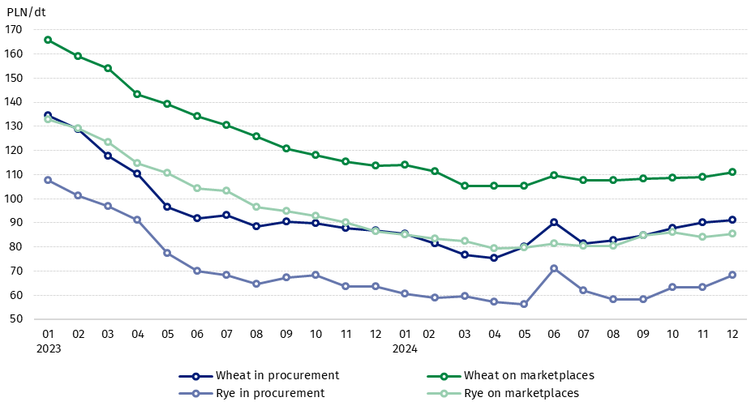

Chart 4. Procurement and marketplaces prices of potatoes

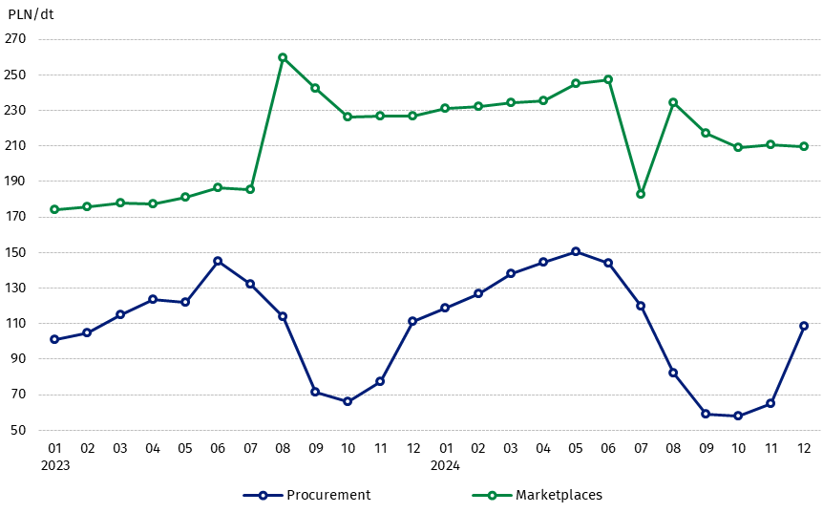

Chart 5. Procurement and marketplaces prices of cattle for slaughter and pigs for slaughter
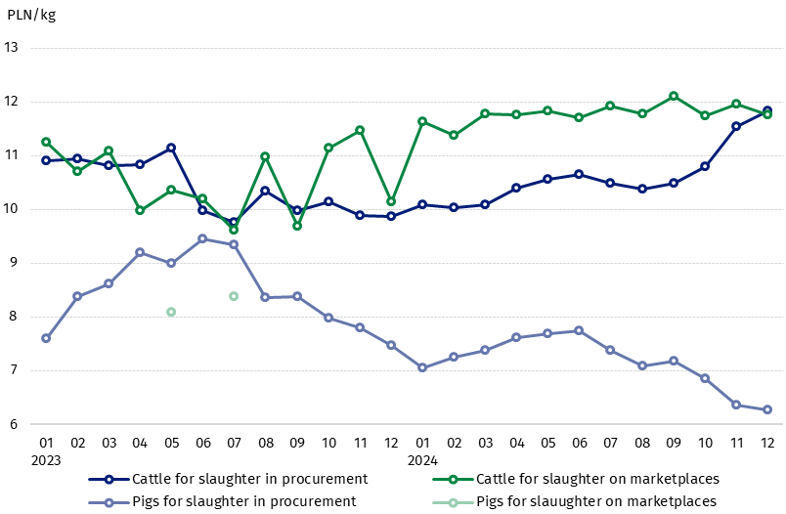

Chart 6. Procurement prices of poultry for slaughter and cows’ milk
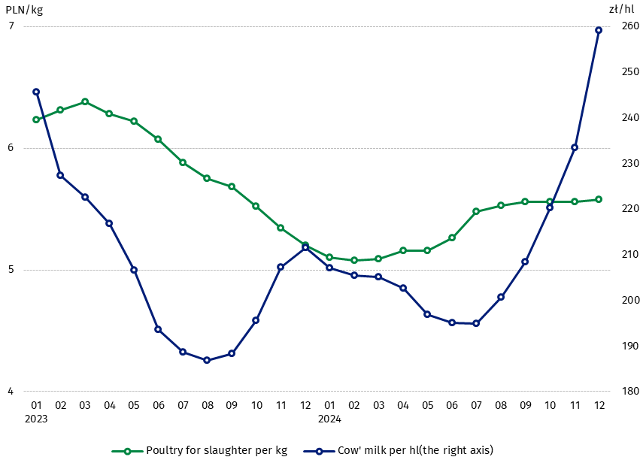

The differentiation of the level of prices of basic agricultural products in particular voivodships is presented in Table 2 for procurement prices and in Table 3 for prices obtained by farmers on marketplaces (Excel sheet).
In case of quoting Statistics Poland data, please provide information: “Source of data: Statistics Poland”, and in case of publishing calculations made on data published by Statistics Poland, please include the following disclaimer: “Own study based on figures from Statistics Poland”.

Prepared by:  Trade and Services Departament  Director Ewa Adach-Stankiewicz  Phone: (+48 22) 608 31 24 | Issued by:  Press Office  Mobile: (+48) 695 255 032  Phone: (+48 22) 608 38 04, (+48 22) 449 41 45.  (+48 22) 608 30 09  e-mail: obslugaprasowa@stat.gov.pl

stat.gov.pl/en/

@StatPoland

@GlownyUrzadStatystyczny

gus_stat

glownyurzadstatystycznygus

glownyurzadstatystyczny
Related information
Socio-economic situation of the country in 2024
Procurement and prices of agricultural products in 2023

Data available in databases
BDL - Prices in agriculture (monthly and annual data)
DBW - Prices in agriculture (monthly and annual data)

Terms used in official statistics
Procurement of agricultural products
Procurement prices
Marketplace
Marketplace prices

Wheat, rye, cattle for slaughter, pigs for slaughter, poultry, cows’ milk
Procurement prices – excluding sowing seed.
Procurement prices – total (of which: edible early kinds, seed, edible late, industrial, of which starch). Marketplaces prices – edible excluding early kinds.
Marketplaces prices – average weighted price of cattle for slaughter calculated with the adoption of the structure of procurement quantity of young cattle and cows for slaughter.

