Employed, unemployed and economically inactive persons (preliminary results of the Polish Labour Force Survey in the first quarter of 2025)

In the first quarter of 2025, economically active persons accounted for 58.2% of the population aged 15-89. This indicator was lower compared to both the fourth quarter of 2024 and the first quarter of 2024 (a decrese by 0.3 pp. in each). The activity rate was 65.4% among men and 51.4% among women.
58.2%
Activity rate of persons
aged 15-89

Economic activity of the population aged 15-89 by the LFS
The activity rate for persons aged 15-89 was lower than in the first and fourth quarter of 2024. It concerned both men and women.
In the first quarter of 2025, the number of economically active persons aged 15-89 amounted to 17 660 thousand, of which: 17 060 thousand constituted employed persons, while 600 thousand – the unemployed. The population of economically inactive persons in this age group comprised 12 709 thousand persons.
Population of economically active persons decreased compared to the fourth quarter of 2024 (by 82 thousand persons, i.e. by 0.5%) and compared to the first quarter of 2024 (by 94 thousand, i.e. by 0.5%).
Chart 1. Structure of the population aged 15-89 by status on the labour market in the first quarter of 2025
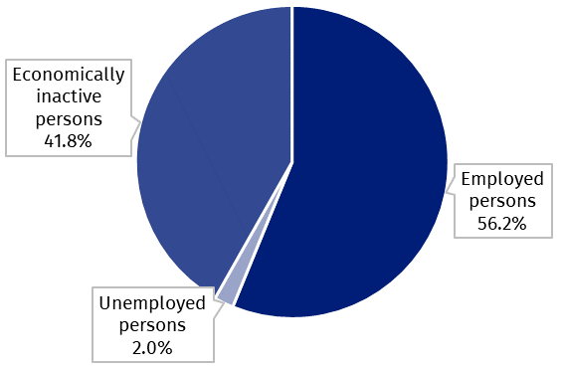

The activity rate of persons aged 15-89 in the first quarter of 2025 was higher among men and accounted for 65.4%, in the population of women it was at a much lower level of 51.4% (respective values for persons at the working age were 84.4% and 78.0%). Corresponding indicators for urban and rural residents accounted respectively for: 58.5% and 57.7% (at the working age: 83.3% and 78.6%).
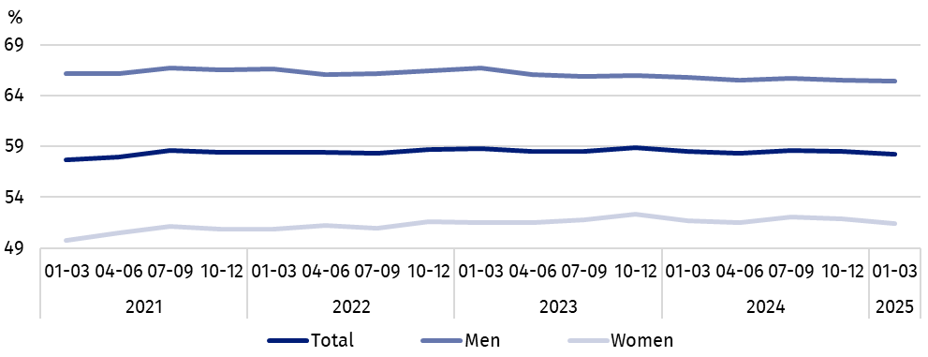
Chart 2. Activity rate of persons aged 15-89
The indicator describing the relation of not working persons to the number of employed persons was higher than in the first and fourth quarter of 2024.
Within the scope of population aged 15-89, the ratio of the number of not working persons (the unemployed or the economically inactive) to the employed persons increased compared to the previous quarter and to the first quarter of 2024. In the first quarter of 2025, there were 780 unemployed or economically inactive persons aged 15-89 per 1 000 employed persons (in the fourth quarter of 2024 – 760 persons and in the first quarter of 2024 – 765 persons).
In the first quarter of 2025, employed persons accounted for 56.2% of the population aged
15-89. The employment rate was lower than noted in the fourth quarter of 2024 (by 0.6 pp.), as well as compared to that observed in the first quarter of 2024 (by 0.4 pp.). In the male population this indicator was 63.3%, and in the female population – 49.6%.
56.2%
Employment rate
of persons aged 15-89

Employed persons aged 15-89 by the LFS
In the first quarter of 2025, population of employed persons aged 15-89 amounted to 17 060 thousand persons and decreased compared to the fourth quarter of 2024 (by 187 thousand persons, i.e. by 1.1%) and compared to the first quarter of 2024 (by 134 thousand, i.e. by 0.8%).
Chart 3. Employed persons and employment rate of persons aged 15-89 and at the
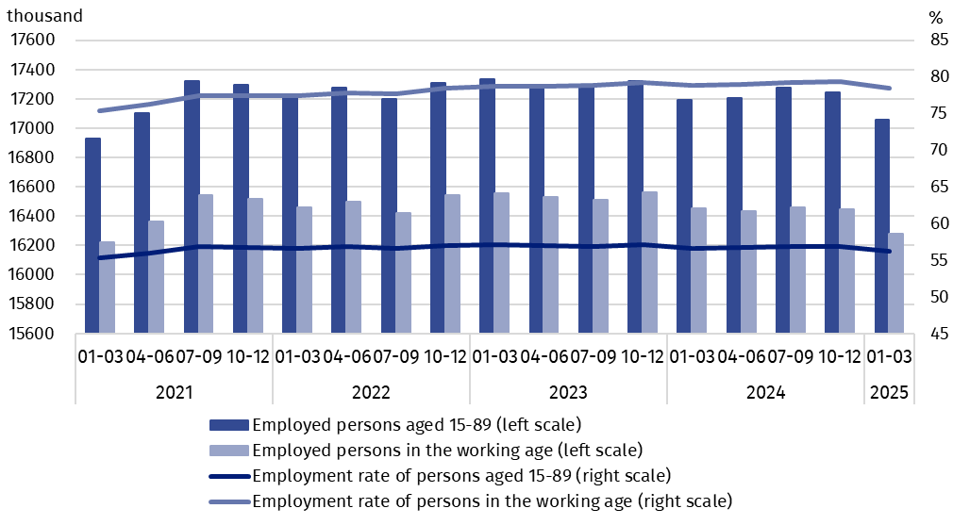
working age

Compared to the fourth quarter of 2024, the number of employed persons decreased to a greater extent among women (by 111 thousand persons, i.e. by 1.4%) than among men (by 75 thousand, i.e. by 0.8%). Taking into account the place of residence, the decline in the number of employed persons was greater among urban residents (by 112 thousand, i.e. 1.1%) than among rural residents (by 75 thousand, i.e. 1.1%).
Similar trends were noted compared to the first quarter of 2024 – the number of employed persons was lower both among men (by 73 thousand persons, i.e. by 0.8%) and women (by 61 thousand, i.e. by 0.8%). The number of employed urban residents decreased to a greater extent (by 104 thousand, i.e. by 1.0%) than the number of employed rural residents (by 31 thousand, i.e. by 0.5%).
In the population of employed persons, taking into account division by sex, men still predominated constituting 54.1% (i.e. 9 229 thousand persons) of this group. Regarding the place of residence, there were more employed persons living in urban areas (60.7%, i.e. 10 354 thousand), which is a direct consequence of the higher population in urban than rural areas.
In the first quarter of 2025, total employment rate amounted to 56.2%, and it was lower than noted in the fourth quarter of 2024 – by 0.6 pp., and in the first quarter of 2024 – by 0.4 pp. The employment rate for men (63.3%) was from the analogical indicator for women (49.6%), and taking into account the place of residence, a higher indicator was noted in urban areas (56.6%) than in rural areas (55.6%).
Over the quarter, similarly to the total employed population, the employment rate decreased among women (by 0.7 pp.) and among men (by 0.6 pp.). Taking into account the place of residence, an identical decrease of this indicator (by 0.6 pp. in each) was noted among urban and rural residents.
Compared to the first quarter of 2024, the decrease in the employment rate was observed regardless of sex, with a higher rate among men (by 0.6 pp.) than among women (by 0.4 pp.). In the case of persons living in urban areas, this indicator decreased by 0.5 pp, and for persons living in rural areas by 0.3 pp.
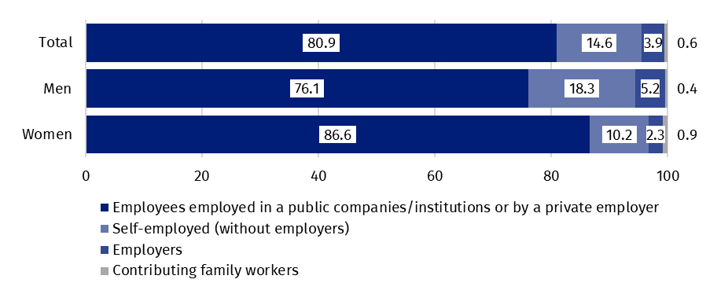
Chart 4. Structure of employed persons aged 15-89 by employment status in the main job in the first quarter of 2025 (in %)
The LFS results indicate that in the first quarter of 2025:
The number of full-time employees was lower than in the first and fourth quarter of 2024.
- 15 910 thousand persons (i.e. 93.3%) performed full-time work, while 1 150 thousand (i.e. 6.7%) were employed part-time,
- the average number of hours worked in the reference week in the main job amounted to 38.7 hours,
- in the total number of employed persons, the share of employees employed in public companies/institutions or by a private employer was 80.9% (13 809 thousand persons), self-employed – 18.5% and contributing family members – 0.6%, but a significantly higher share of self-employed was noted among men (23.5%) than women (12.5%), while the share of employees employed by a public or private employer was higher among women (86.6%) than men (76.1%),
- a vast majority of employees employed in public companies/institutions or by a private employer performed their work on the basis of the contract for an indefinite period (84.4%, i.e. 11 657 thousand persons),
The size of the working population changes throughout the year due to i.a. the seasonality of some work.
- the sections where the most people worked were: Manufacturing – 19.2% of all employed persons (3 281 thousand persons); Wholesale and retail trade; repair of motor vehicles and motorcycles – 13.0% (2 213 thousand), Education – 7.9% (1 353 thousand) and Construction – 7.5% (1 275 thousand).
The decrease in the number of employed persons observed in the first quarter of 2025 compared to previous periods occurred to a greater extent in the public sector (by 181 thousand less, i.e. 4.2% compared to the fourth quarter of last year and by 71 thousand less, i.e. 1.7% compared to the first quarter of 2024). In the private sector, the number of employed persons was at a similar level to the previous quarter (by 6 thousand less), and was lower by 63 thousand, i.e. 0.5% over the year. In the case of the private sector, a significantly greater decrease in the number of employed persons was observed on private farms in agriculture (by 45 thousand, i.e. 4.7% compared to the previous quarter and by 137 thousand, i.e. 13.0% compared to the first quarter of 2024). The number of persons employed in private farms in agriculture has been systematically decreasing for years.
The decrease in the number of employed persons in the first quarter of 2025 compared to previous periods concerned the public sector to a greater extent than the private sector.
Taking into account the kind of activity of the place of work, in the first quarter of 2025, the highest (in absolute values) decreases in the number of employed persons compared to the previous quarter were noted in the sections: Agriculture, forestry and fishing (by 153 thousand persons, i.e. 13.1%) and in Trade and motor vehiclesΔ (by 100 thousand, i.e. by 4.3%). The highest increases were noted among employed persons in the sections: Information and communication and Education (by 43 thousand in each, i.e. by 6.7% and by 3.3%) as well as Professional, scientific and technical activities (by 37 thousand, i.e. by 4.5%).
In the case of the private sector, the number of persons working on private farms in agriculture is systematically decreasing. In the first quarter of 2025, this population amounted to 920 thousand persons and was lower by 13.0% compared to the first quarter last year. The scale of these changes was higher than in other types of activity.
The size of the employed population changes throughout the year due to i.a. the seasonality of some work. The highest declines (in absolute values) in the number of employed compared to the previous quarter were noted in the following sections: Public administration and national defence; compulsory social security (by 89 thousand persons, i.e. 7.0%) and Trade and motor vehicles^{Δ} (by 74 thousand, i.e. 3.2%). The highest increases in the employed population (in absolute values) concerned the Professional, scientific and technical activities section (by 83 thousand, i.e. 10.7%) and the Accommodation and good service section (by 50 thousand, i.e. 14.3%).
In the first quarter of 2025, 955 thousand persons had a job, but were not performing the work in the reference week, which accounted for 5.6% of the total number of the employed (the corresponding population in the previous quarter comprised 960 thousand, i.e. 5.6%, while a year ago it was 804 thousand, i.e. 4.7%). The most common reasons for not performing work were own illness and paid, unpaid or occasional leave – they accounted jointly for 63.1% of all causes of absence.
Every ninth employee worked in a form of remote work.

The number of persons performing their work usually or sometimes at home amounted to 2 784 thousand persons, which accounted for 16.3% of the total number of the employed. In a form of remote work (the place of performing work is not considered here), their work related responsibilities were performed usually or sometimes by 1 912 thousand persons, i.e. 11.2% of the total number of the employed.

In the first quarter of 2025, unemployed persons accounted for 3.4% of the economically active population aged 15-89. The unemployment rate increased compared to the fourth quarter of 2024 (by 0.6 pp.) and the first quarter of 2024 (by 0.3 pp.). The unemployment rate was lower among men than among women (3.2% versus 3.6%).
3.4%
Unemployment rate of persons aged 15-89

Unemployed persons aged 15-74 by the LFS
In the first quarter of 2025, the population of unemployed persons aged 15-74, featured by the international criteria used in the BAEL, was at the level of 600 thousand (average value in the analysed period) and was higher both in compared to the fourth quarter of 2024 – by 105 thousand persons, i.e. by 21.2%, and to the first quarter of 2024 – by 41 thousand, i.e. by 7.3%.
In the first quarter of 2025, the number of unemployed persons was higher than in the first and fourth quarter of 2024. This applied to both persons separated according to the BAEL criteria and those registered at labour offices.
The size of the unemployed population, both according to BAEL criteria and the criteria for registration at labour offices, changes during the year due to i.a. the seasonality of some work. The highest number of unemployed persons is usually in the first quarter, which is also related to the expiry of part-time employment contracts at the end of the year (and the failure to take up another job or the ongoing process of concluding new employment contracts).
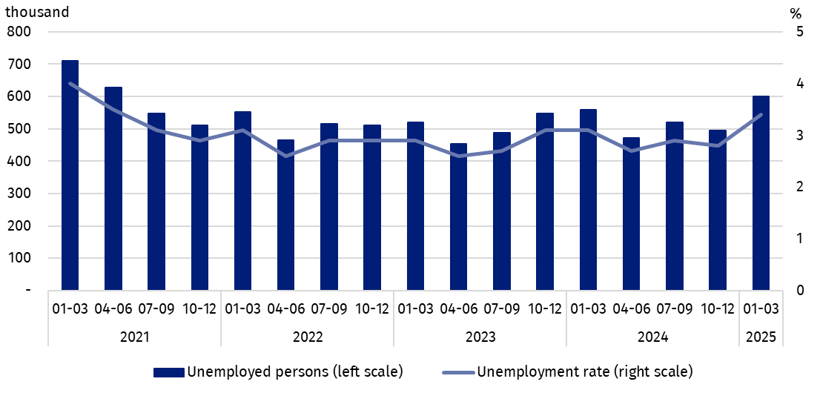
Chart 5. Unemployed persons aged 15-74 and unemployment rate of persons aged 15-89
The seasonality of some work also has a significant impact on the size of the unemployed population. The highest number of unemployed persons is usually in the first quarter.
In the first quarter of 2025, more than half of unemployed population were men – 51.0%, i.e. 306 thousand persons. Unemployed urban residents constituted 58.0% of the total number of the unemployed, which is a lower percentage than the share of the urban population in the population of Poland (60.3%).
The increase in the number of unemployed persons compared to the fourth quarter of 2024 was observed regardless of sex and it was greater among men (by 67 thousand persons, i.e. by 28.0%) than among women (by 39 thousand, i.e. by 15.2%). Taking into account the place of residence, a greater increase in the population of unemployed persons occurred among urban residents (by 69 thousand, i.e. by 24.7%) than rural residents (by 37 thousand, i.e. by 17.1%).
Compared to the first quarter of 2024, a similar increase in the number of unemployed persons occurred among men (by 22 thousand persons, i.e. by 7.7%) and among women (by 20 thousand, i.e. by 7.3%). Among urban residents, the number of unemployed persons increased by 26 thousand, i.e. by 8.1%), and in rural areas by 16 thousand, i.e. by 6.8%.
In the first quarter of 2025, the unemployment rate according to the BAEL amounted to 3,4% and was higher than in the fourth quarter of 2024 (by 0.6 pp) and in the first quarter of 2024 (by 0.3 pp.).
For comparison, the registered unemployment rate was higher than according to the BAEL criterion and amounted to 5.3% at the end of March this year.
In the first quarter of 2025, unemployment in Poland was still one of the lowest in the European Union.
In the first quarter of 2025, the unemployment rate in Poland was still one of the lowest in the European Union. In March 2025, the harmonized unemployment rate for the population aged 15-74, after eliminating the seasonality factor, was 2.7% (2.6% in January and February this year, 2.9% in March 2024).
The unemployment rate according to the BAEL criterion was lower for men than for women (3.2% vs. 3.6%), and taking into account the place of residence - for urban residents than for rural residents (3.3% vs. 3.6%). Compared to the fourth quarter of 2024, changes were noted in the unemployment rate by sex and place of residence. The increase occurred among men (by 0.7 pp.) and women (by 0.5 pp). The unemployment rate increased among urban residents (by 0.7 pp.) and among rural residents (by 0.5 pp.).
Compared to the first quarter of 2024, the intensity of unemployment increased to the same extent among men and women (an increase of 0.2 pp in each). Taking into account place of residence, the unemployment rate increased both among urban residents - by 0.3 pp. and among rural residents - by 0.2 pp.
Changes in the level of unemployment rate are also noticeable when taking into account the division of population by age groups. The highest unemployment rate was recorded for the youngest, i.e. in the age group 15-24 years – 13.4%. Significantly lower unemployment rates occurred in other older age groups. The unemployment rate was 3.5% for persons aged
25-34, 2.6% for aged 35-44, and 2.4% for aged 45-89.
As in previous periods, the highest unemployment rate was observed among the youngest persons, i.e. aged 15-24.
Compared to the fourth quarter of 2024, the unemployment rate increased in all analysed age groups – from 2.2 pp. for persons aged 15-24 to 0.2 pp. for persons aged 25-34.
Compared to the first quarter of 2024, the unemployment rate increased for persons aged 15-24 – by 1.6 pp. and for persons aged 45-89 – by 0.4 pp. A decrease in the unemployment rate was recorded among persons aged 25-34 – by 0.2 pp. The unemployment rate remained unchanged for persons aged 35-44.
Persons with tertiary education are still in the best situation – the unemployment rate in this group is the lowest – in the first quarter of 2025 it was 1.6%. For persons with post-secondary and technical secondary or secondary sectoral vocational education, unemployment rate was 3.7% and for those with basic vocational or basic sectoral vocational education – 4.9%. Among persons with general secondary education, the unemployment rate in the first quarter of 2025 was 4.6%. On the other hand, the highest unemployment rate is observed among persons with the lowest level of education, i.e. with lower secondary education or less, in the first quarter of 2025 it was 10.2%.
To the greatest extent, unemployment affected persons with the lowest level of education.

Compared to the fourth quarter of 2024, the unemployment rate increased in all groups of persons separated by level of education (from 1.0 pp. among persons with post-secondary and technical secondary or secondary sectoral vocational education to 0.2 pp. among persons with higher education).
Compared to the first quarter of 2024, the unemployment intensity increased among persons with lower secondary education or less (by 3.0 pp.), among persons with basic vocational or basic sectoral vocational education (by 0.6 pp.) and among persons with tertiary education (by 0.3 pp.). Among persons with post-secondary and technical secondary or secondary sectoral vocational education, the unemployment rate decreased by 0.3 pp, and among persons with general secondary education, it did not change compared to the first quarter of 2024.
Each unemployed person was classified into one of four categories separated due to the reason of inflow to unemployment. The largest population of unemployed were those who lost their job, i.e. persons who left their last job in the last 3 months not on their own initiative (44.8%, i.e. 269 thousand persons). The share of unemployed intending to return to work after a break (lasting longer than 3 months) was 24.7% (i.e. 148 thousand), but among women this share was higher than among men and amounted to 26.8% and 22.3%, respectively. The unemployed who resigned from work on their own initiative constituted 15.3% (i.e. 92 thousand) and the unemployed who were looking for their first job – 15.2% (i.e. 91 thousand).
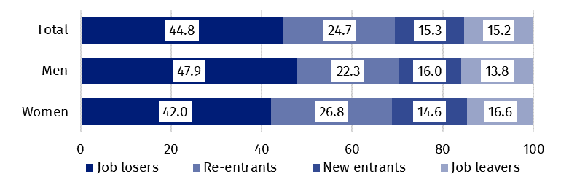
Chart 6. Structure of unemployed persons by the source of inflow to unemployment in the first quarter of 2025 (in %)
The average duration of job search by unemployed persons in the first quarter of 2025 was 7.5 months.
In the first quarter of 2025, unemployed persons had been looking for a job 7.5 months on average (in the previous quarter 8.4 months and in the first quarter of 2024 it was 7.8 months). Persons who were seeking a job for the longest duration were the ones aged
55-74 (an average 9.3 months), while the shortest job search duration was observed for the youngest persons i.e. aged 15-19 (4.5 months).
41.8%
The share of economically
inactive persons in the total number of the population aged 15–89

In the first quarter of 2025, economically inactive persons accounted for 41.8% of the total number of population aged 15-89. The percentage was higher compared to the previous quarter (an increase by 0.2 pp.) and in relation to the first quarter of 2024 (an increase by 0.3 pp.).

Economically inactive persons aged 15-89 by the LFS
The number of economically inactive persons was higher than in the first and fourth quarter of 2024.
In the first quarter of 2025, population of economically inactive persons aged 15-89 amounted to 12 709 thousand and was higher in relation to the fourth quarter of 2024 (by 99 thousand persons, i.e. 0.8%) and compared to the first quarter of 2024 (by 109 thousand, i.e. 0.9%).
Over half of the population of economically inactive persons in the analysed age group constituted women –their share was 60.4% (7 674 thousand). Economically inactive women accounted for 48.6% of all women aged 15-89, while analogous indicator for men was 34.6%. A majority of economically inactive persons constituted urban residents (59.8%; i.e. 7 597 thousand) than rural residents, which is connected with a higher population in urban than in rural areas. The share of economically inactive in the analysed age group among all urban residents was at the level of 41.5% and among rural residents amounted to 42.4%.
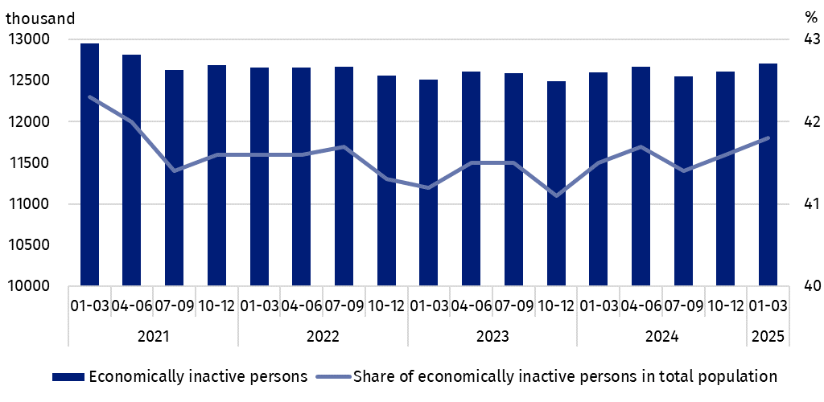
Chart 7. Economically inactive persons and the share of economically inactive persons in population aged 15-89
Compared to the fourth quarter of 2024, the number of economically inactive women (by 79 thousand persons, i.e. by 1.0%), and men although to a lesser extent (by 19 thousand, i.e. by 0.4%) increased. A similar increase in the number of economically inactive persons was recorded among all urban residents (by 52 thousand, i.e. by 0.7%) and rural residents (by 47 thousand, i.e. by 0.9%).
Compared to the first quarter of 2024, the number of economically inactive men (by 63 thousand people, i.e. by 1.3%), and women (by 46 thousand, i.e. by 0.6%) increased. An increase in the number of economically inactive persons was also recorded regardless of the place of residence, but it was higher among urban residents – an increase by 73 thousand, i.e. 1.0%, than among rural residents – an increase by 36 thousand, i.e. 0.7%.
The economically inactive population is a specific one in respect to the labour market resources. Its scope includes persons who have not entered the labour market yet (including the majority of the youth still participating in education) and persons who have definitely left the labour market or will never enter the labour market (some retirees, pensioners, persons maintaining themselves from other sources than work), but also persons who entered the labour market, then partially deactivated and who will want to re-enter the labour market after a break.
Family and households responsibilities were much more often the reason for women's economic inactivity.
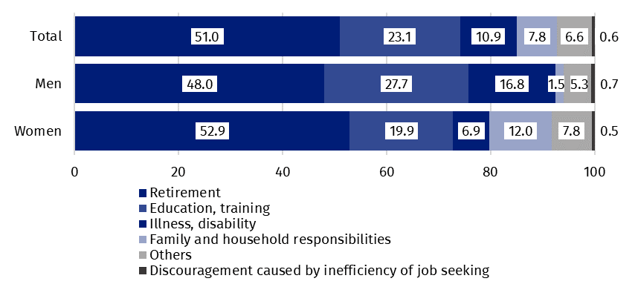
Chart 8. Structure of economically inactive persons aged 15-74 by sex and reasons for inactivity in the first quarter of 2025 (in %)
Education and training were the most often reason for economic inactivity of persons at the working age.
In the first quarter of 2025, over half of the economically inactive persons aged 15-74 comprising 10 080 thousand (the reason for inactivity was determined for this age group) constituted retirees (51.0%), while the second largest group were students (23.1%). It is worth noting that education and training as well as illness and disability were more often the reasons for inactivity among men (respectively 27.7% and 16.8%) than among women (respectively 19.9% and 6.9%). On the other hand, family responsibilities were much more often the reason for inactivity among women (12.0%) than men (1.5%).
Among the economically inactive of working age (3 859 thousand persons) the most often reasons for inactivity were: education and training – 30.6%, illness and disability – 25.1% and family responsibilities – 19.4%. Retirement as the reason for inactivity on the labour market indicated 7.8% persons at the working age, while persons discouraged with unsuccessful job search constituted 1.5% of this group.

Methodological notes

The presented news release was prepared on the basis of the generalised results of the sample survey Badanie Aktywności Ekonomicznej Ludności/BAEL (Eng.: Labour Force Survey/PL-LFS).
Since the fourth quarter of 2023, generalization of the survey results over the general population has been carried out with the use of the data on resident population in Poland coming from the balances compiled on the basis of the Population and Housing Census 2021 (by the third quarter of 2023, the results were generalized over the general population using population data from the balances compiled on the basis of the Population and Housing Census 2011). The data published in this news release and in the attached tables for the period from the first quarter of 2021 to the third quarter of 2023 have been recalculated in accordance with the new basis for generalizing results and are therefore comparable.
Badanie Aktywności Ekonomicznej Ludności has been carried out in Poland quarterly since May 1992 and it has been improved in accordance with the International Labour Organization and Eurostat recommendations.
From the first quarter of 2021 onwards, the base of the EU-LFS methodology are definitions of the employed, the unemployed and economically inactive persons in accordance with the Resolution concerning statistics of work, employment and labour underutilization adopted in 2013 on the 19th International Conference of Labour Statisticians in Geneva (19th ICLS) and recommended by the International Labour Organization (ILO) for the use in all countries. The survey object is the situation within the scope of economic activity of the population, i.e. the fact of performing work, being unemployed or economically inactive persons in the reference week. In the European Union, the implementation of the provisions of the above mentioned Resolution was carried out through introduction of new legal acts. From 2021 onwards, EU-LFS has been one of the key surveys embraced by the framework regulation for social statistics (the so-called IESS FR). Accompanying IESS FR implementing regulations in the domain of the labour force specify the range of the core survey and module surveys, determine survey organisation and define in detail particular populations specified according to the status of persons in the labour market.
Detailed results of the survey as well as the up-dated methodology – obligatory from the first quarter of 2021, are included in the quarterly publication “Labour Force Survey in Poland” and in the Methodological report available on the Statistics Poland website:
https://stat.gov.pl/en/topics/labour-market/working-unemployed-economically-inactive-by-lfs/labour-force-survey-in-poland-quarter-42024,2,56.html
https://stat.gov.pl/en/topics/labour-market/yearbook-of-labour/methodological-report-labour-force-survey,8,2.html
In the case of quoting Statistics Poland data, please provide information: ‘Source of data: Statistics Poland’, and in the case of publishing calculations made on data published by Statistics Poland, please provide information: ‘Own work based on Statistics Poland data.’

Prepared by:  Social Surveys and Labour Market Department  Director Agnieszka Zgierska, PhD  Phone: (+48 22) 608 30 15 | Issued by:  Press Office  Mobile +48 695 255 032  Phone +48 22 608 38 04, +48 22 449 41 45,  +48 22 608 30 09  e-mail: obslugaprasowa@stat.gov.pl

www.stat.gov.pl/en/

@StatPoland

@GlownyUrzadStatystyczny

gus_stat

glownyurzadstatystycznygus

glownyurzadstatystyczny
Related information
Methodological report. Labour Force Survey
Labour Force Survey in Poland
Other publications containing the results of LFS and its module surveys
stat.gov.pl → Topics → Labour Market
Data available in databases
Strateg → Topics → Labour Market
Local Data Bank → labour Market
Terms used in official statistics
Economic activity by LFS
Economically active population by LFS
Employed persons by LFS
Unemployed persons by LFS
Economically inactive population according to the LFS

Activity rate by LFS
Employment rate by LFS
Unemployment rate by LFS

The LFS results refer to the resident population i.e. staying or intending to stay in the country’s territory for at least 12 months, living in private households. Generalisation of the survey results over the general population has been carried out with the use of the data on resident population in Poland coming from the balances compiled on the basis of the Population and Housing Census 2021. Data for the period from the first quarter of 2021 to the third quarter of 2023 was recalculated in line with the new generalisation basis. See methodological notes on page 8.
Men aged 18-64 and women aged 18-59.
Categories of applied classification are presented in abbreviated form.
Work at home is performed by, for example, persons who conducted own economic activity and their home is their workplace, as well as employees who work at home in the form of remote work.
Remote work is performed outside the establishment with the use of electronic communication means.
See methodological notes at the end of this news release.
The average duration of job search is the period, counted in months, during which unemployed persons are actively looking for a job (the last continuous period of looking for a job is taken into account here, i.e. without a significant interruption).
Regulation (EU) 2019/1700 of the European Parliament and of the Council of 10 October 2019 establishing a common framework for European statistics relating to persons and households, based on data at individual level collected from samples.

