Employed, unemployed and economically inactive persons (preliminary results of the Polish Labour Force Survey)
According to the preliminary results of the Polish Labour Force Survey, a decrease in the economic activity of the population was observed in the fourth quarter of 2024. The number of employed persons and the employment rate were lower than in the third quarter of 2024. The number of unemployed persons and the unemployment rate also decreased. However, the number of economically inactive persons increased.
In the fourth quarter of 2024, economically active persons accounted for 58.5% of the population aged 15-89. This indicator was lower compared to both the third quarter of 2024 (a slight decrease by 0.1 pp.) and the fourth quarter of 2023 (by 0.4 pp.). The activity rate was 65.5% among men and 51.9% among women.
58.5%
Activity rate of persons
aged 15-89

Economic activity of the population aged 15-89 by the LFS
The activity rate for persons aged 15-89 compared to the third quarter of 2024 and the fourth quarter of 2023 decreased for both men and women
In the fourth quarter of 2024, the number of economically active persons aged 15-89 amounted to 17 742 thousand, of which: 17 247 thousand constituted employed persons, while 495 thousand – the unemployed. The population of economically inactive persons in this age group comprised 12 610 thousand persons.
Population of economically active persons decreased compared to the third quarter of 2024 (by 56 thousand persons, i.e. by 0.3%) and compared to the fourth quarter of 2023 (by 128 thousand, i.e. by 0.7%).
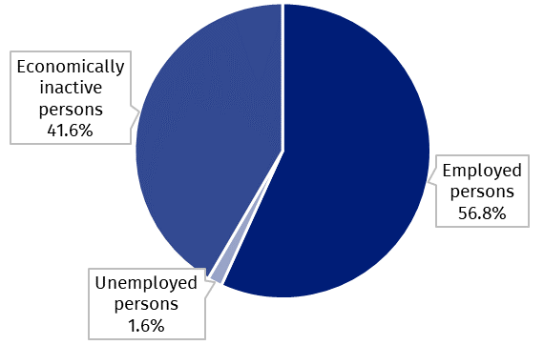
Chart 1. Structure of the population aged 15-89 by status on the labour market in the fourth quarter of 2024

The activity rate of persons aged 15-89 in the fourth quarter of 2024 was higher among men and accounted for 65.5%, in the population of women it was at a much lower level of 51.9% (respective values for persons at the working age were 84.4% and 78.6%). Corresponding indicators for urban and rural residents accounted respectively for: 58.7% and 58.0% (at the working age: 83.4% and 79.2%).
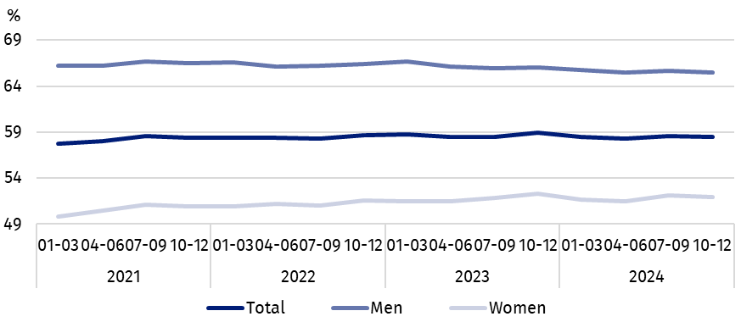
Chart 2. Activity rate of persons aged 15-89
The indicator describing the relation of jobless persons to the number of employed persons was higher compared to both the third quarter of 2024 and the fourth quarter of 2023
Within the scope of population aged 15-89, the ratio of the number of not working persons (the unemployed or the economically inactive) to the employed persons increased compared to the previous quarter and to the fourth quarter of 2023. In the fourth quarter of 2024, there were 760 unemployed or economically inactive persons aged 15-89 per 1 000 working people (in the third quarter of 2024 – 757 persons and in the fourth quarter of 2023 – 753 persons).
In the fourth quarter of 2024, employed persons accounted for 56.8% of the population aged
15-89. The employment rate was lower than noted in the third quarter of 2024 (a slight decrease of 0.1 pp.), as well as compared to that observed in the fourth quarter of 2023 (by 0.3 pp.). The rate was higher among men (63.9%) than among women (50.3%).
56.8%
Employment rate
of persons aged 15-89

Employed persons aged 15-89 by the LFS
The number of employed persons was lower than in the third quarter of 2024 and compared to the fourth quarter of 2023
In the fourth quarter of 2024, population of employed persons aged 15-89 amounted to 17 247 thousand persons and decreased both compared to the third quarter of 2024 (by 30 thousand persons, i.e. by 0.2%) and compared to the fourth quarter of 2023 (by 76 thousand, i.e. by 0.4%).
Chart 3. Employed persons and employment rate of persons aged 15-89 and at the
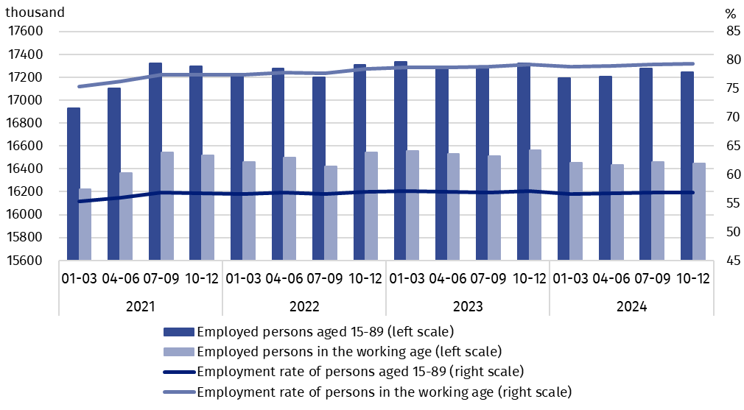
working age
Compared to the third quarter of 2024, the number of employed persons decreased among women (by 27 thousand persons, i.e. by 0.3%) and among men it remained at a similar level. Considering the place of residence, the decrease in the number of employed persons occurred only among urban residents (by 39 thousand, i.e. by 0.4%), while among rural residents there was a slight increase in the number of this group (by 10 thousand, i.e. by 0.1%).
Compared to the fourth quarter of 2023, the number of employed persons decreased among both women (by 55 thousand persons, i.e. by 0.7%) and men (by 22 thousand, i.e. by 0.2%). The number of employed persons also decreased among rural residents (by 56 thousand, i.e. by 0.8%) and among urban residents (by 20 thousand, i.e. by 0.2%).
In the population of employed persons, taking into account division by sex, men still predominated constituting 53.9% (i.e. 9 304 thousand persons) of this group, while regarding the place of residence, there were more employed persons living in urban areas (60.7%, i.e. 10 466 thousand), which is a direct consequence of the higher population in urban than rural areas (respectively 3/5 and 2/5 of the total population in Poland).
In the fourth quarter of 2024, total employment rate amounted to 56.8%, and it was slightly lower than noted in the third quarter of 2024 – by 0.1 pp., and in the fourth quarter of 2023 – by 0.3 pp.
In line with the observed trend, the employment rate was higher among men (63.9%) than among women (50.3%) and regarding the place of residence, a slightly higher level of the indicator was noted in urban areas (57.2%) than in rural areas (56.2%).
Over the quarter, similarly to the total employed population, the employment rate decreased among women – by 0.2 pp., and among men remained at the same level. Taking into account the place of residence, the decrease of this indicator was noted only among urban residents – by 0.2 pp., while among rural residents there was no change.
Compared to the fourth quarter of 2023, the employment rate decreased among women (by 0.3 pp.) and slightly among men (by 0.1 pp.). In the case of persons living in rural areas, this indicator decreased by 0.6 pp, while in urban areas it remained at the same level.
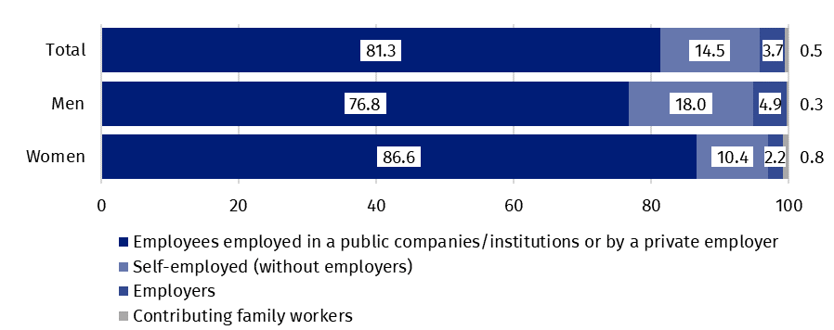
Chart 4. Structure of employed persons aged 15-89 by employment status in the main job in the fourth quarter of 2024 (in %)
The LFS results indicate that in the fourth quarter of 2024:
The number of persons employed full-time increased compared to the third quarter of 2024, but decreased compared to the fourth quarter of 2023
- 16 127 thousand persons (i.e. 93.5%) performed full-time work, while 1 120 thousand (i.e. 6.5%) were employed part-time,
- the average number of hours worked in the reference week in the main job amounted to 37.9 hours,
- in the total number of the employed, the share of employees employed in public companies/institutions or by a private employer was 81.3% (14 028 thousand persons), self-employed – 18.2% and contributing family members – 0.5%, but a significantly higher share of self-employed was noted among men (22.9%) than women (12.6%), while the share of employees employed by a public or private employer was higher among women (86.6%) than men (76.8%),
- a vast majority of employees employed in public companies/institutions or by a private employer performed their work on the basis of the contract for unlimited duration (84.8%, i.e. 11 893 thousand persons),
- the sections where the most people worked were: Manufacturing – 19.2% of all employed persons (3 307 thousand persons); Wholesale and retail trade; repair of motor vehicles and motorcycles – 13.3% (2 287 thousand), Education – 8.2% (1 417 thousand) and Construction – 7.6% (1 308 thousand).
Taking into account the kind of activity of the place of work, in the fourth quarter of 2024, the highest decreases in the number of employed persons compared to the previous quarter were noted in the Agriculture, forestry and fishing section (by 54 thousand persons) and in the Professional, scientific and technical activities section (by 49 thousand). Whereas, the highest increases concerned the number of employed persons in the Human health and social work activities section (by 55 thousand) and in the Wholesale and retail trade; repair of motor vehicles and motorcycles section (by 46 thousand).
Compared to the fourth quarter of 2023, the highest decreases in the number of employed persons occurred in the Agriculture, forestry and fishing section (by 165 thousand persons) and in the Accommodation and food service activities section (by 62 thousand), while the highest increases – among the employed persons in the Transportation and storage section (by 93 thousand) and in the Education section (by 72 thousand).
In the fourth quarter of 2024, 960 thousand persons had a job, but were not performing the work in the reference week, which accounted for 5.6% of the total number of the employed (the corresponding population in the previous quarter comprised 1 605 thousand, i.e. 9.3%, while a year ago it was 936 thousand, i.e. 5.4%). The most common reasons for not performing work were own illness and paid, unpaid or occasional leave – they accounted jointly for 64.7% of all causes of absence.
Every tenth employee worked in a form of remote work

The number of persons performing their work usually or sometimes at home amounted to 2 590 thousand persons, which accounted for 15.0% of the total number of the employed. In a form of remote work (the place of performing work is not considered here), their work related responsibilities were performed usually or sometimes by 1 733 thousand persons, i.e. 10.0% of the total number of the employed.
In the fourth quarter of 2024, unemployed persons accounted for 2.8% of the economically active population aged 15-89. Unemployment intensity (measured by the unemployment rate) decreased compared to the third quarter of 2024 (by 0.1 pp.) and the fourth quarter of 2023 (by 0.3 pp.). The unemployment rate was lower among men than among women (2.5% versus 3.1%).
2.8%
Unemployment rate of persons aged 15-89

Unemployed persons aged 15-74 by the LFS
In the fourth quarter of 2024, the population of unemployed persons aged 15-74 was 495 thousand and was lower compared to both the third quarter of 2024 – by 26 thousand persons, i.e. by 5.0%, and the fourth quarter of 2023 – by 52 thousand, i.e. by 9.5%.
The number of unemployed persons was lower compared to the third quarter of 2024 and the fourth quarter of 2023
In the fourth quarter of 2024, more than half of unemployed population were women – 51.7%, i.e. 256 thousand persons. Unemployed urban residents constituted 56.4% of the total number of the unemployed, which is a lower percentage than the share of the urban population in the population of Poland (60.3%).
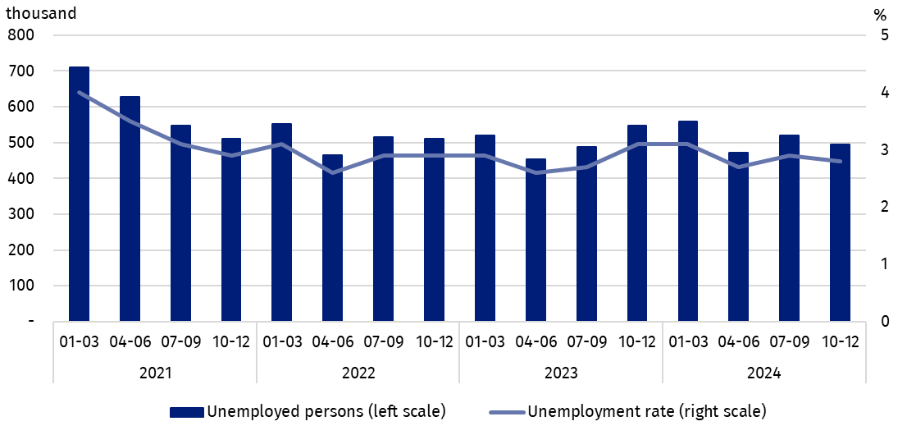
Chart 5. Unemployed persons aged 15-74 and unemployment rate of persons aged 15-89
The decrease in the number of unemployed persons compared to the third quarter of 2024 was observed regardless of sex and it was slightly greater among men (by 17 thousand persons, i.e. by 6.6%) than among women (by 9 thousand, i.e. by 3.4%). Taking into account the place of residence, the decrease in the unemployed population was mainly due to the decrease in the number of this population among urban residents (by 28 thousand, i.e. by 9.1%), while among rural residents the number of unemployed people remained at the level observed in the third quarter of 2024.
Compared to the fourth quarter of 2023, the decrease in the number of unemployed persons was greater among men (by 42 thousand persons, i.e. by 14.9%) than among women (by 9 thousand, i.e. by 3.4%). Among the unemployed distinguished by place of residence, the decrease in the number of unemployed persons in the analysed period occurred both among rural residents (by 39 thousand, i.e. by 15.3%) and, although to a lesser extent, among urban residents (by 13 thousand, i.e. by 4.5%).
In the fourth quarter of 2024, the unemployment rate amounted to 2.8% and was slightly lower than in the third quarter of 2024 (by 0.1 pp) and in the fourth quarter of 2023 (by 0.3 pp.). A lower unemployment rate was observed among men than among women (2.5% versus 3.1%) and among persons living in urban areas than in rural areas (2.6% versus 3.1%).
Compared to the third quarter of 2024, there were minor changes in the unemployment rate by sex and place of residence. The decrease occurred among men (by 0.2 pp.) and among women (by 0.1 pp.). The unemployment rate decreased among urban residents (by 0.2 pp.) and remained at the same level among rural residents.
Compared to the fourth quarter of 2023, the decrease in the intensity of unemployment occurred to a greater extent among men (by 0.4 pp.) than among women (a small decrease of 0.1 pp.). Considering the place of residence, the unemployment rate decreased both among rural residents – by 0.5 pp., and among urban residents – although to a much lesser extent – by 0.1 pp.
As in previous periods, the highest unemployment rate concerned the youngest persons i.e. aged 15-24, with its value increasing compared to the third quarter of 2024, but decreasing compared to the fourth quarter of 2023
Changes in the level of unemployment rate are also noticeable when taking into account the division of population by age groups.
The highest unemployment rate was recorded among the youngest, i.e. in the age group
15-24 years – 11.2%. Significantly lower unemployment rates occurred in other older age groups. The unemployment rate was 3.3% for persons aged 25-34, 1.8% for persons aged
35-44 and 1.9% for persons aged 45-89.
Compared to the third quarter of 2024, the unemployment rate decreased among persons aged 35-44 – by 0.4 pp. and among persons aged 25-34 – by 0.2 pp. The increase was observed in the group of the youngest persons i.e. aged 15-24 – by 0.3 pp. Among the oldest persons i.e. aged 45-89, the unemployment rate remained at the same level.
In relation to the fourth quarter of 2023, a decrease in unemployment intensity was observed in most of the analysed age groups – from 1.6 pp. among persons aged 15-24 to 0.2 pp. among persons aged 25-34. The unemployment rate remained unchanged among the oldest age group, i.e. 45-89.
When analysing the unemployment rate according to the level of education of the unemployed, it should be noted that persons with tertiary education still remain in the best situation – the unemployment rate in this group is the lowest – in the fourth quarter of 2024 amounted to 1.4%. For persons with post-secondary and technical secondary or secondary sectoral vocational education, unemployment rate in the fourth quarter of 2024 was at the level of 2.7% and for those with basic vocational or basic sectoral vocational education - at the level of 4.4%. Among persons with general secondary education, the unemployment rate in the fourth quarter of 2024 was 3.8%. However, the highest unemployment rate is observed among persons with the lowest level of education, i.e. with lower secondary education or less, in the fourth quarter of 2024 it was 9.5%.
To the greatest extent, unemployment affected persons with the lowest level of education

Compared to the third quarter of 2024, the unemployment rate decreased in the most groups distinguished by education level (from 0.9 pp. among persons with general secondary education to 0.1 pp. among persons with tertiary education). Only among persons with basic vocational or basic sectoral vocational education the unemployment rate increased – by 1.0 pp.
Compared to the fourth quarter of 2023 the unemployment rate decreased among persons with post-secondary and technical secondary or secondary sectoral vocational education (by 1.1 pp) and to a small extent among persons with general secondary education and basic vocational or basic sectoral vocational education (each by 0.1 pp.). In the remaining two groups of unemployed persons separated by level of education, the unemployment rate increased (by 0.1 pp. among persons with tertiary education and by 1.8 pp. among persons with lower secondary education or less).
Each unemployed person was classified into one of four categories separated due to the reason of inflow to unemployment. The largest population of unemployed were those who lost their job, i.e. persons who left their last job in the last 3 months not on their own initiative (41.7%, i.e. 206 thousand persons). The share of unemployed intending to return to work after a break (lasting longer than 3 months) was 24.1% (i.e. 119 thousand), but among women this share was much higher than among men and amounted to 28.8% and 19.3%, respectively. The unemployed who were looking for their first job constituted 18.2% (i.e. 90 thousand) and the unemployed who resigned from work on their own initiative – 16.0% (i.e. 79 thousand).
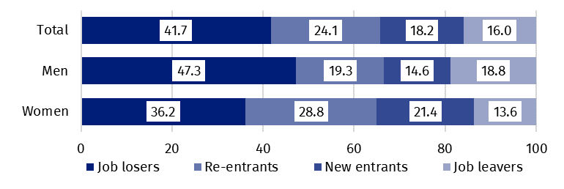
Chart 6. Structure of unemployed persons by the source of unemployment in the fourth quarter of 2024 (in %)
The average duration of job search by unemployed persons in the fourth quarter of 2024 was 8.4 months

In the fourth quarter of 2024, unemployed persons had been looking for a job 8.4 months on average (in the previous quarter 7.6 months and in the fourth quarter of 2023 it was 8.5 months). On average, persons who were seeking a job for the longest duration were the ones aged 35-44 (10.5 months), aged 55-74 (9.8 months) and aged 45-54 (9.6 months), while the shortest job search duration was observed for the youngest persons i.e. aged 15-19 (4.1 months) and aged 30-34 (6.4 months).
41.6%
The share of economically
inactive persons in the total number of the population aged 15–89

In the fourth quarter of 2024, economically inactive persons accounted for 41.6% of the total number of population aged 15-89. The percentage was higher compared to the previous quarter (an increase by 0.2 pp.) and in relation to the fourth quarter of 2023 (an increase by 0.5 pp.).

Economically inactive persons aged 15-89 by the LFS
The number of economically inactive persons was higher than that recorded in the third quarter of 2024 and in the fourth quarter of 2023
In the fourth quarter of 2024, population of economically inactive persons aged 15-89 amounted to 12 610 thousand and was higher in relation to the third quarter of 2024 (by 58 thousand persons, i.e. 0.5%) and compared to the fourth quarter of 2023 (by 118 thousand, i.e. 0.9%).
Over half of the population of economically inactive persons constituted women – in the analysed age group their share was 60.2% (7 595 thousand). Economically inactive women accounted for 48.1% of all women aged 15-89, while analogous indicator for men was 34.5%. Taking into account division into urban and rural areas, a majority of economically inactive persons constituted urban residents (59.8%; i.e. 7 545 thousand), which is connected with a higher population in urban than in rural areas (respectively 3/5 and 2/5 of the total population in Poland). The share of economically inactive among all urban residents in the analysed age group was at the level of 41.3% and among rural residents amounted to 42.0%.
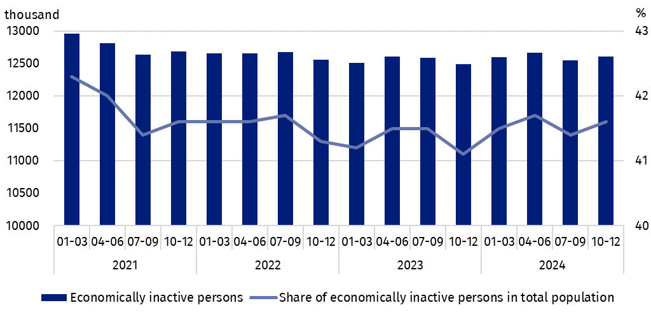
Chart 7. Economically inactive persons and the share of economically inactive persons in population aged 15-89
Compared to the third quarter of 2024, the number of economically inactive women (by 37 thousand persons, i.e. by 0.5%) and men (by 22 thousand, i.e. by 0.4%) increased. An increase in the number of economically inactive persons was recorded among all urban residents (by 54 thousand, i.e. by 0.7%), while among rural residents their number remained at a similar level.
Compared to the fourth quarter of 2023, the number of economically inactive men (by 62 thousand persons, i.e. by 1.3%) and women (by 58 thousand, i.e. by 0.8%) increased. An increase in the number of economically inactive persons was recorded among rural residents – by 120 thousand, i.e. by 2.4%, while among urban residents the number of economically inactive persons did not change.
The economically inactive population is a specific one in respect to the labour market resources. Its scope includes persons who have not entered the labour market yet (including the majority of the youth still participating in education) and persons who have definitely left the labour market or will never enter the labour market (some retirees, pensioners, persons maintaining themselves from other sources than work), but also persons who entered the labour market, then partially deactivated and who will want to re-enter the labour market after a break.
In the fourth quarter of 2024, over half of the economically inactive persons aged
15-74 comprising 10 008 thousand (the reason for inactivity was determined for this age group) constituted retirees (51.3%), while the second largest group were students (22.8%). It is worth noting that education and training as well as illness and disability were more often the reasons for inactivity among men (respectively 27.4% and 16.8%) than among women (respectively 19.6% and 6.9%). On the other hand, family responsibilities were much more often the reason for inactivity among women (11.7%) than men (1.3%).
Education and training were the most often reason for economic inactivity of persons at the working age, and family and households responsibilities were much more often the reason for women's economic inactivity
In the case of 3 797 thousand economically inactive persons at the working age (women aged 18-59 and men aged 18-64), the most often reasons for inactivity were: education and training – 29.9%, illness and disability – 24.9% and family responsibilities – 18.8%. Retirement as the reason for inactivity on the labour market indicated 8.7% persons at the working age, while persons discouraged with unsuccessful job search constituted 1.3% of this group.
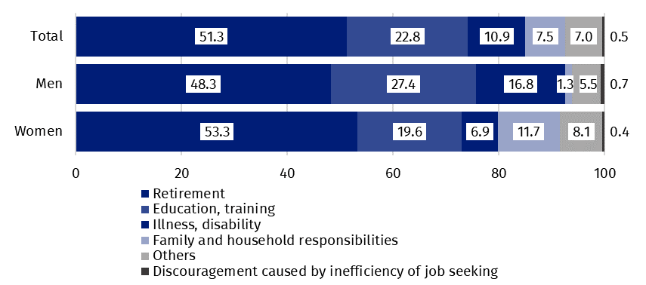
Chart 8. Structure of economically inactive persons aged 15-74 by sex and reasons for inactivity in the fourth quarter of 2024 (in %)

Methodological notes

The presented news release was prepared on the basis of the generalised results of the sample survey Badanie Aktywności Ekonomicznej Ludności/BAEL.
Since the fourth quarter of 2023, generalization of the survey results over the general population has been carried out with the use of the data on resident population in Poland coming from the balances compiled on the basis of the Population and Housing Census 2021 (by the third quarter of 2023, the results were generalized over the general population using population data from the balances compiled on the basis of the Population and Housing Census 2011). The data published in this news release and in the attached tables for the period from the first quarter of 2021 to the third quarter of 2023 have been recalculated in accordance with the new basis for generalizing results and are therefore comparable.
Badanie Aktywności Ekonomicznej Ludności (Eng. Labour Force Survey) has been carried out in Poland quarterly since May 1992 and it has been improved in accordance with the International Labour Organization and Eurostat recommendations.
From the first quarter of 2021 onwards, the base of the EU-LFS methodology are definitions of the employed, the unemployed and economically inactive persons in accordance with the Resolution concerning statistics of work, employment and labour underutilization adopted in 2013 on the 19th International Conference of Labour Statisticians in Geneva (ICLS) and re-commended by the International Labour Organization (ILO) for the use in all countries. The survey object is the situation within the scope of economic activity of the population, i.e. the fact of performing work, being unemployed or economically inactive persons in the reference week. In the European Union, the implementation of the provisions of the above mentioned Resolution was carried out through introduction of new legal acts. From 2021 onwards, EU-LFS has been one of the key surveys embraced by the framework regulation for social statistics (the so-called IESS FR). Accompanying IESS FR implementing regulations in the domain of the labour force specify the range of the core survey and module surveys, determine survey organisation and define in detail particular populations specified according to the status of persons in the labour market.
Detailed results of the survey as well as the up-dated methodology – obligatory from the first quarter of 2021, are included in the quarterly publication “Labour Force Survey in Poland” and in the Methodological report available on the Statistics Poland website:
https://stat.gov.pl/en/topics/labour-market/working-unemployed-economically-inactive-by-lfs/labour-force-survey-in-poland-quarter-32024,2,55.html
https://stat.gov.pl/en/topics/labour-market/yearbook-of-labour/methodological-report-labour-force-survey,8,2.html

Prepared by:  Social Surveys and Labour Market Department  Director Hanna Strzelecka  Phone: (+48 22) 608 32 79 | Issued by:  Press Office  Mobile +48 695 255 032  Phone +48 22 608 38 04, +48 22 449 41 45,  +48 22 608 30 09  e-mail: obslugaprasowa@stat.gov.pl

www.stat.gov.pl/en/

@StatPoland

@GlownyUrzadStatystyczny

gus_stat

glownyurzadstatystycznygus

glownyurzadstatystyczny
Related information
Methodological report. Labour Force Survey
Labour Force Survey in Poland
Other publications containing the results of LFS and its module surveys
stat.gov.pl → Topics → Labour Market
Data available in databases
Strateg → Topics → Labour Market
Local Data Bank → labour Market
Terms used in official statistics
Economic activity by LFS
Economically active population by LFS
Employed persons by LFS
Unemployed persons by LFS
Economically inactive population according to the LFS

Activity rate by LFS
Employment rate by LFS
Unemployment rate by LFS

Generalisation of the survey results over the general population has been carried out with the use of the data on resident population in Poland coming from the balances compiled on the basis of the Population and Housing Census 2021. Data for the period from the first quarter of 2021 to the third quarter of 2023 was recalculated in line with the new generalisation basis. See methodological notes on page 8.
The LFS results refer to the resident population i.e. staying or intending to stay in the country’s territory for at least 12 months, living in private households.
Men aged 18-64 and women aged 18-59.
Work at home is performed by, for example, persons who conducted own economic activity and their home is their workplace, as well as employees who work at home in the form of remote work.
Remote work is performed outside the establishment with the use of electronic communication means.
The average duration of job search is the period, counted in months, during which unemployed persons are actively looking for a job (the last continuous, i.e. without a significant interruption, period of looking for a job is taken into account here).
Regulation (EU) 2019/1700 of the European Parliament and of the Council of 10 October 2019 establishing a common framework for European statistics relating to persons and households, based on data at individual level collected from samples.

