Light utility vehicles survey in 2023

Operational transport performance in the group of vehicles with a maximum permissible laden weight (MPLW) up to 3.5 t reached the value of 4.3 billion vehicle-kilometres whereas transport performance 963.4 million tkm. Transport performance by vehicles with a MPLW in the range from 2.5 to 3.5 t accounted to 91.3% of the total transport performance.
Operational transport perfor-mance by light utility vehicles 4,3 billion
vehicle-kilometres

Survey results
The study covered vehicles with a MPLW of up to 3.5 t (excluding special purpose vehicles). Their use expressed in vehicle-kilometres was analysed according to three main categories:
- freight transport, including both for hire or reward (transport services performed for a fee on behalf of companies and individuals) and for own account (transport for the company's own needs, not directly related to transport services);
- passenger transport for hire or reward, including that performed on behalf of companies and institutions or transport of people for their own account, e.g. transporting employees to work;
- other transport, including private transport and empty trips, i.e. trips without goods, which may result from the need to return the vehicle to the base or move to the loading place.
In the group of vehicles with a MPLW of up to 3.5 t, two subgroups were distinguished:
- vehicles with a MPLW of up to 2.5 t;
- vehicles with a MPLW of over 2.5 t to 3.5 t.
Vehicles with a maximum permissible laden weight (MPLW) of 2.5 to 3.5 tonnes had the largest share in operational work performance in the transport of goods. They performed more than twice as much work compared to vehicles with MPLW below 2.5 tonnes. The opposite situation was in the case of other transports, including private transport and empty trips, where vehicles with MPLW up to 2.5 tonnes were used more intensively.
Chart 1. Operational work performance structure of light utility vehicles by category of use
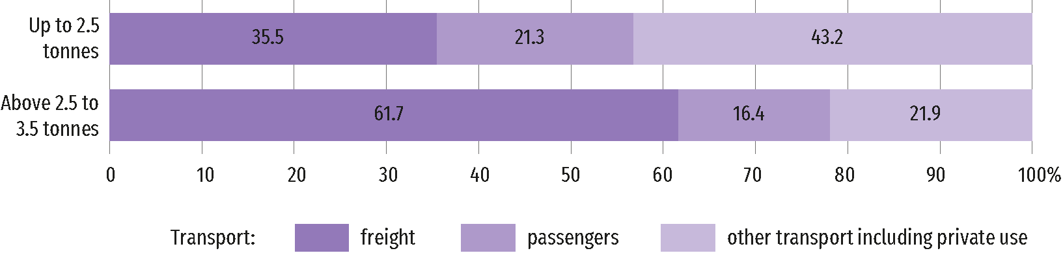
Source: own work.
The distances travelled by light utility vehicles on roads in urban areas amounted to 39.7% of all distances, which indicates the intensive use of these vehicles in urban transport,
including deliveries to commercial, service or household entities. Trips on motorways had a small share, which results from the specificity of use of these vehicles. Whereas the largest share of trips by these vehicles was made on other roads (i.e. 48.9% of all distances), including national, provincial and local roads, which are key communication routes between smaller towns and rural areas.
Chart 2. Light utility vehicles mileage structure by road type
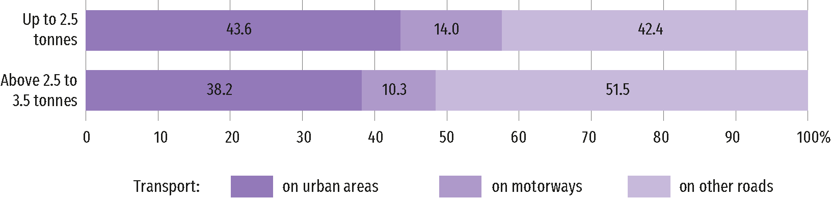
Source: own work.

The types of activities carried out by entities who use vehicles up to 3.5 tons are quite diversified. Vehicles used by entities from section G – Wholesale and retail trade and section N – Administrative and support services activities to performed relatively largest mileage, accounting for 18.2% and 16.3%, respectively.
Chart 3. Structure of mileage of light utility vehicles with MPLW up to 3.5 tonnes
by NACE sections
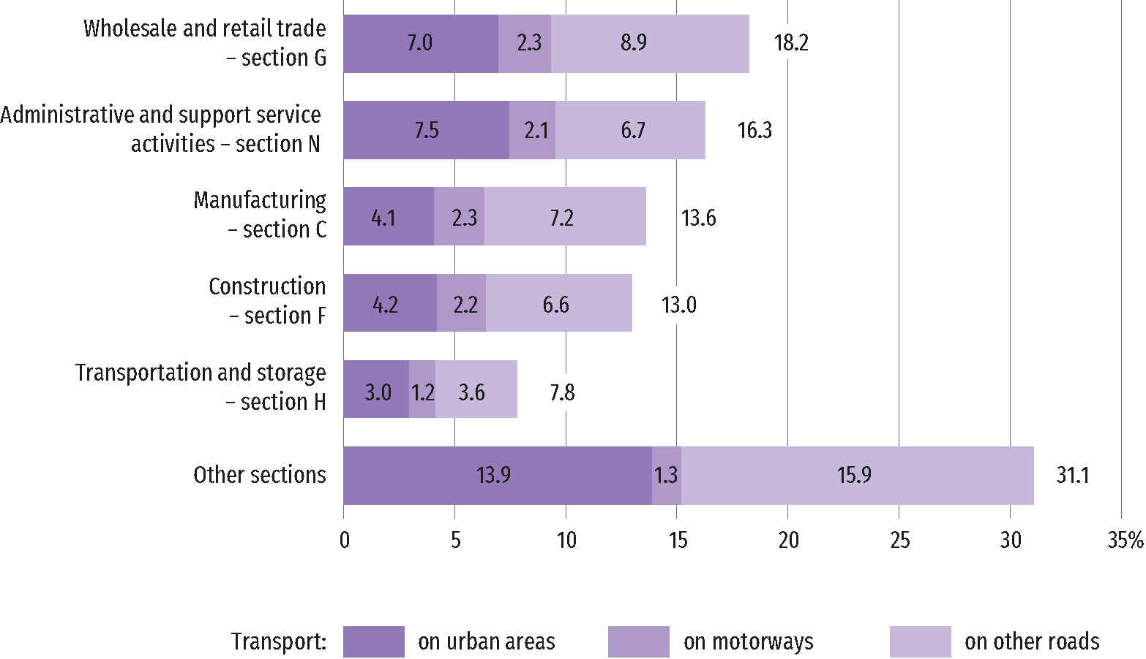
Source: own work.

Domestic transport dominated in goods transport, accounting for 99.7% of all goods trips and 94.9% of all transport performance. The "Machinery, equipment and apparatus" group, including mechanical and electronic equipment, industrial tools and spare parts, was the largest group of goods transported by light utility vehicles. Goods from this group accounted for 43% of all goods transported, and its share was more than three times greater than in the case of the next group – "Food products, beverages and tobacco products".

Chart 4. Structure of transport of goods by light utility vehicles with MPLW up to 3.5 tonnes
according to the NST 2007 classification
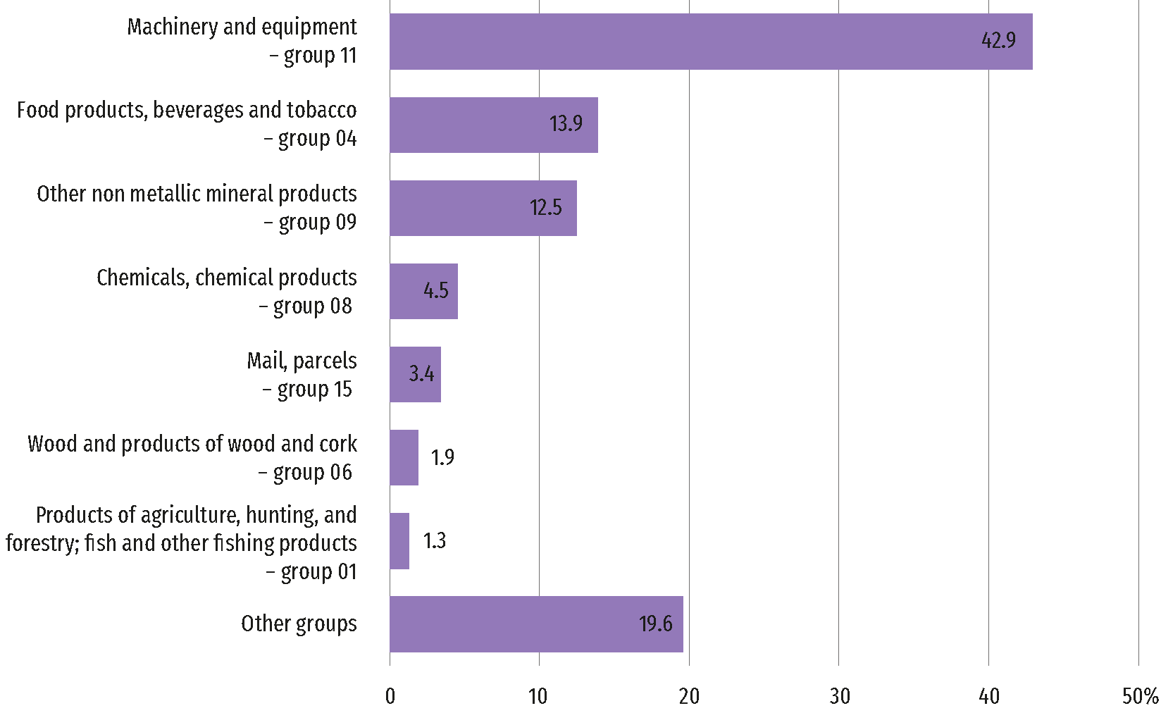
Source: own work.

Methodological notes / Final remarks
The initiated project is the result of activities aimed for monitoring and analysis of the
"European Green Deal", which sets the directions for the development of the economies of the Member States in the perspective of the European Union's climate goal, which is climate neutrality by 2050. One of the main areas of intervention (strategy) is transport.
The study of Transport by light utility vehicles, i.e. vehicles with a maximum permissible laden weight (MPLW) of up to 3.5 tonnes was conducted as part of the project "Development of new transport statistics", implemented on the basis of a grant agreement with Eurostat on a random sample of vehicles used by enterprises (excluding households). The study lasted 12 months – from the beginning of June 2023 to the end of May 2024.
The main objective of the activity was to implement a pilot data collection and measure the scale of transport and travel distances in the light utility vehicles (LUV) segment. The study was conducted based on the methodology developed by the Light Utility Vehicles Task Force.
As a result of the work carried out, a national methodology for collecting harmonized data and a set of output data for light commercial vehicles (LUV) were developed.

When quoting data from the Central Statistical Office, please include the following information: "Source of data from the Central Statistical Office", and in the case of publishing calculations made on the data published by the Central Statistical Office, please include the following information: "Own study based on Central Statistical Office data".

Funded by the European Union. Views and opinions expressed are however those of the author(s) only and do not necessarily reflect those of the European Union or Eurostat. Neither the European Union nor the granting authority can be held responsible for them.

Prepared by:  Statistical Office in Szczecin  Deputy director Katarzyna Dmitrowicz-Życka  Phone: (+48 91) 459 77 00 | Issued by:  Press Office  Mobile: (+48) 695 255 032  Phone: (+48 22) 608 38 04, (+48 22) 449 41 45,  (+48 22) 608 30 09  e-mail: obslugaprasowa@stat.gov.pl

stat.gov.pl/en/

@StatPoland

@GlownyUrzadStatystyczny

gus_stat

glownyurzadstatystycznygus

glownyurzadstatystyczny

