Social Protection Benefits in 2021

According to the data of the European system of integrated social protection statistics (ESSPROS), in Poland in 2021 the expenditures for social protection benefits amounted to 591.9 billion PLN, which accounted for 98.4% of total sum of expenditures for social protection.
591.9 billion PLN
The expenditures for social protection benefits in 2021

Expenditures for social protection benefits by function
Social protection benefits in the ESPROS system are broken down by eight functions: Sickness/Health Care, Disability, Old Age, Survivors, Family/Children, Unemployment, Housing, Social Exclusion (not elsewhere classified).
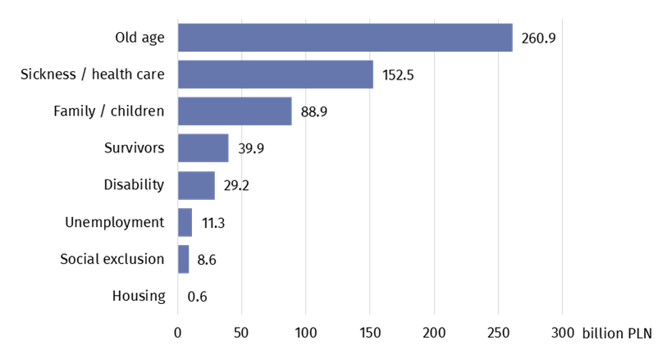
Chart 1. Expenditures for social protection benefits by function in 2021
The expenditures in function Old Age accounted for the biggest share of total expenditures (44.1%)
Source: Eurostat
Considering the type of benefit, social benefits are divided into cash benefits and benefits in kind. Cash benefits are not required to evidence actual expenditures. Benefits in kind are delivered in form of goods and services. They can be granted directly or be reimbursed thus required to evidence them.
In 2021 cash benefits constituted the biggest share of expenditures for social protection benefits (73.1%), while benefits in kind were remaining part. There were no benefits in kind in Survivors function.
Cash benefits constituted 73.1% of total expenditures for social protection benefits
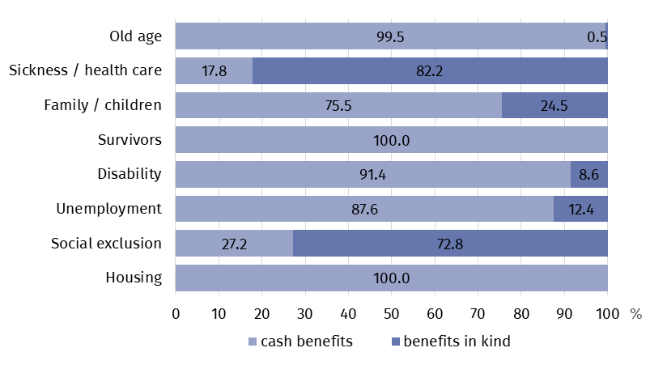
Chart 2. Expenditures for social protection benefits in cash and in kind by function in 2021
Source: Eurostat
Non means-tested benefits accounted for 98.1% of total expenditures
In 2021 r. the biggest share of expenditures was assigned for non means-tested benefits (ca. 98%). Just 1.9% of the financial resources was spent in compliance with means-tested criterion for their beneficiaries.
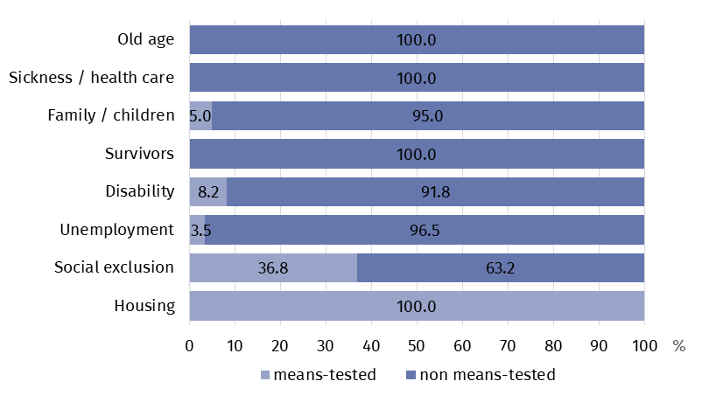
Chart 3. Expenditures for non means-tested and means-tested social protection benefits by function in 2021
Source: Eurostat

Poland in comparative perspective
The comparison of social protection systems in various European countries constitutes one of the principal objective of the preparation of the data produced annually in consistence with the ESSPROS methodology. In order to do that the expenditures for social protection per capita and the share of social protection expenditures in gross national product are most frequently used indexes.
In Poland the index of the level of expenditures for social protection benefits per capita amounted to 3.4 thousand euro
The index of the level of expenditures for social protection benefits per capita in Poland in 2021 amounted to 3.4 thousand euro. Similar level of expenditures featured Latvia (3.4) and Slovakia (3.5). The lowest level of expenditures was observed in Albania (0.7) and the highest one in Luxembourg (24.4). The average for all analysed countries amounted to 8.7 thousand euro per capita.
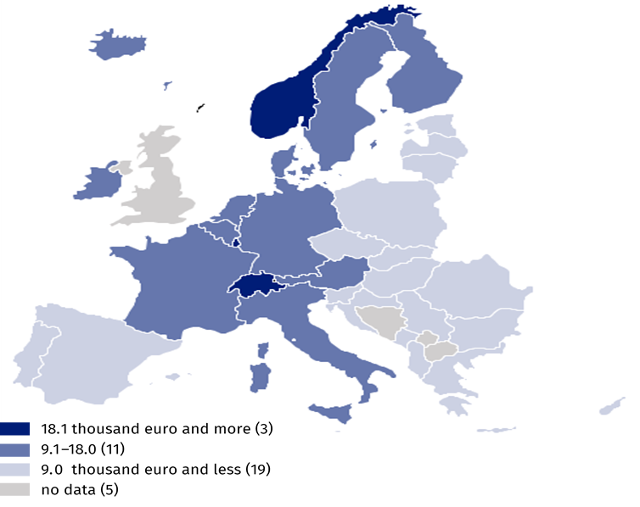
Map 1. Expenditures for social protection benefits per capita in the European countries in 2021
Source: Eurostat
Poland with the share of expenditures for social protection in gross national product index at 22.5% is in the middle in the ranking of the European countries
In 2021 Poland assigned 22.5% of gross national product for social protection benefits, which is the value close to the European average (23.3%). Slightly higher share of expenditures was noted in Slovenia (24.8), Portugal (25.6) and Norway (26.2). Scarcely lower share was observed in Cyprus and Croatia (21.8 each), Luxembourg (21.5) and Czech Republic (21.2). The highest share of expenditures for social protection in gross national product occurred in France (33.4) and the lowest one in Albania (12.8).
Map 2. Share of expenditures for social protection benefits in gross national product in the European countries in 2021
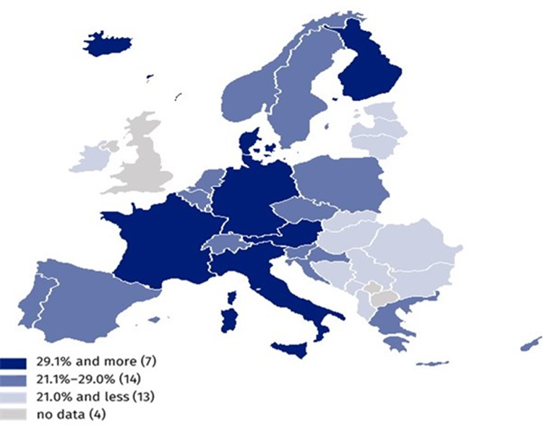
Source: Eurostat

Supplementary notes
The European system of integrated social protection statistics (ESSPROS) has been developed in response to the need for creating the special instrument of statistical observance of social protection. The underlying goal of the ESSPROS methodology is to provide the complex and consistent description of social protection in the European Union member states by calculating the value of the full scope of benefits and their financing in order to enable their international comparability and harmonisation with other statistics, in particular with national accounts. The formal basis for the ESSPROS methodology application are defined in the legal provisions, laid mainly in the Regulation (EC) No 458/2007 of the European Parliament and of the Council of 25 April 2007 on the European system of integrated social protection statistics (ESSPROS).
The scope of benefits granted in social protection in Poland has been defined on the basis of the ESSPROS methodology as well as on Polish legislative acts: Act of 12 March 2004 on Social Assistance, (consolidated text of Journal of Laws of 2023, item 901), Act of 13 June 2003 on Social Employment (consolidated text of Journal of Laws of 2022, item 2241), Act of 24 April 2003 on Public Benefit Activity and on Volunteering (consolidated text of Journal of Laws 2023, item 571).
According to the ESSPROS methodology there are four categories of expenditures: social protection benefits, administrative costs related to the benefits delivery, transfers to other schemes and other expenditures.
Social protection benefits are divided into cash transfers and transfers in kind, which are granted by social protection schemes to the households and individual persons in order to relieve them from the burden of the certain type of risk or to meet specific need. They refer to cash payments, reimbursements (cash benefits) and to goods and services provided directly (benefits in kind). They imply an equivalent rise in the disposable income of the beneficiaries.
Administration costs are incurred in relation to managing and administering social protection schemes and include outgoings on registration of beneficiaries, collection of contributions, administration of benefits, inspection, reinsurance and financial management
Transfers to other schemes mean unrequited payments made to other social protection schemes which are re-routed social contribution to other schemes, while they are in line with a rule that the value the expenditures in one scheme is equal to the receipt side in the other scheme. In the receiving schemes those values finally increase their expenditures for benefits.
Other expenditures are mostly actual interests payable due to the bank loans and payments of taxes on income or property.
In the case of quoting data from the Statistics Poland, please provide information: "Statistics Poland data source", and in the case of publishing calculations made on data published by the Statistics Poland, please provide information: "Own study based on Statistics Poland data".
Prepared by:  Statistical Office in Kraków  Director Agnieszka Szlubowska  Phone: (+48 12) 420 40 50 | Issued by:  Press Office  Mobile: (+48) 695 255 032  Phone: (+48 22) 608 38 04, (+48 22) 449 41 45,  (+48 22) 608 30 09  e-mail: obslugaprasowa@stat.gov.pl

stat.gov.pl/en/

@StatPoland

@GlownyUrzadStatystyczny

gus_stat

glownyurzadstatystycznygus

glownyurzadstatystyczny
Related information
Social Protection Satellite Account
Terms used in official statistics
Social assistance
Social protection
Social protection benefits

The principal typologies, categorisations as well as definitions included in the news release and referred to the European system of integrated social protection statistics (ESSPROS) are listed under the item Supplementary notes.

