Persons performing work under contracts of mandate and related contracts in Poland in March 2023
2 262.9 thousand
the number of persons performing work under contracts of mandate and related contracts in Poland as at 31 March 2023.

On the last day of March 2023, there were 2 262.9 thousand persons performing work under contracts of mandate and related contracts in Poland. Of these, 967.9 thousand were simultaneously performing work qualifying them as employed persons in the national economy.
The data presented in this study concern persons performing work under contracts of mandate together with contracts of a related nature, i.e. agency agreements, service contracts, activation agreements, appointment letters and contracts with members of supervisory boards. The results presented are part of experimental work aimed at determining the number of persons performing work under civil law contracts.
9 out of 10 persons performing contracts of mandate and related contracts were related to the private sector
At the end of March 2023, there were 2 262.9 thousand persons performing work under contracts of mandate and related contracts (contractors) in Poland. The share of women, who accounted for 51.3%, was slightly higher in the analysed population. This type of contract was mainly used in the private sector, which accounted for 89.6% of the total number of contractors. In the public sector, women accounted for 55.7% and in the private sector for 50.8%.
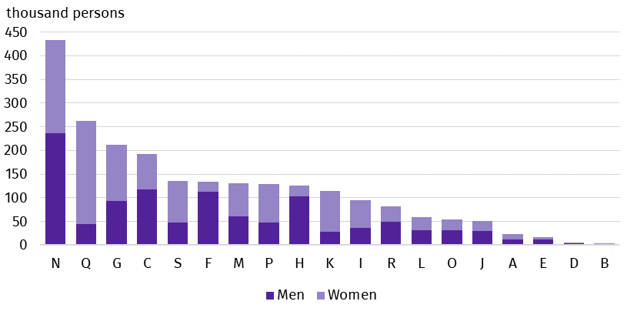
Chart 1. Persons performing work under contracts of mandate and related contracts by PKD/NACE section and sex in 2023
As at 31 March
One in five persons performing contracts of mandate and related contracts was related to the section Administrative and support service activities

As at 31 March 2023, the largest number of persons working under contracts of mandate and related contracts was in the section Administrative and support service activities (19.1%). This section includes, inter alia, the activities of employment agencies providing placement services. The second section in terms of the number of persons performing work on the basis of the contracts in question, Human health and social work activities, had 11.6% of the total number of contractors. At the same time, it was the most feminised PKD/NACE section, in which the share of women was 83.1%. A high share of women was also noted in the section Financial and insurance activities – 75.4%. On the other hand, the highest share of men among contractors was recorded in the sections Construction and Transportation and storage (84.5% and 81.0% respectively).
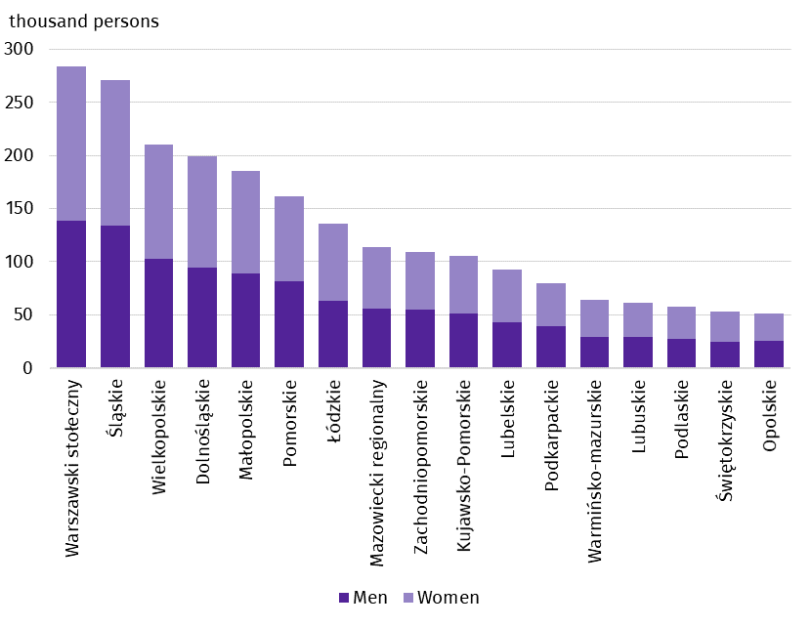
Chart 2. Persons performing work under contracts of mandate and related contracts by place of residenceª and sex in 2023
As at 31 March
a Data by statistical region; excluding persons performing contracts of mandate and related contracts living abroad.
One in four contractors lived in the Warszawski stołeczny region
On the last day of March 2023, the highest number of persons performing work under contracts of mandate and related contracts lived in the Warszawski stołeczny region and the Śląski region – 284.1 thousand and 270.6 thousand persons respectively. The regions with the lowest number of contractors were Opolskie and Świętokrzyskie, where 51.1 thousand and 53.5 thousand persons respectively lived. The share of women ranged from 49.2% in the Zachodniopomorskie region to 54.4% in the Świętokrzyskie region.
There were 26.9 thousand persons living abroad among the contractors, and women accounted for 38.9% of this group.

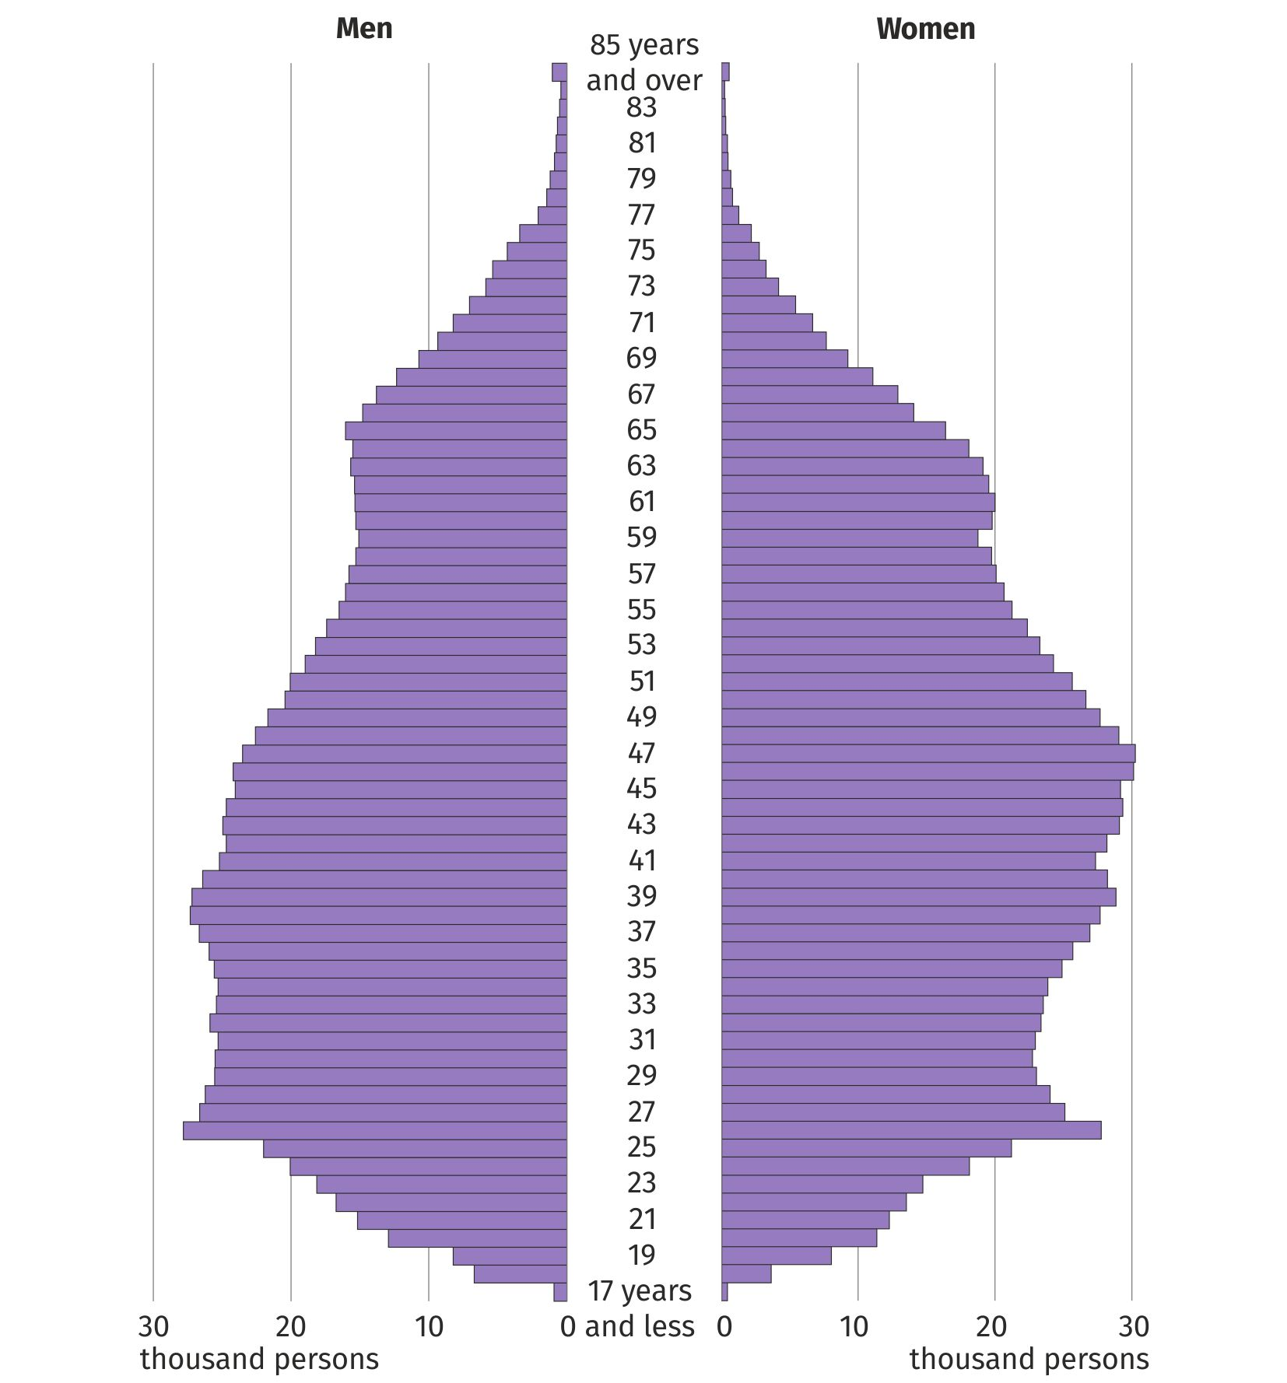
Chart 3. Persons performing work under contracts of mandate and related contracts by age and sex in 2023
As at 31 March
Women outnumbered men among contractors aged 37 to 65 years
According to the provisions of the Polish Civil Code, in Poland, contracts of mandate and related contracts can be concluded by persons aged 13 or over. At the end of March 2023, the median age of contractors was 43 years, and it was two years higher for women than for men (44 years against 42 years). Among contractors between the ages of 37 and 65, there were more women than men performing contracts of mandate and related contracts, while there was a male predominance in the other single-year cohorts.
The median age of women performing work under contracts of mandate and related contracts was 2 years higher than that of men
In labour market statistics, persons performing contracts of mandate and related contracts are not counted as employed persons in the national economy. However, from the population of contractors it is possible to distinguish a set of persons who simultaneously performed work meeting the criteria for employed persons in the national economy. On the last day of March 2023, there were 967.9 thousand such contractors. Among them, 53.8% were women.

Methodological notes
The source of the presented data is administrative registers. The population under study includes persons performing work under contracts of mandate, together with contracts of a related nature to which the provisions of the Civil Code apply and which involve the obligation to be covered by social and/or health insurance at the Social Insurance Institution (ZUS), i.e. agency agreements, service contracts, activation agreements, appointment letters and contracts with members of supervisory boards. However, it does not include those working under contracts to perform a specified task or those performing harvest assistance contracts (farmer's helpers). It also does not include those persons performing work under contracts of mandate and related contracts who have concluded such a contract with their own employer or with another entity but on behalf of their own employer, or who are secondary school pupils or students under the age of 26.

In this news release abbreviated names of NACE, Rev. 2 sections were used. Abbreviations are marked with a ‘Δ’ symbol. Full names are listed below.

The data presented refer to the predominant kind of activity. The data for the section Other service activities (S) also include those employed in the sections Activities of households as employers; undifferentiated goods- and services-producing activities of households for own use (T) and Activities of extraterritorial organisations and bodies (U).

PKD/NACE section symbols:
A – Agriculture, forestry and fishing,
B – Mining and quarrying;
C – Manufacturing;
D – Electricity, gas, steam and air conditioning supply;
E – Water supply; sewerage, waste management and remediation activities;
F – Construction;
G – Wholesale and retail trade; repair of motor vehicles and motorcycles;
H – Transportation and storage;
I – Accommodation and food service activities;
J – Information and communication;
K – Financial and insurance activities;
L – Real estate activities;
M – Professional, scientific and technical activities;
N – Administrative and support service activities;
O – Public administration and defence; compulsory social security;
P – Education;
Q – Human health and social work activities;
R – Arts, entertainment and recreation;
S – Other service activities;
T – Activities of households as employers; undifferentiated goods- and services-producing activities of households for own use;
U – Activities of extraterritorial organisations and bodies.

In the case of quoting Statistics Poland data, please provide information: ‘Source of data: Statistics Poland’, and in the case of publishing calculations made on data published by Statistics Poland, please provide information: ‘Own elaboration based on Statistics Poland data.’
Prepared by:  Statistical Office in Bydgoszcz  Director Wiesława Gierańczyk, Ph.D.  Phone: (+48 52) 366 93 90 | Issued by:  The Spokesperson for the President  of Statistics Poland  Karolina Banaszek  Phone: (+48) 695 255 011
Press Office  Phone: (+48 22) 608 38 04  e-mail: obslugaprasowa@stat.gov.pl |   stat.gov.pl/en/

@GUS_STAT

@GlownyUrzadStatystyczny

gus_stat

glownyurzadstatystycznygus

glownyurzadstatystyczny
Related information
Methodological report Employment in the national economy
Methodological report Employment in the national economy according to administrative data sources
Employed persons in the national economy in Poland in March 2023
Terms used in official statistics
Employment in national economy

Act of April 23, 1964, Civil Code (Journal of Laws of 2023, item 1610, as amended).

