Population exposure to noise in cities
with over 100 thousand inhabitants
Strategic noise maps for 2021 were developed within the framework of environmental monitoring. They illustrate the acoustic condition in cities with over 100 thousand inhabitants. The maps provided the basis for the "Population exposure to noise in cities with over 100 thousand inhabitants" survey which allowed i.a. to estimate the number of people exposed to road traffic, railway, aircraft and industrial noise exceeding the permissible sound levels.
282,8 thousand people living in cities with over
100 thousand inhabitants were exposed to noise exceeding the permissible sound levels.
Noise pollution is a major environmental phenomena adversely affecting the health and well-being of millions of Europeans. At least 20% of the EU population is exposed to health impact of noise.
In Poland, population exposure to noise is monitored based on the Directive of the European Parliament and of the Council of 25 June 2002 relating to the assessment and management of environmental noise. The exposure is assessed using L_{DEN,} day-evening-night noise indicator for overall annoyance and L_{Night} night noise indicator for sleep disturbance.
Pursuant to the Environmental Protection Law, the mayors of indicated cities are obliged to submit strategic noise maps to the Chief Inspector of Environmental Protection every five years (no later than 30 June). 36 cities took part in the fourth round of acoustic mapping in 2021.

Exposure to noise exceeding the limit values during the day-evening-night period
In 2021, 270.0 thousand inhabitants of cities with over 100,000 population were exposed to road traffic noise exceeding the permissible day-evening-night limits, measured by the L_{DEN} indicator, while 9.9 thousand people were exposed to industrial noise exceeding the limit values, 2.2 thousand people were affected by railway noise and 2.5 thousand by aircraft noise.
2.6% of all inhabitants of cities with over 100 thousand population were exposed to road traffic noise exceeding the permissible sound levels
The highest share of people exposed to noise exceeding the permissible day-evening-night limits in the total population of a given city was recorded in Gliwice, Chorzów and Szczecin (10.2%, 8.2% and 7.9%, respectively), while the smallest share (less than 0.05%) was observed in Toruń, Dąbrowa Górnicza and Olsztyn.
Chart 1. Population exposed to noise and areas where the permissible sound levels are exceeded during the day-evening-night period in cities with over 100 thousand inhabitants
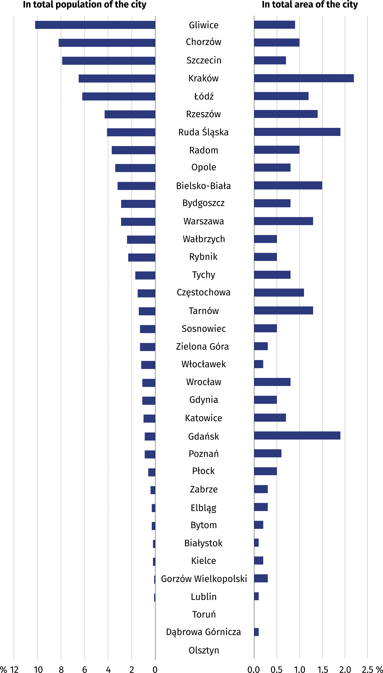
Permissible sound levels exceeded during the night period
190,5 thousand inhabitants of cities with over
100 thousand population were exposed to noise exceeding the permissible sound levels during the night period
The permissible sound levels at night, measured by the L_{Night} index, were exceeded for
190.5 thousand people living in cities with over 100 thousand population. The largest number of people were exposed to road traffic noise (165.1 thousand).
Noise burden from railway and industry above the permissible limits affected more people at night than during the day-evening-night period.
Table 1. Population exposed to noise in cities with over 100 thousand inhabitants
by noise sources
Specification |  | Noise sources
 |  | Road traffic |  | Railway | Industry |  | Aircrafts
The exceeding of a limit value:
during the day-evening-night period |  | 269969 |  | 2197 | 9888 |  | 2482
during the night period |  | 165130 |  | 2458 | 24409 |  | 844
The exceeding of noise limit values is determined according to the ranges indicated in the guidelines for strategic noise mapping. In 2021, the permissible sound levels during
night-time were usually not exceeded by more than 5.0 dB in cities with over 100 thousand population.
Chart 2. Population in cities with over 100 thousand inhabitants exposed to noise
by exceeding of the permissible sound levels during the night period
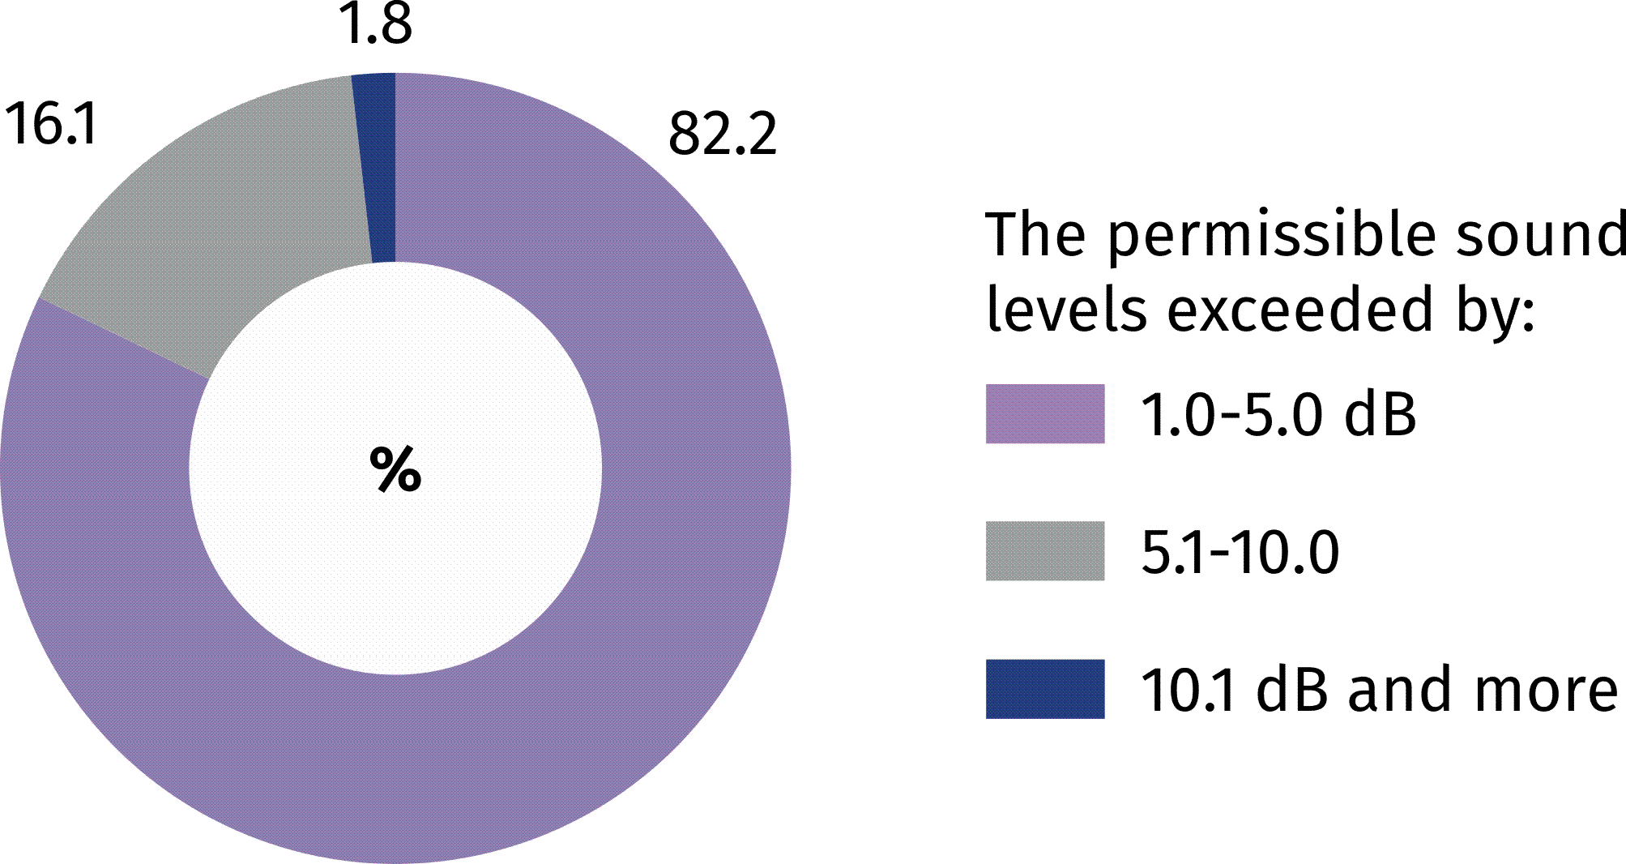
The largest share of inhabitants exposed to noise exceeding the permissible levels during night-time was recorded in Szczecin, Chorzów and Gliwice. However, the largest share of the area where the permissible sound levels are exceeded in the total area of a city was found in Gdańsk, Ruda Śląska and Kraków.
Chart 3. Population exposed to noise and areas where the permissible sound levels
are exceeded during the night period in cities with over 100 thousand inhabitants
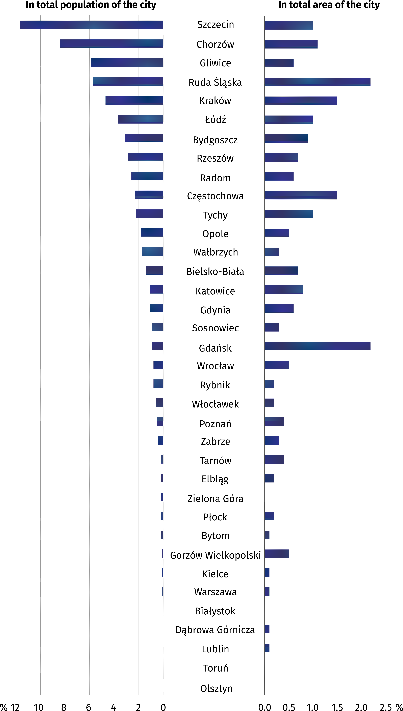
METODOLOGICAL NOTES
- The "Population exposure to noise in cities with over 100,000 inhabitants" survey is conducted every 5 years. The first edition was carried out in 2024 based on data from the following sources:
- strategic noise maps for 2021 - spatial data sets regarding strategic noise maps were obtained from the EHAŁAS-M system administered by the Chief Inspector of Environmental Protection. The detailed scope of data included in strategic noise maps are laid down in the Regulation of the Minister of Climate and Environment of 1 July 2021 on the detailed scope of data included in strategic noise maps, the method of their presentation and the form of their transmission. The deadline for drawing up strategic noise maps is strictly defined by Directive 2002/49/EC of the European Parliament and of the Council of 25 June 2002 relating to the assessment and management of environmental noise (Official Journal L189/12, 18/07/2002 P. 0012 -0025). Member States are obliged to prepare strategic noise maps every 5 years no later than 30 June.
- the resident population assigned to address points - data from the Demographic Surveys Department of Statistics Poland, prepared on the basis of the results of the National Population and Housing Census 2021 (2021 Census) regarding the number of residents assigned to address points in the analysed area.
2. The computations were made for cities with over 100 thousand population for which strategic noise maps for 2021 were drawn up.
3. The exceeded total permissible sound levels for a given area refer to the highest noise level indicated on the strategic noise maps, i.e. the highest value of the L_{DEN} or L_{Night} indicator for road traffic, railway, industrial or aircraft noise.
- Basic definitions
Noise indicators – indicators used to prepare strategic noise maps and environmental protection programmes against noise.
L_{DEN -} A-weighted long-term average sound level expressed in decibels (dB), as defined in ISO 1996-2: 1987 over all days, evenings and nights in a year (understood as a relevant year as regards the emission of sound and an average year as regards the meteorological circumstances), taking into account the time of day (understood as the time interval from 6:00 a.m. to 6:00 p.m.), the time of evening (understood as the time interval from 6:00 p.m. to 10:00 p.m.) and the time of night (understood as the time interval from 10 p.m. to 6 a.m.); this indicator is used to assess the overall noise annoyance.
L_{Night} ₋ A-weighted long-term average sound level A, expressed in decibels (dB), determined as defined in ISO 1996-2: 1987 over all the night periods (understood as the time interval from 10 p.m. to 6 a.m.) of a year (understood as a relevant year as regards the emission of sound and an average year as regards the meteorological circumstances); this indicator is used to assess sleep disturbance.
The exceeding of a noise level - refers to values above the permissible sound levels laid down in the Regulation of the Minister of the Environment of 14 June 2007 on permissible levels of noise caused by particular groups of noise sources.
When quoting Statistics Poland data , please provide the information: "Source of data: Statistics Poland", and when publishing calculations made on data published by Statistics Poland, please include the following disclaimer: "Own study based on figures from Statistics Poland".
Prepared by:  Statistical Office in Gdańsk  Director Jerzy Auksztol  Office: phone (+48 58) 76 83 130 | Dissemination:  Press Office  Mobile: +48 695 255 032  Phones: +48 22 608 38 04,  +48 22 449 41 45,  +48 22 608 30 09  e-mail: obslugaprasowa@stat.gov.pl

www.stat.gov.pl

@GUS_STAT

@GlownyUrzadStatystyczny

gus_stat

glownyurzadstatystycznygus

glownyurzadstatystyczny

"Environmental noise in Europe -2020" European Environment Agency (EEA) report.

