ICT usage by public administration units in 2023
In 2023, all marshal offices equipped employees with portable devices enabling mobile connection to the Internet for business purposes.
89.1%
of public administration units equipped employees with portable devices that allow them to connect
to the Internet for business purposes

Information system security audit
In 2023, over a quarter of public administration units had an ISO system compliant with the standard 27001 implemented
In 2023, 82.4% of public administration units conducted an information system security
audit. This type of audit was carried out more often by local government administration units – 82.6% than by government administration units – 75.9%.
Chart 1. Public administration units that conducted an information system security audit
in 2023
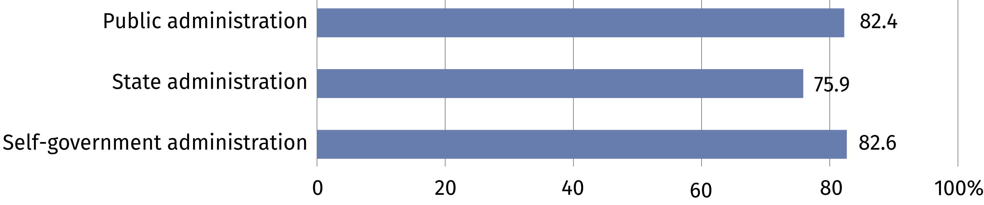

Training for employees in the field of information and communication technologies
The dynamic development of information and communication technologies makes it necessary to improve the competences of persons employed in public administration units.
In 2023, 64.4% of units provided appropriate training for employees for this purpose.
Chart 2. Public administration units that provided training for employees in the field
of information and communication technologies in 2023
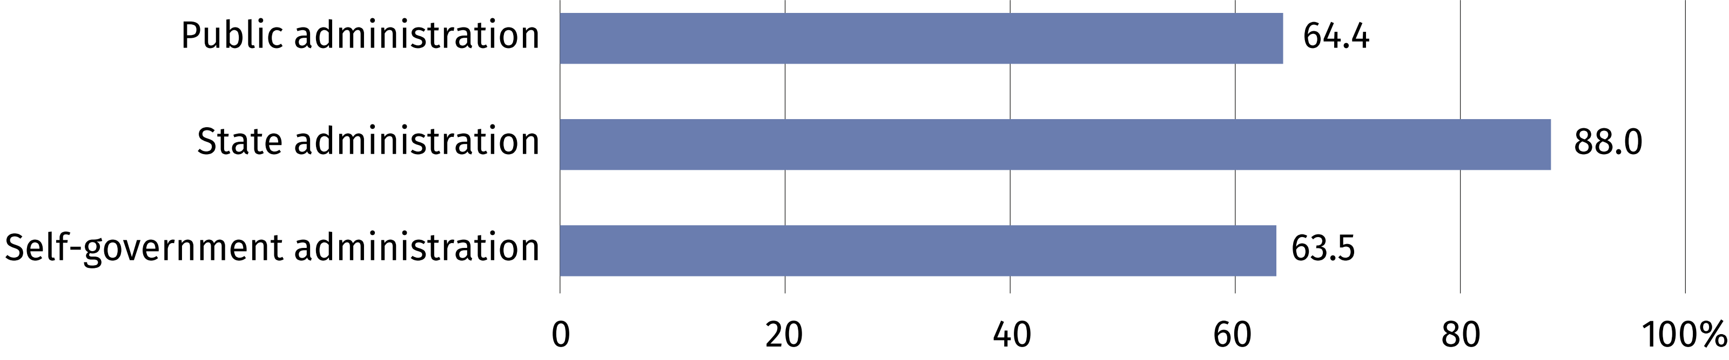

Supporting citizens' digital skills
The need to improve the quality of public administration functioning in the sphere of e-services requires the implementation of new solutions dedicated to both employees and
citizens. In 2023, 95.9% of units that supported the development of digital skills of citizens mentioned activities related to providing advice/instructions on the use of administration
e-services.

Open data
In 2023, 84.3% of government administration units used EDMS as the basic method
of documenting of handling and settling official cases
In order to re-use public sector information, public administration units make available their information resources. Their use comes down primarily to their economic and social nature. This creates the opportunity to use public information in new products or services. In 2023, one fourth of public administration units had an open data policy or had an implemented strategy related to this area, of which over half of government administration units (50.9%).
Chart 3. Public administration units that had an open data policy or had an open data strategy implemented in 2023
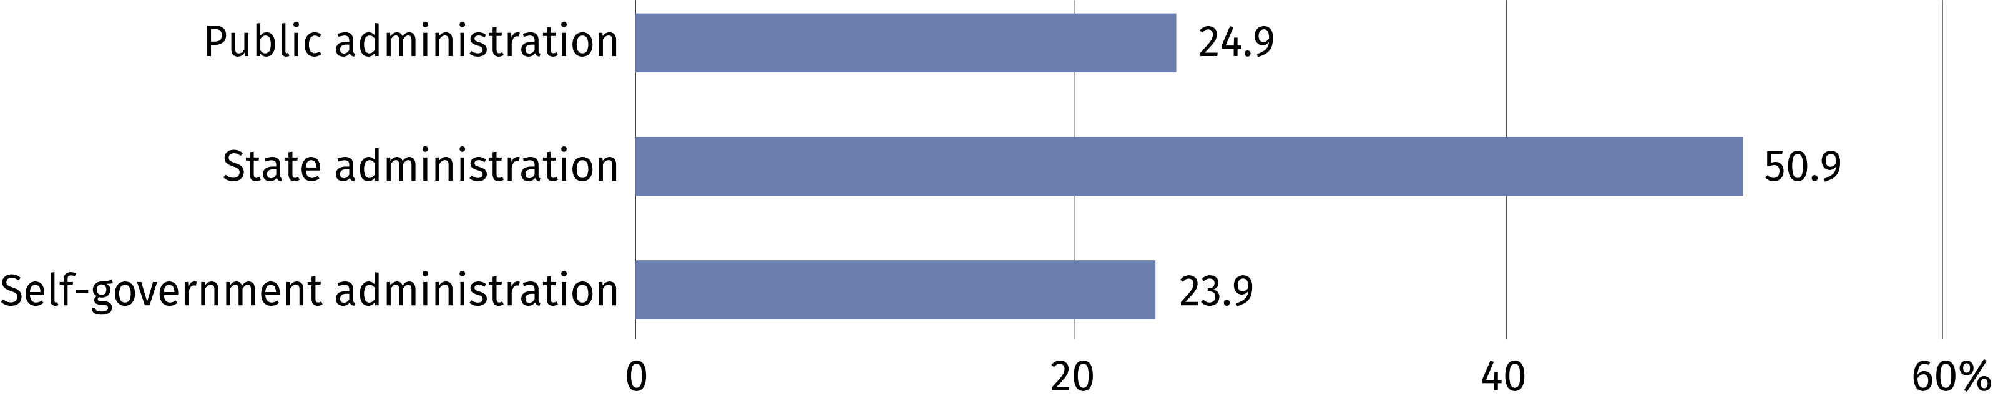

ERP system
The implementation of an ERP system in public administration units translates into, among others, improving their operations and optimising the management of public resources.
In 2023, almost half of public administration units declared the use of this specialised software (47.7%). ERP was used much more often in government administration (80.6%), less
often in local government administration (46.4%).

E-services
Public administration is constantly building new e-services and improving existing ones
in order to enable citizens to handle official matters from anywhere and at any time. In 2023, 96.6% of public administration units declared that their website was compatible with mobile devices. 78.7% of government administration units had website translation services. 26.8%
of public administration units enabled participation in voting or social consultations online.

Providing applications offering e-services
In 2023, government administration monitored the number of cases handled electronically much more often than local government administration (72.2% compared to 34.9%)
Downloadable applications for mobile devices take into account the specific needs of the particular social groups of citizens. In 2023, 33.8% public administration units provided
applications offering e-services.
Chart 4. Public administration units providing applications for mobile devices
in 2023
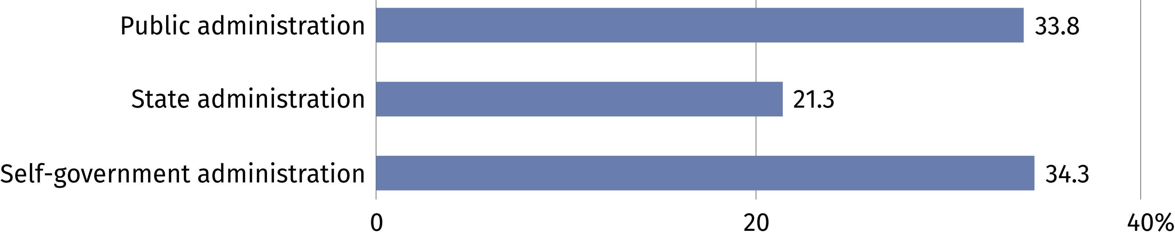

Sharing spatial data
In 2023, 85.4% of public administration units made spatial data available to citizens. This type of e-service was most often provided by district offices (97.1%).

When quoting data from Statistics Poland, please include the following information: "Source of data from Statistics Poland", and in the case of publishing calculations made on the data published by Statistics Poland, please include the following information: "Own study based on Statistics Poland data".

Prepared by:  Statistical Office in Szczecin  Director Magdalena Wegner  Phone: (+48 91) 459 77 00 | Issued by:  Press Office  Mobile: (+48) 695 255 032  Phone: (+48 22) 608 38 04, (+48 22) 449 41 45,  (+48 22) 608 30 09  e-mail: obslugaprasowa@stat.gov.pl

stat.gov.pl/en/

@StatPoland

@GlownyUrzadStatystyczny

gus_stat

glownyurzadstatystycznygus

glownyurzadstatystyczny
Related information
Information society in Poland in 2023
Terms used in official statistics
ERP
Geospatial data
Open data

