Information society in Poland 2024

INFORMATION AND COMMUNICATION TECHNOLOGIES USAGE IN HOUSEHOLDS
AND BY INDIVIDUALS
In 2024, the percentage of individuals aged 16–74 having basic or above basic digital skills amounted to 48.8%, that is, 4.5 p.p. more than in the previous year.
4.5 p.p.
An increase in the percentage of individuals having basic or above basic digital skills compared to 2023

Almost 96% of households
had access to the Internet
In 2024, 95.9 percent of households had access to the Internet, which means a on an annual basis a 2.6 p.p. increase. The percentage of households with fixed-line broadband access
to the Internet increased by 2.6 p.p., while access via mobile broadband was in 2.2 p.p. more households than last year.
Both Internet access and the type of Internet connection owned varied by household type, domicile classes and degree of urbanisation. Households with children were more likely
to have Internet access than the ones without them. Taking into account domicile classes, the percentage of households with Internet was greater in large cities than in smaller towns and in rural areas, and taking into account the degree of urbanisation – it was the highest
in densely populated areas.
Chart 1. Access to the Internet in households
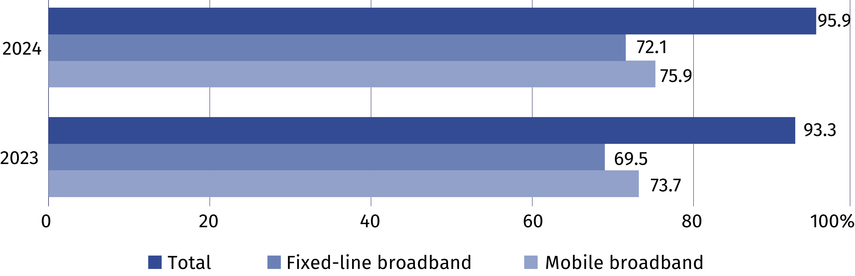
Chart 2. Households with Internet access at home
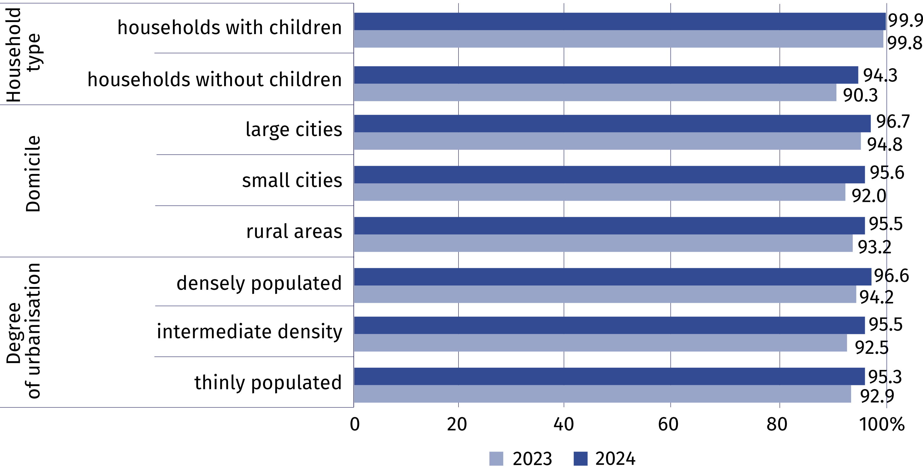
In 2024, individuals using public administration services online in the last 12 months accounted for 61.0% of the population aged 16–74. Use of e-government was indicated by
16.4 p.p. more residents of urban areas than rural areas. The most popular activities performed via the websites or applications of public administration included sending completed tax declarations, searching for information on websites of public authorities, downloading or printing official forms and receiving any official communication/document by public authorities via account on a website or app.
61.0% of individuals aged 16–74 used public administration websites or apps
Table 1. Individuals using e-government services in the last 12 months
Specification | Total | Urban areas | Rural areas
Specification | in % of total individuals
Individuals using e-government services  in the last 12 months | 61.0 | 67.5 | 51.1

in order to:
access personal information stored  by public authorities or public services | 26.2 | 33.0 | 15.9
access information from public databases or registers | 10.3 | 13.2 | 5.8
obtain information | 34.0 | 37.1 | 29.4
make an appointment or reservation | 16.4 | 21.2 | 9.1
receive any official communication/document by public authorities via account on a website  or app | 29.1 | 33.1 | 22.6
print or download official forms | 29.2 | 32.3 | 24.2
submit tax declaration | 39.4 | 46.9 | 27.6
request official documents or certificates | 7.3 | 9.0 | 4.4
request benefits or entitlements | 15.8 | 16.3 | 15.0
In 2024, 67.4% of individuals aged 16–74 ordered or purchased goods or services over the Internet
In 2024, 67.4% of individuals aged 16–74 ordered or purchased goods or services over the
Internet (compared to 64.3% in 2023). On an annual basis, the disparity between urban and rural areas increased (from 9.3 p.p. to 11.1 p.p.); the largest remained in Macroregion Mazowieckie Voivodship (16.9 p.p.), while the smallest in Macroregion Northwest (2.3 p.p.).

Chart 3. Individuals ordering or purchasing goods or services over the Internet for private
use in the last 12 months
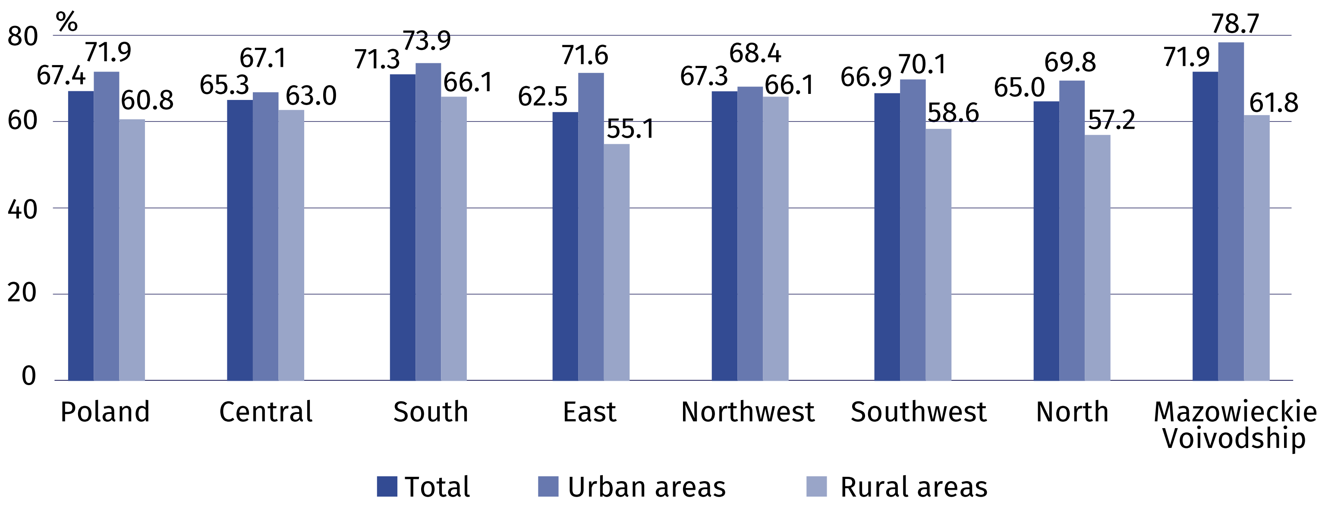
Taking into account the place of residence of individuals ordering or buying online, it can
be noted that the highest percentage of such individuals for urban areas occurred
in Macroregion Mazowieckie Voivodship and for rural areas in Macroregion South and Northwest, whereas the lowest percentage of such individuals for urban areas occurred
in Macroregion Central and for rural areas in Macroregion East.
Analysing data on digital skills, it can be seen that the highest percentage of individuals with basic or above basic digital skills occurred in the 16–24 age group (73.5%), slightly smaller percentage was noted among individuals aged 25–34 (72.1%). The lowest share was found
in the age group 65–74 – it amounted to only 13.7%.
Chart 4. Individuals with basic or above basic digital skills
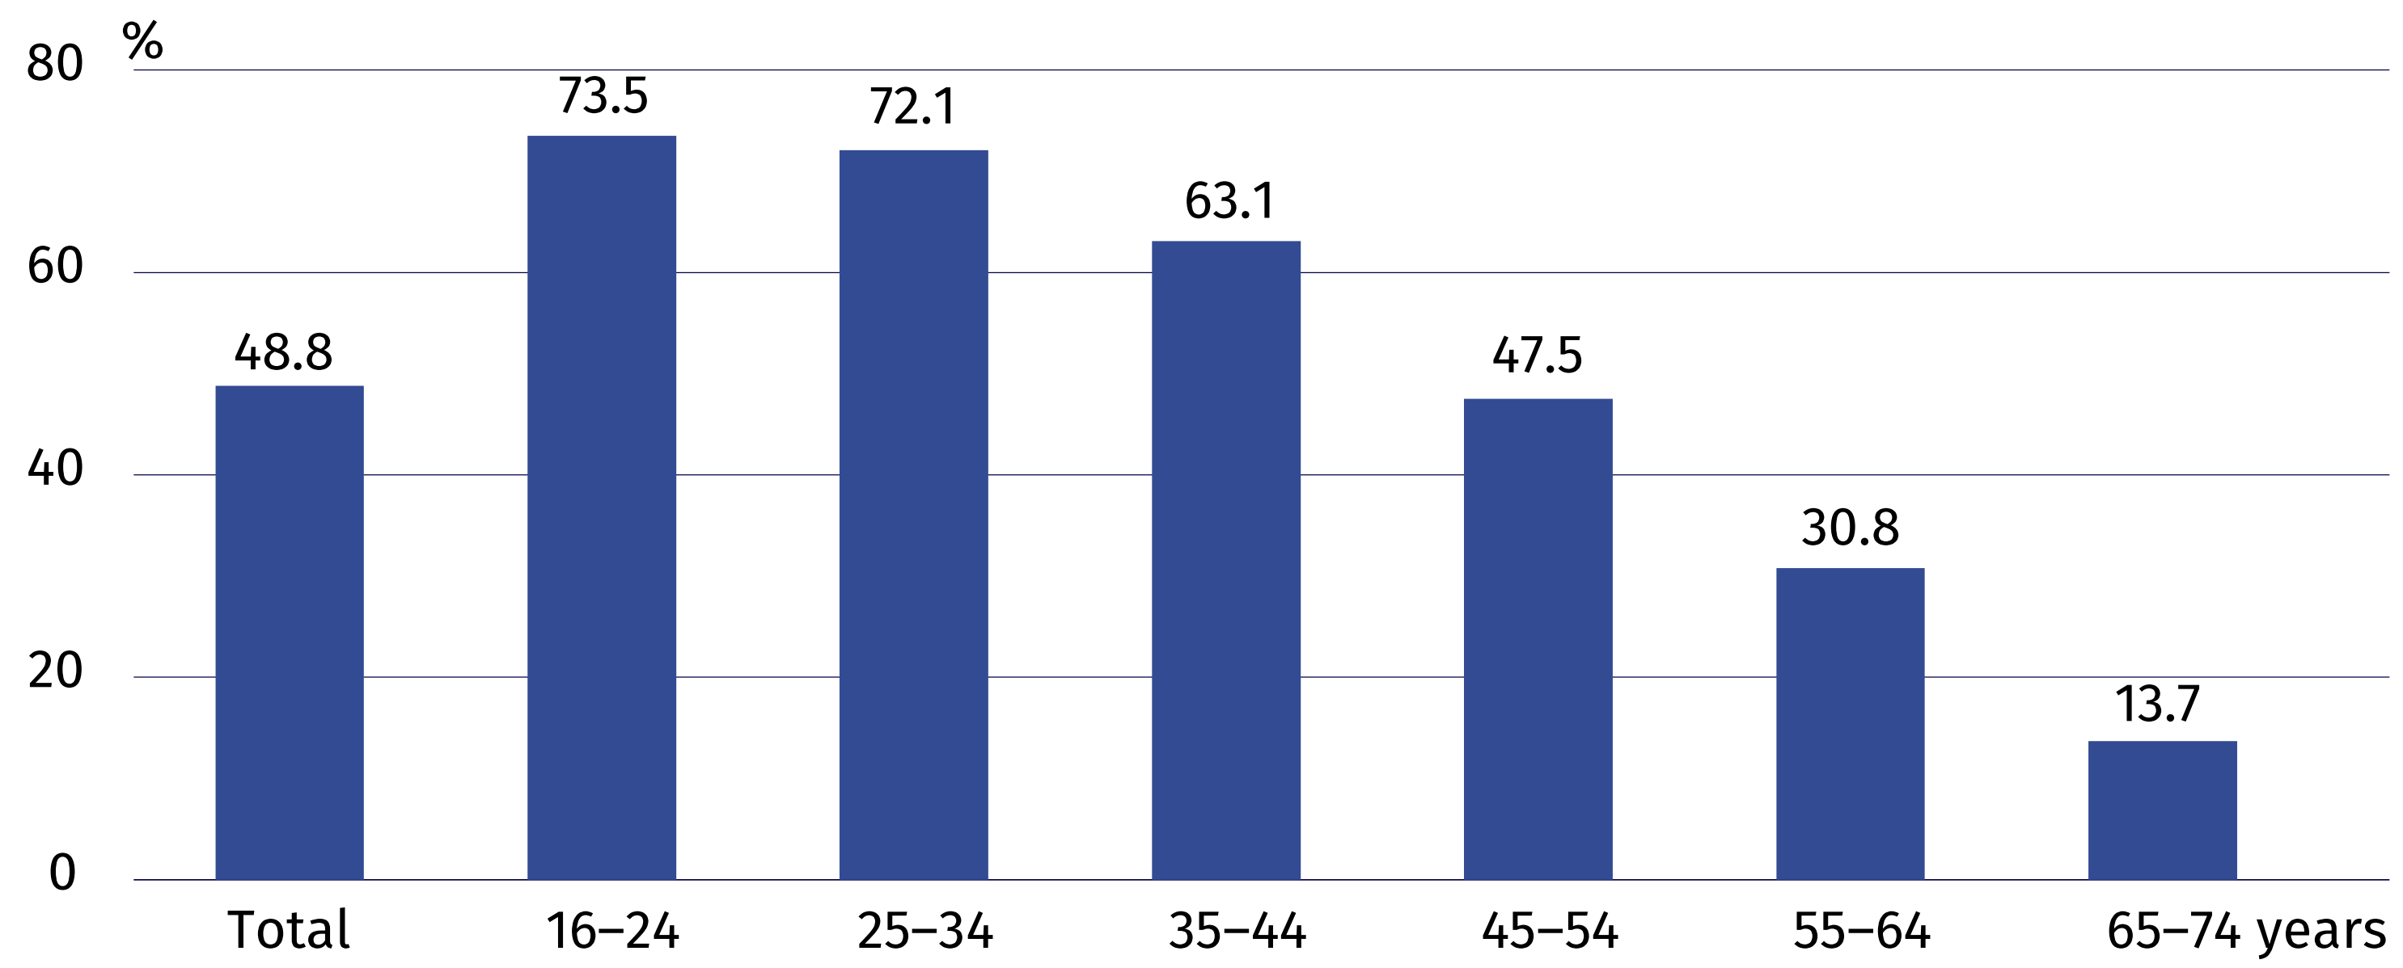

INFORMATION AND COMMUNICATION TECHNOLOGIES USAGE IN ENTERPRISES
In 2024, 26.0% of enterprises employed ICT specialists. Every fifth company paid for advertising
on the Internet. Compared to 2022, the percentage of enterprises providing employees with remote access to their resources has increased significantly (by 21.6 percentage points).
The share of entities with an Internet connection with a capacity of 500 Mbit/s increased over the year (by 6.0 p.p.).
21.6 p.p.
An increase in the percentage of companies providing employees with remote access
to resources compared to 2022.

In 2024, more than a quarter of enterprises (26.0%) employed ICT specialists, 5.6% were recruiting such a specialist, including 1.8% who had difficulties in filling such a position.
In 2024, 5.9% of enterprises used artificial intelligence technologies
Less than one third of enterprises (31.4%) provided their employees with training to improve their ICT skills, including: training for ICT specialists (19.0%), and training for other employees (24.8%).
The percentage of enterprises using ICT security measures was 94.1% in 2024. The most commonly used method was identification and authentication with strong password (84.0%), followed by data backup to separate location (71.4%).
In 2024, 88.7% of enterprises provided their employees with remote access to enterprise resources, including – to business email (83.2%), to business documents and files (63.2%),
to business applications (68.2%).
Chart 5. Enterprises provide employees with remote access to systems
(% of total enterprises)
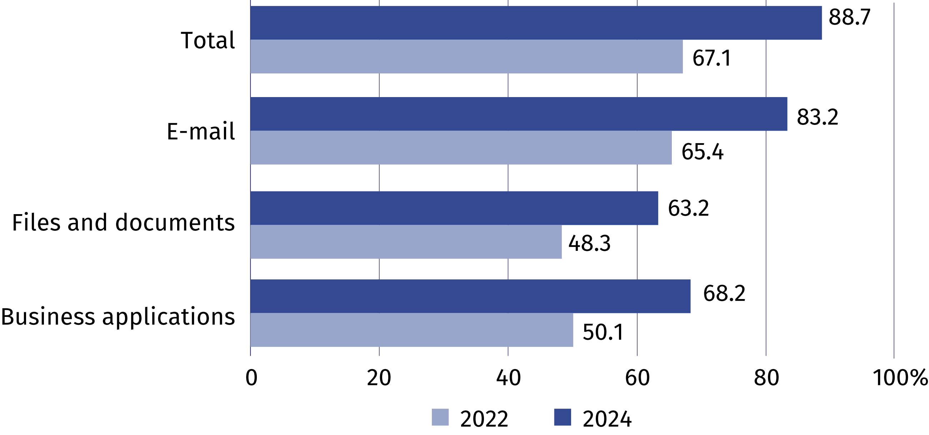
In 2023, 85.5% of enterprises dealt with official matters electronically using a qualified electronic signature or Trusted Profile
In 2023, every fifth company declared that it used open data. Large entities used this type
of data most often (53.7%). Economy and finance were the most popular domain of open data.
Chart 6. Enterprises using open data (in % of total enterprises)
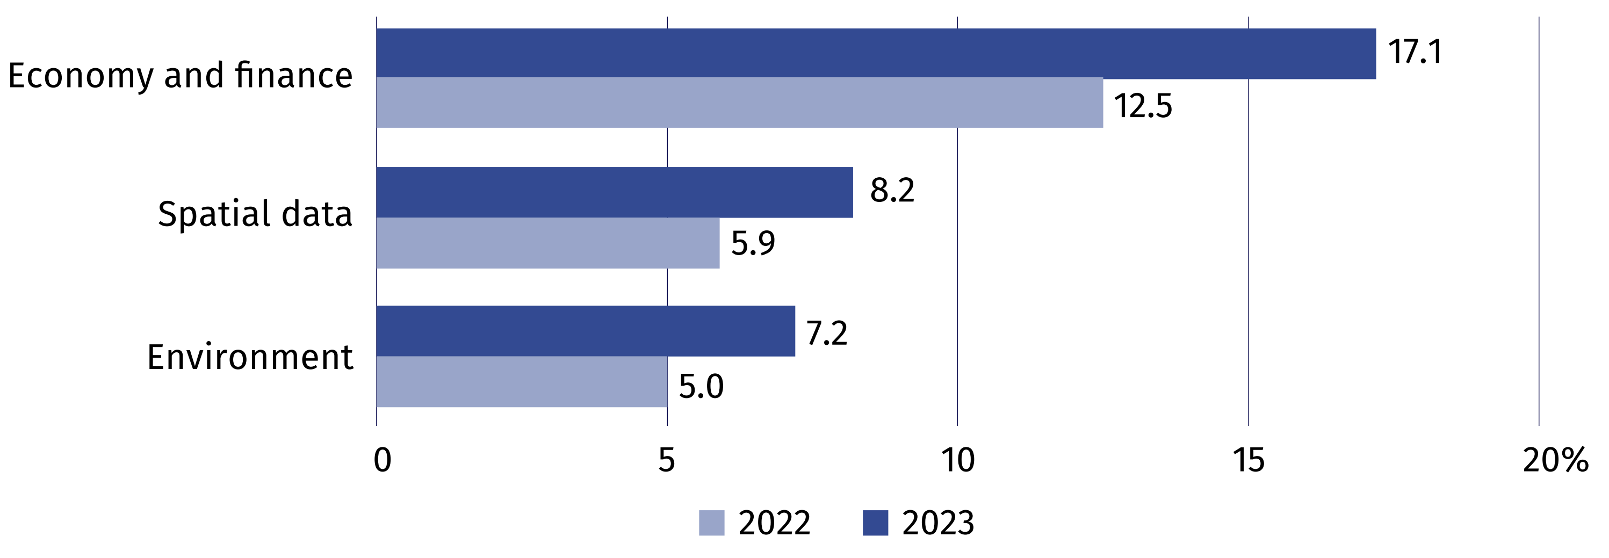
In 2024, over one fifth of businesses paid for online advertising. The most frequently used advertising was based on the content of websites visited by Internet users or keywords entered by them in search engines.

Chart 7. Enterprises paying for advertising on the Internet (% of total enterprises)
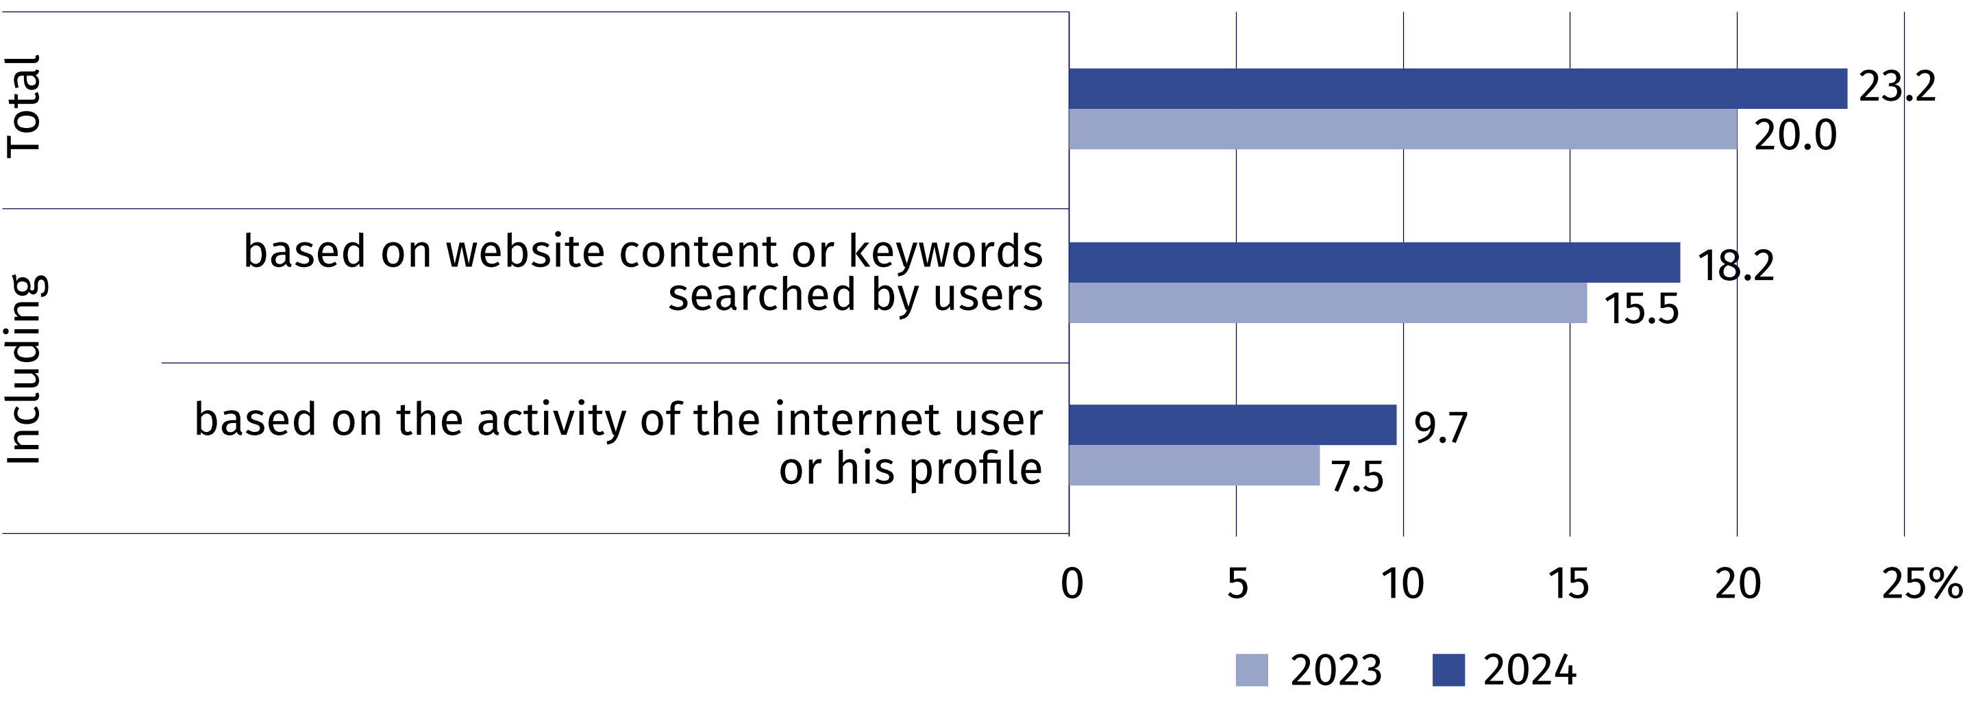
In less than one third of enterprises (32.9%), IT-related tasks were performed by their own employees, while in 78.5% of them they were performed by external entities.
Chart 8. Enterprises where IT tasks were performed by employees or external entities
(in % of total enterprises)
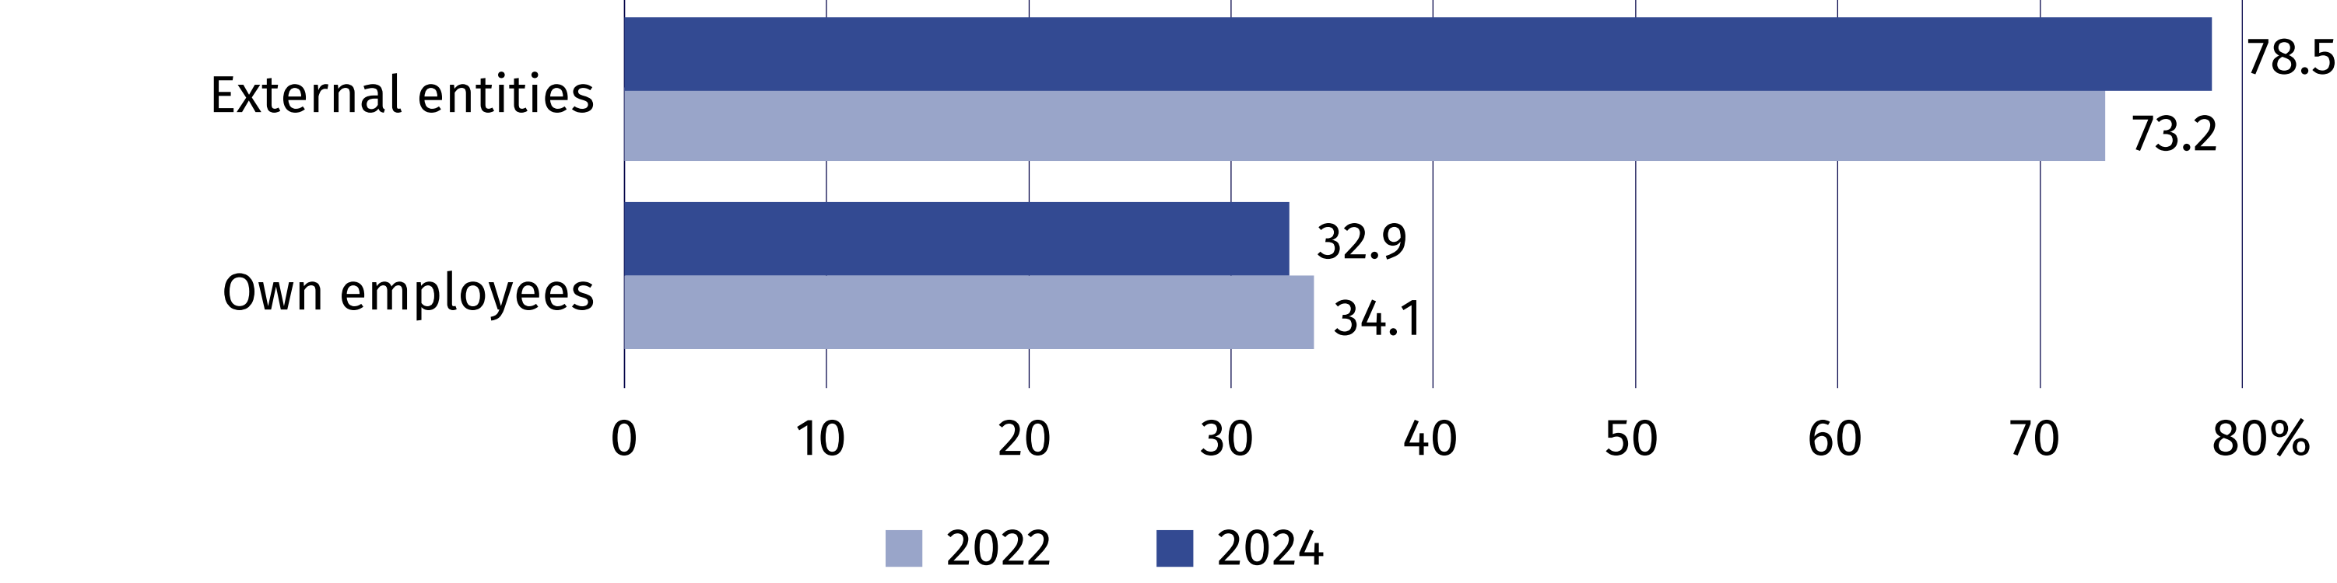
In 2023, 18.1% of enterprises conducted e-commerce; whereby 12.0% of enterprises made sales through own website or application, 10.3% – through online e-commerce platforms, and 3.5% via EDI-type messages.
The percentage of enterprises with an Internet connection with a capcity of at least 500 Mbit/s increased annually by 6.0 p.p. and amounted to 31.3% in 2024. The largest increase was noted among middle sized enterprises (by 8.2 p.p.).
Chart 9. Enterprises with an Internet connection with a capacity of at least 500 Mbit/s
(in % of all enterprises)
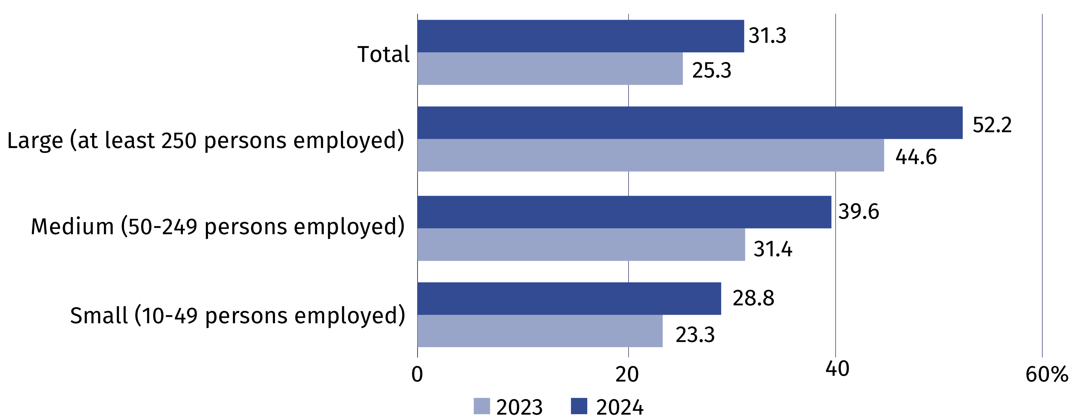

In case of quoting Statistics Poland data, please provide information: “Source of data: Statistics Poland”, and in case of publishing calculations made on data published
by Statistics Poland, please include the following disclaimer: “Own study based on figures from Statistics Poland”.
Prepared by:  Statistical Office in Szczecin  Director Magdalena Wegner  Phone: (+48 91) 459 77 00 | Issued by:  Press Office  Mobile: (+48) 695 255 032  Phone: (+48 22) 608 38 04, (+48 22) 449 41 45,  (+48 22) 608 30 09  e-mail: obslugaprasowa@stat.gov.pl

stat.gov.pl/en/

@StatPoland

@GlownyUrzadStatystyczny

gus_stat

glownyurzadstatystycznygus

glownyurzadstatystyczny
Related information
Information society in Poland in 2023
Methodological report. Information society indicators. Surveys on the use of information and communication technologies
Data available in databases
Knowledge Databases - Digital economy and telecommunications
Local Data Bank – Science and technology – Information society in Poland
Terms used inn official statistics
E-government
E-commerce
Internet
Broadband connection
Mobile connection to the Internet
Open data
Remote access
Information society

Retrospective data according to the years in which the survey in a given domain was carried out.

