Inland waterways transport in Poland in 2023

Both the shape and the length of Poland's inland waterways network have remained almost unchanged for years, while the weight of the inland waterways freight by Polish fleet owners decreased. Factors that directly impacted the decline in inland waterways freight and transport performance, included inadequately developed waterways and unfavourable navigational conditions that determined the basic parameters of the fleet, i.e. the relatively low loading capacity of barges. Regarding a small share of inland waterways transport, the volume of transported cargo expressed in tonnes was highly unstable due to the nature of this type of transport.
8.3%
A decrease in transportation performance against 2022
18.6%
A decrease in freight
against 2022

Inland waterways
The main factors determining the efficiency of inland waterways transport are the navigability of waterways and the adaptation of their navigational conditions to a level appropriate
for waterways of international importance.

Chart 1. Inland waterways in use in Poland in 2023

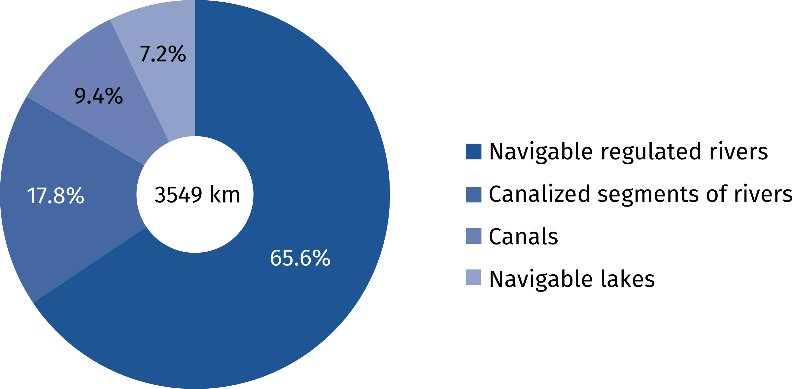
The inland waterways in Poland were 3,767 km long in 2023, of which 2,522 km represented navigable regulated rivers, 656 km – canalized segments of rivers, 335 km – canals, and 255 km – navigable lakes. A 3,549 km (94.2%) of the waterways were in use. In Poland, 5.5% of the
total length of waterways (205.9 km) satisfied the requirements for routes of international importance (classes IV and V) in 2023 in Poland. The rest of the network consisted of waterways of regional importance (classes I, II and III), whose total length in 2023 was 3,561.5 kilometers.

Inland waterways transport fleet
77.0% of barges is represented
by non-self-propelled vessels, and over half of them was
manufactured in the years
1949–1979
The number of pushers and tugboats of the inland waterways towing fleet in Poland in 2023 had a total of 141 vessels, i.e. 17 more than in the previous year. The passenger fleet consisted of 109 vessels, i.e. 7 less than in the preceding year. The number of self-propelled barges decreased by 4 vessels (to the level of 58). However, the number of not self-propelled barges (push and towing ones) increased by 15 vessels (to the level of 192). Push vessels prevailed within the barges by type (76.4% of the total barge fleet) which carried 845.9 thousand tonnes of goods (50.1% of total inland waterways freight) in 2023. Among the barges, vessels of poorer construction parameters according to lower technical standards for water infrastructure, were the predominant ones.

Chart 2. Inland waterways barges by load capacity groups in 2023

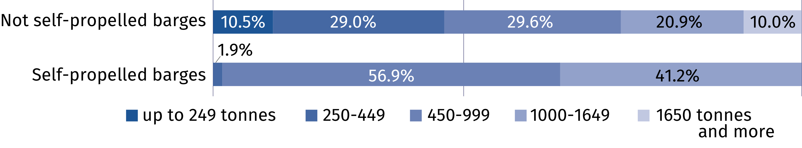

The majority of the inland waterways fleet has been decapitalized and in need of replacement. The age of the fleet is well beyond its normal service life and continued operation
is only possible through continuous modernisation. According to 2023 data, the majority
of the operated pushers (68.5%), over half of push barges (54.7%) and all self-propelled barges were manufactured during the years 1949–1979.

Chart 3. Inland waterways fleet by age in 2023

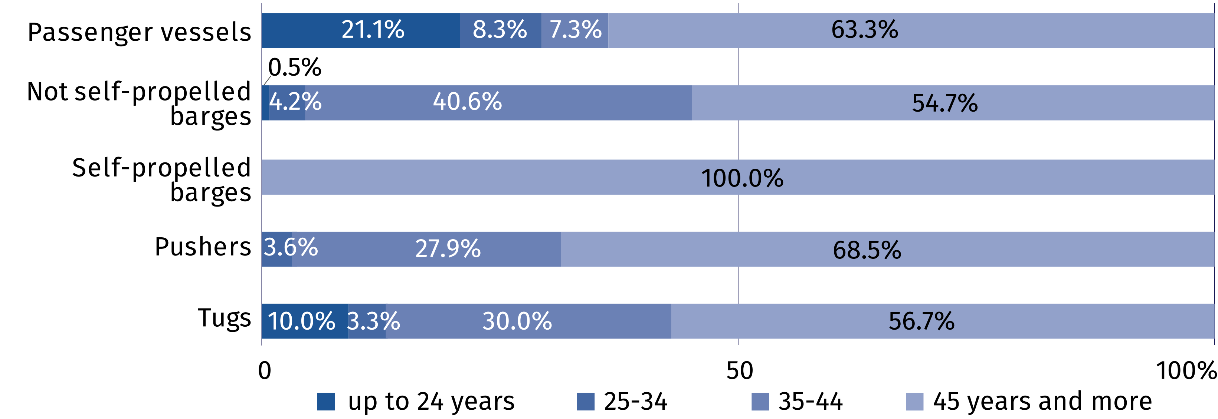

Inland waterways carriages
In 2023, the share of inland
waterways transport in the
total transport of goods amounted to 0.08% on an
annual basis
Inadequately managed navigable waterways in Poland, both in terms of their nature (canalized rivers, free-flowing rivers, canals) and technical parameters (dimensions of locks, depth and width of routes, heights of bridges) affect the specificity of inland navigation and depreciate its role in the transportation system in Poland.
In 2023, 1,689.2 thousand tonnes of goods were transported on inland waterways, which corresponded to 408.4 million t∙km. In comparison to the previous year, these values were lower by 18.6% and 8.3%, respectively. The largest annual declines in the freight volume and transport performance were recorded in the third quarter (24.5% and 21.5%, respectively).

Chart 4. Cargo carried by inland waterways transport, quarterly

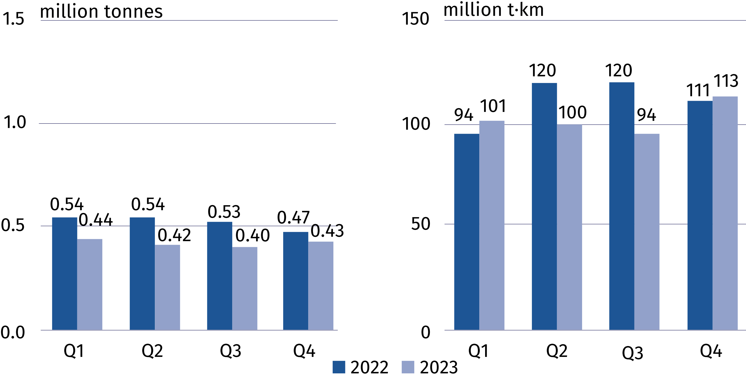
The average distance per
1 tonne of cargo increased
in both domestic and international transport
In 2023, the average distance per 1 tonne of cargo carried as international transport amounted to 303.0 km (294.7 km the year before) while 55.3 km countrywide (44.8 km,
respectively). In comparison to 2022, the domestic freight decreased by 38.0% (to 414.2 thousand tonnes) and transport performance – by 26.2% (to 22.1 million tonne-kilometres).
Severe declines in the freight were reported mainly in case of the following: coal and lignite, crude petroleum and natural gas, coke and refined petroleum products and other non-metallic mineral products. Growths were reported in the groups of: food products, beverages and tobacco, metal ores and other mining and quarrying products, peat, uranium and thorium as well as basic metals, fabricated metal products, except machinery and equipment.
In 2023 more than half of the inland waterways freight by Polish fleet owners was carried out
as international transport (75.5%). The carriages between ports abroad decreased by 4.8% comparing to previous year. Nevertheless, their share in total international transport
remained dominant and amounted to 86.5% in 2023 (increased by 4.3 percentage points).
Exported and imported cargo declined by 19.9% and 82.3%, respectively. Exports accounted for 12.8% of the total international freight, with Germany as the main direction. The contribution of carriages on that route amounted to 87.6% of all exports of goods by inland waterways.
Chart 5. Cargo transport by inland waterways by directions 2023 and developments against the previous year

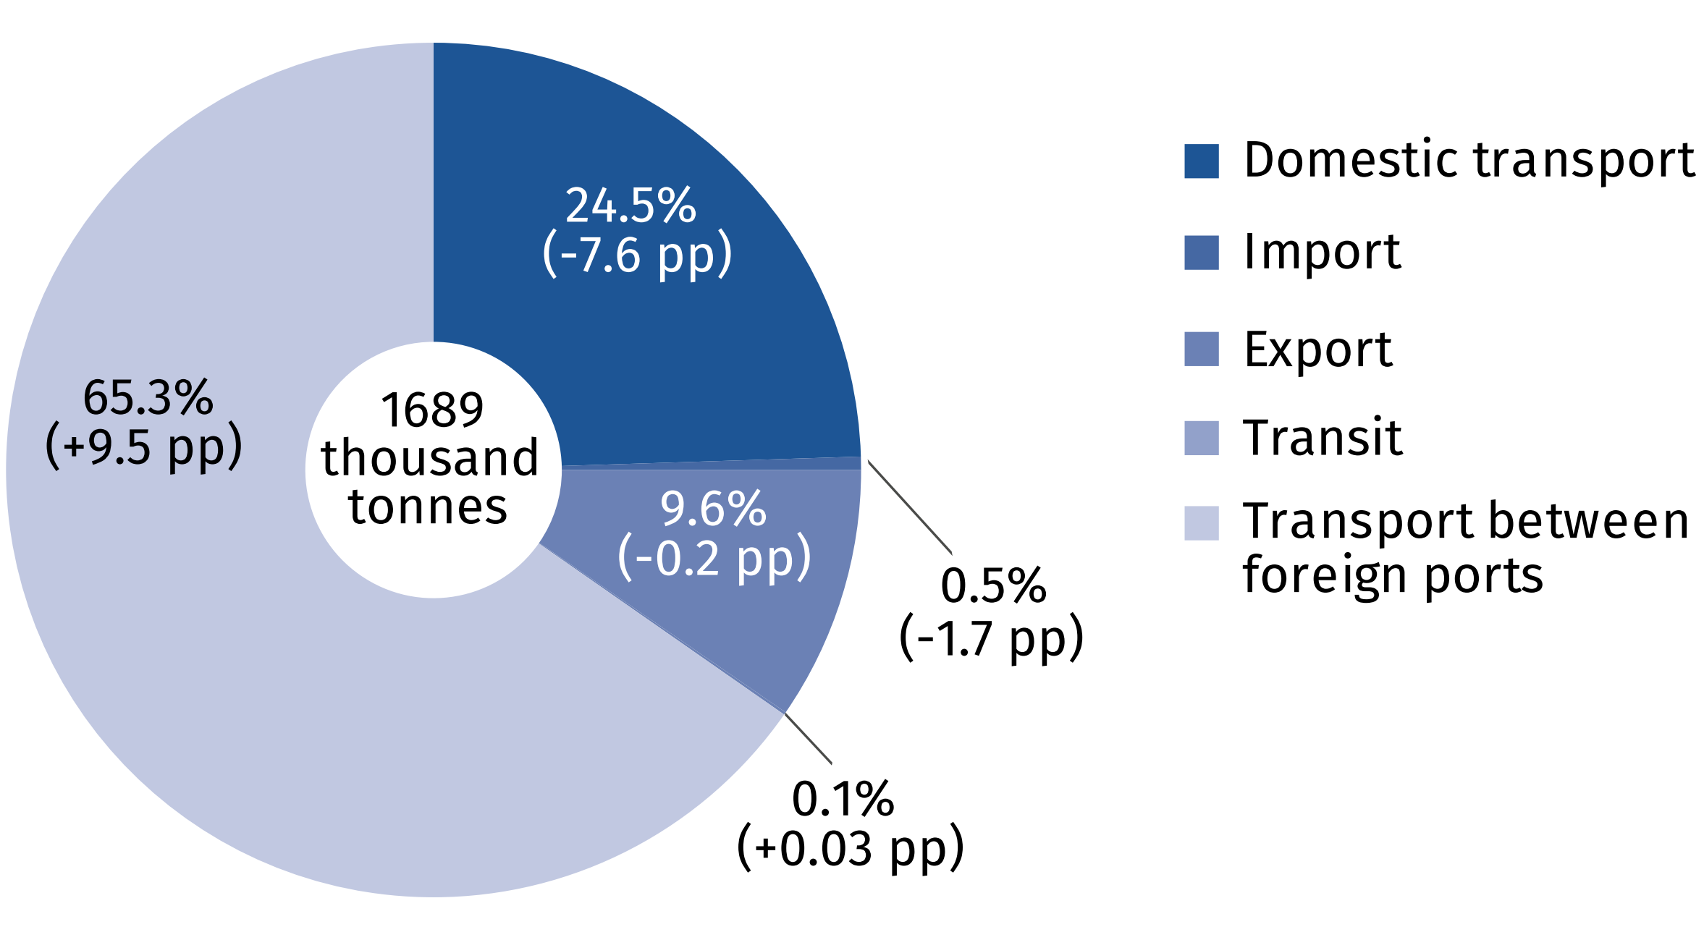
Similarly to the previous years, metal ores and other mining and quarrying products, peat; uranium and thorium (37.3%) prevailed in the structure of goods freighted in 2023.
Chart 6. Cargo transport by inland waterways by main cargo groups in 2023
and developments against the previous year

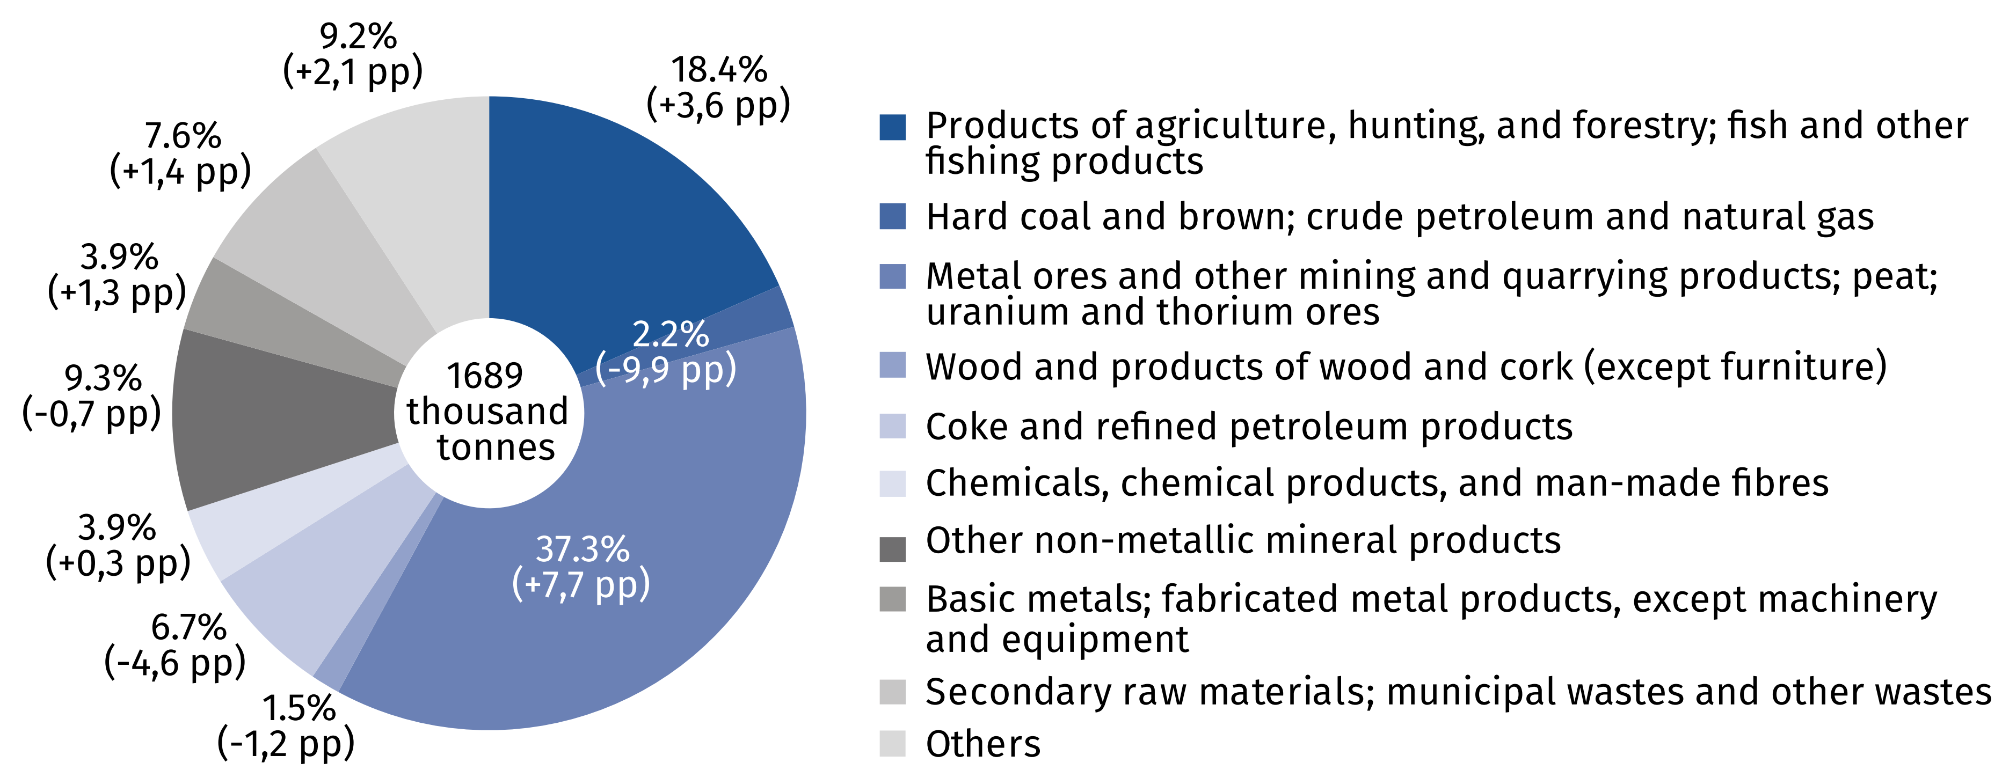
The number of people carried by inland waterways fleet grew by 2.5% on an annual basis
As part of tourist traffic, 109 inland waterways passenger vessels carried a total of 1,128.0 thousand people, and transport performance of 12,269.4 thousand passenger-kilometres in 2023, i.e. 2.5% more passengers, with a lower transportation performance (by 9.4% p∙km) as compared with the previous year.
Table 1. Inland waterways transport of passengers
Specification | 2022 | 2023
Number of passenger seats | 11 017 | 10 487
Number of passengers | 1 100 941 | 1 128 011
Number of passenger-kilometres | 13 548 681 | 12 269 426
Average distance travelled, per 1 passenger, km | 12 | 11

Inland transportation remains one of the safest modes of transport. In 2023, there were
3 navigation accidents recorded in registers kept by the competent inland waterways transport offices, and none of those events involved the carriages of hazardous cargo.

When quoting data from the Central Statistical Office (CSO), please include the information: "Source of Statistics Poland" and when publishing calculations made on data published
by the CSO, please include: "Own compilation based on Statistics Poland data".

Prepared by:  Statistical Office in Szczecin  Deputy director Katarzyna Dmitrowicz-Życka  Phone: (+48 91) 459 77 00 | Issued by:  Press Office  Mobile: (+48) 695 255 032  Phone: (+48 22) 608 38 04, (+48 22) 449 41 45,  (+48 22) 608 30 09  e-mail: obslugaprasowa@stat.gov.pl

stat.gov.pl/en/

@StatPoland

@GlownyUrzadStatystyczny

gus_stat

glownyurzadstatystycznygus

glownyurzadstatystyczny
Related information
Inland water transport in Poland in 2022
Inland waterways transport in Poland in 2020-2021
Transport – activity results in 2022
Data available in databases
Domain Knowledge Base Transport and Communications
Terms used inn official statistics
Inland waterways
Inland waterways transport fleet
Tugs fleet
Barges fleet
Inland waterways transport of goods
International inland waterways transport of goods
Inland waterways transport of passengers
Tonne-kilometres by inland waterways
Passenger-kilometres by inland waterways

Classification of inland waterways accepted by the European Economic Commission of the UN and ECMT in 1992.

