Biotechnology and nanotechnology in Poland
in 2023

In 2023, 195 firms conducted biotechnology activities, which constitutes an increase by 4.3%
in comparison to the previous year. Biotechnology intramural expenditures incurred by firms amounted to PLN 2 382.2 million and increased by 22.0% on an annual basis. In 2023, 4 482 persons were employed in biotechnology in firms. Biotechnology research and experimental development was conducted by 239 entities, that is, by 2.1% more in comparison with the previous year. Biotechnology R&D intramural expenditures amounted to PLN 1 719.9 million and increased by 20.1% annually. 8 419 persons were involved in biotechnology research and experimental development.
22.0%
An increase in biotechnology
intramural expenditures in firms year-on-year
83 firms conducted nanotechnology activities, i.e. by 18.6% more than in the previous year. Intramural expenditures on nanotechnology incurred by firms amounted to PLN 390.0 million and were lower by 19.7% in comparison with the previous year. 3 339 persons were employed in the field of nanotechnology, of which 1 264 persons
in firms. Research and experimental development in the field of nanotechnology was carried out
by 146 entities, by 16,8% more in comparison with the previous year. Nanotechnology R&D intramural expenditures amounted to PLN 380.3 million and were by 4.9% lower than in the previous year. 2 610 persons were involved in nanotechnology research and experimental development.
4.9%
A decrease in nanotechnology R&D intramural expenditures year-on-year

BIOTECHNOLOGY

Biotechnology in firms
In 2023, biotechnology research and experimental development was conducted in Poland
by 195 entities, called biotechnology firms (BF). Among them 49.2% constituted dedicated biotechnology firms (DBF).
Biotechnology research and experimental development (R&D) firms (BRDF) constituted 67.2% of all biotechnology firms, of which 62.6% conducted only R&D in biotechnology.
The remaining firms (BRDF) combined R&D with biotechnology manufacturing.
Firms employing up to 49 persons, constituted over a half
of biotechnology firms
Taking into account size classes of surveyed entities, firms employing up to 49 persons
prevailed – they constituted 54.8% of the total number of biotechnology firms; the share
of firms employing 50–249 persons and firms employing 250 and more persons amounted
to 30.3% and 14.9%, respectively.

Chart 1. Biotechnology firms conducting biotechnology activities

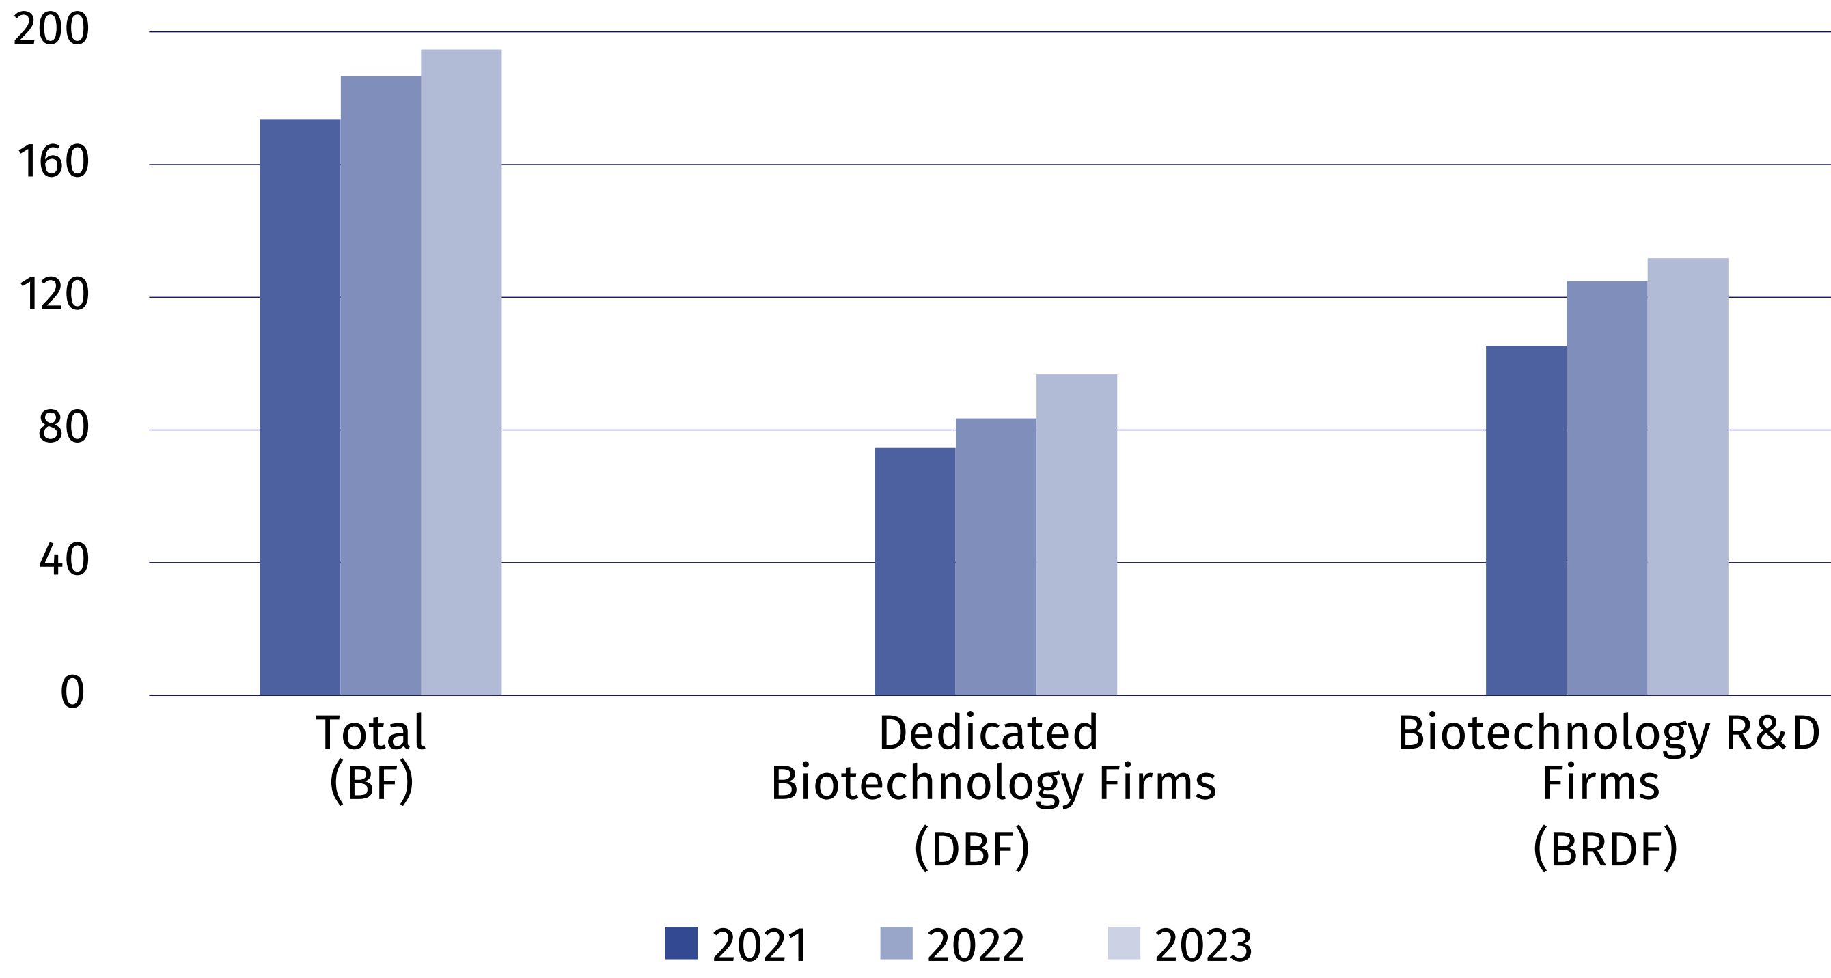

Biotechnology intramural expenditures of biotechnology firms
In 2023, intramural expenditures of firms incurred on biotechnology amounted
to PLN 2 382.2 million, of which internal funds of firms constituted 88.1%.
Chart 2. Biotechnology intramural expenditures of biotechnology firms

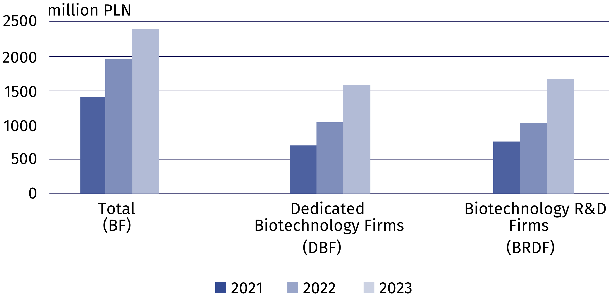

Biotechnology personnel
In 2023, the number of persons employed in biotechnology R&D firms (BRDF) increased
by 15.5%
In 2023, 10 424 persons were involved in biotechnology (by 1.6% less than in the previous year). Firms employed 4 482 persons, i.e. by 3.8% more than in the previous year. Research and experimental development in firms was carried out by 2 477 persons, which constituted 23.8% of the total number of persons employed in the field of biotechnology.

Chart 3. Biotechnology personnel in firms

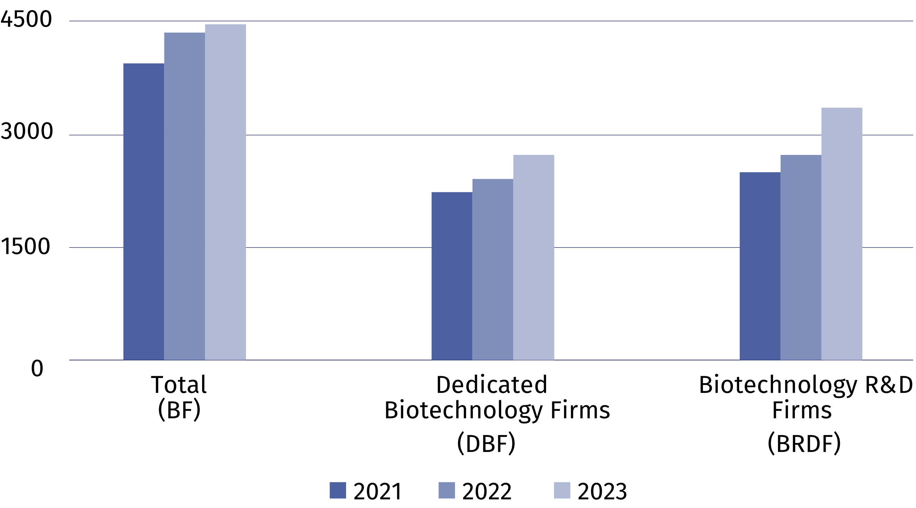

Biotechnology research and experimental development
In 2023, biotechnology research and experimental development was conducted in Poland
by 239 entities, of which over a half belonged to the business enterprise sector.
In 2023, biotechnology R&D intramural expenditures increased by 20.1% on an annual basis amounting to PLN 1 719.9 million. Intramural expenditures of entities which belong to the business enterprise sector and the higher education sector constituted 53.7% and 43.7%
of this amount, while of the government and private non-profit sector entities – 2.6%.
8 419 persons were engaged in biotechnology R&D in 2023. The number of persons employed remained at the same level compared to 2022. Researchers constituted almost three-fourths of personnel involved in biotechnology R&D.
Table 1. Biotechnology R&D intramural expenditures by sectors of performance
Sectors of performance | 2021 | 2022 | 2023
Sectors of performance | in thousand PLN
TOTAL | 1 184 735.1 | 1 432 365.7 | 1 719 941.3
Business enterprise sector | 536 196.0 | 700 258.2 | 924 358.1
of which enterprises | 459 609.0 | 604 399.1 | 852 405.1
Government and private  non-profit sector | 23 055.5 | 31 492.1 | 44 447.8
Higher education sector | 625 483.6 | 700 615.4 | 751 135.4

NANOTECHNOLOGY

Nanotechnology in firms
In 2023, the number of firms which indicated conducting nanotechnology activities in the survey, i.e. used nanotechnology for the production of intermediate and final goods and/or conducted research and experimental development in the field of nanotechnology, amounted to 83, which means an 18.6% increase compared to the previous year.
Chart 4. Nanotechnology firms conducting nanotechnology activities
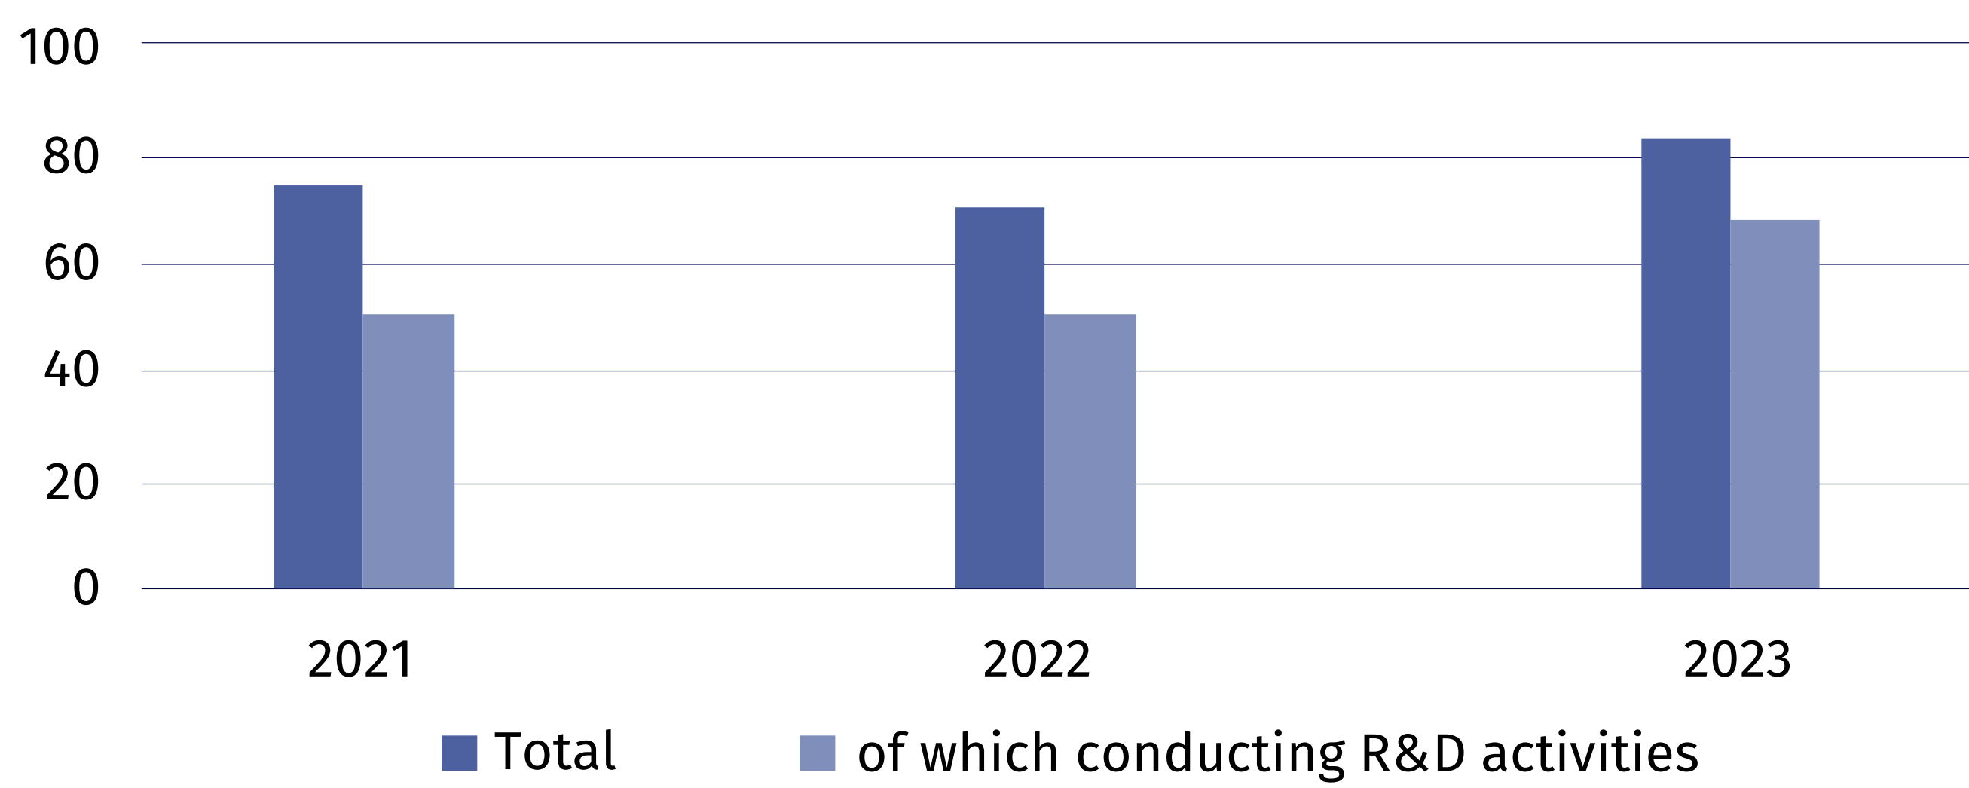

Nanotechnology activities in firms are related to production in which nanotechnology is used to produce intermediate and final goods. Applying nanotechnology in production also
includes indirect involvement of firms, as a user or an integrator. Nanotechnology is also used in research and development, i.e. in scientific research and experimental development.
In 2023, nanomaterials constituted the dominant area
of ​​nanotechnology application for 73.5% of surveyed firms
In the nanotechnology survey firms defined the areas of nanotechnology application in production and in research and experimental development as well as indicated the dominant area. In 2023, as in the previous years, nanomaterials constituted the dominant area
of ​​nanotechnology application for the majority of firm - the number of such entities
increased annually by 22.0%.
Table 2. Firms by the dominant area of ​​nanotechnology application
Application areas | 2021 | 2022 | 2023
Total | 75 | 70 | 83
Nanomaterials | 59 | 50 | 61
Nanoelectronics | – | 1 | –
Nanophotonics | 1 | 1 | 3
Nanobiotechnology | 2 | 4 | 5
Nanomedicine | 2 | 2 | 3
Nanomechanics | – | 1 | –
Filtration and membranes | – | – | 1
Catalysis | – | – | 1
Modelling and simulation software | 1 | 1 | –
Other | 10 | 10 | 9

Nanotechnology intramural expenditures of nanotechnology firms
Nanotechnology intramural expenditures are expenditures incurred for this purpose by firms in the reporting year, regardless of the source of the funds spent.
In 2023, PLN 390.0 million was allocated to nanotechnology activities, of which 86.3%
constituted internal funds of enterprises. Compared to the previous year, expenditures
on nanotechnology decreased by 19.7%.
Chart 5. Nanotechnology intramural expenditures of nanotechnology firms

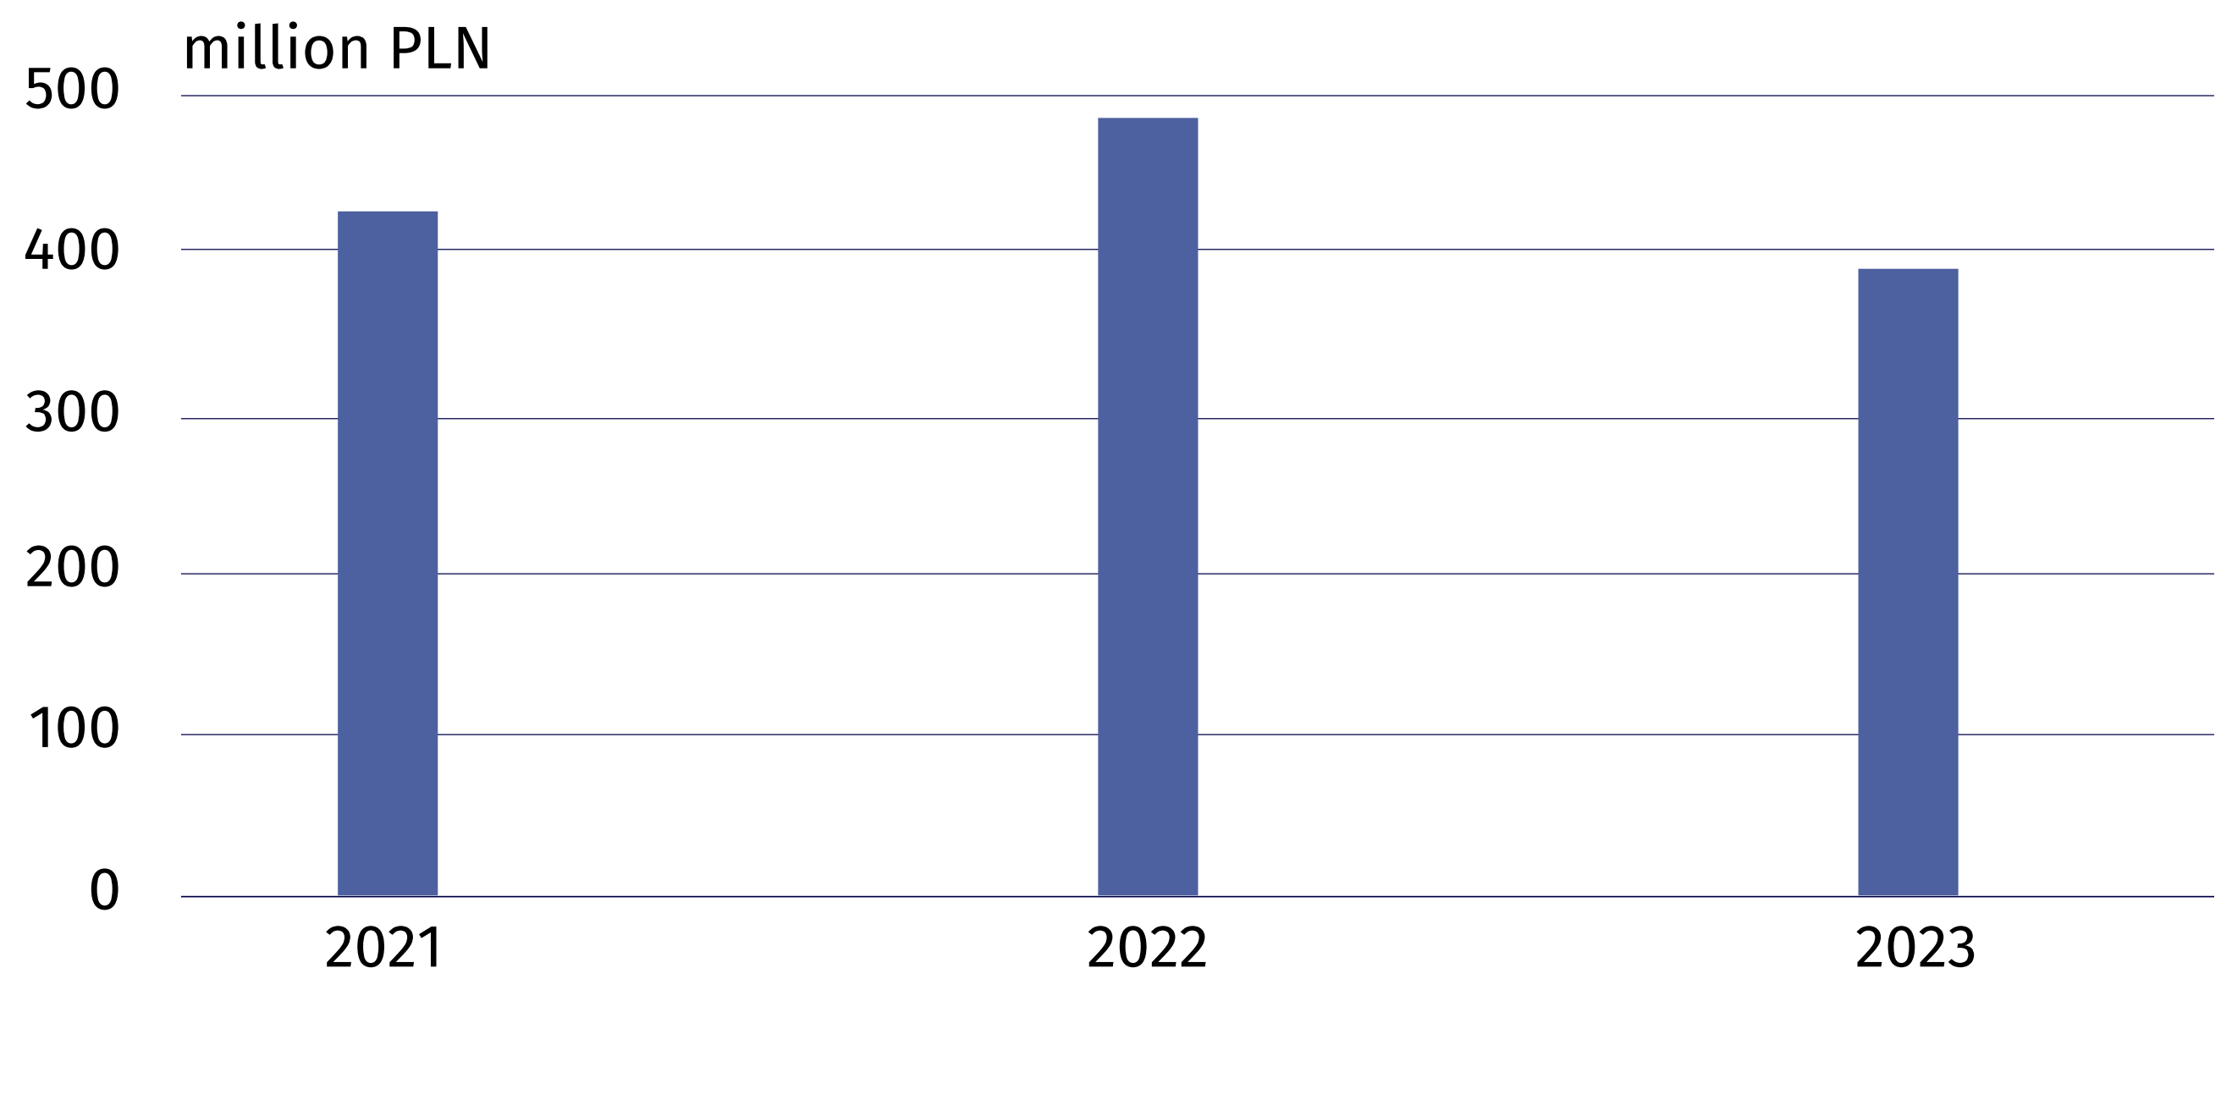

Nanotechnology personnel
In 2023, the number of persons employed in nanotechnology firms decreased annually
by 6.0%
In 2023, 3 339 persons were involved in nanotechnology activities (both in scientific units and firms). Firms employed 1 264 persons, i.e. by 6.0% less than in the previous year. Research and experimental development in firms was carried out by 535 persons (of which 199 women), which constituted 42.3% of the total number of persons employed in the field of nanotechnology in firms.
Chart 6. Nanotechnology personnel in firms

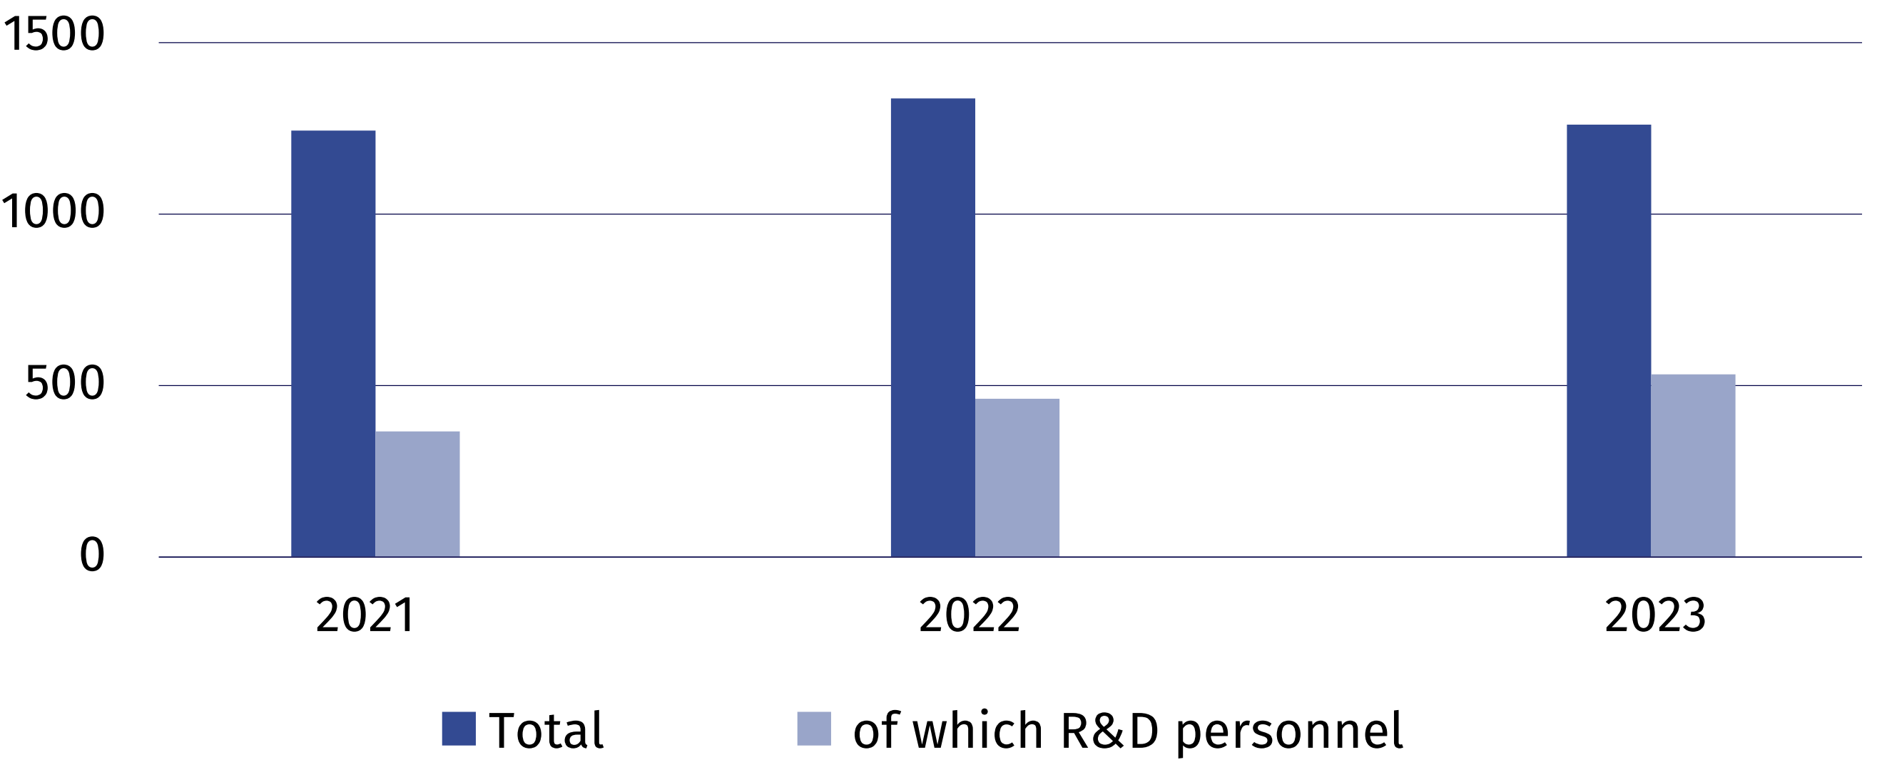

Nanotechnology research and experimental development
In 2023, the number of firms conducting research and
experimental development
in nanotechnology was by 18.4% higher than last year
The basic classification of research and experimental development is the division of entities into sectors of performance. In 2023, nanotechnology research and experimental development was carried out by 146 entities.
In 2023, nanotechnology R&D intramural expenditures amounted to PLN 380.3 million, i.e.
by 4.9% less than in the previous year. The higher education sector had the highest share
in nanotechnology R&D intramural expenditures (55.3%).
Table 3. Nanotechnology R&D intramural expenditures by sectors of performance
Sectors of performance | 2021 | 2022 | 2023
Sectors of performance | in thousand PLN
Total | 373 386.9 | 399 929.5 | 380 293.6
Business enterprise sector | 166 965.3 | 154 476.3 | 155 736.3
of which enterprises | . | 83 639.9 | 89 211.0
Government and private non-profit  sector | . | 18 500.9 | 14 358.4
Higher education sector | 199 478.3 | 226 952.3 | 210 198.9

2 610 persons, of which 1 098 women, were involved in research and experimental development in the field of nanotechnology in 2023. Compared to 2022, there was a decrease in the number of R&D personnel in the field of nanotechnology by 7.3%, of which women – by 1.9%.

In case of quoting Statistics Poland data, please provide information: “Source of data: Statistics Poland”, and in case of publishing calculations made on data published by Statistics Poland, please include the following disclaimer: “Own study based on figures from Statistics Poland”.

Prepared by:  Statistical Office in Szczecin  Director Magdalena Wegner  Phone: (+48 91) 459 77 00 | Issued by:  Press Office  Mobile: (+48) 695 255 032  Phone: (+48 22) 608 38 04, (+48 22) 449 41 45,  (+48 22) 608 30 09  e-mail: obslugaprasowa@stat.gov.pl

stat.gov.pl/en/

@StatPoland

@GlownyUrzadStatystyczny

gus_stat

glownyurzadstatystycznygus

glownyurzadstatystyczny
Related information
Biotechnology and nanotechnology in Poland in 2022
Science and technology in 2022
Terms used inn official statistics
Biotechnology
The areas of activity in the field of biotechnology
Enterprise by type of biotechnology activity
Nanotechnology

