Research and experimental development in Poland in 2023
In 2023, gross domestic expenditure on R&D (GERD) amounted to 53.1 billion PLN and increased by 18.8% in comaparison to the previous year. R&D intensity indicator, which constitutes a share of intramural R&D expenditure in GDP, amounted to 1.56% (in 2022 – 1.45%). Gross domestic expenditure on R&D
per capita amounted to 1 409 PLN and was higher
by 19.2% than in the previous year. The number
of R&D entities increased by 1.6% in comaparison to the previous year.
18.8%
An increase y/y in gross
domestic expenditure on R&D

Table 1. Selected data on R&D
Specification | 2016 | 2017 | 2018 | 2019 | 2020 | 2021 | 2022 | 2023
Number of entities in R&D | 4 871 | 5 102 | 5 779 | 5 863 | 6 381 | 7 370 | 7 431 | 7 549
Gross domestic expenditure on R&D (GERD) in million PLN | 17 943 | 20 578 | 25 648 | 30 285 | 32 402 | 37 676 | 44 702 | 53 116
Relation of GERD to GDP in % | 0.97ª | 1.04ª | 1.21 | 1.32 | 1.39 | 1.43ª | 1.45ª | 1.56
a Data changed compared to previously published due to GDP revision.

INTRAMURAL EXPENDITURE ON RESEARCH AND DEVELOPMENT
R&D intensity (GERD/GDP) amounted to 1.56%
In the year 2023, like in the previous years, current expenditure prevailed in the structure
of intramural expenditure on R&D by type of costs. Their share in all incurred expenditure on scientific research and experimental development amounted to 82.2%.
Chart 1. Intramural expenditure on R&D by type of costs
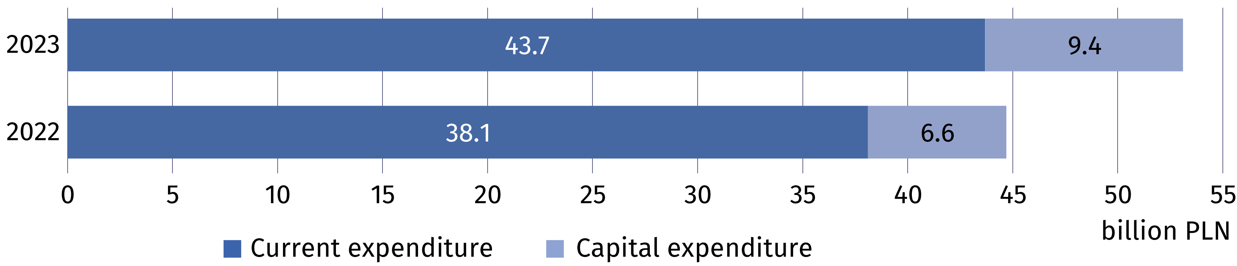
The business enterprise
expenditure on R&D (BERD) accounted for 64.6% of gross domestic expenditure on R&D (GERD)

The highest intramural expenditure on research and experimental development among
the sectors of performance were incurred by the business enterprise sector which allocated on conducting research and experimental development 34.3 billion PLN (by 16.4% more than in 2022). Expenditure of this sector accounted for 64.6% of gross domestic expenditure
on R&D in 2023 (compared to 65.9% in 2022). In the higher education sector the share amounted to 33.4%, in the government sector – 1.8% and in the private non-profit sector – 0.2% (compared to 32.0%, 1.9% and 0.2% in 2022 respectively).
Table 2. Intramural expenditure on R&D by sectors of performance
Sectors of performance | 2022 | 2023
Sectors of performance | in million PLN
Total (GERD) | 44 702.4 | 53 115.9
Business enterprise (BERD) | 29 455.1 | 34 288.7
Government (GOVERD) | 863.7 | 962.0
Higher education (HERD) | 14 296.8 | 17 751.4
Private non-profit (PNPERD) | 86.8 | 113.8

In the year 2023, like in the previous years, main funding sectors for research and experimental development were the business enterprise sector and the government sector whose funds accounted for 54.8% and 31.9% of all intramural expenditure on R&D, respectively (compared to 54.8% and 33.5% in 2022).
Chart 2. Intramural expenditure on R&D by funding sectors
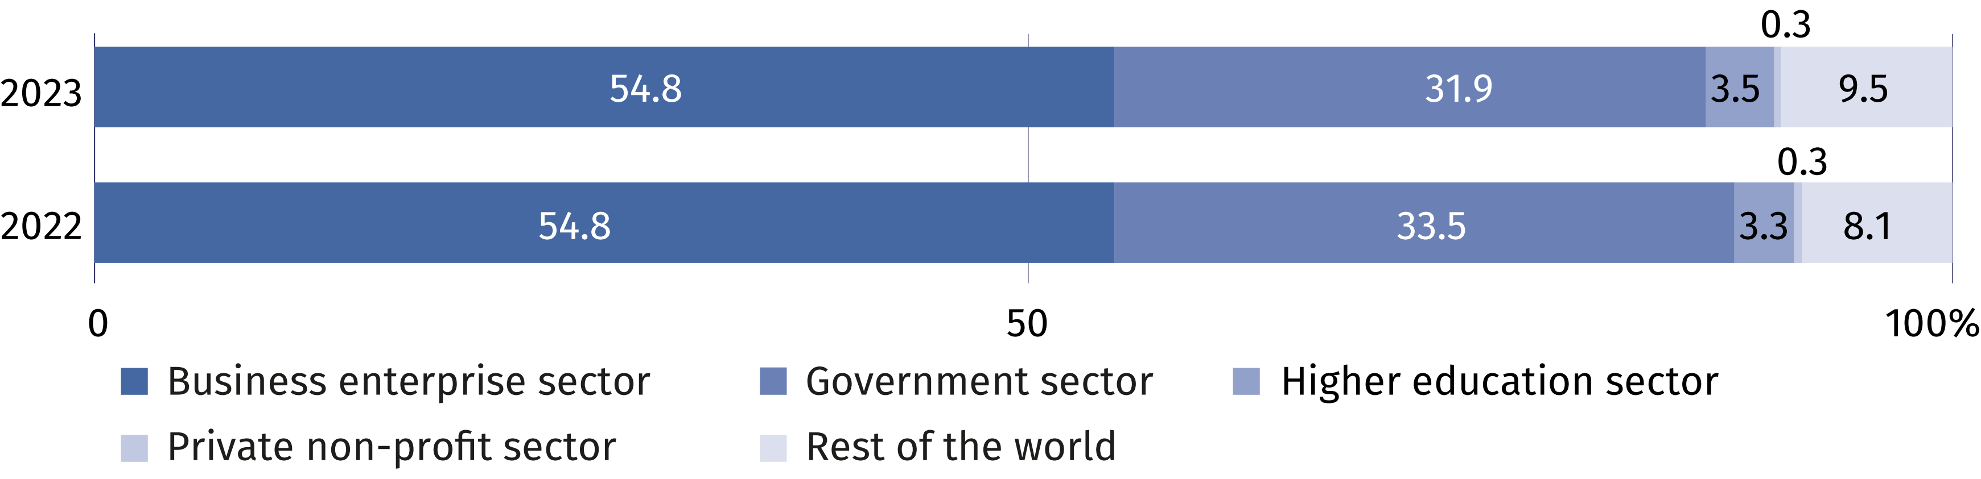

PERSONNEL IN RESEARCH AND DEVELOPMENT
Internal personnel accounted for 83.7% of R&D personnel
in FTE
The number of personnel involved in research and experimental development in 2023 amounted to 326.1 thousand persons, that is, by 1.5% more than in the previous year. Actual involvement of R&D personnel in research and experimental development in full-time equivalents amounted to 199.9 thousand FTE and increased by 2.4% on an annual basis. R&D was mainly performed by internal personnel which accounted for 81.7% of personnel
in headcount and 83.7% – in FTE in 2022 (in 2022 these shares amounted to 81.8% and 84.1%, respectively).
Chart 3. R&D personnel by main groups
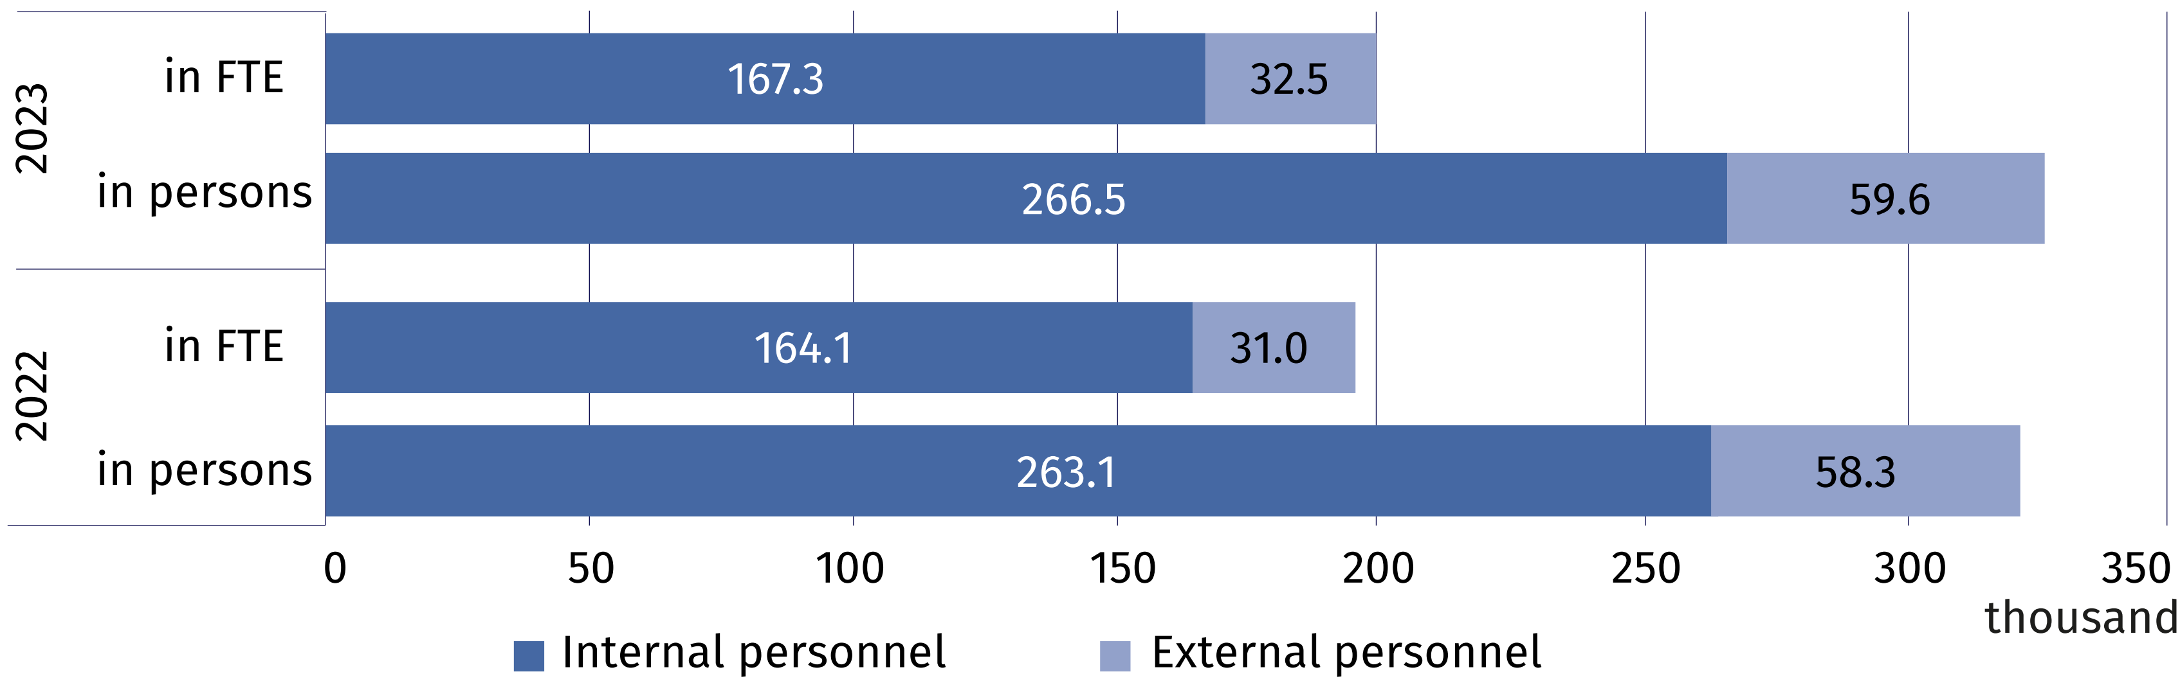

In 2023, researchers prevailed in the structure of persons engaged in research and experimental development by R&D functions. They accounted for 69.1% of internal personnel and 68.3% of external personnel in headcount (compared to 69.3% and 71.2% in 2022). In FTE,
researchers as the share of persons employed in R&D accounted for 71.9% and as the share of external contributors 68.5% (compared to 72.5% and 71.7% in 2022).
Table 3. Selected indicators on internal R&D personnel ª
Specification | 2016 | 2017 | 2018 | 2019 | 2020 | 2021 | 2022 | 2023
per 1000 active population ^{b}
Internal R&D personnel | 6.6 | 7.1 | 7.8 | 8.1 | 8.6 | 9.0 | 9.5 | 9.4
of which researchers | 5.2 | 5.7 | 5.8 | 5.9 | 6.2 | 6.5 | 6.9 | 6.8
per 1000 persons employed ^{c}
Internal R&D personnel | 7.0 | 7.5 | 8.1 | 8.4 | 8.8 | 9.3 | 9.8 | 9.7
of which researchers | 5.5 | 6.0 | 6.1 | 6.1 | 6.4 | 6.8 | 7.1 | 7.0
a In full-time equivalents (FTE). b Active population aged 15–89 years according to the LFS – average annual data. c Persons employed aged 15–89 years according to the LFS – average annual data.

In 2023, the business enterprise sector and higher education sector had the highest share
in the structure of internal R&D personnel by sectors of performance. The percentage of internal personnel in these sectors accounted for 57.3% and 40.1% of total number of internal personnel engaged in conducting research and experimental development. On an annual basis, the number of person included in internal personnel increased by 1.5% in the business enterprise sector and by 1.0% in the higher education sector. The highest value of full-time equivalent was noted in the business enterprise sector (104.5 thousand FTE) which
increased by 2.8% in comparison to 2022.
Chart 4. Internal R&D personnel by sectors of performance

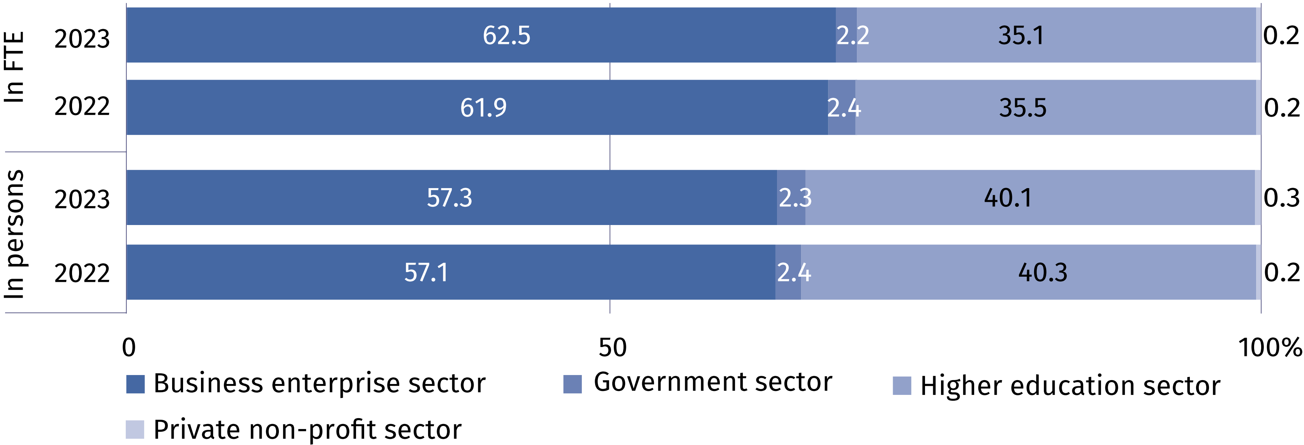

Persons with other tertiary education prevailed among both internal personnel and external personnel – they accounted for 56.3% and 64.7% of a given R&D personnel group, respectively. Among internal R&D personnel 31.7% of persons held at least the scientific degree
of doctor (PhD) and among external personnel – 19.0%.

Table 4. R&D personnel by educational level and main groups
Specification  a – 2022  b – 2023 |  | Total | With tertiary education |  |  |  |  |  |  |  |  | Persons with other  educational level
 |  | Total | with  professor title |  | with scientific degree of |  |  |  |  | other |  | Persons with other  educational level
 |  | Total |  |  | habilitated doctor |  |  | doctor (PhD) |  |  |  | Persons with other  educational level
 |  | in headcount
Total | a | 321 391 |  | 14 760 |  | 25 989 | 53 872 |  | 189 237 |  | 37 533
Total | b | 326 075 |  | 150 94 |  | 25 167 | 55 629 |  | 188 693 |  | 41 492
Internal  personnel | a | 263 057 |  | 11 248 |  | 22 859 | 48 932 |  | 149 870 |  | 30 148
Internal  personnel | b | 266 452 |  | 11 916 |  | 22 234 | 50 412 |  | 150 103 |  | 31 787
External  personnel | a | 58 334 |  | 3 512 |  | 3 130 | 4 940 |  | 39 367 |  | 7 385
External  personnel | b | 59 623 |  | 3 178 |  | 2 933 | 5 217 |  | 38 590 |  | 9 705

When citing data from the Central Statistical Office, please include the following information: "Source of CSO data", and in the case of publishing calculations made on the data published by the Central Statistical Office, please include the following information: "Own study based on GUS data"

Prepared by:  Statistical Office in Szczecin  Director Magdalena Wegner  Phone: (+48 91) 459 77 00 | Issued by:  Press Office  Mobile: (+48) 695 255 032  Phone: (+48 22) 608 38 04, (+48 22) 449 41 45,  (+48 22) 608 30 09  e-mail: obslugaprasowa@stat.gov.pl

stat.gov.pl/en/

@StatPoland

@GlownyUrzadStatystyczny

gus_stat

glownyurzadstatystycznygus

glownyurzadstatystyczny
Related information
Research and experimental development in Poland 2022
Science and technology in 2022
Methodological report. Research and experimental development
Data available in databases
Macroeconomic Data Bank (BDM)
Local Data Bank (BDL)
Knowledge Databases (DBW)
Strateg
Terms used inn official statistics
Research and experimental development (R&D)
Gross domestic expenditures on research and development (GERD)
Intramural expenditures on R&D
Basic research
Applied research
Experimental development
R&D personnel
Internal R&D personnel
External R&D personnel

