Physical education in Poland in 2023
7.8%
Increase in the number of competitors holding Polish sports association licences compared to 2022
In 2023, there were 69 sports associations in Poland. Compared to 2022, the number of competitors, coaches and instructors holding licences from the Polish sports associations increased, whereas the number of Polish representatives and judges decreased. Physical education organisations associated 6.6 thousand units. In relation to the previous year, the number of units, members and persons practising sports in these organizations decreased slightly.
Polish sports associations
In 2023, Polish sports associations selected 8794 members of the national team
In 2023, a total of 69 Polish sports associations (in 2022 – 70, the Polish Curling Association lost its status as a Polish sports association) and 516 regional sports associations were active. The Polish sports associations selected 8.8 thousand members of the national team, 38.6% of whom were women. There were 40.7% of Polish representatives in junior categories.
Table 1. Basic information on Polish sports associations in 2023
SPECIFICATION | Total | Of which females
Polish representatives | 8,794 | 3,391
of which:
juniors | 3,583 | 1,571
Competitorsª | 825,903 | 169,552
of which:
junior competitors^{b} | 521,113 | 132,272
Coaching staff^{c}
coaches | 35,455 | 3,439
instructors | 12,572 | 3,700
Judges^{c} | 40,847 | 9,183
of which:
with international class | 1,759 | 440
a Including foreign competitors performing in Poland. The competitors can be shown several times if they are licensed in several sports supervised by one sports association. b Total juniors, younger junior "cadets", sub-juniors and children. c Members of the coaching staff and judges can be shown several times if they are licensed in several sports supervised by one sports association.
Compared to 2022, there was a 15.4% decrease in the number of Polish representatives. However, the number of representatives who are members of foreign clubs increased (from 273 in 2022 to 425 in 2023).
In 2023, the largest number of members of the national team was in the Polish Basketball Association (726 representatives), followed by the Polish Deaf Sports Association (389). In 2022, the most numerous was the Polish Volleyball Federation (1476 representatives).
Chart 1. Polish representatives in 2023
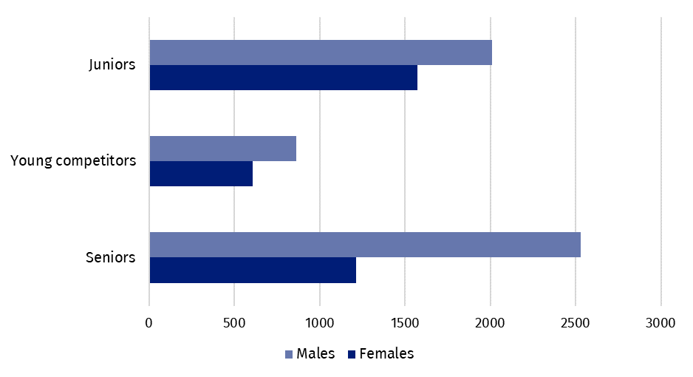
In 2023, 825.9 thousand competitors held licenses of the Polish sports associations (in 2022 – 766.0 thousand), of which 20.5% were women (in 2022 – 19.6%). There were 32.7% competitors in the senior category (in 2022 – 34.1%).
The number of competitors licensed by Polish sports associations in 2023 increased by 7.8% compared to 2022. The percentage of competitors with disabilities was 0.4%, and of foreign competitors was 1.3%
Map 1. Competitors registered in Polish sports associations in 2023
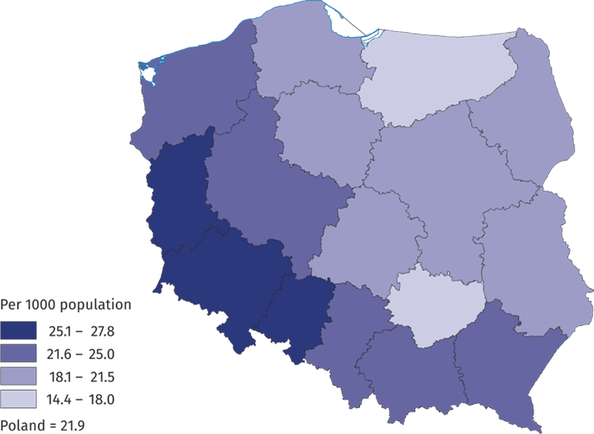
Most persons were practising in Mazowieckie Voivodship (13.9%) followed by Śląskie Voi-vodship (12.1%) and Małopolskie Voivodship (9.9%). As in previous years, the highest percentage were competitors holding Polish Football Association licences – 46.7% (in 2022 – 47.9%), followed by the Polish Sport Shooting Federation – 8.6% and the Polish Volleyball Federation – 5.1%.
The number of competitors with disabilities holding licenses of the Polish sports associa-tions was 3,119 persons in 2023 (an increase of 1.4% compared to 2022), of which over 75% were men. The percentage of competitors with disabilities in relation to the total number of competitors was 0.4% - the highest in Zachodniopomorskie Voivodship (0.9%).
Foreign competitors holding licenses of the Polish sports association constituted 1.3% of all competitors in 2023 (1.0% in 2022). Of these, football licensed competitors predominated (57.4%, 62.4% in 2022). Disciplines frequently practiced by foreign competitors were also squash (12.3%) and ice hockey (4.4%). The highest percentage of foreign competitors was recorded in Mazowieckie Voivodships (21.9%).
In 2023, the number of coaches and instructors holding licences of the Polish sports association increased in relation to 2022 by 1.2% and 8.7% respectively, whereas the number judges decreased by 5.8%
In 2023, the coaching staff employed in the Polish sports associations amounted to 738 persons. This number decreased in relation to 2022 (by 79 persons), with a decrease recorded also in the employment of medical staff (255 persons in 2023 compared to 287 persons in 2022).
In 2023, 35.5 thousand coaches and 12.6 thousand instructors held current licenses of the Polish sports associations. Compared to the previous year, the number of coaches in-creased by 0.5 thousand, and the number of instructors by 1.0 thousand.
Chart 2. Coaching staff in Polish sports associations in 2023
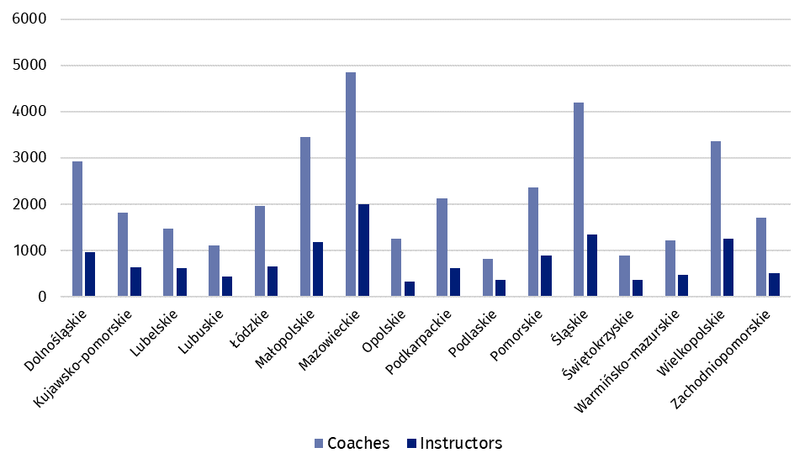
In 2023, 40.8 thousand sports judges were registered in the Polish sports associations (a decrease of 5.8% compared to 2022). Of these, 22.5% were women. The percentage of judges with international class was 4.3%. The highest number of judges held licences in sports shooting and football (19.6% each). Women as judges prevailed mainly in artistic swimming – 100% and in artistic gymnastics – 99.1%. A significant part of them were also certified to judge wheelchair rugby (73.3%) and cheerleading (71.1%).
Achievements of Polish competitors in the international area
In 2023, the Polish representatives won 222 World Championships medals and 470 European Championships medals

In 2023, Polish representatives at the World Championships occupied the podium 222 times (in 2022 – 277 times). They won 63 gold and silver medals each and 96 bronze medals. The most medal places in 2023 were won by competitors in kick-boxing (33 medals, including 8 gold), followed by aerial sports (31 medals, including 14 gold) and canoeing (25 medals, including 3 gold).
At sports events of the European Championships⁵ rank, the Poles won a total of 470 medals in 2023 (480 in 2022), including: 134 gold, 137 silver and 199 bronze. The most medals were won also in kick-boxing (87 medals, including 29 gold), followed by sumo (49 medals, including 8 gold).
In 2023, the Polish competitors with disabilities won 117 World Championships medals and 95 European Championships medals
In 2023, competitors with disabilities won 117 medals at the World Championships (39 gold, 37 silver, 41 bronze) and 95 medals at the European Championships (32 gold, 37 silver and 26 bronze).
At the World Championships, competitors with disabilities were most often on the podium in athletics (34 medals, including 15 gold), and at the European Championships in bowling (23 medals, including 9 gold). At the 2022 World Championships, competitors with disabilities won 59 medals, and at the European Championships 118.
Table 2. Medals won by Polish competitors in the international arena in 2023
SPECIFICATION | Medals
SPECIFICATION | total | gold | silver | bronze
World Championships | 222 | 63 | 63 | 96
of which young competitors and juniors | 106 | 28 | 39 | 39
European Championships | 470 | 134 | 137 | 199
of which young competitors and juniors | 298 | 85 | 82 | 131
World Championships for persons with disabilities | 117 | 39 | 37 | 41
European Championships for persons with disabilities | 95 | 32 | 37 | 26

Physical education organisations
In 2023, physical education organisations such as: Academic Sports Association (AZS), National „Rural Sports Teams” Association (LZS), The Polish Sports Association for the Disabled ’’Start’’ (PZSN “Start”) and the Society for the Promotion of Physical Education (TKKF) showed a total of 6.67 thousand organisational units (a decrease of 2.8% compared to 2022). The organizations associated 308.5 thousand members (8.1 thousand less than in the previous year) and 297.5 thousand persons practising sports (down by 5.1 thousand persons).
In terms of the number of members and persons actively practising sports, the National „Rural Sports Teams” Association was the most numerous one (207.3 thousand members, 184.8 thousand persons practising sports). The Society for Promotion of Physical Education also had a large membership base (50.4 thousand members, 73.5 thousand persons practising sports). The Academic Sports Association reported 49.1 thousand members and 37.9 thousand persons practising sports and the Polish Sports Association for the Disabled "Start" – 1.5 thousand members and 1.3 thousand persons practising sports. The number of organizational units compared to 2022 decreased in each of the listed organizations, while the number of members and persons practising sports increased only in the units of the Academic Sports Association. Among persons practising sports in physical education organizations, men predominated, accounting for 70.1% (in 2022 – 69.3%). Just over half of those practising sports (51.3%) were under the age of 18 (in 2022 – 50.9%).
The highest number of members of physical education organisations was recorded in Lubelskie Voivodship (11.3%). The highest number of persons actively practising sports was registered in Wielkopolskie Voivodship (13.2%).
In 2023, physical education organizations organized 79 thousand events (in 2022 – 80 thousand), the majority of which (90.9%) were carried out by units of the National Association (LZS). The events were attended by 4.2 million people (in 2022 – 4.1 million).

When quoting Statistics Poland data, please provide information: “Source of data: Statistics Poland”, and when publishing calculations made on data published by Statistics Poland, please provide information: “Own study based on Statistics Poland data”.
Prepared by:  Statistical Office in Rzeszów  Director Marek Cierpiał-Wolan  Phone: (+48 17) 853 52 10,  (+48 17) 853 52 19 | Issued by:  Press Office  Mobile: (+48) 695 255 032  Phones: (+48 22) 608 38 04, (+48 22) 449 41 45,  (+48 22) 608 30 09  e-mail: obslugaprasowa@stat.gov.pl

stat.gov.pl /en/

@StatPoland

@GlownyUrzadStatystyczny

gus_stat

glownyurzadstatystycznygus

glownyurzadstatystyczny
Related information
Physical education in years 2021 and 2022

Data available in databases
Local Data Bank
Knowledge Databases - Construction

Terms used in official statistics
Sports instructor
Regional sports association
Organisation of physical education
Sports judge
Sport
Sports
Sports coach
Competitor
Sports association

Sports associations according to the list of Polish sports associations announced by the Minister of Sport and Tourism – Communication of 13 March 2023. Data are preliminary.
Competitors can be shown more than once if they hold licences in several sports supervised by one sports association.
Coaches and instructors be shown more than once if they hold licences in several sports supervised by one sports association.
Sports judges may be shown more than once if they hold licence in several sports.
In sports supervised by sports associations with the status of a Polish sports association.
This news release covers: in AZS - clubs, in LZS - teams, sports clubs and student sports clubs, in PZSN "Start" - organizational units, in TKKF - centres and clubs.

