Tourist accommodation establishments in coastal areas in July and August 2024
(concerns tourist accommodation establishments with 10 or more bed places)
13.2%
Increase in the number of tourists in tourist accommodation establishments in coastal areas in July and August 2024 compared to the corresponding months of the previous year

In July and August 2024, 2.0 million tourists were accommodated in tourist accommodation establishments located in coastal areas, and 8.7 million overnight stays were provided for them. Compared to the same period last year, the number of tourists was higher by 13.2%, and number of overnight stays increased by 7.7%.

Coastal gminas according to Eurostat methodology
According to the Eurostat methodology, 55 gminas of the voivodships: Pomorskie (26), Zachodniopomorskie (23) and Warmińsko-Mazurskie (6) are classified as coastal areas in Poland. They are situated by the Baltic Sea or are in direct proximity to the sea. They cover 2.9% of Poland's territory (9.1 thousand square kilometres) and are inhabited by 4.2% of the country's population (1.6 million people) .
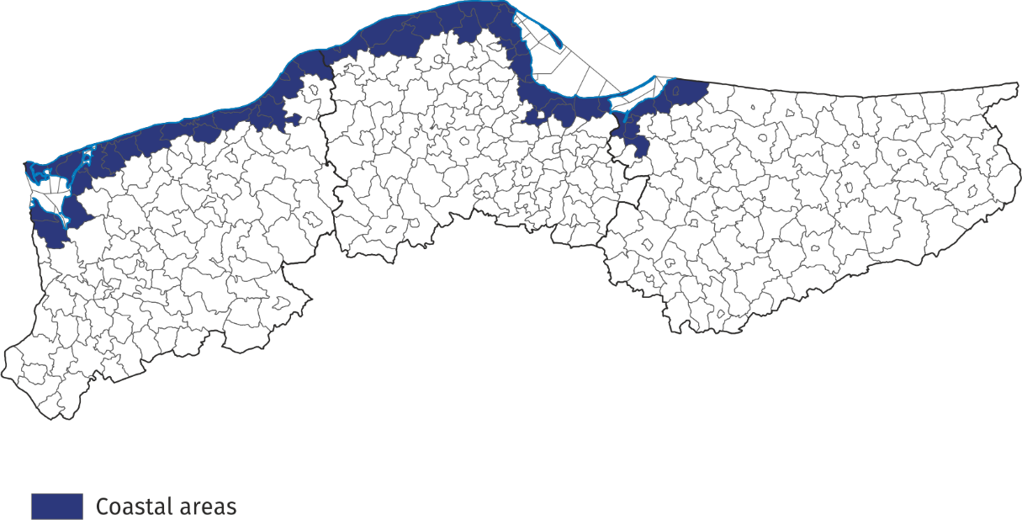
Map 1. Coastal gminas
Tourist accommodation establishments in coastal areas
As of the end of July 2024, 2344 tourist accommodation establishments operated in coastal areas, i.e. almost 1/4 of all establishments in Poland. The vast majority of them (2/3) operated on a seasonal basis (the percentage of seasonal establishments in Poland was less than 30%).
Almost half of the holiday centres operating in the country functioned here, as well as
39.3% of complexes of tourist cottages, 38.1% of rooms for guest, 38.0% of holiday youth centres and 30.3% of camping sites. Compared to the previous year, the number of accommodation establishments in coastal areas increased by 58, i.e. by 2.5%.
The structure of accommodation establishments in coastal areas is fundamentally different from the structure of establishments in total in Poland. Rooms for guests prevail – at the end of July this year there were 863 of them and they accounted for 36.8% of all establishments in these areas. There were numerous holiday centres – 431 (18.4% of all establishments in coastal area) and complexes of tourist cottages – 252 (10.8%). Hotels accounted for 10.5% of tourist accommodation establishments in coastal areas (24.9% in Poland).
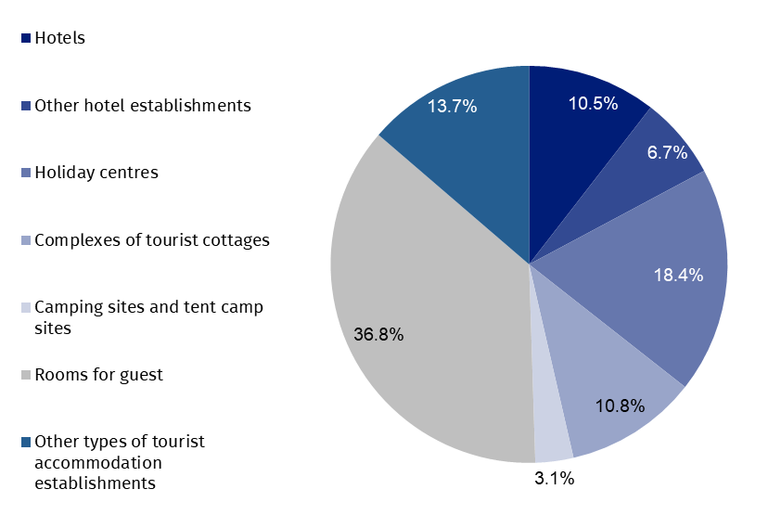
Chart 1. Tourist accommodation establishments in coastal areas in 2024
as of 31 July

At the end of July 2024, tourist accommodation establishments located in coastal gminas had 228.6 thousand bed places, which accounted for 27.2% of the total number of bed places in accommodation establishments in Poland, and it was 10.9 thousand (5.0%) more than a year ago. Compared to the corresponding period of the previous year, the number of bed places increased, among other things, in rooms for guests/private lodgings (by 3.6 thousand), camping sites (by 2.1 thousand), other types of tourist accommodation establishments and other hotel establishments (by 1.8 thousand each).

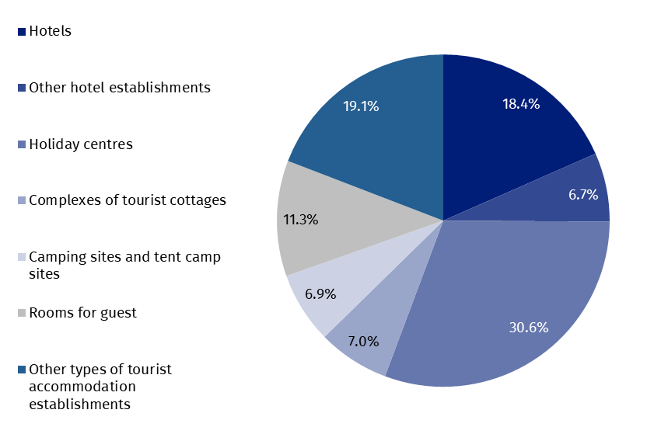
Chart 2. Bed places in coastal areas in 2024
as of 31 July
The largest number of bed places was offered by holiday centres – 69.9 thousand, i.e. 30.6% of the total number of bed places in the area. Hotels had 42.0 thousand (i.e. 18.4%) places prepared for tourists, while rooms for guest had 25.8 thousand (i.e. 11.3%). Among other types of establishments, 15.9 thousand bed places were available for tourists in complexes of tourist cottages, 15.3 thousand in other hotel establishments and 12.9 thousand in health establishments.
Establishments in coastal areas are larger than the average in Poland. One establishment functioning in coastal areas had an average of 98 places (81 places in the country).
In 2024, the density index of the accommodation establishments in coastal areas was 25.0 places per 1 square kilometre of area (in the country – 2.7) .
Tourists accommodated in tourist accommodation establishments
Tourists accommodated in establishments in coastal areas during the holiday period 2024 constituted 22.0% of all tourists accommodated in the whole country during that period

During the holiday season (i.e. in July and August) of 2024, 2.0 million tourists were accommodated in accommodation establishments located in coastal gminas (969.1 thousand – in July and 1033.8 thousand – in August), i.e. 22.0% of tourists accommodated in accommodation establishments throughout the country during this period (in the corresponding period of 2023 this percentage amounted to 21.3%). Compared to the corresponding period of 2023, the number of tourists using overnight stays in July and August was higher by 234.3 thousand,
i.e. by 13.2% (in July higher by 6.6% and in August by 20.3%).
Over 1/3 of tourists (693.5 thousand) staying in these areas were accommodated in hotels.
A large number of tourists chose to stay in holiday centres – 422.1 thousand (21.1%) and in other types of establishments – 206.1 thousand (10.3%).
Among the total number of tourists accommodated in tourist accommodation establishments 81.7% (1.6 million) were domestic tourists, and 18.3% (0.4 million) were foreign tourists. In relation to the same period of 2023, the number of domestic tourists was higher by 12.6% and the number of foreign tourists by 16.1%.
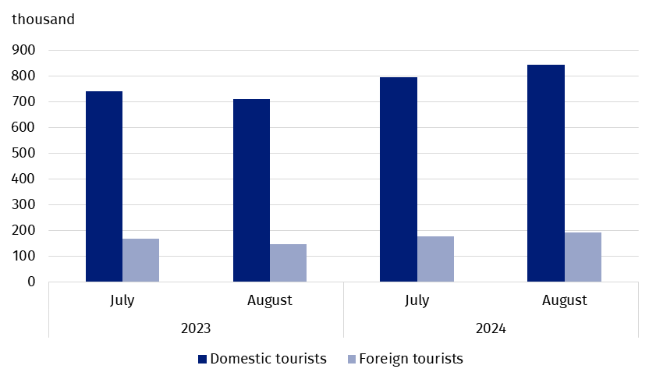
Chart 3. Tourists accommodated in coastal areas in July-August
In July and August 2024, as in previous years, the majority of foreign tourists accommodated in coastal areas were from Germany. During this period, 184.0 thousand of them arrived and compared to the same period last year there were more of them by 16.6 thousand, but their share in the total number of foreign tourists was lower than the year before and amounted to 50.3% – in the same period of 2023 they accounted for 53.1% of the total number of foreign tourists. The share of guests from other countries did not exceed 8.0%; most of them were from Czechia (29.2 thousand), followed by Sweden (22.6 thousand) and Norway (17.1 thousand), who constituted, respectively, 8.0%, 6.2% and 4.7% of the total number of foreign tourists accommodated in coastal areas.
Overnight stays provided at tourist accommodation establishments
Overnight stays provided in July and August in coastal areas accounted for 32.3% of all overnight stays in Poland during this period

A total of 8.7 million overnight stays were provided for tourists staying in coastal areas in July and August this year, which accounted for 32.3% of all overnight stays provided at tourist accommodation establishments in Poland during that period. In the same period last year, the share was 0.3 percentage points lower.
This year, both July and August saw 4.3 million overnight stays each for tourists. Compared to the same period in 2023, the total number of overnight stays provided in July and August this year was higher by 7.7% (i.e. 618.5 thousand) – in July by 5.2% (212.0 thousand), and in August by 10.3% (406.5 thousand).
On average, 4.3 overnight stays were provided for tourists during their holiday trips, while the average length of a tourist stay in Poland during that period was 2.9 nights.
7.4 million overnight stays were provided for domestic tourists (7.7% more than in July and August last year) in the period July-August 2024, and they accounted for 85.5% of the total number of overnight stays in coastal areas and 33.1% of the total number of overnight stays provided for domestic tourists in the same period in Poland. A total of 1.3 million overnight stays were provided for foreign tourists, which was 7.5% more than in the previous year. Most overnight stays were provided to tourists from countries neighbouring Poland, i.e. Germany (771.9 thousand – 61.2% of overnight stays of foreign tourists), Czechia (106.7 thousand – 8.5%) and Sweden (53.3 thousand – 4.2%).

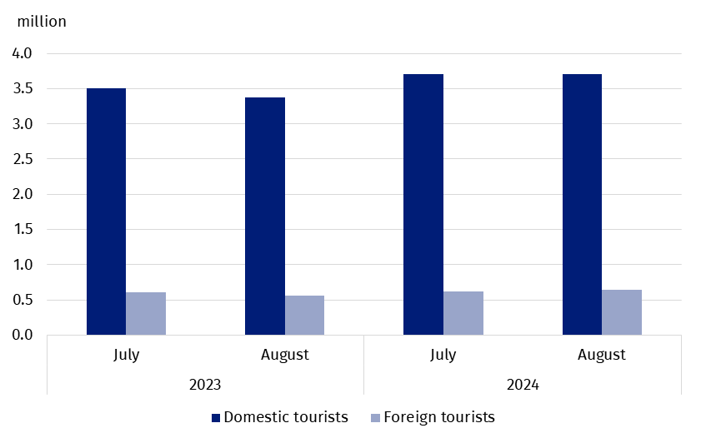
Chart 4. Overnight stays provided tourist accommodation establishments in coastal areas
in July-August
Occupancy rate of bed places in tourist accommodation establishments
During the holiday season (July, August), places in tourist accommodation establishments located in coastal gminas are usually better occupied than in other areas of the country.
The occupancy rate of bed places in coastal gminas was higher than the national average and amounted to 61.1% in July and 62.3% in August

In July, the occupancy rate of bed places amounted to 61.1%, and in August – 62.3%, while the average for the entire country amounted to 50.8% and 52.8%, respectively.
Similarly, in the corresponding months of 2023, the indicator for coastal areas was higher than for the country – in July 61.2% and 51.2%, and in August, 59.0% and 51.6%, respectively.
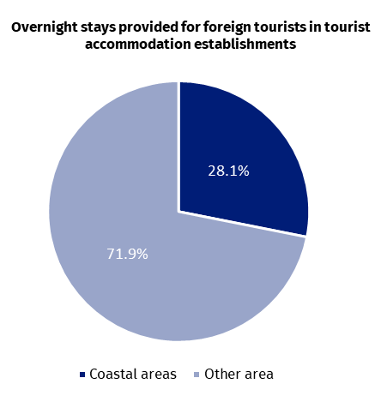
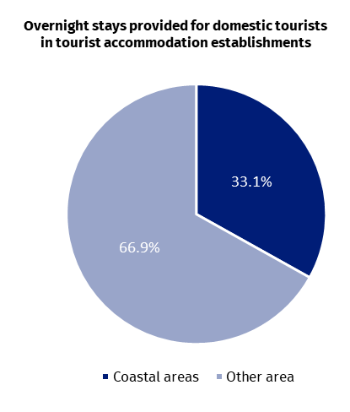
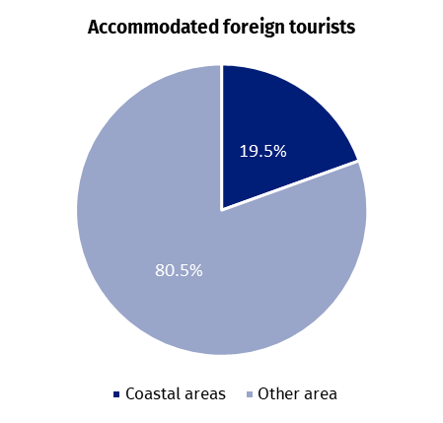
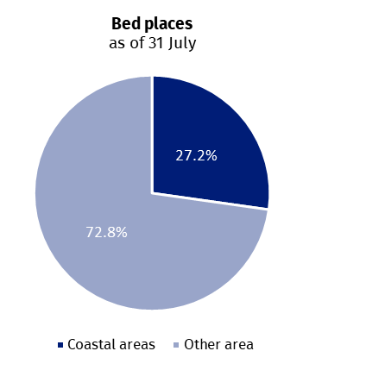
Chart 5. Tourism in coastal areas in comparison with the country in July-August 2024
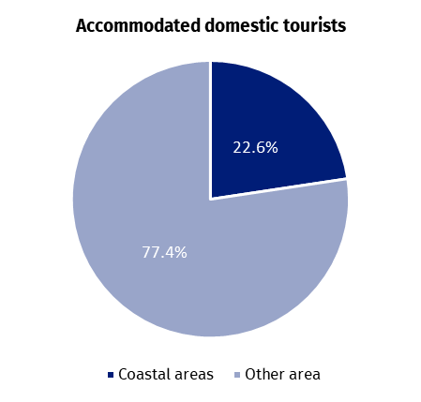
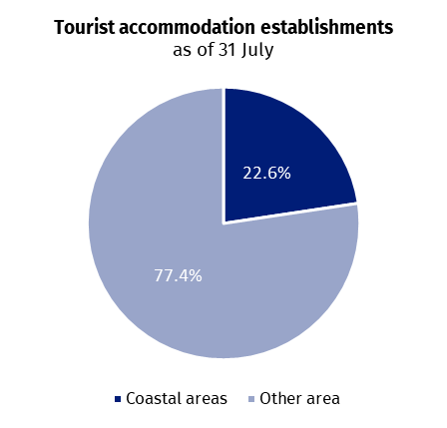

Occupancy of tourist accommodation establishments in gminas located in coastal areas in July and August 2024
In the coastal areas in July and August this year the highest number of overnight stays were provided in accommodation establishments located in Kołobrzeg urban gmina - 967.8 thousand, which constituted over 1/10 of all overnight stays provided in this area. 183.6 thousand tourists were accommodated there. This means that during the two holiday months, there were 423 tourists using the accommodation establishment and 2229 overnight stays per
100 inhabitants of the city.
In the period July-August, the largest number of overnight stays in coastal gminas was provided in Kołobrzeg and Gdańsk

Large tourist traffic was also recorded in Gdańsk, where in July-August with almost 920.8 thousand overnight stays were provided to 351.3 thousand tourists. For 100 inhabitants of this city there were 72 tourists and 189 overnight stays.
From approximately 500 thousand up to 600 thousand overnight stays were provided in 4 gminas: Rewal – 594.0 thousand, Władysławowo – 573.0 thousand, Mielno – 533.9 thousand and Świnoujście – 503.1 thousand.
After over 300 thousand overnight stays were recorded in tourist night establishments in the following gminas: Ustronie Morskie (398.1 thousand), Kołobrzeg rural gmina (390.5 thousand), Międzyzdroje (369.4 thousand) and Łeba (344.6 thousand).
Table 1. Tourist accommodation establishments and its occupancy in the period July-August in 2024
Gmina | Overnight stays provided |  |  | Tourists accommodated
Gmina | in thousand | July-August 2023=100 | in per-centages | in thousand | July-August 2023=100
Coastal area  of which: | 8666.4 | 107.7 | 100.0 | 2002.9 | 113.2
Kołobrzeg  (urban gmina) | 967.8 | 104.0 | 11.2 | 183.6 | 107.3
Gdańsk | 920.8 | 108.3 | 10.6 | 351.3 | 115.3
Rewal | 594.0 | 102.1 | 6.9 | 124.6 | 111.3
Władysławowo | 573.0 | 110.0 | 6.6 | 120.1 | 102.6
Mielno | 533.9 | 98.1 | 6.2 | 100.2 | 103.4
Świnoujście | 503.1 | 108.1 | 5.8 | 119.1 | 115.3
Ustronie Morskie | 398.1 | 103.5 | 4.6 | 72.9 | 107.1
Kołobrzeg  (rural gmina) | 390.5 | 108.6 | 4.5 | 82.3 | 121.9
Międzyzdroje | 369.4 | 145.1 | 4.3 | 88.3 | 154.7
Łeba | 344.6 | 111.3 | 4.0 | 79.0 | 126.6
In total, over 60% of tourist traffic from coastal areas was concentrated in the above-mentioned 10 gminas, both in terms of the number of tourists using accommodation establishments and overnight stays.
In case of quoting Statistics Poland data, please provide information: “Source of data: Statistics Poland”, and in case of publishing calculations made on data published by Statistics Poland, please include the following disclaimer: “Own study based on figures from Statistics Poland”.

Prepared by:  Statistical Office in Rzeszów  Director Marek Cierpiał-Wolan  Phone: (+48 17) 853 52 10 | Issued by:  Press Office  Mobile: (+48) 695 255 032  Phone: (+48 22) 608 38 04, (+48 22) 449 41 45,  (+48 22) 608 30 09  e-mail: obslugaprasowa@stat.gov.pl

stat.gov.pl/en/

@StatPoland

@GlownyUrzadStatystyczny

gus_stat

glownyurzadstatystycznygus

glownyurzadstatystyczny
Related information
Occupancy of tourist accommodation establishments in the first quarter of 2024
Tourism in 2023
Data available in databases
Local Data Bank
Terms used in official statistics
Tourist
Tourist accommodation establishment
Bed places in tourist accommodation establishments
Foreign tourists in tourist accommodation establishments
Nights spent (overnight stays) in tourist accommodation establishments.
Duration of stay
Occupancy rate of bed places or rooms

According to the Eurostat methodology, coastal areas are classified on the basis of the distance of a given gmina from the sea: if a gmina borders on the sea, it is, as a rule, a coastal gmina; if a gmina does not border on the sea but 50% of its area is within 10 km from the sea, it is also considered a coastal gmina. In Poland, in agreement with Eurostat, the following gminas: Słupsk (rural gmina), Główczyce, Gniewino, Pruszcz Gdański (rural gmina), Cedry Wielkie, Koszalin (urban gmina) and Sianów (urban-rural gmina), are additionally considered to be coastal gminas. The list of coastal gminas is included in Annex 4 of the Methodological report "Tourist accommodation statistics" available on the website https://stat.gov.pl/obszary-tematyczne/kultura-turystyka-sport/turystyka/zeszyt-metodologiczny-statystyka-turystycznej-bazy-noclegowej,15,1.html
The total area of the units, including the area of internal marine waters, is included in the indicator.
The total area of the units, including the area of internal marine waters, is included in the indicator.

