Occupancy of tourist accommodation establish-ments in the first quarter of 2024
(concerns tourist accommodation establishments with 10 or more bed places)
⇧ 0.7%
Increase in the number of tourists in tourist accommodation establishments in the 1st quarter of 2024 compared to the corresponding period of 2023
In the first quarter of 2024, 7.1 million tourists were accommodated in tourist accommodation establishments, with 17.4 million overnight stays provided to them. Compared to the first quarter of 2023, the number of tourists staying in accommodation establishments increased by 0.7%, while the number of overnight stays provided to them increased by 0.3%.

Occupancy of tourist accommodation establishments in the first quarter of 2024
In the first quarter of 2024, 68.1 thousand more foreign tourists were accommodated in tourist accommodation establishments than in the first quarter of 2023
In the first quarter of 2024, there was an increase in the occupancy of tourist accommo-dation establishments in Poland compared to the same period of 2023. According to the results obtained from the tourist accommodation establishments survey, 7.1 million tourists were accommodated in tourist accommodation establishments in the first quarter of 2024, of which 5.7 million were domestic tourists and 1.4 million were foreign tourists. Compared to the first quarter of 2023, the number of total tourists increased by 0.7%, of which the number of domestic tourists decreased by 0.3%, while the number of foreign tourists increased by 5.1%.
Among foreign tourists, visitors from Europe were the most frequent users of accommo-dation establishments – 1.2 million. They accounted for 86.2% of all foreign tourists and their number was 5.3% more than in the first quarter of 2023. The largest number of tourists came from Germany (309.6 thousand), followed by tourists from Ukraine (184.9 thousand) and tourists from the United Kingdom (158.9 thousand). Tourists from these three countries constituted together 46.2% of the total number of foreign tourists who were accommodated in tourist establishments in Poland in the first quarter of 2024.
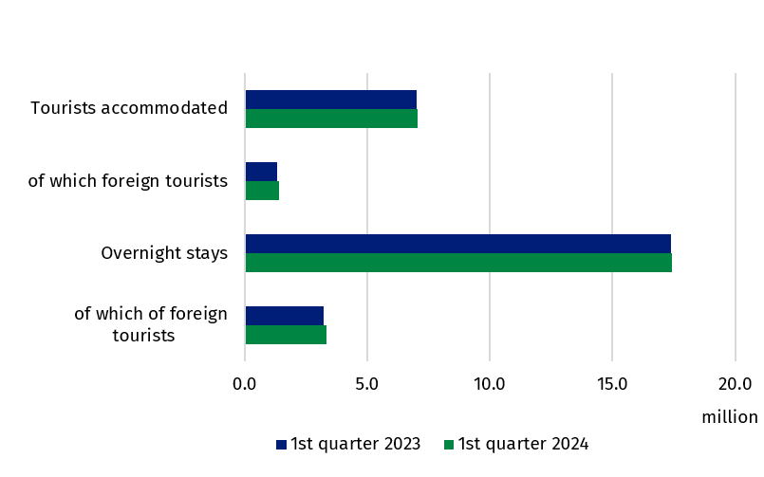
Chart 1. Tourists in tourist accommodation establishments and overnight stays
Compared to the same period last year, 14 of the 20 types of establishments saw an increase in the number of tourists. The largest increase in the number of tourists occurred at complexes of tourist cottages (by 155.1%). Tourists also significantly increased at camping sites (by 84.0%), holiday youth centres (by 70.0%) and tent camp sites (by 69.8%). A decrease in the number of tourists compared to the first quarter of the previous year was recorded to the greatest extent at creative arts centres (by 5.2%), followed by health establishments (by 4.4%) and hostels (by 2.3%). In the first quarter of 2024, tourists were most likely to choose to stay in hotels, where 5.2 million people stayed. Overnight statys in these establishments were provided to 71.8% of all domestic tourists and 82.8% of all foreign tourists.
In the first quarter of 2024, 4.1 million domestic tourists were accommodated in hotels
Table 1. Occupancy of tourist accommodation establishments by type of establishment
Specification | Tourists accommodated |  | Overnight stays provided
Specification | in thousand | Q1/2023=100 | in thousand | Q1/2023=100
Total | 7 073.5 | 100.7 | 17 440.3 | 100.3
Hotels and similar establishments | 5 953.7 | 100.1 | 12 038.6 | 100.6
hotels | 5 237.1 | 98.7 | 10 281.9 | 98.8
motels | 41.4 | 100.4 | 64.1 | 88.3
boarding houses | 108.9 | 103.9 | 268.4 | 100.6
other hotel establishments | 566.3 | 113.6 | 1 424.3 | 116.4
Other establishments | 1 119.8 | 104.3 | 5 401.7 | 99.8
excursion hostels | 8.3 | 110.9 | 37.4 | 113.8
shelters | 36.0 | 111.3 | 63.3 | 108.0
youth shelters | 10.4 | 99.5 | 33.0 | 105.6
school youth shelters | 31.5 | 100.2 | 105.5 | 87.1
holiday centres | 220.6 | 105.0 | 918.4 | 100.5
holiday youth centres | 6.9 | 170.0 | 26.0 | 141.7
training-recreational centres | 129.0 | 98.2 | 449.8 | 93.8
creative arts centres | 5.2 | 94.8 | 19.2 | 91.1
complexes of tourist cottages | 37.2 | 255.1 | 130.7 | 229.4
camping sites and tent camp sites | 4.8 | 180.9 | 10.8 | 146.2
hostels | 143.3 | 97.7 | 290.2 | 89.9
health establishments | 183.7 | 95.6 | 2 317.1 | 96.8
rooms for guests | 176.2 | 104.4 | 535.3 | 101.3
agritourism lodgings | 18.6 | 122.4 | 70.4 | 113.5
other not classified | 108.1 | 107.6 | 394.7 | 108.4
Compared with the first quarter of 2023, an increase in the number of tourists accommoda-ted was recorded in 7 voivodships, with the largest in Zachodniopomorskie Voivodship (by 9.7%) and the largest decrease was in Lubelskie Voivodship (by 12.1%). Nearly half of tourists (48.7%) accommodated in the first quarter of 2024, stayed in three voivodships: Mazowieckie, Małopolskie and Dolnośląskie (3.4 million in total). The fewest tourists (63.5 thousand) stayed in establishments located in Opolskie Voivodship – 0.9% of the total.
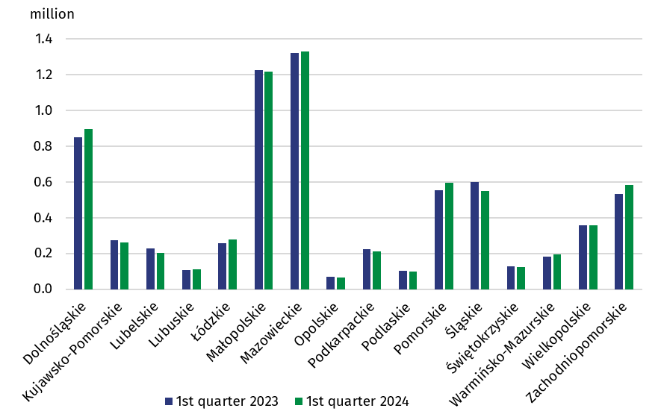
Chart 2. Tourists accommodated by voivodship
In the first quarter of 2024, tourists made 17.4 million overnight stays (i.e. 0.3% more than in the corresponding quarter of 2023). Domestic tourists made 14.1 million overnight stays, and foreign tourists – 3.3 million. Compared to the first quarter of 2023, there was an 0.4% decrease in the number of overnight stays provided to domestic tourists and a 3.4% increase in overnight stays provided to foreign tourists. Tourists were most likely to choose hotels, where they made 10.3 million overnight stays i.e. 1.2% less than a year ago.
In the first quarter of 2024, 57.4 thousand fewer overnight stays were provided to tourists than in the same quarter last year
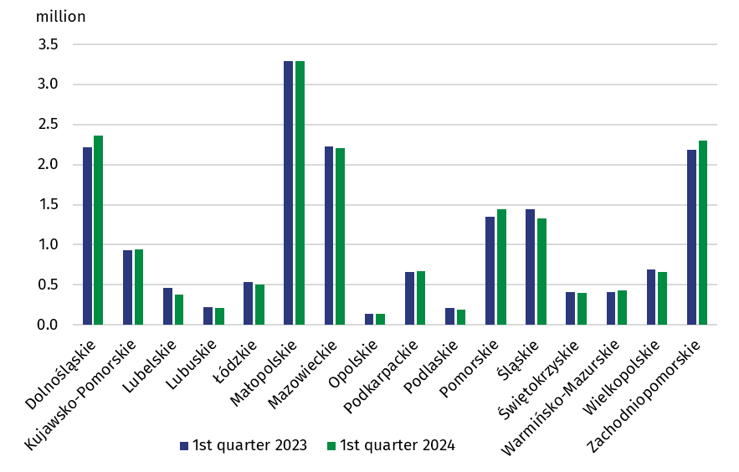
Chart 3. Overnight stays provided in tourist accommodation establishments by voivodship

The highest number of overnight stays was provided in Małopolskie Voivodship – 3.3 million (18.8% of the total), and the lowest in Opolskie Voivodship – 140.3 thousand (0.8%). The increase in the number of overnight stays was recorded in 7 voivodships. The largest increase was in Pomorskie Voivodship (by 6.8%), while the largest decrease was in Lubelskie Voivodship (by 17.2%). In the first quarter of 2024, the occupancy rate was 34.0% and was 1.7 pp lower than in the first quarter of last year. The lowest occupancy rate was recorded in January – 32.3% (down 0.7 pp). In February this year, the value of this rate was 36.6% (a decrease of 3.0 pp), while in March this year it amounted to 33.3%, compared to 34.9% a year ago.
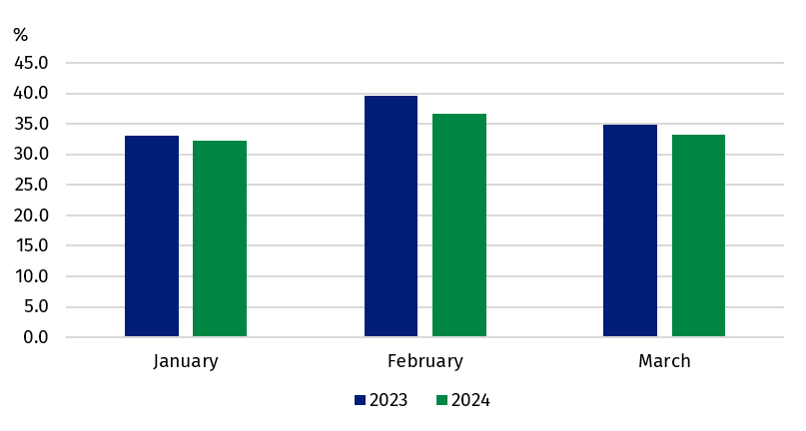
Chart 4. Occupancy rate of bed places
In the first quarter of 2024, the occupancy rate of bed places in accommodation
establishments was 43.2%
In hotels and similar establishments, 7.0 million rooms were rented in the first quarter of this year (7.1 million in the same period of 2023), while the occupancy rate was 43.2%, 1.7 pp lower than in the first quarter of last year.
When quoting Statistics Poland data, please provide information: “Source of data: Statistics Poland”, and when publishing calculations made on data published by Statistics Poland, please provide information: “Own study based on Statistics Poland data”.

Prepared by:  Statistical Office in Rzeszów  Director Marek Cierpiał-Wolan  Office: tel. (+48 17) 853 52 10  (+48 17) 853 52 19 | Issued by:  Press Office  Mobile: (+48) 695 255 032  Phone: (+48 22) 608 38 04, (+48 22) 449 41 45,  (+48 22) 608 30 09  e-mail: obslugaprasowa@stat.gov.pl

stat.gov.pl/en/

@StatPoland

@GlownyUrzadStatystyczny

gus_stat

glownyurzadstatystycznygus

glownyurzadstatystyczny
Related information
Occupancy of tourist accommodation establishments in 2023
Occupancy of tourist accommodation establishments in the first quarter of 2023
Tourism in 2022
Data available in databases
Local Data Bank
Knowledge Databases
Terms used in official statistics
Tourist
Tourist accommodation establishment
Bed places in tourist accommodation establishments
Foreign tourists in tourist accommodation establishments
Nights spent (overnight stays) in tourist accommodation establishments
Duration of the stay
Occupancy rate of bed places in tourist accommodation establishments

