Index numbers of construction and assembly
production in November 2024
According to preliminary data construction and assembly production (in constant prices) carried out domestically by construction enterprises employing more than 9 persons was in November 2024 by 9.3% lower than in the same period of 2023 (an increase of 3.8% the year before) and by 3.3% higher compared to October 2024 (an increase of 3.0% in the corresponding period of 2023).
90.7
Index number of construction and assembly production
compared to November of 2023
Table 1. Index numbers of construction and assembly production (constant prices)
SPECIFICATION | 11 2024 |  | 01-11 2024
SPECIFICATION | 10 2024=100 | 11 2023=100 | 01-11 2023=100
CONSTRUCTION | 103.3 | 90.7 | 92.6
Construction of buildings ^{Δ} | 97.4 | 84.0 | 93.9
Civil engineering works ^{Δ} | 112.2 | 96.8 | 92.9
Specialised construction activities | 94.0 | 87.0 | 90.5

^{Δ} Abbreviated form according to PKD 2007.

Construction and assembly production in November 2024, showed an annual decrease in all divisions of construction. For entities whose basic type of activity was construction of buildings of 16.0%, performing specialised construction activities it recorded of 13.0% and for entities dealing mainly with civil engineering works of 3.2%.
In the period of January-November 2024, in relation to the same period of the previous year, a decreas in the sales of construction and assembly production was noted in entities performing specialised construction activities of 9.5%. In entities dealing mainly with civil engineering works and in whose basic type of activity was construction of buildings decreases were recorded of 7.1% and of 6.1% respectively.
Compared to October 2024, an increase in the sales of construction and assembly production was noted in in entities whose basic type of activity was civil engineering works of 12.2%, whereas in entities performing specialised construction activities and in entities dealing mainly with construction of buildings decreases were recorded of 6.0% and 2.6% respectively.
A decrease in construction and assembly production in November 2024, compared with the same month of the previous year, was observed for investment works by 7.2% and for restoration works by 13.9% (in 2023, an increase of 21.6% and a decrease of 21.1% respectively).
In the period of January-November 2024, in relation to the corresponding period of 2023, there was a decrease in the investment works by 9.0% and a decrease in the restoration works by 3.6%. In the same period of 2023, was observed an increase of 28.0% and a decrease of 29.0%, respectively.
Chart 1. Index numbers of construction and assembly production (constant prices; average monthly base 2021=100)
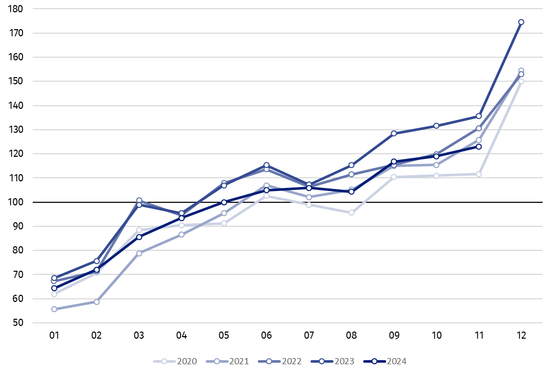

Index number of construction and assembly production in November 2024 (in constant prices), compared to the average monthly value of 2021, was 123.0.
In November 2024, after eliminating the seasonal factors, construction and assembly production reached the level by 5.8% lower than in the corresponding month of the previous year and higher by 2.7% in comparison to October 2024.

In case of quoting Statistics Poland data, please provide information: “Source of data: Statistics Poland” and in case of publishing calculations made on data published by Statistics Poland, please include the following disclaimer: “Own study based on figures from Statistics Poland”.

Prepared by:  Statistical Office in Lublin  Director Krzysztof Markowski, Ph.D.  Phone: (+48) 695 255 301 | Issued by:  Press Office  Mobile: (+48) 695 255 032  Phone: (+48 22) 608 38 04, (+48 22) 449 41 45,  (+48 22) 608 30 09  e-mail: obslugaprasowa@stat.gov.pl

stat.gov.pl/en/

@StatPoland

@GlownyUrzadStatystyczny

gus_stat

glownyurzadstatystycznygus

glownyurzadstatystyczny
Related information
Statistical Bulletin
Socio-economic situation of the country
Data available in databases
Knowledge Database - Construction
Macroeconomic Data Bank
Macroeconomic indicators
Local Data Bank

Terms used in official statistics
Sale of construction and assembly production
Seasonally unadjusted index of sale of construction and assembly production in constant prices
Seasonally adjusted index of sale of construction and assembly production
Sale of construction works with an investment character
Sale of construction works with a restoration character and other works

Preliminary data; comprise enterprises employing over 9 persons, whose the main type of activity is included in the section F “Construction” in accordance with the Polish Classification of Activities (PKD 2007).
² Data including final information on production and prices in October and preliminary data in November.
Preliminary data for November 2024.

