Index numbers of construction and assembly
production in March 2024
According to preliminary data construction and assembly production (in constant prices) carried out domestically by construction enterprises employing more than 9 persons was in March 2024 by 13.3% lower than in the same period of 2023 (a decrease of 1.6% the year before) and by 19.1% higher compared to February 2024 (an increase of 30.6% in the corresponding period of 2023).
86.7
Index number of construction and assembly production compared to March of 2023

Table 1. Index numbers of construction and assembly production (constant prices)
SPECIFICATION | 03 2024 |  | 01-03 2024
SPECIFICATION | 02 2024=100 | 03 2023=100 | 01-03 2023=100
CONSTRUCTION | 119.1 | 86.7 | 89.2
Construction of buildings ^{Δ} | 106.0 | 83.9 | 93.1
Civil engineering works ^{Δ} | 131.2 | 82.2 | 83.8
Specialised construction activities | 122.5 | 96.8 | 91.2

^{Δ} Abbreviated form according to PKD 2007.

Construction and assembly production in March 2024, showed an annual decrease in all divisions of construction, in entities performing specialised construction activities of 3.2% and in entities whose basic type of activity was construction of buildings of 16.1% and dealing mainly with civil engineering works of 17.8%.
In the first quarter of 2024, in relation to the same period of the previous year, a decrease in the sales of construction and assembly production was noted in entities whose basic type of activity was construction of buildings (6.9%), performing specialised construction activities (8.8%) and dealing mainly with civil engineering works (16.2%).
Compared to February 2024, an increase was noted in all divisions of construction, whereas in entities whose basic type of activity was civil engineering works of 31.2%, performing specialised construction activities of 22.5% and dealing mainly with construction of buildings of 6.0%.
Construction and assembly production in March 2024, compared to the corresponding month of 2023, decreased of 2.1% in the investment works and of 28.9% in the restoration works (respectively an increase of 1.7% and a decrease of 5.9% in 2023).
In the first quarter of 2024, in relation to the corresponding period of 2023, there were decreases of 3.6% in the investment works and of 21.9% in the restoration works (respectively an increase of 8.5% and a decrease of 3.4% in 2023).
Chart 1. Index numbers of construction and assembly production (constant prices; average monthly base 2021=100)
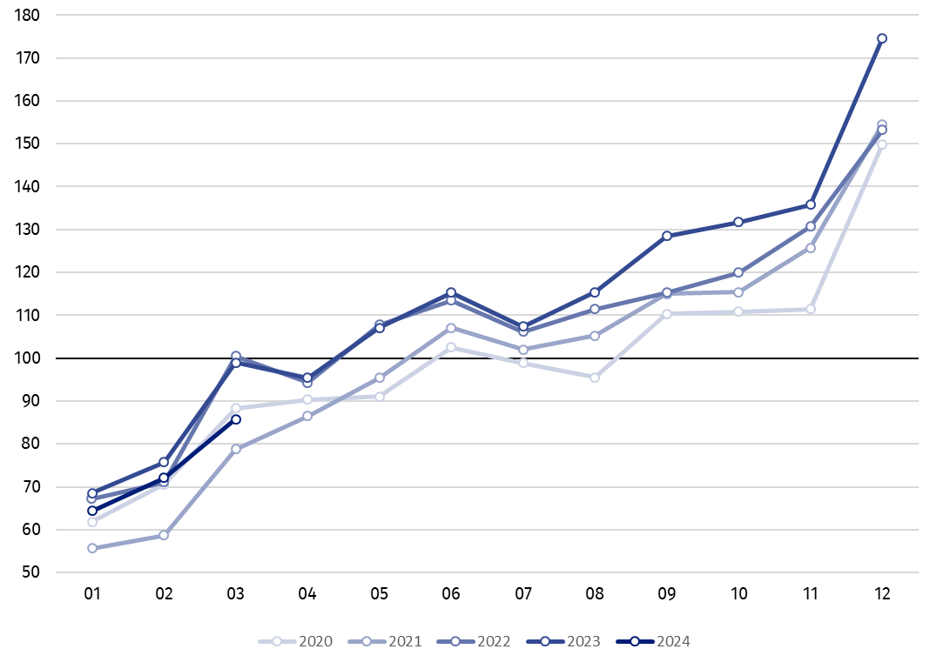

Index number of construction and assembly production in March 2024 (in constant prices), compared to the average monthly value of 2021, was 85.8.
In March 2024, after eliminating the seasonal factors, construction and assembly production reached the level by 8.6% lower than in the corresponding month of the previous year and lower by 4.3% in comparison to February 2024.

In case of quoting Statistics Poland data, please provide information: “Source of data: Statistics Poland” and in case of publishing calculations made on data published by Statistics Poland, please include the following disclaimer: “Own study based on figures from Statistics Poland”.

Prepared by:  Statistical Office in Lublin  Director Krzysztof Markowski, Ph.D.  Phone: (+48) 695 255 301 | Issued by:  The Spokesperson for the President of Statistics Poland  Karolina Banaszek  Phone: (+48) 695 255 011
Press Office  Phone: (+48 22) 608 38 04  e-mail: obslugaprasowa@stat.gov.pl |   stat.gov.pl/en/

@StatPoland

@GlownyUrzadStatystyczny

gus_stat

glownyurzadstatystycznygus

glownyurzadstatystyczny
Related information
Statistical Bulletin
Socio-economic situation of the country
Data available in databases
Knowledge Database - Construction
Macroeconomic Data Bank
Macroeconomic indicators
Local Data Bank

Terms used in official statistics
Sale of construction and assembly production
Seasonally unadjusted index of sale of construction and assembly production in constant prices
Seasonally adjusted index of sale of construction and assembly production
Sale of construction works with an investment character
Sale of construction works with a restoration character and other works

Preliminary data; comprise enterprises employing over 9 persons, whose the main type of activity is included in the section F “Construction” in accordance with the Polish Classification of Activities (PKD 2007).
² Data including final information on production and prices in February and preliminary data in March.
Preliminary data for March 2024.

