Index numbers of construction and assembly
production in January 2024
According to preliminary data construction and assembly production (in constant prices) carried out domestically by construction enterprises employing more than 9 persons was in January 2024 by 6.1% lower than in the same period of 2023 (an increase of 2.0% in the corresponding period of 2023) and by 63.2% lower compared to December 2023 (a decrease of 55.3% in the corresponding period of 2023).
93.9
Index number of construction and assembly production compared to January of 2023

Table 1. Index numbers of construction and assembly production (constant prices)

SPECIFICATION | 01 2024
SPECIFICATION | 12 2023=100 | 01 2023=100
CONSTRUCTION | 36.8 | 93.9
Construction of buildings ^{Δ} | 47.4 | 92.7
Civil engineering works ^{Δ} | 24.7 | 89.5
Specialised construction activities | 50.8 | 100.5
^{Δ} Abbreviated form according to PKD 2007.

Construction and assembly production in January 2024, compared to the corresponding period of 2023, increased in entities performing specialised construction activities (0.5%). The decrease was recorded in entities whose basic type of activity was construction of buildings (7.3%) and dealing mainly with civil engineering works (10.5%).

Compared to December 2023, the decrease was noted in all divisions of construction, in entities whose basic type of activity were civil engineering works of 75.3%, dealing mainly with construction of buildings of 52.6% and performing specialised construction activities of 49.2%.

Construction and assembly production in January 2024, compared to corresponding month of 2023, decreased for investment works by 2.1% and for restoration works by 12.3% (respectively increases of 3.0% and 0.5% in 2023).
Chart 1. Index numbers of construction and assembly production (constant prices; average monthly base 2021=100)
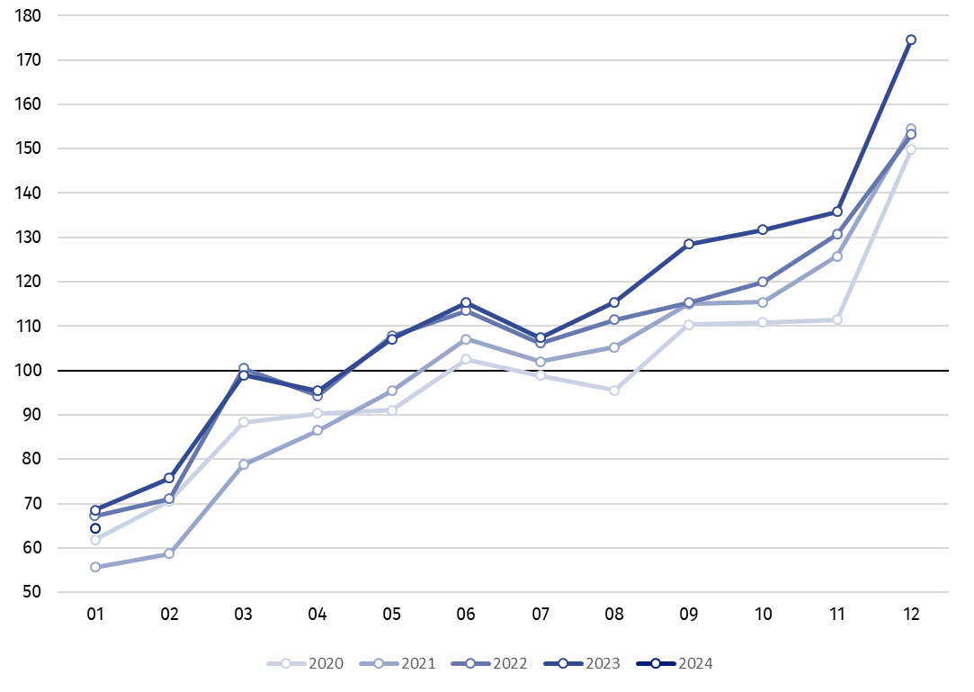

Index number of construction and assembly production in January 2024 (in constant prices), compared to the average monthly value of 2021, was 64.3.
In January 2024, after eliminating the seasonal factors, construction and assembly production reached the level by 7.8% lower than in the corresponding month of the previous year and lower by 16.5% in comparison to December 2023.

In case of quoting Statistics Poland data, please provide information: “Source of data: Statistics Poland” and in case of publishing calculations made on data published by Statistics Poland, please include the following disclaimer: “Own study based on figures from Statistics Poland”.

Prepared by:  Statistical Office in Lublin  Director Krzysztof Markowski, Ph.D.  Phone: (+48) 695 255 301 | Issued by:  The Spokesperson for the President of Statistics Poland  Karolina Banaszek  Phone: (+48) 695 255 011
Press Office  Phone: (+48 22) 608 38 04  e-mail: obslugaprasowa@stat.gov.pl |   stat.gov.pl/en/

@StatPoland

@GlownyUrzadStatystyczny

gus_stat

glownyurzadstatystycznygus

glownyurzadstatystyczny
Related information
Statistical Bulletin
Socio-economic situation of the country
Data available in databases
Knowledge Databases - Construction
Knowledge Databases - Construction (new)
Macroeconomic Data Bank
Macroeconomic indicators
Local Data Bank

Terms used in official statistics
Seasonally unadjusted index of sale of construction and assembly production in constant prices
Seasonally adjusted index of sale of construction and assembly production
Sale of construction works with an investment character
Sale of construction works with a restoration character and other works

Reported data; comprise enterprises employing over 9 persons, whose the main type of activity is included in the section F “Construction” in accordance with the Polish Classification of Activities (PKD 2007).
Reported data for January 2024.

