Index numbers of construction and assembly
production in December 2023
According to preliminary data construction and assembly production (in constant prices) carried out domestically by construction enterprises employing more than 9 persons was in December 2023 by 14.0% higher than in the same period of 2022 (a decrease of 0.9% in the corresponding period of 2022) and by 28.7% higher compared to November 2023 (an increase of 17.2% in the corresponding period of 2022).
114.0
Index number of construction and assembly production compared to December of 2022

Table 1. Index numbers of construction and assembly production (constant prices)
SPECIFICATION | 12 2023 |  | 01-12 2023
SPECIFICATION | 11 2023=100 | 12 2022=100 | 01-12 2022=100
CONSTRUCTION | 128.7 | 114.0 | 105.0
Construction of buildings ^{Δ} | 121.1 | 113.4 | 98.7
Civil engineering works ^{Δ} | 137.3 | 119.2 | 111.3
Specialised construction activities | 121.1 | 104.7 | 102.7

^{Δ} Abbreviated form according to PKD 2007.

Construction and assembly production in December 2023, showed an annual increase in entities dealing mainly with civil engineering works (19.2%), whose basic type of activity was construction of buildings (13.4%) and in entities performing specialised construction activities (4.7%).
Compared to November 2023, an increase was noted in all division of construction, in entities whose basic type of activity was civil engineering works of 37.3%, among entities dealing mainly with construction of buildings and performing specialised construction activities of 21.1% each.
In 2023 compared to 2022, an increase in the sales of construction and assembly production was noted in entities dealing mainly with civil engineering works (11.3%) and performing specialised construction activities (2.7%), whereas a decrease was recorded in entities whose basic type of activity was construction of buildings (1.3%).
Construction and assembly production in December 2023, compared to corresponding month of 2022, increased for investment works by 46.6% and decreased for restoration works by 25.7% (respectively a decrease of 10.1% and an increase of 13.2% in 2022).
In 2023 compared to 2022, there was an increase of 30.0% in the investment works and a decrease of 28.3% in the restoration works (respectively increases of 1.1% and of 13.9% in 2022).
Chart 1. Index numbers of construction and assembly production (constant prices; average monthly base 2015=100)
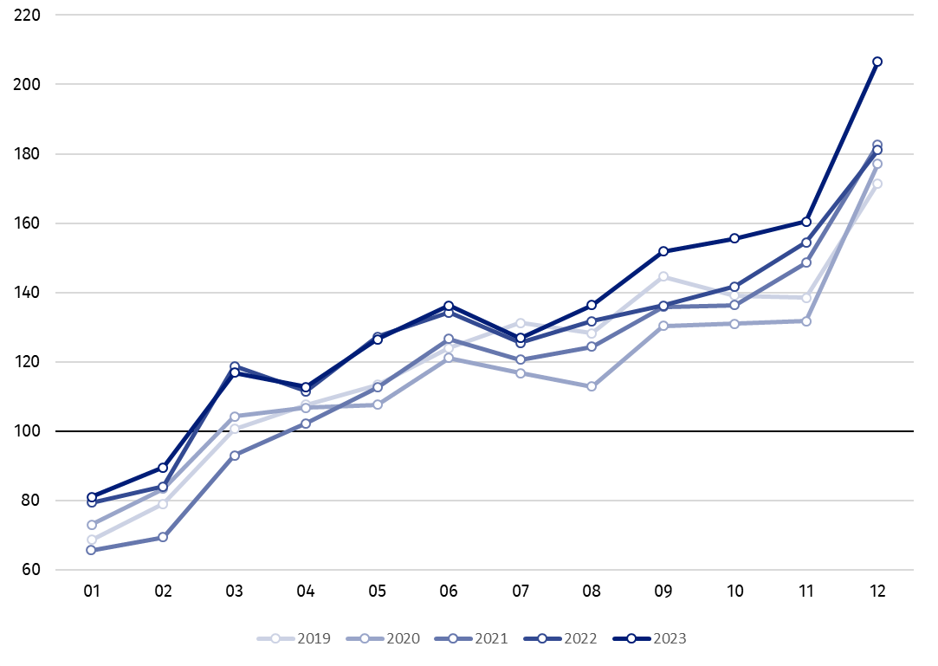

Index number of construction and assembly production in December 2023 (in constant prices), compared to the average monthly value of 2015, was 206.5.

In December 2023, after eliminating the seasonal factors, construction and assembly production reached the level by 16.1% higher than in December 2022 and by 8.5% higher in comparison to November 2023.

In case of quoting Statistics Poland data, please provide information: “Source of data: Statistics Poland” and in case of publishing calculations made on data published by Statistics Poland, please include the following disclaimer: “Own study based on figures from Statistics Poland”.

Prepared by:  Statistical Office in Lublin  Director Krzysztof Markowski, Ph.D.  Phone: (+48) 695 255 301 | Issued by:  The Spokesperson for the President of Statistics Poland  Karolina Banaszek  Phone: (+48) 695 255 011
Press Office  Phone: (+48 22) 608 38 04  e-mail: obslugaprasowa@stat.gov.pl |   stat.gov.pl/en/

@StatPoland

@GlownyUrzadStatystyczny

gus_stat

glownyurzadstatystycznygus

glownyurzadstatystyczny
Related information
Statistical Bulletin
Socio-economic situation of the country
Data available in databases
Knowledge Databases - Construction
Knowledge Databases - Construction (new)
Macroeconomic Data Bank
Macroeconomic indicators
Local Data Bank

Terms used in official statistics
Sale of construction and assembly production
Seasonally unadjusted index of sale of construction and assembly production in constant prices
Seasonally adjusted index of sale of construction and assembly production
Sale of construction works with an investment character
Sale of construction works with a restoration character and other works

Preliminary data; comprise enterprises employing over 9 persons, whose the main type of activity is included in the section F “Construction” in accordance with the Polish Classification of Activities (PKD 2007).
² Data including final information on production and prices in November and preliminary data in December.
Premilinary data for December 2023.

