Residential construction in the period of January-May 2024

In the period of January-May 2024, there were less dwellings completed than the year before. Whereas the number of dwellings for which permits have been granted or which have been registered with a construction project as well as dwellings in which construction has begun increased.
84.1
Index number of dwellings
completed y/y

Dwellings completed
Developers and private
investors completed respectively: 60.6% and 37.0% of the total number of dwellings
According to the preliminary data, 78.7 thousand dwellings were completed in the period of January-May 2024, i.e. by 15.9% less than in the corresponding period of 2023. Developers completed 47.7 thousand dwellings – by 6.4% less than a year ago, whereas private investors completed 29.1 thousand dwellings, i.e. by 29.2% less. Within these forms of construction, 97.6% of the total number of newly completed dwellings was built. Within other forms of construction 1.9 thousand dwellings were completed (1.5 thousand in the previous year).
The total useful floor area of dwellings completed amounted to 7.2 million m², i.e. by 20.8%
less than a year ago and its average value for 1 dwelling was 91.1 m².

Table 1. Dwellings completed
SPECIFICATION | 05 2024 |  |  | 01-05 2024
SPECIFICATION | Number  of dwellings | 05 2023=100 | 04 2024=100 | Number  of dwellings | 01-05 2023=100
TOTAL | 14 513 | 81.9 | 91.3 | 78 691 | 84.1
Private | 5 273 | 74.4 | 91.6 | 29 115 | 70.8
For sale or rent | 8 813 | 85.0 | 90.2 | 47 690 | 93.6
of which for rent | 44 | 16.9 | 314.3 | 291 | 44.0
Cooperative | 61 | 59.8 | 96.8 | 180 | 31.1
Municipal | 256 | 825.8 | 266.7 | 778 | 253.4
Public building society | 98 | 74.2 | 47.6 | 915 | 145.7
Company | 12 | . | 12-  fold more | 13 | 433.3

Dwellings for which permits have been granted or which have been registered with
a construction project
In the period of January-May 2024, permits and registrations have been granted for construction of 119.3 thousand dwellings, i.e. by 31.0% more than a year ago. Permits for construction of the biggest number of dwellings were given to developers (85.0 thousand, an increase of 41.4% y/y) and to private investors (31.8 thousand, an increase of 13.1%). Within these forms of construction, permits have been granted and registrations with a construction project were made for 97.9% of dwellings in total. In other forms of construction 2.5 thousand dwellings for which permits have been granted or which have been registered with a construction project were noted (2.8 thousand in the previous year).

Table 2. Dwellings for which permits have been granted or which have been registered with a construction project
SPECIFICATION | 05 2024 |  |  | 01-05 2024
SPECIFICATION | Number  of dwellings | 05 2023=100 | 04 2024=100 | Number  of dwellings | 01-05 2023=100
TOTAL | 24 460 | 131.6 | 98.5 | 119 265 | 131.0
Private | 6 867 | 104.0 | 92.5 | 31 775 | 113.1
For sale or rent | 16 971 | 152.3 | 99.8 | 85 009 | 141.4
Cooperative | - | . | . | - | .
Municipal | 170 | 197.7 | 404.8 | 582 | 106.4
Public building society | 452 | 103.9 | 121.8 | 1 890 | 101.6
Company | - | . | . | 9 | 32.1
Dwellings in which construction has begun
In the first five months of 2024, the number of dwellings in which construction has begun was 101.1 thousand, i.e. by 45.6% more than a year before. Developers have started construction
of 66.5 thousand dwellings (by 70.1% more y/y), and private investors of 33.1 thousand (by 14.8% more). Altogether the share of these forms of construction was 98.4% of the total number of dwellings. In other forms of construction the number of dwellings in which construction has begun was 1.6 thousand (similar amount in the previous year).

Table 3. Dwellings in which construction has begun
SPECIFICATION | 05 2024 |  |  | 01-05 2024
SPECIFICATION | Number  of dwellings | 05 2023=100 | 04 2024=100 | Number  of dwellings | 01-05 2023=100
TOTAL | 19 826 | 121.1 | 93.3 | 101 143 | 145.6
Private | 7 555 | 102.0 | 89.0 | 33 073 | 114.8
For sale or rent | 11 924 | 137.2 | 94.8 | 66 499 | 170.1
of which for rent | 21 | 35.0 | 63.6 | 188 | 145.7
Cooperative | 156 | . | 487.5 | 292 | over 32-fold more
Municipal | 87 | 202.3 | 124.3 | 259 | 113.1
Public building society | 104 | 114.3 | 192.6 | 1 003 | 84.8
Company | - | . | . | 17 | 12.0
It is estimated that at the end of May 2024, there were 823.4 thousand dwellings under construction, i.e. by 1.8% more than in the corresponding month of 2023.

Chart 1. Residential construction in Poland
In May 2024, compared to April 2024, the number of dwellings for which permits have been granted or which have been registered with a construction project, the number of dwellings in which construction has begun and the number of dwellings completed decreased (respectively by 1.5%, 6.7% and 8.7%)
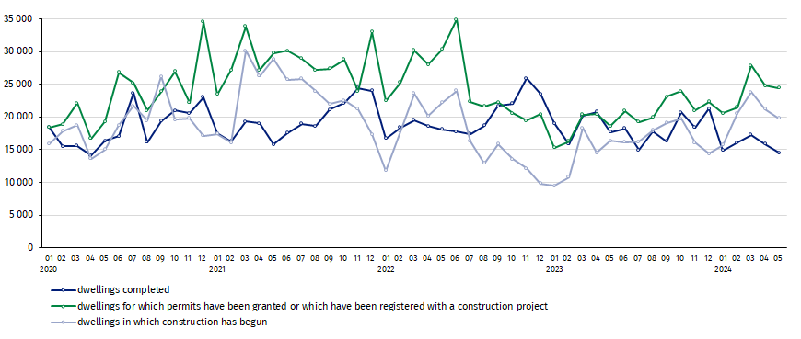

In the period of January-May 2024, the highest total number of dwellings completed, as well as dwellings in which construction has begun and dwellings for which permits have been granted or which have been registered with a construction project, were recorded in Mazowieckie voivodship (respectively: 14.3 thousand, 19.3 thousand and 25.7 thousand dwellings). High values were also noted in: Małopolskie (8.7 thousand, 9.0 thousand and 11.3 thousand), Dolnośląskie (6.2 thousand, 10.0 thousand and 11.5 thousand) and Wielkopolskie (7.2 thousand, 9.3 thousand and 10.7 thousand).

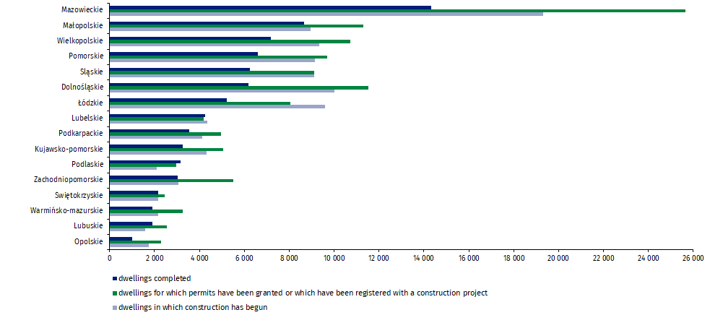
Chart 2. Residential construction by voivodships in January-May 2024

In case of quoting Statistics Poland data, please provide information: “Source of data: Statistics Poland” and in case of publishing calculations made on data published by Statistics Poland, please include the following disclaimer: “Own study based on figures from Statistics Poland”.
Prepared by:  Statistical Office in Lublin  Director Krzysztof Markowski, Ph.D.  Phone: (+48) 695 255 301 | Issued by:  Press Office  Mobile +48 695 255 032  Phone +48 22 608 38 04, +48 22 449 41 45,  +48 22 608 30 09  e-mail: obslugaprasowa@stat.gov.pl

www.stat.gov.pl/en/

@StatPoland

@GlownyUrzadStatystyczny

gus_stat

glownyurzadstatystycznygus

glownyurzadstatystyczny
Related information
Statistical Bulletin
Socio-economic situation of the country
Construction results
Data available in databases
Macroeconomic Data Bank
Knowledge Databases - Construction
Local Data Bank
Terms used in official statistics
Dwellings for which permits have been granted or which have been registered with a construction project
Dwellings in which construction has begun
Dwellings completed

Preliminary data; subject to change upon developing final data.
Including a simplified procedure for single-family residential buildings.

