Residential construction in the period of January-February 2024

In the first two months of 2024, there were less dwellings completed than the year before. Whereas the number of dwellings for which permits have been granted or which have been registered with a construction project as well as dwellings in which construction has begun increased.
88.3
Index number of dwellings
completed y/y

Dwellings completed
Developers and private investors completed respectively: 58.8% and 38.9% of the total number of dwellings
According to the preliminary data, 30.8 thousand dwellings were completed in the period of January-February 2024, i.e. by 11.7% less than in the corresponding month of 2023. Developers completed 18.1 thousand dwellings – by 5.9% less than a year ago, whereas private investors completed 12.0 thousand dwellings, i.e. by 20.0% less. Within these forms of construction, 97.7% of the total number of newly completed dwellings was built. Within other forms of construction 0.7 thousand dwellings were completed (similar amount in the previous year).
The total useful floor area of dwellings completed amounted to 2.9 million m², i.e. by 14.3%
less than a year ago and its average value for 1 dwelling was 92.8 m².

Table 1. Dwellings completed
SPECIFICATION | 02 2024 |  |  | 01-02 2024
SPECIFICATION | Number  of dwellings | 02 2023=100 | 01 2024=100 | Number  of dwellings | 01-02 2023=100
TOTAL | 16 048 | 101.7 | 108.7 | 30 810 | 88.3
Private | 5 913 | 82.2 | 97.6 | 11 970 | 80.0
For sale or rent | 9 796 | 120.2 | 117.9 | 18 103 | 94.1
of which for rent | 27 | 45.8 | 33.3 | 108 | 70.1
Cooperative | - | . | . | 113 | 58.2
Municipal | 105 | 214.3 | 57.4 | 288 | 180.0
Public building society | 234 | 105.9 | 229.4 | 336 | 108.7
Company | - | . | . | - | .

Dwellings for which permits have been granted or which have been registered with
a construction project
In the period of January-February 2024, permits and registrations have been granted for construction of 41.9 thousand dwellings, i.e. by 32.7% more than a year ago. Permits for construction of the biggest number of dwellings were given to developers (30.1 thousand, an increase of 42.3% y/y) and to private investors (11.0 thousand, an increase of 14.7%). Within these forms of construction, permits have been granted and registrations with a construction project were made for 98.0% of dwellings in total. In other forms of construction 0.8 thousand dwellings for which permits have been granted or which have been registered with a construction project were noted (0.9 thousand in the previous year).

Table 2. Dwellings for which permits have been granted or which have been registered with a construction project
SPECIFICATION | 02 2024 |  |  | 01-02 2024
SPECIFICATION | Number  of dwellings | 02 2023=100 | 01 2024=100 | Number  of dwellings | 01-02 2023=100
TOTAL | 21 382 | 131.3 | 104.2 | 41 912 | 132.7
Private | 5 620 | 117.9 | 105.2 | 10 963 | 114.7
For sale or rent | 15 469 | 142.3 | 105.7 | 30 101 | 142.3
Cooperative | - | . | . | - | .
Municipal | 100 | 36.1 | 80.0 | 225 | 73.1
Public building society | 193 | 59.2 | 45.3 | 619 | 118.8
Company | - | . | . | 4 | 400.0
Dwellings in which construction has begun
In the first two months of 2024, the number of dwellings in which construction has begun was 36.3 thousand, i.e. by 79.0% more than a year before. Developers have started construction of 26.2 thousand dwellings (by 111.4% more), and private investors of 9.4 thousand (by 25.3% more). Altogether the share of these forms of construction was 98.2% of the total number of dwellings. In other forms of construction the number of dwellings in which construction has begun was 0.6 thousand (0.4 thousand in the previous year).

Table 3. Dwellings in which construction has begun
SPECIFICATION | 02 2024 |  |  | 01-02 2024
SPECIFICATION | Number  of dwellings | 02 2023=100 | 01 2024=100 | Number  of dwellings | 01-02 2023=100
TOTAL | 20 551 | 190.0 | 130.7 | 36 271 | 179.0
Private | 5 873 | 148.7 | 166.4 | 9 403 | 125.3
For sale or rent | 14 179 | 215.2 | 117.7 | 26 230 | 211.4
of which for rent | 72 | over 14-fold more | 189.5 | 110 | 785.7
Cooperative | 81 | . | 352.2 | 104 | .
Municipal | 64 | 48.5 | 355.6 | 82 | 62.1
Public building society | 352 | 237.8 | 359.2 | 450 | 204.5
Company | 2 | . | . | 2 | .
It is estimated that at the end of February 2024, there were 806.4 thousand dwellings under construction, i.e. by 1.5% less than in the corresponding month of 2023.

Chart 1. Residential construction in Poland
In February 2024, compared to January 2024, the number of dwellings completed as well as the number of dwellings for which permits have been granted or which have been registered with a construction project and the number of dwellings in which construction has begun increased (respectively by 8.7%, 4.2% and 30.7%)
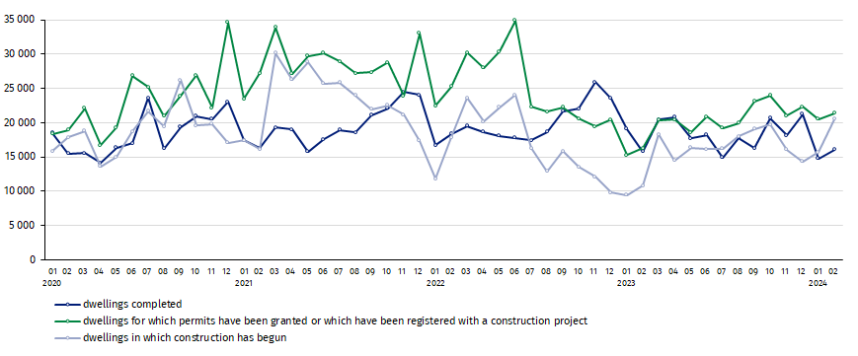

In the period of January-February 2024, the highest values of dwellings completed, as well as dwellings in which construction has begun and dwellings for which permits have been granted or which have been registered with a construction project, were recorded in Mazowieckie voivodship (respectively: 6.0 thousand, 6.5 thousand and 8.7 thousand dwellings). High values were also noted in Dolnośląskie (3.0 thousand, 3.7 thousand and 4.2 thousand), Małopolskie (2.9 thousand, 3.3 thousand and 3.9 thousand) and Wielkopolskie (2.6 thousand, 3.2 thousand and 4.0 thousand).

Chart 2. Residential construction by voivodships in January-February 2024
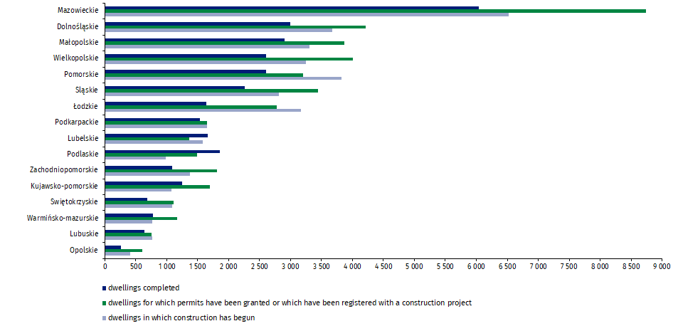

In case of quoting Statistics Poland data, please provide information: “Source of data: Statistics Poland” and in case of publishing calculations made on data published by Statistics Poland, please include the following disclaimer: “Own study based on figures from Statistics Poland”.
Prepared by:  Statistical Office in Lublin  Director Krzysztof Markowski, Ph.D.  Phone: (+48) 695 255 301 | Issued by:  The Spokesperson for the President  of Statistics Poland  Karolina Banaszek  Phone: (+48) 695 255 011
Press Office  Phone: (+48 22) 608 38 04  e-mail: obslugaprasowa@stat.gov.pl |   www.stat.gov.pl/en/

@StatPoland

@GlownyUrzadStatystyczny

gus_stat

glownyurzadstatystycznygus

glownyurzadstatystyczny
Related information
Statistical Bulletin
Socio-economic situation of the country
Construction results
Data available in databases
Macroeconomic Data Bank
Knowledge Databases - Construction
Dwellings in which construction has begun - monthly accruing data
Dwellings completed – quarterly accruing data
Local Data Bank
Terms used in official statistics
Dwellings for which permits have been granted or which have been registered with a construction project
Dwellings in which construction has begun
Dwellings completed

Preliminary data; subject to change upon developing final data.
Including a simplified procedure for single-family residential buildings.

