Residential construction in the period of January 2024

In January 2024, there were less dwellings completed than the year before. Whereas the number of dwellings for which permits have been granted or which have been registered with a construction project as well as dwellings
in which construction has begun increased.
77.3
Index number of dwellings
completed y/y

Dwellings completed
Developers and private investors completed respectively: 56.3% and 41.0% of the total number of dwellings
According to the preliminary data, 14.8 thousand dwellings were completed in January 2024, i.e. by 22.7% less than in the corresponding month of 2023. Developers completed 8.3 thousand dwellings – by 25.1% less than a year ago, whereas private investors completed 6.1 thousand dwellings, i.e. by 22.1% less. Within these forms of construction, 97.3% of the total number of newly completed dwellings was built. Within other forms of construction, i.e. cooperative, municipal and public building society 0.4 thousand dwellings were completed (0.2 thousand
in the previous year).
The total useful floor area of dwellings completed amounted to 1.4 million m², i.e. by 21.0%
less than a year ago and its average value for 1 dwelling was 95.6 m².

Table 1. Dwellings completed
SPECIFICATION | 01 2024
SPECIFICATION | Number  of dwellings | 01 2023=100 | 12 2023=100
TOTAL | 14 762 | 77.3 | 71.1
Private | 6 057 | 77.9 | 89.1
For sale or rent | 8 307 | 74.9 | 61.3
of which for rent | 81 | 85.3 | 108.0
Cooperative | 113 | 538.1 | 262.8
Municipal | 183 | 164.9 | 136.6
Public building society | 102 | 115.9 | 47.9
Company | - | . | .

Dwellings for which permits have been granted or which have been registered with
a construction project
In January 2024, permits and registrations have been granted for construction of 20.5 thousand dwellings, i.e. by 34.1% more than a year ago. Permits for construction of the biggest number of dwellings were given to developers (14.6 thousand, an increase of 42.2% y/y) and to private investors (5.3 thousand, an increase of 11.5%). Within these forms of construction, permits have been granted and registrations with a construction project were made for 97.3% of dwellings in total. In other forms of construction 0.6 thousand dwellings for which permits have been granted or which have been registered with a construction project were noted (0.2 thousand in January 2023).

Table 2. Dwellings for which permits have been granted or which have been registered with a construction project
SPECIFICATION | 01 2024
SPECIFICATION | Number  of dwellings | 01 2023=100 | 12 2023=100
TOTAL | 20 530 | 134.1 | 93.2
Private | 5 343 | 111.5 | 91.9
For sale or rent | 14 632 | 142.2 | 92.5
Cooperative | - | . | .
Municipal | 125 | 403.2 | 119.0
Public building society | 426 | 218.5 | 151.6
Company | 4 | . | .
Dwellings in which construction has begun
In January 2024, the number of dwellings in which construction has begun was 15.7 thousand, i.e. by 66.4% more than a year before. Developers have started construction of 12.1 thousand dwellings (by 107.2% more), and private investors of 3.5 thousand (by 0.8% less). Altogether the share of these forms of construction was 99.1% of the total number of dwellings. In other forms of construction the number of dwellings in which construction has begun was 0.1 thousand (i.e. almost twice as much as in January 2023).

Table 3. Dwellings in which construction has begun
SPECIFICATION | 01 2024
SPECIFICATION | Number  of dwellings | 01 2023=100 | 12 2023=100
TOTAL | 15 720 | 166.4 | 109.3
Private | 3 530 | 99.2 | 123.8
For sale or rent | 12 051 | 207.2 | 108.1
of which for rent | 38 | 422.2 | 100.0
Cooperative | 23 | . | 71.9
Municipal | 18 | . | 54.5
Public building society | 98 | 136.1 | 30.9
Company | - | . | .

It is estimated that at the end of January 2024, there were 802.8 thousand dwellings under construction, i.e. by 2.5% less than in the corresponding month of 2023.

Chart 1. Residential construction in Poland
In January 2024, compared to December 2023, the number of dwellings completed as well as the number of dwellings for which permits have been granted or which have been registered with a construction project decreased (respectively by 28.9% and 6.8%), whereas the number of dwellings in which construction has begun increased (by 9.3%)
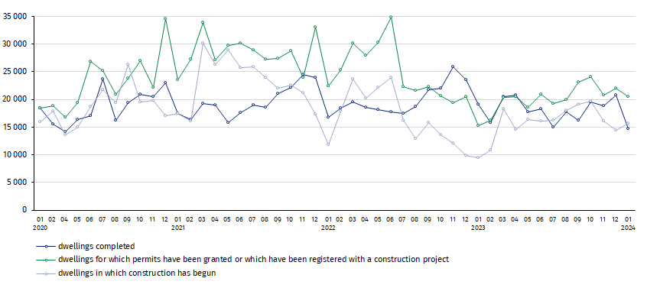

In January 2024, the highest values of dwellings completed, as well as dwellings in which construction has begun and dwellings for which permits have been granted or which have been registered with a construction project, were recorded in Mazowieckie voivodship (respectively: 2.8 thousand, 3.0 thousand and 4.3 thousand dwellings). High values were also noted in Małopolskie (1.5 thousand, 1.2 thousand and 1.8 thousand), Wielkopolskie (1.4 thousand, 1.5 thousand and 1.5 thousand) and Dolnośląskie (1.4 thousand, 2.0 thousand and 1.8 thousand).

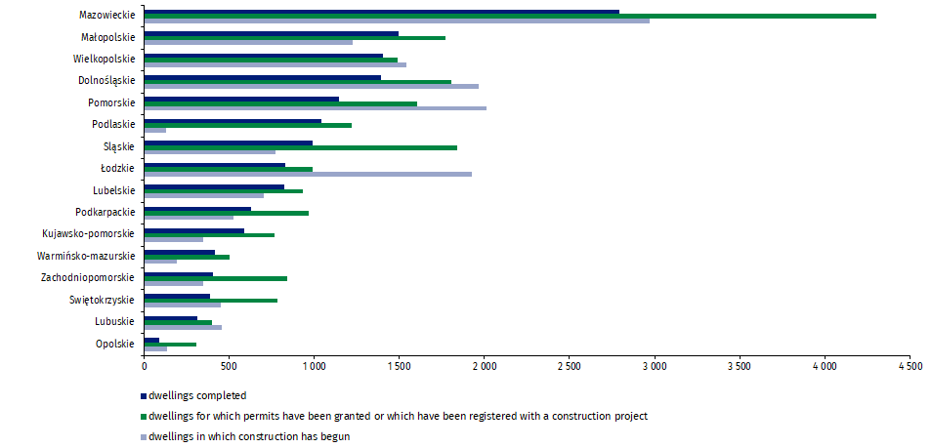
Chart 2. Residential construction by voivodships in January 2024

In case of quoting Statistics Poland data, please provide information: “Source of data: Statistics Poland” and in case of publishing calculations made on data published by Statistics Poland, please include the following disclaimer: “Own study based on figures from Statistics Poland”.
Prepared by:  Statistical Office in Lublin  Director Krzysztof Markowski, Ph.D.  Phone: (+48) 695 255 301 | Issued by:  The Spokesperson for the President  of Statistics Poland  Karolina Banaszek  Phone: (+48) 695 255 011
Press Office  Phone: (+48 22) 608 38 04  e-mail: obslugaprasowa@stat.gov.pl |   www.stat.gov.pl/en/

@StatPoland

@GlownyUrzadStatystyczny

gus_stat

glownyurzadstatystycznygus

glownyurzadstatystyczny
Related information
Statistical Bulletin
Socio-economic situation of the country
Construction results
Data available in databases
Dwellings in which construction has begun - monthly accruing data
Dwellings completed – quarterly accruing data
Knowledge Databases - Construction
Local Data Bank
Terms used in official statistics
Dwellings for which permits have been granted or which have been registered with a construction project
Dwellings in which construction has begun
Dwellings completed

Preliminary data; subject to change upon developing final data.
Including a simplified procedure for single-family residential buildings

