Culture satellite account for 2019
The share of culture in the national economy in 2019 did not change compared to 2018 and accounted for 2.8%. Three domains dominated most of the transactions that made up the cultural satellite account: Advertising, Audio-visual arts and multimedia as well as Books and Press.
2.8%
The share of the culture area in generating the gross value added in 2019

The share of the culture area in the national economy
The culture satellite account makes it possible to estimate the contribution of the area of culture, understood as the activity of local government and state cultural institutions, non-governmental organisations operating in the field of culture, and entities belonging to the cultural and creative industries, to the national economy. The share of the culture area in the national economy is best assessed by the gross value added of the area of culture in relation to the gross value added of the entire economy. In 2019 that value amounted to 2.8%, as in 2018. The largest share in the creation of the gross value added in the cultural area had entities belonging to the Advertising domain (19.4% of the gross value added in the area of culture). Audio-visual arts and multimedia (16.7%) as well as Books and press (13.6%) had also a significant share. The smallest share in the generation of gross value added was observed for the Culture management and administration domain (0.4%).

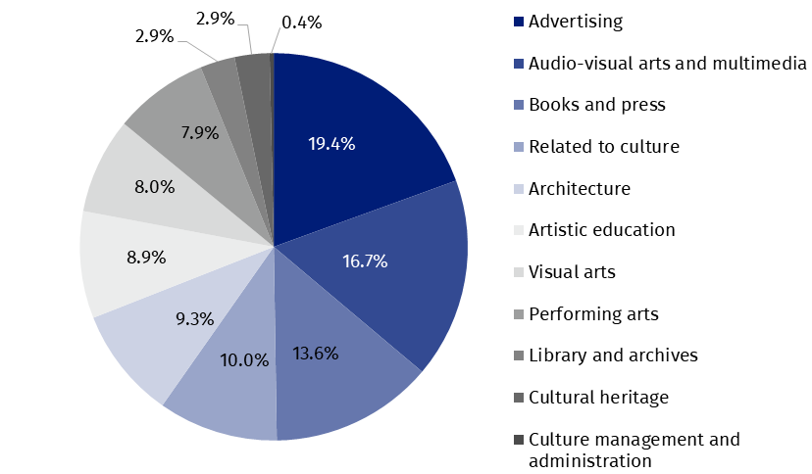
Chart 1. The structure of gross value added of culture by cultural fields in 2019
Compared to 2018, the structure of the gross value added of culture by cultural domains has not changed significantly. The share of Advertising domain decreased slightly (by 1.5 p.p.), while the share of Visual arts (by 1.4 p.p.) and Architecture (by 0.8 p.p.) increased.
The entities included in Advertising domain had the largest share in generating gross value added in the area of culture (19.4%)

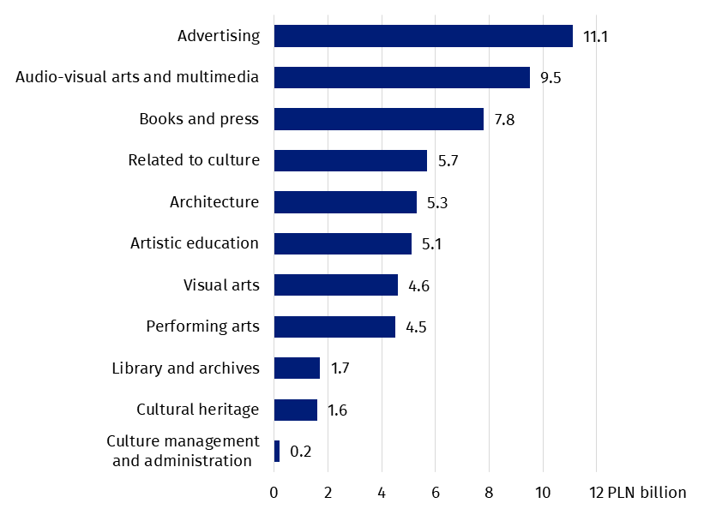
Chart 2. Gross value added in the area of culture by cultural domains in 2019
The largest increase in gross value added was recorded in the Visual arts domain (by 30.8%). Architecture also recorded a significant increase (by 18.6%). Gross output also increased in these domains (by 20.9% and 8.9%, respectively). High increase in value added was also observed for entities in the field of Artistic education (by 16.0%), with a similar increase in gross output (by 15.1%).
The comparison of the area of culture with other sectors of the national economy, taking into account the Polish Classification of Activities (PKD), shows the real role of the area of culture in the national economy and, therefore, its contribution to the creation of Poland’s Gross Domestic Product (GDP). Gross value added generated by entities operating within the PKD classes included in the area of culture in 2019 was slightly higher than the gross value added generated by entities included in section D – electricity, gas, steam and air conditioning supply (by 0.1 p p.), and also higher than for the entities belonging to section A – agriculture, forestry and fishing (by 0.2 p. p.) and section B – mining and quarrying (by 1.2 p. p.).

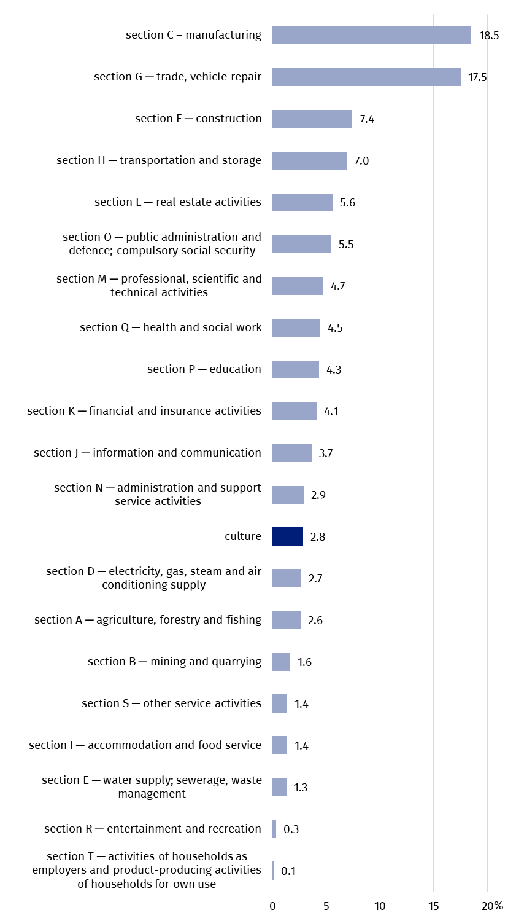
Chart 3. Share of the culture area in generating gross value added as compared to other sections of national economy in 2019 (according to PKD 2007)
The contribution of the cultural area to the national economy, counted by the gross value added, was 2.8%

Transactions in the culture satellite account
In the area of culture 69.0% of the total gross output was generated by four domains: Advertising, Audio-visual arts and multimedia, Books and press and Related to culture

The value of the gross output of the culture area increased by 4.7% (i.e. PLN 5,862.8 million) compared to 2018 and amounted to PLN 130,710.5 million. The highest value of gross output was recorded in the Advertising domain (PLN 34,429.3 million, i.e. 26.3% of the gross output for the entire area of culture). The following domains had also a significant share: Audio-visual arts and multimedia (19.3%), Books and press (11.9%) and Related to culture (11.5%). The total share of the gross output generated by these four domains amounted to 69.0% of the total gross output in the area of culture. The smallest contribution to the gross output of the area of culture was made by entities from the Culture management and administration domain (0.4%). The largest increase in the value of gross output was recorded once again in the Visual arts domain (increased by 20.9% as compared to 2018). The structure of the share of individual cultural domains in gross output did not change significantly compared to 2018.
The value of intermediate consumption, measuring the value of goods and services used as inputs in the production process, increased in comparison to 2018 by 2.1% (i.e. by PLN 1,533.1 million) to PLN 73,471.9 million. Total gross value added for the entire area of culture amounted to PLN 57,238.6 million (8.2% more than in 2018). Domains such as Libraries and archives and Artistic education deserve attention, as in their case the gross value added was almost twice as high as the value of intermediate consumption. By comparison, in case of Advertising the gross value added was lower than the intermediate consumption by half (52.3%), while in Audio-visual arts and multimedia and Related to culture domains – by nearly 40%.
Intermediate consumption was higher than gross value added generated in case of entities operating in the following domains: Advertising, Audio-visual arts and multimedia, and Related to culture
In 2019 compensation of employees amounted to PLN 24,051.2 million (an increase by 1,836.4 million in comparison to 2018, i.e. by 8.3%). In the structure of compensation of employees the largest share was recorded by entities in the Advertising domain (14.4%). The share of the following domains was also significant: Books and press (13.7%), Related to culture (13.3%), as well as Performing arts and Audio-visual arts and multimedia (13.1% each). On the other hand, the smallest share in the structure of compensation of employees was recorded by entities from the Culture management and administration domain (1.0%).
Gross operating surplus, constituting the difference between gross value added and compensation of employees and other taxes related to production diminished by other subsidies related to production, amounted to PLN 32,715.1 million (7.3%, i.e. PLN 2,230.0 million more than in 2018). The highest result was related to the Advertising domain (PLN 7,596.6 million). The lowest gross operating surplus values were observed for Libraries and archives domain (PLN 212.0 million). The highest increase in the gross operating surplus compared to 2018 was noticed in the Visual arts domain (by 36.0%). The largest decrease was in Culture management and administration domain (by 9.0%).
The Visual arts domain recorded the highest increase (by 36.0%) in the gross operating surplus, compared to 2018
Entities in the Artistic education domain received the most subsidies on production (56.1%, PLN 175.0 million). As in 2018, the highest other taxes on production were recorded for entities in the Audio-visual arts and multimedia domain (48.9% of all taxes on production, i.e. PLN 383.6 million), although compared to 2018 this domain had a smaller share in them (in 2018 – 60.0%).
Gross capital formation in 2019 amounted to PLN 5,629.8 million (14.6% less than in 2018)
In the analysed year, gross capital formation in the area of culture, reached PLN 5,629.8 million (PLN 965.2 million less than in 2018). The highest value, as in 2018, was recorded in the Architecture domain (PLN 3,221.0 million).

Table 1. Main transactions in culture satellite account according to cultural domains in 2019
Specification | Gross output | Interme-diate consump-tion | Value added, gross | Compensation of employ-yees | Other taxes on produc-tion | Other subsidies on produc-tion | Operating surplus, gross
Specification | in PLN million
Total | 130,710.5 | 73,471.9 | 57,238.6 | 24,051.2 | 784.2 | 311.9 | 32,715.1
Cultural heritage | 3,533.5 | 1,880.2 | 1,653.2 | 1,279.5 | 33.1 | 0.4 | 341.0
Library and archives | 2,542.1 | 863.8 | 1,678.3 | 1,451.4 | 15.0 | 0.1 | 212.0
Books and press | 15,563.1 | 7,776.8 | 7,786.3 | 3,299.4 | 51.4 | 22.6 | 4,458.1
Visual arts | 7,793.2 | 3,191.6 | 4,601.7 | 697.4 | 21.6 | 2.0 | 3,884.6
Performing arts | 8,787.9 | 4,249.4 | 4,538.6 | 3,142.3 | 96.0 | 2.9 | 1,303.2
Audio-visual arts and multi-media | 25,179.9 | 15,626.0 | 9,553.8 | 3,140.1 | 383.6 | 10.9 | 6,041.0
Architecture | 9,232.8 | 3,925.9 | 5,306.9 | 1,061.7 | 24.5 | 5.7 | 4,226.4
Advertising | 34,429.3 | 23,309.5 | 11,119.8 | 3,467.2 | 76.1 | 20.1 | 7,596.6
Artistic education | 8,077.9 | 3,011.2 | 5,066.8 | 3,076.8 | 35.3 | 175.0 | 2,129.7
Related to culture | 15,005.6 | 9,306.0 | 5,699.5 | 3,203.2 | 45.5 | 61.1 | 2,511.9
Culture management and administration | 565.0 | 331.3 | 233.7 | 232.1 | 2.1 | 11.1 | 10.6

Table 1. Main transactions in culture satellite account according to cultural domains in 2019 (cont.)
Specification | Final consumption expenditure |  |  | Gross capital formation | Imports of goods and services | Exports of goods and services
Specification | by house-holds | by non-profit institu-tions | by general govern-ment | Gross capital formation | Imports of goods and services | Exports of goods and services
Specification | in PLN million
Total | 37,714.2 | 1,289.5 | 15,123.7 | 5,629.8 | 19,954.4 | 25,906.1
Cultural heritage | 724.9 | 331.4 | 158.6 | -1.7 | 244.2 | 408.0
Library and archives | – | 117.1 | 805.6 | -0.5 | – | –
Books and press | 5,753.7 | 26.9 | 1,240.3 | 263.1 | 2,642.5 | 6,640.3
Visual arts | 4,103.3 | 59.9 | 106.1 | 6.2 | 58.7 | 29.9
Performing arts | 3,218.6 | 393.8 | 8,050.3 | 1,529.5 | 778.7 | 253.5
Audio-visual arts and multimedia | 22,509.1 | 3.7 | 1,765.6 | 589.8 | 9,941.9 | 7,621.8
Architecture | – | – | 248.1 | 3,221.0 | 129.4 | 231.3
Advertising | – | – | – | 0.7 | 6,110.9 | 10,580.6
Artistic education | 877.8 | 204.5 | 2,670.8 | -0.2 | – | –
Related to culture | 526.7 | 4.6 | – | 21.1 | 48.1 | 140.7
Culture management and administration | – | 147.6 | 78.2 | 0.8 | – | –

Final consumption expenditure for the area of culture amounted to PLN 54,127.3 million. Audio-visual arts and multimedia domain was responsible for almost half of it (PLN 24,278.4 million). High final consumption expenditure was recorded also in the case of Performing arts (PLN 11,662.7 million). The consumption related to households accounted for 69.7% of total final consumption expenditure. In this case, the highest value of consumption was recorded in Audio-visual arts and multimedia domain (PLN 22,509.1 million, i.e. PLN 248.3 million more than in 2018). In the general government sector (27.9% of total consumption, PLN 1,929.0 million more than in 2018), the highest value of final consumption was recorded in Performing arts domain (PLN 8,050.3 million, i.e. PLN 245.0 million more than in 2018). In the sector of non-profit institutions serving households, which are related to culture, final consumption expenditure amounted to PLN 1,289.5 million (PLN 65.7 million less than in 2018). The highest value of final consumption expenditure was recorded in Performing arts domain (PLN 393.8 million).
In 2019, there was a positive balance in foreign trade in cultural and creative goods and services in the amount of PLN 5,951.6 million (by PLN 852.0 million more than in 2018). The positive balance of foreign trade was mainly due to the commercial activity of entities from the Advertising domain (the balance of PLN 4,469.7 million, PLN 129.2 million less than in 2018) and Books and press (the balance of PLN 3,997.8 million, PLN 591.0 million more than in 2018). The Audio-visual arts and multimedia, Performing arts and Visual arts domains recorded once again a negative balance (minus PLN 2,320.1 million, minus PLN 525.2 million and minus PLN 28.8 million, respectively). The largest share in exports of goods and services was observed in the Advertising domain (40.8%, 3.7% more than in 2018). A large share in exports was also recorded in the Audio-visual arts and multimedia (29.4%, 8.0% less than in 2018), and Books and press domains (25,6%, 11.4% more than in 2018). In the case of imports, the same fields dominated: Audio-visual arts and multimedia (49.8% of total cultural imports), Advertising (30.6%) and Books and press (13.2%). The value of imports in the following domains: Audio-visual arts and multimedia amounted to PLN 9,941.9 million, Advertising – PLN 6,110.9 million, and Books and press – PLN 2,642.5 million. It is worth noting the percentage increase in exports compared to 2018 in the area of Architecture (by 25.7%) and Cultural heritage and Books and press (11.4% each) – in this domains imports also increased (by 25.4% and 3.5%, respectively). The value of exports in the field of Visual arts decreased by half (52.5%).
The positive balance (PLN 5,951.6 million) in foreign trade in cultural goods and services is mainly related to the Advertising and Books and press domains.
In the case of quoting data from the Statistics Poland, please provide information: "Statistics Poland data source", and in the case of publishing calculations made on data published by the Statistics Poland, please provide information: "Own study based on Statistics Poland data".
Prepared by:
Statistical Office in Kraków
Director Agnieszka Szlubowska
Phone: (+48 12) 420 40 50
Issued by:  Press Office  Mobile +48 695 255 032  Phone +48 22 608 38 04, +48 22 449 41 45, +48 22 608 30 09  e-mail: obslugaprasowa@stat.gov.pl |   stat.gov.pl/en/

@StatPoland

@GlownyUrzadStatystyczny

gus_stat

glownyurzadstatystycznygus

glownyurzadstatystyczny
Related information
Report on methodological work. Culture Satellite Account (PL version only)
Cultural satellite account for 2018
Cultural and creative industries 2017–2021
Cultural and creative industries in 2022
Culture and national heritage in 2022
Terms used in the official statistics
Gross capital formation
Exports of goods and services
Imports of goods and services
Compensation of employees
Operating surplus, gross
Gross output
Gross Domestic Product (GDP)
Final consumption expenditure
Value added, gross
Intermediate consumption

In order to present the data according to PKD sections, it was necessary to exclude from some sections of the national economy individual classes that were included in the calculations for the area of culture. The area of culture includes the following classes: 18.11; 18.12; 18.20; 32.20; 47.61; 47.62; 47.63; 58.11; 58.13; 58.14; 58.21; 59.11; 59.12; 59.13; 59.14; 59.20; 60.10; 60.20; 63.91; 71.11; 73.11; 74.10; 74.20; 74.30; 77.22; 90.01; 90.02; 90.03; 90.04; 91.01; 91.02; 91.03 and for data concerning the general government sector also some part of classes: 84.11; 84.12; 84.25, 94.12 and in the field of artistic education some part of classes: 85.10; 85.20; 85.31; 85.32; 85.41; 85.42; 85.52; 85.59; 85.60.
Gross capital formation measures the increase in national capital in given period, including, in terms of value, gross fixed capital formation, changes in inventories and acquisitions less disposals of valuables.
Data on final consumption expenditure, gross capital formation and foreign trade in Culture satellite account are calculated on the basis of data by balance groups presented in the supply and use tables.
Expenditure incurred by resident institutional units (including households sector, general government sector and non-profit institutions servicing households sector) on goods and services used to meet the direct, individual and collective needs of members of society.

