Cultural and creative industries in 2022
130.1 thousand enterprises belonging to the cultural and creative industries operated in 2022, of which 99.1% were micro-enterprises. Number of employed persons amounted to 256.0 thousand and average paid employment amounted to 101.6 thousand full-time jobs. Gross monthly salary per one employee amounted to PLN 7,979. International trade in cultural and creative goods was characterised by a positive balance of turnover, while international trade in cultural and creative services was characterised by negative balance.
3.6%
A decrease in the number of enterprises belonging to the cultural and creative industries in comparison to 2021

The number and types of enterprises belonging to the cultural and creative industries
In 2022, for the first time since 2015, there was a decrease in the number of entities belonging to the cultural and creative industries. The number of entities amounted to 130.1 thousand (in comparison to 2021 decreased by 3.6%, i.e. 4.9 thousand of entities), and accounted for 5.5% of all non-financial enterprises in Poland.

Chart 1. Number of enterprises belonging to the cultural and creative industries
The largest number of enterprises belonging to the cultural and creative industries operated in the field of Visual arts (26.9%)

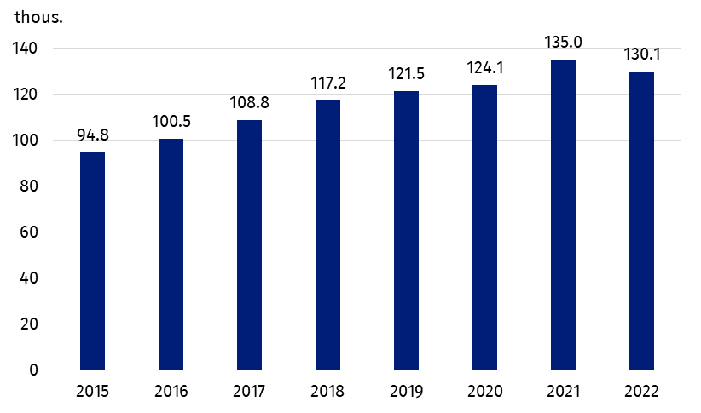
The largest number, i.e. 35.5 thousand (26.9% of the total number of entities included in the cultural and creative industries), conducted activities related to the field of Visual Arts. The number of entities in that field decreased by 0.5 thousand in comparison to 2021, but their share in total number of enterprises belonging to the cultural and creative industries increased by 0.6 percentage points. A slight increase of share in the structure of entities included in the cultural and creative industries was observed also in case of entities belonging to the field of Audiovisual Arts and Multimedia (by 0.7 percentage points) and Cultural Education (by 0.2 percentage points) – only in these two fields there was an increase in the number of entities (by 0.4 thousand and 0.1 thousand, respectively). In other fields of culture there was a decrease in the number of entities – the highest in the field Books and Press (by 1.7 thousand of entities).

Chart 2. The structure of entities belonging to the cultural and creative industries by domain of culture in 2022
The majority of the entities classified as cultural and creative industries were micro-enterprises. They accounted for 5.7% of all non-financial micro-enterprises

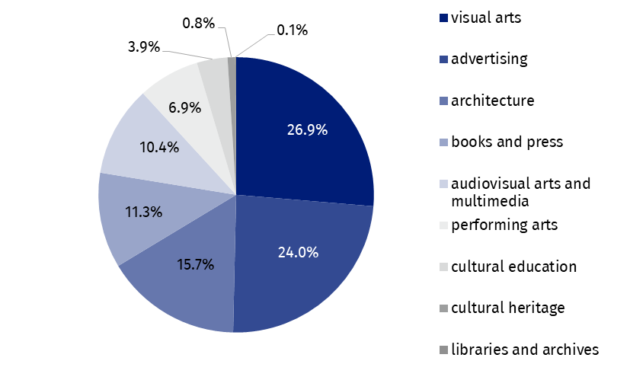The majority of entities were classified as micro-enterprises (129.0 thousand, i.e. 99.1% of all entities belonging to the cultural and creative industries), which accounted for 5.7% of all non-financial micro-enterprises. In other size classes of enterprises, the share of cultural and creative industries in the group of non-financial enterprises was as follows: small enterprises – 1.8%, medium – 1.2% and large – 1.3%.

Employed persons, average employment and salaries
As the number of entities decreased, the number of employees in enterprises belonging to the cultural and creative industries also decreased – at the end of 2022 amounted to 256.0 thousand people, i.e. 1.3 thousand people less than in 2021. At the same time the average employment increased by 1.5 thousand full-time jobs and amounted to 101.6 thousand. In case of micro-enterprises declines were recorded in both the number of employees and the average employment – by 2.3% and 7.6%, respectively. Small enterprises employed 0.7% less people, but the average employment increased by 2.1%. In other size classes of enterprises, both the number of employed persons and average employment increased – in medium-sized enterprises by 0.5% and 2.4%, respectively, and in case of large enterprises by 11.6% and 16.0%, respectively. The structure of people employed in enterprises belonging to cultural and creative industries was different from the structure of average employment - in micro-enterprises worked 74.4% of people, while the share of average employment was 39.4%.
Both in non-financial enterprises and in the cultural and creative industries, the gross monthly salary per one employee increased compared to 2021 (by 13.5% and 15.2%, respectively). In the cultural and creative industries gross monthly salary per one employee amounted to PLN 7,979 and was higher by PLN 1,052 in comparison to the previous year. Average salaries increased regardless of the size class of entities classified as cultural and creative industries, with the highest increase recorded in case of micro-enterprises – by 23.8% (up to PLN 5,183). In small enterprises average salary increased by 11.7%, in medium enterprises – by 8.0% and in large – by 6.5%. The highest gross monthly salary per one employee was recorded in large enterprises (PLN 10,589), and was twice as high as in the case of micro-enterprises.
Gross monthly salary per one employee in the cultural and creative industries was higher by PLN 1,248 compared to the total non-financial enterprises
Regardless of the size class of enterprises, the gross monthly salary per employee in the cultural and creative industries was higher than in the total non-financial enterprises – by PLN 1,248. In the largest group of entities, i.e. micro-enterprises, the difference amounted to PLN 799, in small enterprises – PLN 1,986, in medium-sized enterprises – PLN 2,666, and in large enterprises – PLN 2,822.
Share of gross wages and salaries in total costs for enterprises classified as cultural and creative industries amounted to 11.6% (0.9 percentage points more than in 2021).

Table 1. Employed persons, average paid employment, gross wages and salaries in the cultural and creative industries in 2022
Specification | Number of persons  employedª | Average paid employment | Gross wages and salaries in thousands PLN | Monthly gross wages and salary per 1 paid employee in PLN
Total | 256,021 | 101,572 | 9,725,514 | 7,979
Micro-enterprises | 190,547 | 39,997 | 2,487,773 | 5,183
Small enterprises | 17,763 | 16,442 | 1,637,741 | 8,301
Medium enterprises | 17,261 | 16,186 | 1,921,706 | 9,894
Large enterprises | 30,450 | 28,947 | 3,678,294 | 10,589
a As of December 31.

Financial results
Entities classified as cultural and creative industries generated total revenues of PLN 99.7 billion, with total costs of PLN 84.0 billion. Thus, as in the previous years, a surplus of total revenues over total costs was recorded, amounting to PLN 15.7 billion (PLN 2.4 billion more than in 2021). The cost level indicator (a ratio of total costs to total revenues) for enterprises belonging to the cultural and creative industries amounted to 84.2% (a decrease by 1.1 percentage points in comparison to 2021) and compared to the indicator for all non-financial enterprises was lower by 7.5 percentage points – so cultural and creative activity was less cost-intensive.
The surplus of total revenues over total costs for cultural and creative industries amounted to PLN 15.7 billion

Chart 3. The surplus of total revenues over total costs in enterprises belonging to the cultural and creative industries by enterprise size class
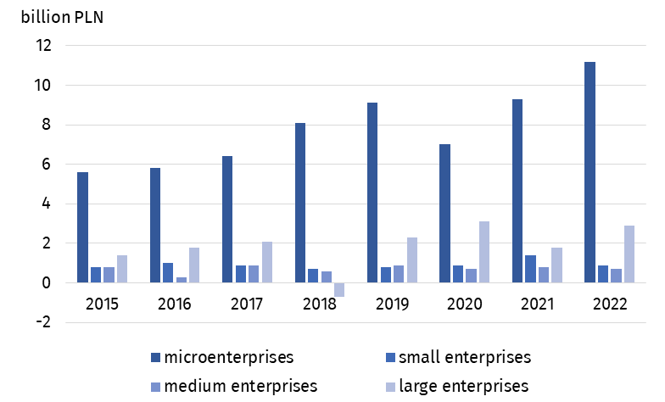
Total costs per one entity classified as the cultural and creative industries amounted to PLN 645.3 thousand, while their total revenues amounted to PLN 766.0 thousand. The share of both total revenues and total costs generated by enterprises classified as cultural and creative industries in total revenues and total costs achieved by all non-financial enterprises amounted to 1.3% and 1.2%, respectively.
Enterprises classified as the cultural and creative industries generated the value added of PLN 31.1 billion (PLN 5.7 billion more than in 2021), which accounted for 1.6% of the value added generated by all non-financial enterprises. Almost half of the value added was provided by micro-enterprises – PLN 14.0 billion. In case of large enterprises, it was PLN 10.0 billion, and small and medium-sized enterprises generated PLN 3.2 billion and PLN 4.0 billion of the value added, respectively. Calculated per one enterprise, the value added of the cultural and creative industries in general was 3.4 times lower than the value added per one non-financial enterprise.

International trade of cultural and creative goods and services
In 2022, cultural and creative goods worth PLN 16,515.5 million were sold abroad (by PLN 1,540 million, i.e. 8.5% less than in 2021). The import of cultural and creative goods also decreased by 16.7%, reaching PLN 10,493.0 million. The foreign trade balance was positive and amounted to PLN 6,022.4 million. The largest amount from the sale of goods was obtained in the field of Books and Press (PLN 7,336.5 million), and the lowest in the field of Arts and Crafts (PLN 0.6 million). The highest value of imports was recorded in the field of Audiovisual Arts and Multimedia (PLN 6,670.1 million), and the lowest, as in the case of exports, in the field of Arts and Crafts (PLN 1.5 million). In comparison to 2021, the largest increase in the value of exported cultural and creative goods was observed in the case of Cultural Heritage (by 53.3%), while in case of import the value increased only in the field of Visual Arts (by 19.0%).
In 2022, a positive balance of international trade of cultural and creative goods was recorded, amounting to PLN 6,022.4 million. The balance of trade of cultural and creative services was negative and amounted to minus PLN 2,295.4 million
The value of cultural and creative services delivered abroad amounted to PLN 15,520.6 million (PLN 2,665.3 million more compared to 2021), while purchased cultural and creative services amounted to PLN 17,816.0 million (PLN 3,531.7 million more than in 2021). Therefore, the balance of turnover was negative and amounted to minus PLN 2,295.4 million. A positive balance of turnover in cultural and creative services was recorded in three fields: Architecture (PLN 180.6 million), Cultural Heritage (PLN 143.3 million) and Advertising (PLN 139.9 million). The highest value of both exports and imports was recorded in the field Advertising – PLN 12,577.8 million (16.1% more than in 2021) and PLN 12,438,9 million (29.3% more than in 2021), respectively.
In the structure of Poland's foreign trade, the share of both exports and imports of the cultural and creative goods and services was relatively small and in comparison to the previous years remained at a similar level. The share of cultural and creative goods in exports of goods was 1.0%, whereas in imports – 0.6% in 2022 (a decrease of 0.4 percentage points in comparison to 2021). The share of cultural and creative services in the foreign trade of services was slightly higher and amounted to 3.6% and 7.0%, respectively (a decrease of 0.5 percentage points compared to the previous year).
The recipients of Polish cultural and creative goods were primarily economically developed countries, especially the EU countries (89.9% of all turnover), including the Euro area members (75.3% of all turnover). The situation was similar in the case of imports of goods, where the main turnover was with developed countries, although to a lesser extent with the EU (51.1%) or the euro area itself (47.2%). In the foreign trade, most of cultural and creative services were exported to and imported from economically developed countries (95.2% and 96.6%, respectively), more than half of them to and from euro area countries.

Table 2. Foreign trade in cultural and creative goods and services by domain of culture in 2022
Specification | Cultural and creative goods |  | Cultural and creative services
Specification | export | import | export | import
Specification | in million PLN
Total | 16,515.5 | 10,493.0 | 15,520.6 | 17,816.0
Cultural heritage | 88.6 | 224.1 | 516.1 | 372.9
Books and press | 7,336.5 | 2,815.4 | 245.7 | 825.8
Visual arts | 332.0 | 222.5 | – | –
Architecture | 1.2 | 3.1 | 312.4 | 131.8
Performing arts | 218.8 | 336.1 | 337.4 | 635.8
Audiovisual arts and multimedia | 6,796.0 | 6,670.1 | 1,531.1 | 3,410.8
Advertising | 1,741.8 | 220.2 | 12,577.8 | 12,438.9
Arts and crafts | 0.6 | 1.5 | – | –
In the case of quoting data from the Statistics Poland, please provide information: "Statistics Poland data source", and in the case of publishing calculations made on data published by the Statistics Poland, please provide information: "Own study based on Statistics Poland data".
Prepared by:  Statistical Office in Kraków  Director Agnieszka Szlubowska  Phone: (+48 12) 420 40 50 | Issued by:  The Spokesperson for the President of Statistics Poland  Karolina Banaszek  Phone: (+48) 695 255 011
Press Office  Phone: (+48 22) 608 38 04  e-mail: obslugaprasowa@stat.gov.pl |   stat.gov.pl/en/

@StatPoland

@GlownyUrzadStatystyczny

gus_stat

glownyurzadstatystycznygus

glownyurzadstatystyczny
Related information
Cultural and creative industries 2017–2021
Cultural and creative industries in 2021
Culture and national heritage in 2022
Terms used in the official statistics
Exports of goods and services
Imports of goods and services
Total costs
Average monthly gross wages and salaries
Average paid employment
Total revenues
Balance foreign trade commodity turnover
Balance of services
Cost level indicator
Gross earnings

