Market of the works of art and antiques in 2023
In 2023 the total amount of sold works of art and antiques amounted to PLN 567.7 million. The largest part of the total value of sales of works of art and antiques was obtained by entities through organisation of auctions – PLN 350.6 million.
12.8%
Decrease in the value of sales of works of art and antiques in comparison to 2022
The information received from 200 entities operating on the works of art and antiques market shows, that 58.0% of them were exclusively engaged in the sale of works of art and antiques, while the rest also conducted exhibition activities.
The largest number of entities on the market of works of art and antiques operated in Mazowieckie Voivodship - 52 (26.0% of the total number of entities), including 45 entities selling works of art and antiques in Warszawa. There were 39 entities (19.5%) in Małopolskie Voivodship, of which 35 operated in Kraków. As in the previous year, the majority of entities (71.0%) involved in the sale of works of art and antiques were based in the capitals of Voivodships.
26.0% of the total number of entities selling works of art and antiques were based in Mazowieckie Voivodship
The total amount of sold works of art and antiques amounted to PLN 567.7 million and decreased by 12.8% in comparison to 2022. As in the previous year, most works of art and antiques were sold in Mazowieckie Voivodship - for the amount of PLN 433.6 million, which accounted for 76.4% of the total amount of sales of works of art and antiques in Poland.
The largest share from the sale of works of art and antiques was obtained in the field of painting - PLN 471.9 million (i.e. 83.1% of the total amount of sales), including contemporary painting - PLN 242.1 million (42.6% of the total amount of sales), and old painting – PLN 229.8 million (40.5%). Compared to 2022, there was a decrease in sales of paintings by 16.2%, with the sale of contemporary paintings increasing by 9.9% and sale of old paintings decreasing by 33.0%.
83.1% of the total sales amount of sold works of art and antiques was obtained in the field of painting

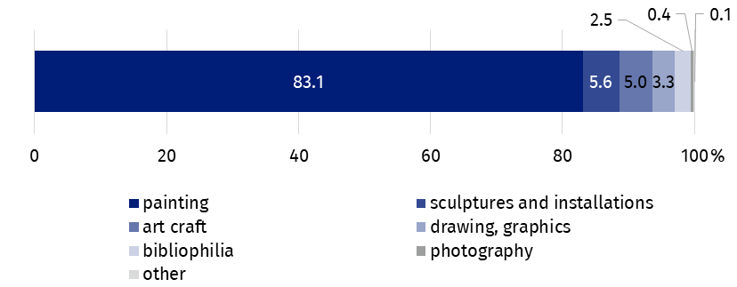
Chart 1. The sale of works of art and antiques by type in 2023
The largest share of the total amount of the sale of works of art and antiques was obtained by entities through auctions – PLN 350.6 million (by PLN 83.5 million, i.e. 19.2% less than in 2022), including online auctions – PLN 26.7 million (by PLN 10.4 million, i.e. 64.1% more than in 2022).
A significant distribution channel, in the terms of the total sale value, was sales in retail outlets. Its value amounted to PLN 188.8 million, which accounted for 33.2% of the total amount of sales. Sales of works of art and antiques in retail outlets increased by 7.5% compared to 2022.
Works of art and antiques were sold via the Internet (e.g. online stores, sales platforms) for the amount of PLN 21.9 million (3.9% of the total sales value), which was less by 34.2% in comparison to 2022.

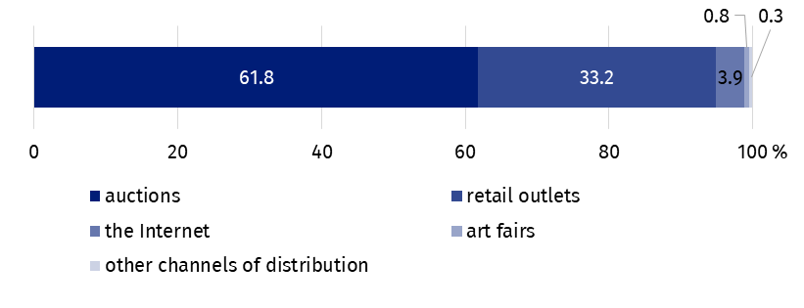
Chart 2. The sale of works of art and antiques by distribution channel in 2023
More than half (61.8%) of the value of the sale of works of art and antiques was obtained through auctions

In the year under review, 16 entities operating on the works of art and antiques market actively participated in art fairs, of which 15 entities in domestic art fairs.

In the case of quoting data from the Statistics Poland, please provide information: "Statistics Poland data source", and in the case of publishing calculations made on data published by the Statistics Poland, please provide information: "Own study based on Statistics Poland data".
Prepared by:  Statistical Office in Kraków  Director Agnieszka Szlubowska  Phone: (+48 12) 420 40 50 | Issued by:  Press Office  Mobile: (+48) 695 255 032  Phone: (+48 22) 608 38 04, (+48 22) 449 41 45,  (+48 22) 608 30 09  e-mail: obslugaprasowa@stat.gov.pl

stat.gov.pl/en/

@StatPoland

@GlownyUrzadStatystyczny

gus_stat

glownyurzadstatystycznygus

glownyurzadstatystyczny
Related information
Culture and national heritage in 2022
Market of works of art and antiques in 2022
Terms used in the official statistics
Works of art
Antiques
Art gallery

